**Assignment – 2 DAA  
22CS132**

Longest Happy String :: Problem 1405  
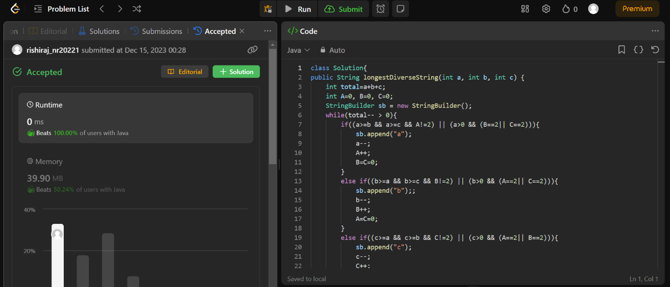  
Longest Common Subsequence : Problem 1143

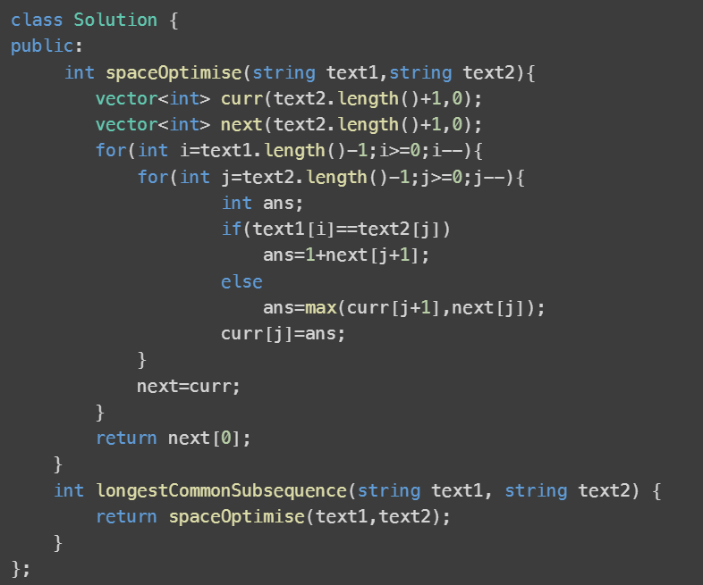

Longest palindrome : Problem 409

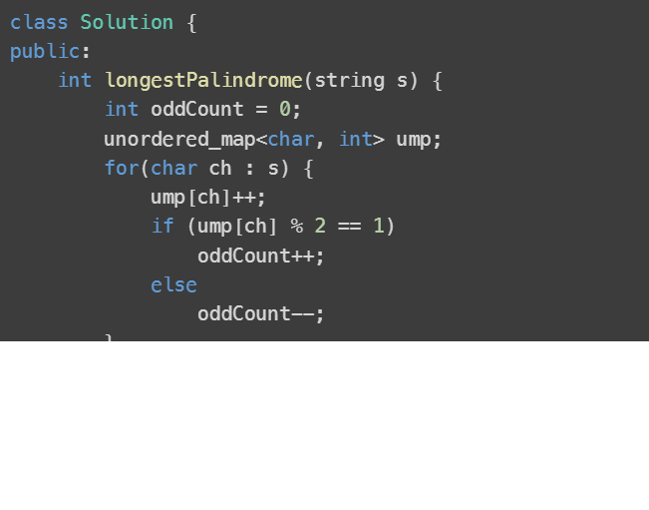

Palindrome partitioning : Problem 131

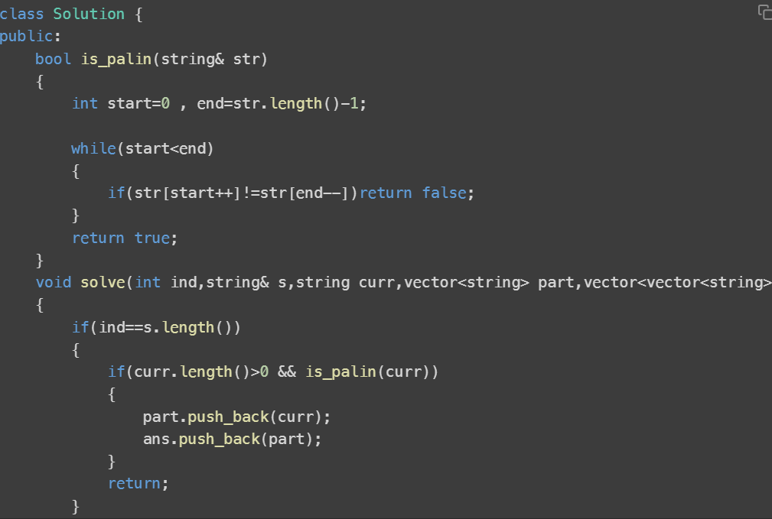

Equal subset sum partition : Problem 416

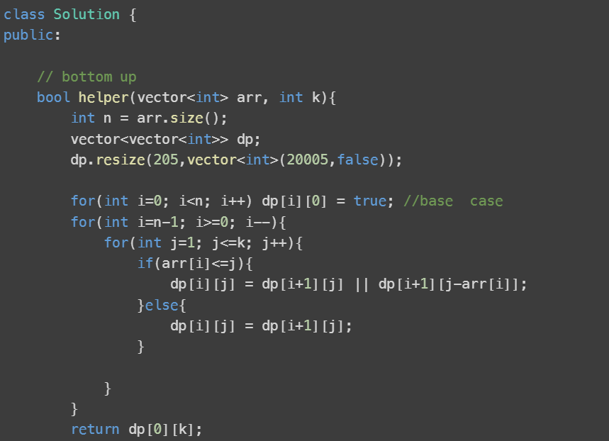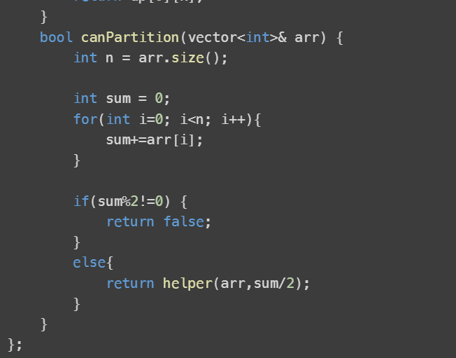

Edit Distance : Problem 72

