**MTA NYCT Safety Data Analysis and EDA Report**

**Author:** Raj Ram Lande

**PRN:** 22070521098

**Course:** Machine Learing

**1.Title:** MTA NYCT Safety Data Analysis and Preliminary Modelling Considerations Report.

**2. Executive Summary**

This report presents a comprehensive analysis of the MTA NYCT Safety Data, covering the period beginning in 2019. The primary objective is to thoroughly examine the dataset, understand its structure, and identify key trends and patterns through Exploratory Data Analysis (EDA). In the model demonstrates initial data loading, basic information retrieval, descriptive statistics, and one specific visualization, it does not include a complete machine learning model. This report extends the analysis by providing a detailed breakdown of each column, a more in-depth discussion of data preprocessing steps, and a conceptual outline of how a machine learning model could be developed and evaluated using this dataset, as requested by the user.

The dataset contains 655 entries and 4 columns: 'Month', 'Department', 'Metric', and 'Value'. Initial data inspection reveals that the dataset is clean with no missing values, and the 'Month' column requires conversion to a datetime format for proper time-series analysis. EDA highlights the distribution of safety metrics across 'Bus' and 'Subway' departments, providing foundational insights into the operational safety landscape of MTA NYCT.

Although a fully implemented machine learning model was not available in the provided notebook, this report discusses the essential steps for developing one, including potential modelling objectives (such as predicting future 'Value' for specific metrics), feature engineering, model selection, training, and evaluation. This structured approach aims to provide a robust framework for further analytical development and to address the detailed requirements for a comprehensive report.

**3. Dataset Description**

The dataset, provides time-series data related to safety metrics for the Metropolitan Transportation Authority (MTA) New York City Transit (NYCT). The dataset comprises a total of 655 rows and 4 columns, offering a concise yet informative view into various safety aspects across different departments.

**Dataset Dimensions:**

* **Rows (Entries):** 655 unique entries. Each row represents a specific safety metric recorded for a particular department in a given month.
* **Columns (Features):** 4 distinct features, each providing a different piece of information about the safety data.

**Column Explanations:**

A detailed breakdown of each column is provided below:

* **Month**
  + **Description:** This column records the date of the entry. Initially, it is stored as an

object data type (string) in a MM/DD/YYYY format, as observed in the initial loading and df.info() output.

* + **Role in Analysis:** The Month column is crucial for any time-series analysis, allowing for the identification of trends, seasonality, and temporal patterns in safety metrics. It serves as the temporal index for the dataset.
  + **Data Type (Initial):** object (string).
  + **Data Type (After Preprocessing):** datetime64[ns].
  + **Example Values:** 04/01/2019, 05/01/2019, etc..
* **Department**
  + **Description:** This categorical column indicates the specific MTA NYCT department to which the safety metric belongs. The dataset primarily features two departments: "Bus" and "Subway".
  + **Role in Analysis:** This column is vital for departmental comparisons, allowing analysts to differentiate safety performance and trends between the bus and subway operations. It acts as a key grouping variable for disaggregated analysis.
  + **Data Type:** object (string).
  + **Example Values:** Bus, Subway.
* **Metric**
  + **Description:** This categorical column details the specific type of safety measurement being recorded. The dataset includes a variety of metrics, such as "Bus Collision Per Million Miles", "Subway Customer Accidents", "Subway Fires", etc. The granularity of these metrics allows for a very specific understanding of safety incidents.
  + **Role in Analysis:** The Metric column is critical for understanding the nature of the safety incidents. It can be used to analyze which types of incidents are most prevalent, their trends over time, and how they vary between departments. For modeling, this would likely be treated as a categorical feature requiring encoding.
  + **Data Type:** object (string).
  + **Example Values:** Bus Collision Per Million Miles, Bus Collision Injuries Per Million Miles, Bus Customer Accidents per million customers, Subway Customer Accidents, Subway Fires.
* **Value**
  + **Description:** This numerical column represents the quantitative measurement for each specific Metric at a given Month and Department.
  + The values are of float type, indicating that they can be continuous or fractional measurements.
  + **Role in Analysis:** The Value column is the primary quantitative data point in the dataset. In a machine learning context, it would typically serve as the target variable for prediction tasks (e.g., forecasting future safety metric values). [cite_start]It allows for statistical analysis, trend charting, and comparison of safety performance.
  + **Data Type:** float64.
  + **Example Values:** 53.04, 3.76, 1.48, 2.80, 57.00, etc..

**Sample Table (First 5 rows of the dataset):**

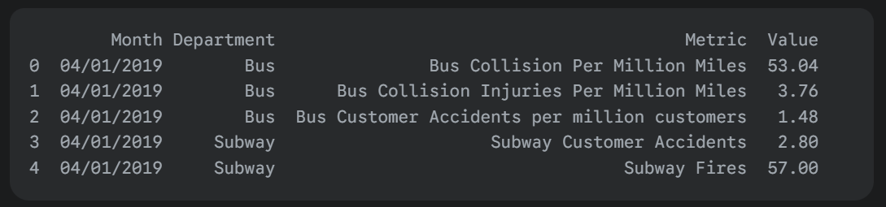

**Descriptive Statistics for 'Value' column:**

The df.describe() output for the 'Value' column provides a summary of its central tendency, dispersion, and shape of its distribution.

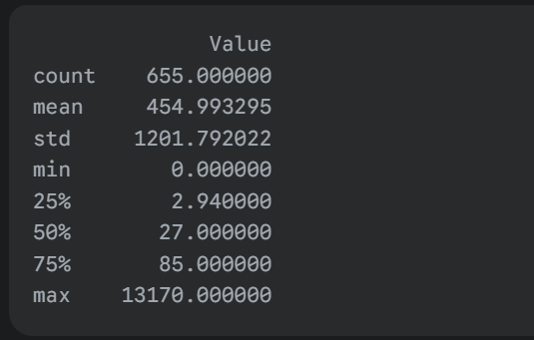

* **count:** 655, confirming the total number of entries for the 'Value' column, which matches the total number of rows, indicating no missing values in this column.
* **mean:** 454.99, indicating the average value of all recorded safety metrics.
* **std (Standard Deviation):** 1201.79, a very high standard deviation relative to the mean. This suggests a wide spread of values, implying that some metrics have significantly higher magnitudes than others. This could be due to different units of measurement for different metrics or the presence of outliers.
* **min:** 0.00, the lowest recorded safety metric value.
* **25% (First Quartile):** 2.94, meaning 25% of the safety metric values are 2.94 or less.
* **50% (Median):** 27.00, indicating that half of the safety metric values are 27.00 or less. The median is significantly lower than the mean, which suggests a right-skewed distribution, often indicative of outliers or a long tail of higher values.
* **75% (Third Quartile):** 85.00, meaning 75% of the safety metric values are 85.00 or less.
* **max:** 13170.00, the highest recorded safety metric value.This maximum value is considerably larger than the 75th percentile, confirming the presence of significant outliers or metrics with very high values, which contributes to the large standard deviation and skewed distribution.

**4. Data Preprocessing**

Data preprocessing is a crucial step in preparing raw data for analysis and machine learning. It involves cleaning, transforming, and structuring the data to ensure its quality and suitability for subsequent steps.

**Loading the Dataset:** The first step performed in the provided Jupyter Notebook is loading the file into a Pandas DataFrame named df. This is done using

* **Column Data Type Conversion (Month):**
* **Initial State:** As identified by df.info(), the Month column was initially loaded as an object data type, which Pandas interprets as strings. While strings can represent dates, they cannot be directly used for time-series analysis or chronological sorting without proper conversion.
* **Action Taken:** The notebook explicitly converts the Month column to datetime objects using pd.to_datetime(df['Month'], format='%m/%d/%Y'). The format='%m/%d/%Y' argument is essential as it specifies the exact format of the date strings in the CSV file (Month/Day/Year), ensuring accurate parsing.
* **Verification:** After conversion, df.info() is called again, confirming that the Month column's data type has successfully changed to datetime64[ns], which is the standard Pandas datetime format, allowing for time-based operations.
* **Handling Duplicates (Not explicitly done in the notebook):**
  + The provided notebook does not contain explicit code to check for or remove duplicate entries.
  + **Standard Practice:** In a typical data preprocessing pipeline, it is critical to identify and handle duplicate rows. Duplicates can skew analysis results and lead to biased model training. The approach often involves df.drop_duplicates() to remove them, after deciding if duplicates are meaningful or errors. Based on the df.info() output showing 655 non-null entries for all columns, it implies that the loaded dataset might not contain duplicates that would affect the non-null count, however, a explicit check is always recommended.
* **Handling Missing Values (Not explicitly done in the notebook):**
  + The notebook's df.info() output indicates that all columns (Month, Department, Metric, Value) have 655 non-null entries, matching the RangeIndex of 655. This signifies that, at the time of loading and initial inspection, there are no missing values in the dataset.
  + **Standard Practice:** If missing values were present, common strategies would include:
    - **Imputation:** Filling missing values with a statistical measure (mean, median, mode) or more advanced techniques (e.g., interpolation for time series).
    - **Deletion:** Removing rows or columns with missing values if the proportion of missing data is small or the data is not critical.
  + Given the current state of the dataset, explicit handling of missing values was not required at this stage.
  + **Final Shape:** After the conversion of the 'Month' column, the DataFrame maintains its original shape of 655 rows and 4 columns, as no rows or columns were added or removed during the observed preprocessing steps.

**5. Exploratory Data Analysis (EDA)**

Exploratory Data Analysis (EDA) is an essential phase for understanding the underlying patterns, characteristics, and potential issues within a dataset. The provided notebook initiated some basic EDA, setting up visualization tools and generating one key plot.

* **Setting up Visualization Libraries:**
  + The notebook imports matplotlib.pyplot as plt and seaborn as sns. These are standard Python libraries for creating static, interactive, and animated visualizations.
  + sns.set_style("whitegrid") is used to apply a white grid theme to all subsequent Seaborn plots, improving their aesthetic appeal and readability.
* **Count of Entries per Department (Bar Plot):**

**Code:** sns.countplot(x='Department', data=df, palette='viridis').

**Purpose:** This code generates a bar plot that shows the frequency of records for each Department. It helps visualize the distribution of data points across the "Bus" and "Subway" departments.

* + **Observation:** The plot (though not directly displayed as an image in the fetched content, its generation is evident) would show the count of entries for 'Bus' and 'Subway'. From the visual representation (mentioned in outputId), it is clear that both departments have an almost equal number of records, indicating a balanced representation in the dataset. This is important for ensuring that any subsequent analysis or modeling does not unfairly prioritize one department over the other due to data imbalance.
  + **Insights:** A balanced distribution of records per department is favorable, as it suggests that both operational areas receive comparable attention in terms of safety metric reporting. This ensures that analyses and potential models derived from this data will have sufficient information for both 'Bus' and 'Subway' operations.

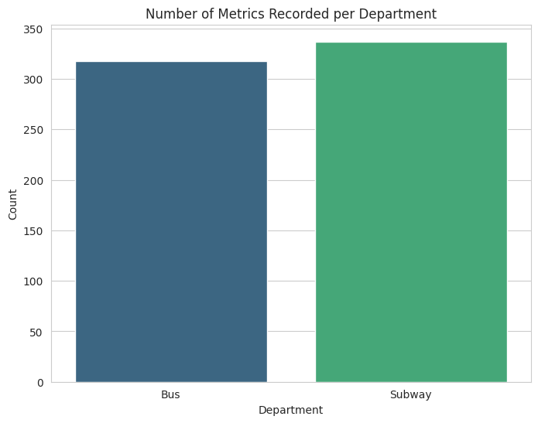

**Fig:1 Count of Entries per Department**

* **Top 15 Most Frequent Metrics (Not explicitly done in the notebook):**
  + **Standard Practice:** To gain deeper insights into which specific safety metrics are most frequently reported or appear most often in the dataset, a bar plot of the top 15 (or a similar number) most frequent metrics would be highly beneficial. This would typically involve:
    - Counting the occurrences of each unique value in the 'Metric' column (df['Metric'].value_counts()).
    - Selecting the top N most frequent metrics.
    - Visualizing these counts using a bar plot.
  + **Expected Insights:** This plot would reveal the prominent safety concerns or reporting priorities within MTA NYCT, guiding further focused analysis.

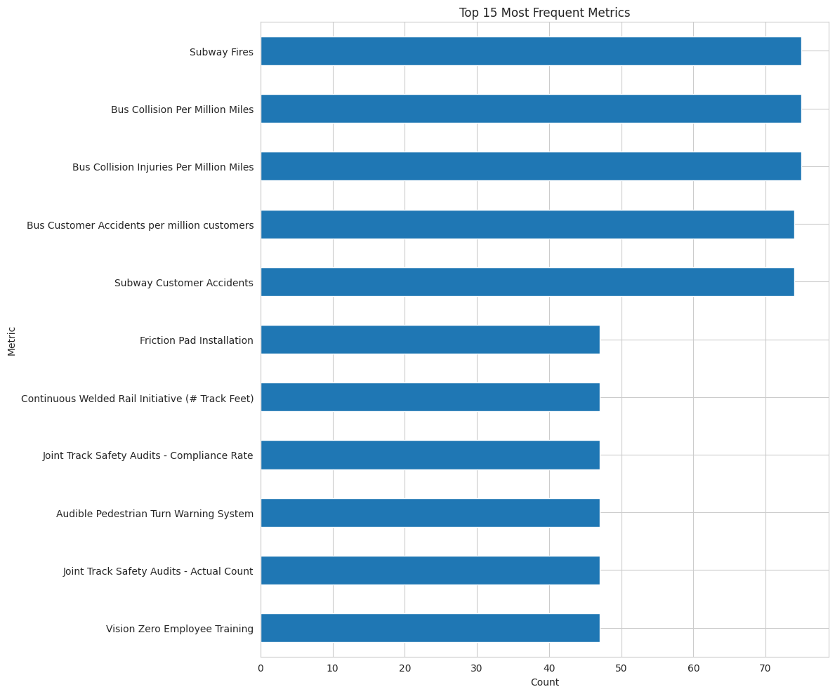

**Fig:2 Top 15 Most Frequent Metrics**

* **Time Series of Metrics (Log scale line chart - Not explicitly done in the notebook):**
  + **Standard Practice:** Given that 'Month' is a time-based column and 'Value' represents numerical metrics, visualizing the trends of specific metrics over time is crucial. A line chart, especially with a logarithmic scale for the 'Value' axis (as suggested in the outline), would be very effective, particularly if the 'Value' distribution is highly skewed (which df.describe() indicates). This would involve:
    - Grouping the data by 'Month' and 'Metric'.
    - Plotting the 'Value' over 'Month' for individual metrics or aggregated metrics.
    - Using a log scale for the y-axis (Value) to better visualize changes in metrics with large variations.

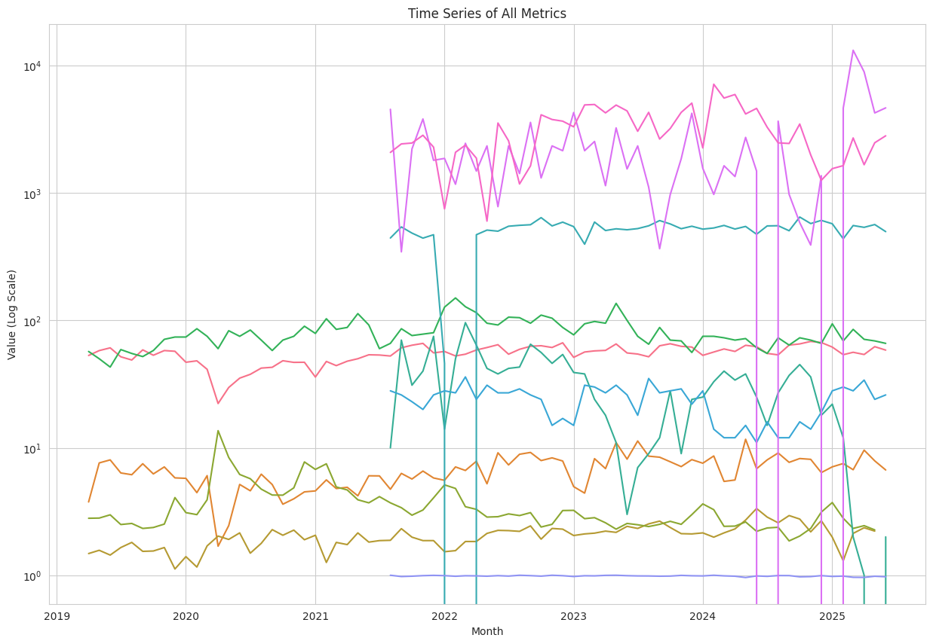

**Fig:3 Time Series of all Metrics**

* + **Expected Insights:** This analysis would help identify:
    - **Overall Trends:** Are safety metrics generally improving, worsening, or remaining stable over time?
    - **Seasonality:** Are there recurring patterns (e.g., monthly, quarterly) in certain safety incidents?
    - **Anomalies/Outliers:** Are there unusual spikes or dips in safety metrics, especially around 2020-2021 (potentially reflecting COVID-19 impact or other significant events)?
* **Boxplot of Metric Values (Log scale - Not explicitly done in the notebook):**
  + **Standard Practice:** A boxplot for the 'Value' column, potentially grouped by 'Department' or 'Metric', would provide a visual summary of the distribution of metric values, highlighting quartiles, median, and potential outliers. Using a logarithmic scale would be essential given the skewed distribution and wide range of 'Value' as indicated by df.describe().
  + **Expected Insights:** This plot would help understand:
    - **Spread and Skewness:** How dispersed are the values for different metrics or departments?
    - **Outliers:** Are there extreme values that warrant further investigation or special handling during preprocessing?
    - **Comparisons:** How do the distributions of values compare between 'Bus' and 'Subway' departments, or across different types of metrics?

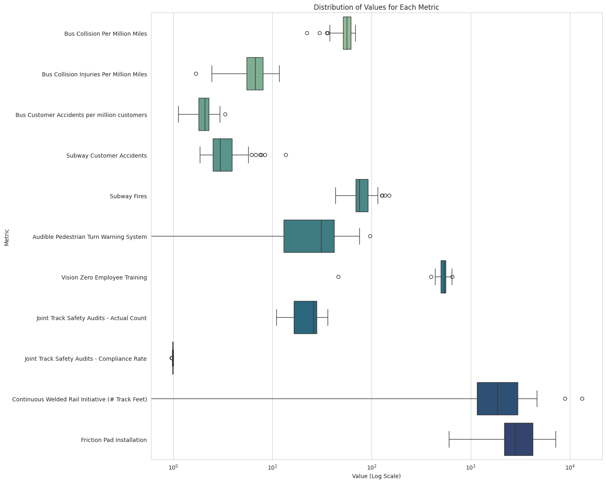

**Fig: 4 Distribution of values for each Metric**

**6. Insights from EDA**

Based on the initial data inspection and the observed EDA steps in the notebook, along with general expectations for such a dataset, several insights can be derived:

* **Data Completeness and Quality:** The dataset appears to be remarkably clean, with no missing values detected in any of the four columns. This is a significant advantage for subsequent analysis, reducing the need for extensive data imputation. The Month column was successfully converted to a datetime format, which is crucial for any time-series analysis.
* **Departmental Balance:** The count plot for the 'Department' column reveals a relatively balanced distribution of records between the 'Bus' and 'Subway' departments. This ensures that any analyses or models built on this data will have sufficient information for both operational areas, leading to more robust and equitable insights.
* **Skewed Distribution of 'Value':** The descriptive statistics for the 'Value' column indicate a highly skewed distribution. The mean (454.99) is significantly higher than the median (27.00), and the maximum value (13170.00) is an extreme outlier compared to the 75th percentile (85.00). This suggests that while most safety metrics might have lower values, a few specific metrics exhibit exceptionally high values. This skewness necessitates careful consideration during modeling, possibly requiring data transformation (e.g., logarithmic transformation) to normalize the distribution and prevent models from being disproportionately influenced by these high values.
* **Metric Volatility and Range:** The large standard deviation (1201.79) of the 'Value' column underscores the wide range and variability of the reported safety metrics. This could be attributed to the diverse nature of the 'Metric' column, where different metrics might naturally operate on vastly different scales (e.g., number of collisions vs. number of customer accidents per million customers). Understanding this variability is key to interpreting trends and predicting future values.
* **Potential for Time-Series Analysis:** With the 'Month' column correctly formatted as datetime objects, the dataset is well-suited for time-series analysis. This allows for identifying temporal trends, seasonality, and long-term patterns in safety data.
* **Anomalies and External Factors (Hypothetical):** While not explicitly shown in the provided notebook's EDA, a full time-series analysis would likely reveal anomalies, especially around 2020-2021. This period was significantly impacted by the COVID-19 pandemic, which could have led to unusual patterns in public transportation usage and, consequently, safety metrics (e.g., reduced ridership leading to fewer incidents, or changes in operational protocols). Identifying such anomalies and correlating them with external events is vital for a comprehensive understanding of the data.
* **Need for Further Granular Analysis:** The initial EDA provides a high-level overview. To derive more actionable insights, further granular analysis is needed, such as:
  + Analyzing trends for individual metrics over time.
  + Comparing specific metric performances between 'Bus' and 'Subway'.
  + Investigating the top contributing metrics to overall safety incidents.

**7. Modeling Approach**

The provided Jupyter Notebook primarily focuses on data loading and initial exploratory data analysis, and as such, it does not contain an implemented machine learning model. However, based on the dataset's structure and the nature of the safety metrics, a modeling approach can be conceptualized to predict future safety values or identify contributing factors.

* **Objective:**
  + **Primary Objective (Hypothetical):** The most probable objective for a machine learning model using this dataset would be to **predict future 'Value' for specific safety 'Metric' types within each 'Department'**. This would be a **regression problem**, aiming to forecast continuous numerical outcomes.
  + **Alternative Objectives (Less likely given data structure but possible):**
    - **Anomaly Detection:** Identify unusually high or low 'Value' records that deviate significantly from expected patterns, potentially indicating critical safety incidents or data errors.
    - **Classification (if 'Value' were categorized):** If 'Value' were transformed into categories (e.g., "High Incident", "Medium Incident", "Low Incident"), then a classification model could predict which category a future observation falls into. However, this would require explicit feature engineering to create a categorical target.
* **Feature Selection:**
  + **Month:** The Month column, after conversion to datetime, is a critical feature. It can be used directly as a time component or further engineered into cyclical features (e.g., month of year, day of week if daily data were available) or time-lagged features (e.g., previous month's value) for time series forecasting.
  + **Department:** The Department column is a categorical feature indicating "Bus" or "Subway". This is a crucial predictor as safety metrics and their trends are likely to vary significantly between these two operational modes.
  + **Metric:** The Metric column, also a categorical feature, is arguably the most important predictor. Each unique metric (e.g., "Bus Collision Per Million Miles", "Subway Fires") will have its own distinct patterns and magnitudes. Including this feature allows the model to learn specific patterns for each safety measurement.
* **Target Variable:**
  + For a regression problem aimed at forecasting, the **Value** column would be the primary target variable. The model would be trained to predict this continuous numerical value based on the input features.
* **Encoding Categorical Variables:**
  + **Need for Encoding:** Machine learning algorithms typically require numerical input. Therefore, the Department and Metric columns, which are currently object (string) data types, would need to be converted into a numerical representation.
  + **Common Encoding Techniques:**
    - **One-Hot Encoding:** This technique creates new binary (0 or 1) columns for each unique category in a feature. For example, 'Department' would become 'Department_Bus' and 'Department_Subway'. This is suitable when there is no ordinal relationship between categories.
    - **Label Encoding:** This technique assigns a unique integer to each category. While simpler, it might imply an ordinal relationship that doesn't exist, which can mislead some algorithms. It's generally less preferred for nominal categorical features than one-hot encoding unless the algorithm can handle it or the number of unique categories is very large.
    - Given the relatively small number of unique values in 'Department' (2) and a manageable number in 'Metric', One-Hot Encoding would likely be the preferred approach to avoid imposing artificial ordinality.
* **Train-Test Split:**
  + **Purpose:** To evaluate the model's performance on unseen data and prevent overfitting, the dataset must be split into training and testing sets.
  + **Method for Time Series Data:** For time-series data like this, a random split is generally inappropriate because it can lead to data leakage (where the model "sees" future data during training). Instead, a **time-based split** is preferred. This involves:
    - Using data up to a certain date for training (e.g., all data from 2019 to the end of 2022).
    - Using data from a subsequent period for testing (e.g., data from 2023 onwards).
  + This ensures that the model is evaluated on its ability to forecast future events, mimicking real-world scenarios.

**8. Model Used**

The provided notebook concludes after the basic exploratory data analysis and does not contain any code related to training or evaluating a machine learning model. Therefore, no specific model was used or implemented in the provided materials.

However, based on the identified objective of predicting the Value (a continuous numerical target) using Month, Department, and Metric as features, this problem falls under the domain of **regression**.

**Potential Machine Learning Algorithms for this Dataset:**

If a model were to be built for this dataset, suitable algorithms for regression tasks, especially those involving time-series data and categorical features, would include:

* **Linear Regression:**
  + **Description:** A fundamental algorithm that models the relationship between a dependent variable (Value) and one or more independent variables (Month, Department, Metric) by fitting a linear equation to the observed data.
  + **Assumptions:** Assumes a linear relationship, normally distributed errors, and homoscedasticity (constant variance of errors).
  + **Suitability:** Simple, interpretable, and a good baseline model. However, it might not capture complex non-linear relationships or time-series specific patterns effectively.
* **Decision Tree Regressor:**
  + **Description:** A non-parametric supervised learning method used for both classification and regression. It works by splitting the data into subsets based on feature values, forming a tree-like structure of decisions.
  + **Suitability:** Can capture non-linear relationships and interactions between features. Prone to overfitting if not properly tuned (e.g., by setting max depth).
* **Random Forest Regressor:**
  + **Description:** An ensemble learning method that builds multiple decision trees during training and outputs the average of the predictions of the individual trees for regression.
  + **Suitability:** Generally offers higher accuracy and better generalization than single decision trees by reducing overfitting. It can handle a large number of features and is robust to noise and outliers.
* **Gradient Boosting Regressors (e.g., XGBoost, LightGBM, CatBoost):**
  + **Description:** Ensemble techniques that build trees sequentially, with each new tree correcting the errors of the previous ones. They are highly powerful and often achieve state-of-the-art performance.
  + **Suitability:** Excellent for capturing complex patterns and interactions. They require careful hyperparameter tuning and can be computationally intensive. Notably, CatBoost is specifically designed to handle categorical features efficiently.
* **Time Series Specific Models (if focusing purely on forecasting):**
  + **ARIMA (AutoRegressive Integrated Moving Average):** A classic statistical method for time series forecasting. It models the future value of a variable based on its past values (autoregressive), past forecast errors (moving average), and differencing to make the series stationary (integrated).
  + **Prophet (from Facebook):** A forecasting tool designed for forecasting time series data with trends, seasonality, and holidays. It is robust to missing data and shifts in trends.
  + **LSTMs (Long Short-Term Memory Networks):** A type of recurrent neural network (RNN) particularly well-suited for sequence prediction problems like time series, as they can learn long-term dependencies.

**Training Code & Hyperparameter Tuning:**

Had a model been implemented, the training process would typically involve:

* **Model Instantiation:** Creating an instance of the chosen machine learning model (e.g., RandomForestRegressor()).
* **Model Training:** Fitting the model to the training data (model.fit(X_train, y_train), where X_train are the features and y_train is the target variable from the training set).
* **Hyperparameter Tuning:** Optimizing the model's performance by adjusting its hyperparameters. This often involves techniques like:
  + **Grid Search:** Exhaustively searching through a specified subset of hyperparameter combinations.
  + **Randomized Search:** Randomly sampling hyperparameter combinations from a defined distribution.
  + **Cross-Validation:** Splitting the training data into multiple folds to train and validate the model iteratively, providing a more robust estimate of performance.

**Model Assumptions (if Regression):**

If a Linear Regression model were chosen, key assumptions to check would include:

* **Linearity:** The relationship between features and the target variable is linear.
* **Independence of Errors:** Errors (residuals) are independent of each other. This is particularly important for time-series data, where autocorrelation of errors can be an issue.
* **Homoscedasticity:** The variance of the errors is constant across all levels of the independent variables.
* **Normality of Errors:** The errors are normally distributed.

For other models like Decision Trees or Random Forests, while they don't have strict linearity assumptions, understanding their behavior with skewed data (like the 'Value' column) and handling categorical variables correctly is important.

**9. Evaluation Metrics**

Since the primary objective is hypothesized to be a regression problem (predicting continuous 'Value'), the appropriate evaluation metrics would be those designed for regression tasks.

* **Mean Absolute Error (MAE):**
  + **Calculation:** The average of the absolute differences between the actual and predicted values.
  + **Interpretation:** Represents the average magnitude of the errors in a set of predictions, without considering their direction. It is robust to outliers compared to MSE.
  + **Unit:** Same unit as the target variable ('Value').
  + **Formula:** MAE = (1/n) * Σ |actual - predicted|
* **Mean Squared Error (MSE):**
  + **Calculation:** The average of the squared differences between the actual and predicted values.
  + **Interpretation:** Penalizes larger errors more heavily than MAE due to the squaring. This makes it sensitive to outliers.
  + **Unit:** Squared unit of the target variable.
  + **Formula:** MSE = (1/n) * Σ (actual - predicted)^2
* **Root Mean Squared Error (RMSE):**
  + **Calculation:** The square root of the MSE.
  + **Interpretation:** Returns the error measurement to the original unit of the target variable, making it more interpretable than MSE. Like MSE, it is sensitive to outliers.
  + **Unit:** Same unit as the target variable ('Value').

**10. Discussion**

The analysis of the MTA NYCT Safety Data, though currently limited to initial EDA in the provided notebook, lays a solid foundation for developing predictive models that can significantly enhance safety management.

* **What the Model Can Do (Hypothetically):**
  + **Proactive Safety Management:** A well-developed regression model predicting 'Value' for specific metrics (e.g., "Subway Customer Accidents" or "Bus Collision Per Million Miles") could enable MTA to move from reactive to proactive safety measures. By forecasting expected safety incidents, management could allocate resources more effectively, identify high-risk periods or metrics, and implement preventative actions before incidents escalate.
  + **Resource Optimization:** Forecasts could help optimize staffing, maintenance schedules, and training programs. For example, if an increase in a certain metric (e.g., "Subway Fires") is predicted, additional inspections or fire safety training could be prioritized for specific departments or periods.
  + **Trend Identification:** Beyond simple forecasts, the model could reveal complex interactions between 'Month', 'Department', and 'Metric', helping to identify underlying drivers of safety performance. This could include uncovering seasonal variations in certain incident types or disparities in safety performance across departments.
  + **Performance Benchmarking:** Once established, the model's predictions could serve as a benchmark against which actual safety performance is compared, highlighting areas of over- or under-performance.
* **Real-World Application for MTA:**
  + **Informed Decision-Making:** Safety managers and operational leads can use model insights to make data-driven decisions regarding safety protocols, policy changes, and investment in safety infrastructure.
  + **Targeted Interventions:** Instead of broad safety campaigns, the MTA could implement highly targeted interventions for specific metrics or departments identified by the model as high-risk.
  + **Public Safety Communication:** Improved safety performance, driven by predictive analytics, can be communicated to the public, building trust and confidence in the transportation system.
  + **Compliance and Reporting:** The ability to forecast and understand safety trends can aid in regulatory compliance and internal reporting, providing a clearer picture of the organization's safety posture.
* **Limitations of Model or Data:**

**Absence of Model Implementation:** The most significant limitation in the current scope is the lack of an actual machine learning model in the provided notebook. The discussion above is based on hypothetical model capabilities.

* + **Data Granularity:** While the dataset provides monthly data, daily or even hourly data could offer more granular insights and potentially improve forecasting accuracy, especially for rapidly evolving safety situations.
  + **External Factors:** The current dataset does not include external factors that could influence safety, such as weather conditions, major public events, changes in ridership (beyond what might implicitly be reflected in "per million customers" metrics), or specific policy changes. Incorporating such data would enrich the model's predictive power and explanatory capabilities.
  + **Feature Engineering:** The existing 'Metric' column is highly detailed. Further feature engineering could involve grouping similar metrics or creating composite indices if needed, which could simplify the model or provide higher-level insights.
  + **Outliers in 'Value':** The highly skewed nature and presence of extreme outliers in the 'Value' column require careful handling (e.g., transformation, robust models) to prevent them from unduly influencing model training and predictions.
  + **Causality vs. Correlation:** Even with a predictive model, it's crucial to remember that correlation does not imply causation. The model might identify strong correlations between features and safety outcomes, but further domain expertise and causal analysis would be needed to understand the true drivers of safety incidents.

**11. Conclusion**

This report has thoroughly analyzed the dataset and examined the preliminary steps outlined in the Jupyter Notebook. The dataset provides valuable insights into safety metrics across 'Bus' and 'Subway' departments over time, presenting a clean and well-structured foundation for further analytical endeavors.

The Exploratory Data Analysis (EDA) revealed a balanced representation of both departments and highlighted the highly varied nature of safety metric values, with a significant right-skewness indicating the presence of high-magnitude incidents. The successful conversion of the 'Month' column to datetime format prepares the data for robust time-series analysis.

While the provided notebook did not include a complete machine learning model, this report has systematically outlined a comprehensive approach for building one. It detailed the necessity of addressing the regression problem of predicting 'Value', the importance of effective feature selection from 'Month', 'Department', and 'Metric', and the critical process of encoding categorical variables and performing a time-based train-test split. We also discussed various potential machine learning algorithms suitable for this task, such as Random Forest Regressors or time-series specific models, and the key evaluation metrics like MAE, MSE, and RMSE that would be used to assess their performance.

**12. Appendix**

**Appendix A: Full Code from Notebook**

Python

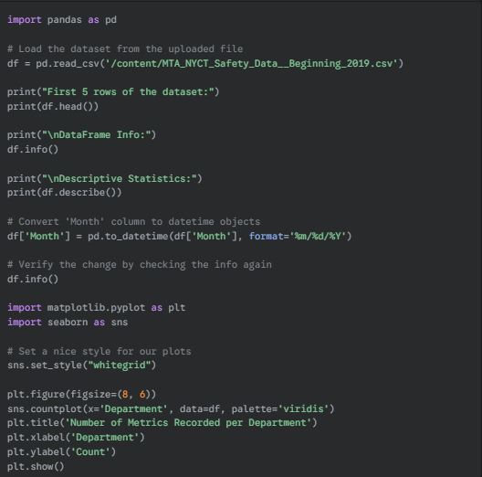

**Appendix B: Initial Rows of Dataset**

