How to Run Junit Test cases?

Step1 :
Select a test case from folder containing Junit test case class.

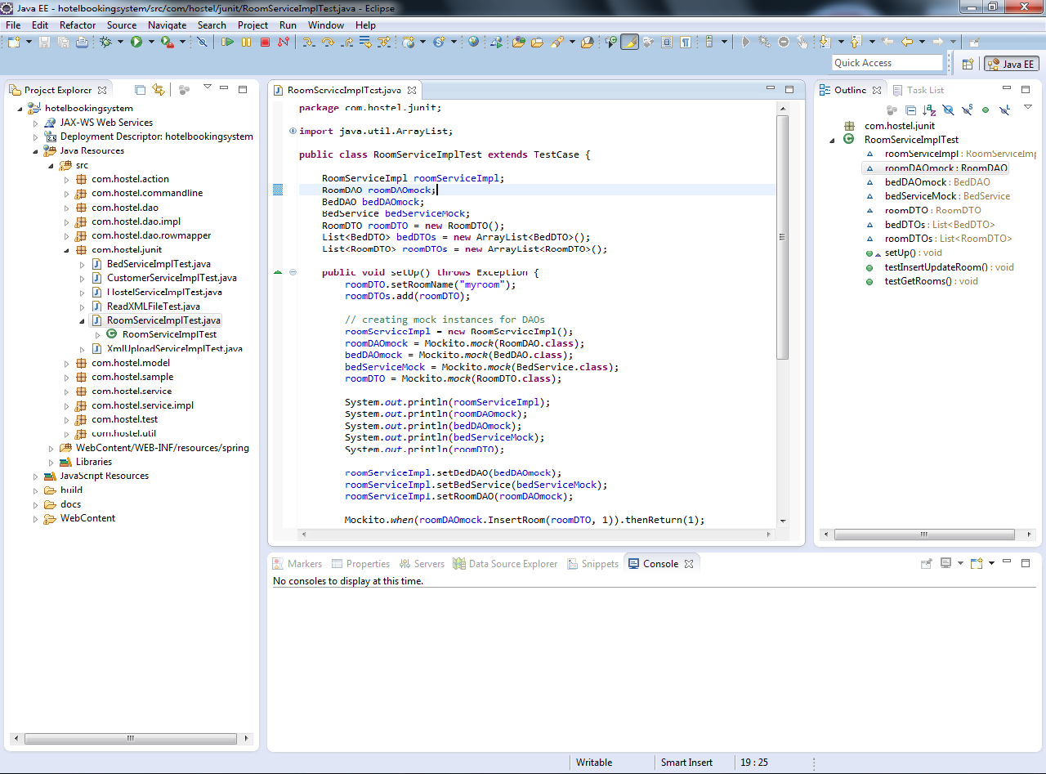

Step 2:
Right click on test case class and select Run As --> Junit Test

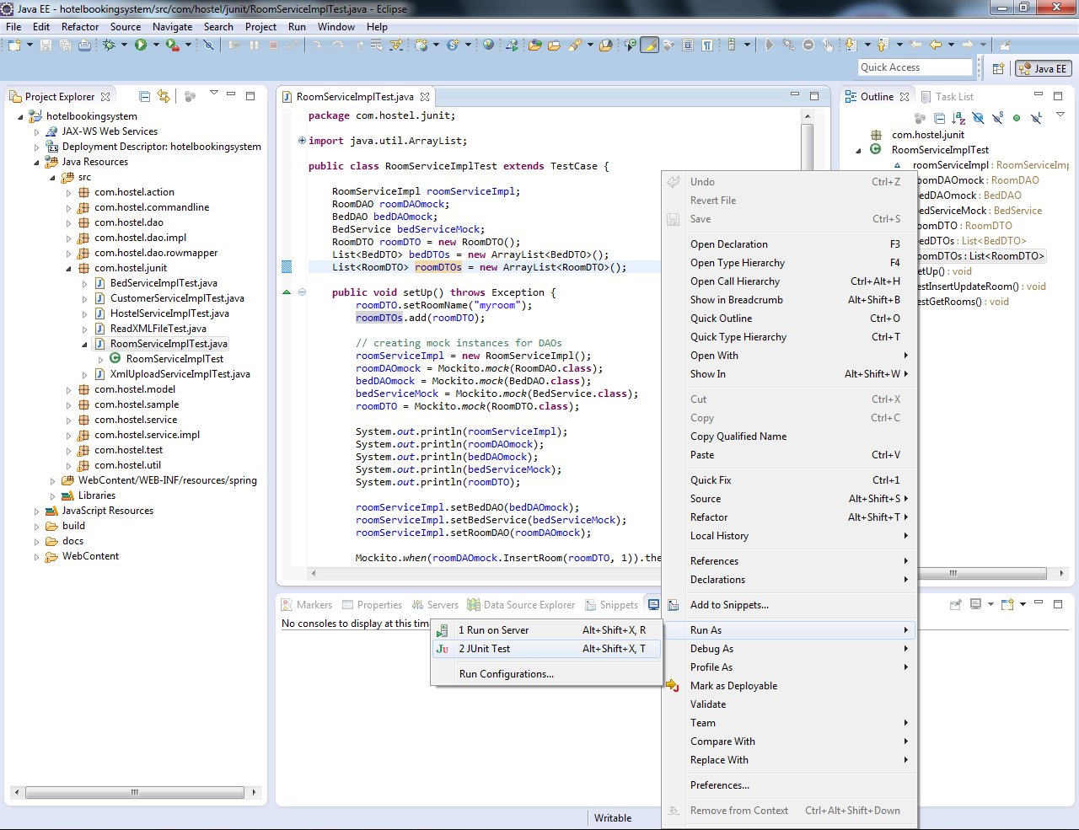

Step 3:

The output of the test case is shown in Junit console. The Green bar indicates that the testcase has been successfully executed. Red bar indicates failure of the test case. A detailed log of success or failure of each method can be seen.

