USE CASE DIAGRAMS:

A graphical over view of the functionality of the system in terms of actors is shown below:

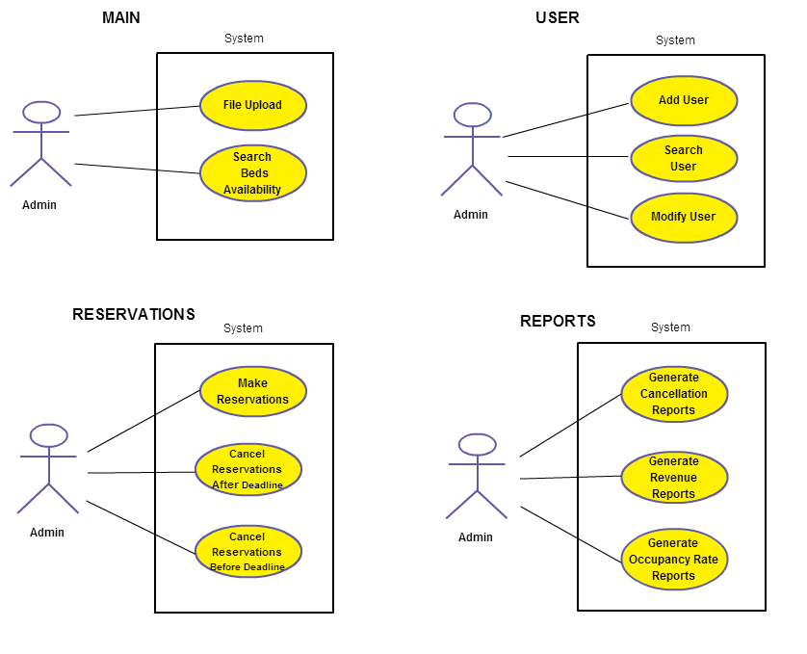
All the actions are performed by admin and are broadly classified into four categories based on the type of functionality. These are described as follows:

Main case:

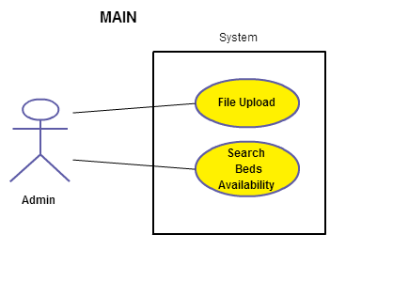

The admin can perform the actions like updating inventory data via file upload, multiple searches by date using data loaded from file, get date-wise information about inventory data updates, search beds availability in rooms for a selected date range with varying price details.

Reservations:

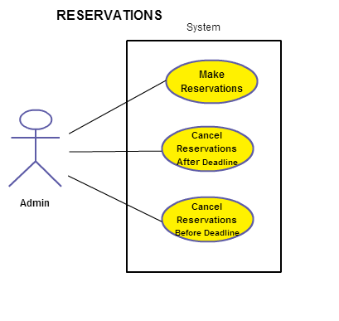

In this case, the admin can make reservations for a selection of beds by the customer by entering his profile and payment details. He/she can also cancel previous bookings as per conditions applicable before or after the pre-determined deadline.

Users:

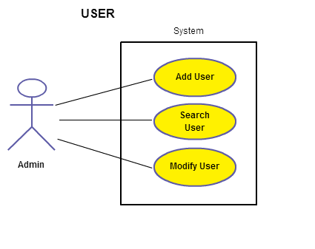

The admin can manage profiles of the customers to the hostel. He/she can add new users, modify an existing user's information, and search a customer's current and previous transactions with the system by his email address.

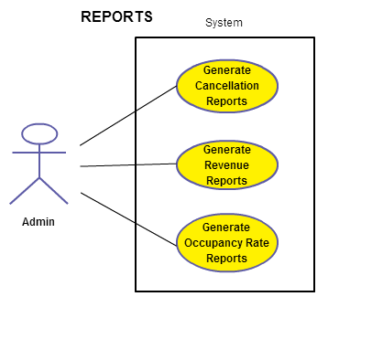
Reports:

Here, the admin can generate various reports on statistical data like total revenue of a hostel over a period of time, cancelled bookings before and after deadline, net income and occupancy rate of a hostel.

