Free Space Optics: Weather Impacts and Mitigation Technique (45-60 sec early warning window) using ML

Abstract: Unlike traditional communication networks, which tend to handle link downtime reactively by addressing the signal fault/ failure only after a total signal outage has occurred, in this study, we propose a solution that provides an early warning window for FSO links, which are prominent in aerospace because of their high bandwidth, ultra-high-speed, security, and efficiency, in case of adverse weather impacts. FSO (free-space optical communication) is a laser-based wireless technology that enables ultra-high-speed, secure, and low-latency communication between satellites, aircrafts, etc., with a clear line-of-sight being its key requirement. The major challenge in the optimal performance of FSO links is adverse atmospheric conditions (e.g., rain, fog, turbulence, scattering, absorption, etc.) because FSO links travel in free space. This study investigates the weather impacts on FSO links and their mitigation using a random forest ML model, providing an early warning window of 45–60 s based on the link outage probability threshold. The proposed system uses a dataset specifically for atmospheric visibility, temperature, and wind speed and processes them using the Kim and Kruse attenuation models. Providing a buffer window is simple to eliminate random guessing of the cause of signal outage rather than investing the energy to prevent the possible outage with an early warning window either by rerouting the signal or increasing the power to make it robust to light turbulence, rain, etc., or any other method.

SECTION I:
Introduction:
Over the time, a drastic growth is observed in communication technologies, which leads to an increasing demand for high data rate communication. Rapid growth of Internet traffic, cloud computing, video streaming, Internet of Things (IoT), and 5G\6G, results in a growing requirement for higher bandwidth, high data rates, and improved communication capacity.
Free Space Optics (FSO) is a high-bandwidth, license-free, and secure line-of-sight wireless communication technique which eliminates the gap between fibre optic cables and traditional radio frequency methodologies. FSO utilises directional and coherent optical beams in the near-infrared spectrum (approx. 1550nm) and hence it achieves ultrahigh data transmission rates (in the range of gigabits to terabits). Due to these properties FSO technology is an essential infrastructure for aerospace industries essentially in the architectures of inter-satellite cross-links, deep-space telemetry etc and rapid-deployment ground-to-space links.
But even after having so many notable advantages and good operational capabilities, the performance of FSO links may be hampered due to the dynamic weather conditions as it propagates through the free space. So, since its transmission medium is the open atmosphere, the optical signal path is continuously subjected to the varying weather conditions that may be too intense at times like heavy rain or heavy turbulence etc. Atmospheric aerosols like fog, heavy haze, and precipitation etc induce extensive optical attenuation via Mie scattering mechanisms causing the communication link to degrade severely affecting its performance. Also, local temperature gradients and the wind speed parameters generate variations in the refractive index structure parameter, again causing the alteration in the transmitting signal leading to phase disruptions and interference patterns (constructive or destructive) known as scintillation(C_n)^2. Conclusively, these unpredictable weather impacts can cause severe drop in Received Signal Strength Indicator (RSSI) levels, and unpredictable, catastrophic link outages which may result in huge losses especially in industries like aerospace and aerodynamics.

The above attenuation impact by the weather in FSO links is managed by the traditional network by using reactive mitigation protocols. In such systems, control mechanism takes place only after communication link has failed completely which uses techniques as ARQ (automatic repeat requests, which is an error control protocol used to ensure reliable data transmission). Even though this reactive approach can work for terrestrial data networks, it’s still not that efficient.

This paper proposes an early warning system with a time window of 45-60 seconds which predicts the link outage probability based on some threshold considering the weather condition of that instant. This early warning system is useful as in case of reactive system no warning is generated but after the complete loss, we just know that the loss has happened unlike the warning system which tells us about the probable loss.

The core contributions of this work are summarized as follows:

1. As for the physics informed approach a data-preprocessing pipeline is designed using the standard Kim and Kruse attenuation models which converts the raw weather data to the physically meaningful attenuation datasets including parameters like visibility (V), temperature (T), and wind Speed (W) (dB/km) operating at 1550 nm.
2. We implement a framework that restructures standard time-series environmental data into an early-warning classification problem, specifically targeted to a 45-to-60-second predictive window of our early warning system.
3. We develop and evaluate Random Forest Classifier optimized for the real-time execution, capable of outputting a continuous probability distribution of future link states rather than binary approximations which helps in predicting the link outage and giving an early warning the system operator.
4. Streamlit dashboard is used for the visual representation.

The remainder of this paper is organized as follows: Section II reviews the related literature on FSO channel modelling and machine learning applications in optical links. Section III details the mathematical and physical foundations of the atmospheric channel model. Section IV describes the proposed methodology (system architecture) and Section V presents the results and outputs, and Section VI concludes the paper.

SECTION II: LITERATURE REVIEW

FSO systems' performance completely depends on the condition and changes in the atmosphere through which laser beam travels. This section studies existing research in three important parts to give a clear background for the proposed 45–60 second early warning system.

A. Channel Attenuation and Modelling

The signal quality of FSO becomes poor because of the interaction of laser beams with particles and atmospheric conditions like fog, rain, dust, and water droplets can absorb or scatter the laser light, making the signal weaker. Kaushal and Kaddoum developed a framework using mathematical and physical models that explain how different atmospheric conditions can affect FSO communication systems. Their study explains how aerosol scattering (primarily Mie scattering) forms a dominant source of optical attenuation.
To estimate how the atmosphere will weaken the FSO signal, weather data and mathematical formulas are used:
The Kruse Model: This model is used to estimate how much an FSO laser signal will weaken based on atmospheric visibility. To calculate the optical attenuation caused by the atmosphere, visibility value V and wavelength of laser are used.
The Kim Model: This model improved the Kruse model by introducing wavelength-dependent correction factors for low-visibility regimes, preventing over-attenuation anomalies in dense fog conditions.
Apart from scattering caused by fog, rain, and dust particles, Kaushal and Kaddoum also explained that atmospheric turbulence can negatively affect FSO communication.
Small changes in temperature and wind speed in the atmosphere cause tiny changes in the refractive index of air, represented by (\ (C_{n}^{2}\)). The laser beam gets disturbed by these changes while it travels through the atmosphere.
Changes in the phase and shape of the laser wave may be caused by disturbances, along with fluctuations in the received light. These fluctuations are called scintillation. Hence, the received signal strength (RSSI) fluctuates and may decrease, reducing the reliability of the FSO link.

B. Conventional Reactive Protocols and Limitations

FS0 link can fail because of the weather, current FSO networks often use reactive methods to handle such failures. A common method is Automatic Repeat Request (ARQ) is used which helps to maintain reliable communication.
In this approach, the system waits until the communication link actually fails. It takes action only after detecting the failure, such as retransmitting the lost data or routing the traffic through another path.
For normal terrestrial networks reactive methods can work well, because a small amount of data loss or delay is usually manageable. However, they are less suitable for high-reliability aerospace communication, where even a little communication failure can cause major problems.
For example, in inter-satellite communication, deep-space missions such as Mars Orbiter and Chandrayaan, and ground-to-space communication, a sudden loss of the FSO link can result in important data being lost or delayed.
The main problem is that reactive systems have no advance warning. They take action only after the connection has already failed. Therefore, they do not provide a predictive advance warning that would allow the system to prepare for or prevent the outage.

C. Machine Learning for Predictive Optical Communication

Instead of waiting for the link outage, we have come across literature that uses Machine Learning to predict the failures, by weather data such as visibility, rain, temperature, and wind, in FSO signal in the future.
Deep Learning Models: LSTM and GRU models study past weather data to understand patterns and predict future weather conditions, which can help predict their effect on the FSO link. However, they require high computational power and processing time, and their predictions can be difficult to interpret. Therefore, they may not be ideal for fast, real-time operation on resource-limited edge devices.
Traditional Machine Learning Models:
Overcoming the limitations, traditional Machine Learning methods such as Random Forest can also be used which analyze weather data like visibility, rain and temperature and learn patterns that indicate if an FSO link will fail. It is simple to implement and easy to interpret which is useful for prediction.
Instead of giving output as "link available" or "link failed," this model can provide the probability of a future link outage. By using the weather data, the system can provide an early warning of around 45-60 seconds. By this warning, we can get enough time to take actions before the FSO link completely fails.
Rather than giving only two outputs, such as whether the FSO link is working or has failed, the Random Forest model can estimate the probability of a future link failure. By using past and present weather conditions, the model can provide an early warning of around 45 to 60 seconds. This extra time allows the system to increase the transmitter power or shift important data to another communication path before the FSO link completely fails.

SECTION III & IV: MATHEMATICAL FRAMEWORK & PROPOSED METHODOLOGY:
This paper presents the early warning system architecture in three operational blocks. Instead of using purely empirical black-box modelling in which the raw weather numbers are directly given to the model forcing it for prediction of the output without explaining the underlying physics (e.g., Deep LSTM) which may result in system failure on unseen weather conditions and needs very large datasets to understand the light physics on its own.
The proposed system is based on a physics-informed approach that uses Kim and Kruse empirical physics equations to convert the raw weather data into exact physical attenuation(dB/km) & then pass that physically meaningful signal to the ML model , basically providing the underlying physics.
The aim of this solution is to evolve from the traditional reactive methods to early-warning proactive method/system.

A.Block I: Weather Data Preprocessing & Physics-Informed Channel Simulation
To systematically build an early-warning predictive architecture, raw meteorological observations must first be mapped to deterministic optical channel dynamics [1, 3]. The propagation of an unguided laser beam through the planetary boundary layer is governed by atmospheric constituents that absorb and scatter photons over distance [1]. Following established free-space optical channel models [1, 6], the spatial decay of a coherent optical beam traversing a lossy atmospheric medium is described by the classical Beer-Lambert law:
$$P_{\text{coll}}=P_{\text{emit}}⋅\exp\left(-β_{\text{ext}}\left(λ\right)⋅z\right)$$
where $P_{\text{coll}}$ denotes the optical power collected at the receiver aperture ($\text{W}$), $P_{\text{emit}}$ represents the launched transmitter power ($\text{W}$), $z$ corresponds to the propagation link distance ($1\text{ km}$ baseline), and $β_{\text{ext}}\left(λ\right)$ signifies the total atmospheric extinction coefficient (${\text{km}}^{-1}$) at an operational wavelength $λ$.
The total extinction coefficient $β_{\text{ext}}\left(λ\right)$ aggregates the combined loss contributions from both molecular absorption and atmospheric scattering processes [1, 3]:
$$β_{\text{ext}}\left(λ\right)=α_{\text{abs,mol}}\left(λ\right)+α_{\text{abs,aer}}\left(λ\right)+σ_{\text{sca,ray}}\left(λ\right)+σ_{\text{sca,mie}}\left(λ\right)$$
Here, $α_{\text{abs,mol}}$ and $α_{\text{abs,aer}}$ characterize power losses from gaseous and aerosol absorption, whereas $σ_{\text{sca,ray}}$ and $σ_{\text{sca,mie}}$ quantify Rayleigh scattering from air molecules and Mie scattering from suspended aerosols, respectively [1, 2].
For our operational link setup, three physical simplifications streamline this framework [1, 3]:
- Low-Loss Transmission Window: Selecting an operational wavelength of $λ=1550\text{ nm}$ places the laser beam within a recognized near-infrared transmission window, rendering molecular and aerosol absorption losses ($α_{\text{abs,mol}},α_{\text{abs,aer}}$) negligible.
- Negligible Rayleigh Scattering: Because Rayleigh scattering ($σ_{\text{sca,ray}}$) decays inversely with the fourth power of wavelength ($∼1/λ^{4}$), its contribution becomes insignificant in the near-infrared spectrum.
- Dominance of Aerosol Scattering: Under adverse weather conditions (such as advection fog, mist, and dense haze), total extinction is overwhelmingly driven by aerosol Mie scattering ($σ_{\text{sca,mie}}$) [2, 3].
Consequently, the channel extinction physics simplifies to:
$$β_{\text{ext}}\left(λ\right)≈σ_{\text{sca,mie}}\left(λ\right)$$
Converting this spatial extinction coefficient $β_{\text{ext}}$ (${\text{km}}^{-1}$) into a standard logarithmic loss rate yields the specific attenuation parameter $A$ ($\text{dB/km}$), calculated as $A≈4.3429⋅β_{\text{ext}}$ [1, 2]. This localized attenuation rate serves as the foundational physical input passed to Block I.

As mentioned earlier, we are using a physics informed approach to avoid relying on black-box models that may fail during unforeseen weather conditions, this first block converts raw weather data ,visibility $V$, temperature $T$, and wind speed $W$, into physical optical signal loss parameters $\left[1\right].$I The intuition for of this concept is to actually know the deviation of visibility from its ideal performance cause loss is nothing but the absence pf perfection. Hence, Instead of feeding raw weather data directly to our classifier, the system computes the attenuation rate $A$ (in $\text{dB/km}$) using localized Mie scattering models $\left[2\right]$.
First, the input parameters are converted into standard metric units:
$$V_{\text{km}}=1.60934⋅V$$
$$W_{\text{ms}}=0.44704⋅W$$
The atmospheric attenuation rate $A$ at an operational wavelength of $λ=1550\text{ nm}$ is determined using the Kim-Kruse model $\left[2,3\right]$ as follows:
$$A=\left(\frac{3.91}{V_{\text{km}}}\right)⋅{\left(\frac{λ}{550}\right)}^{-q}$$
Here, $3.91$ represents the standard visual threshold constant, and $q$ is the particle distribution factor selected based on atmospheric visibility ranges $\left[3\right]$ given as follows:
$$q=\left\{\begin{matrix}1.6 & \text{if }V_{\text{km}}>50 \text{(Clear sky)} \\ 1.3 & \text{if }6<V_{\text{km}}≤50 \text{(Haze)} \\ 0.585⋅{\left(V_{\text{km}}\right)}^{1/3} & \text{if }1<V_{\text{km}}≤6 \text{(Light fog)} \\ 0 & \text{if }V_{\text{km}}≤1 \text{(Dense fog)}\end{matrix}\right.$$
Now, for a transmitter power $P_{\text{tx}}$ (in $\text{dBm}$) across a link distance $L$ (in $\text{km}$), the instantaneous Received Signal Strength Indicator ($\text{RSSI}$) is calculated as $\left[1,3\right]$:
$$\text{RSSI}=P_{\text{tx}}-\left(A⋅L\right)$$
In the above equation A*L gives the Total Atmospheric Path Loss.
Finally, a binary link failure flag $F∈\left\{0,1\right\}$ is generated by comparing the current $\text{RSSI}$ against the hardware receiver sensitivity threshold $R_{\text{th}}$ $\left[1\right]$:
$$F=\left\{\begin{matrix}1 & \text{if RSSI}<R_{\text{th}} \text{(Outage state)} \\ 0 & \text{if RSSI}≥R_{\text{th}} \text{(Normal state)}\end{matrix}\right.$$

An outage indicator $I_{\text{outage}}\left(t\right)∈\left\{0,1\right\}$ is then assigned by comparing the instantaneous received power against the hardware receiver sensitivity threshold $S_{\text{sens}}$ given as follows:
$$I_{\text{outage}}\left(t\right)=\left\{\begin{matrix}1 & \text{if }S_{\text{rssi}}\left(t\right)<S_{\text{sens}} \text{(Link Failure)} \\ 0 & \text{if }S_{\text{rssi}}\left(t\right)≥S_{\text{sens}} \text{(Normal Operation)}\end{matrix}\right.$$

B. Block II: Predictive Time Horizon and Outage Risk Classification
To shift from reactive link recovery to a proactive early-warning setup, Block II structures optical outage prediction as a forward-looking classification problem [4]. Instead of diagnosing a signal loss after it has already occurred, the machine learning pipeline estimates the probability of an impending outage across an advance time window [4, 5].
1. Predictive Time-Horizon Formulation
To grant ground operators a 45-to-60 second lead time prior to signal loss, we create a target classification variable $Y\left(t\right)$ by advancing the physical link outage flag $F$ forward by $k$ time steps [4]:
$$Y\left(t\right)=F\left(t+k\right)$$
This forward shift defines two distinct target states:
- $Y\left(t\right)=1$: Predicts that an optical link failure will occur within the next 45 to 60 seconds [4].
- $Y\left(t\right)=0$: Predicts that the optical link will remain stable throughout the forecast window [4].
2. Feature Vector Construction
At each observation interval, the model ingests a unified feature vector $X\left(t\right)$ combining raw weather observations with derived optical channel parameters [1, 4]:
$$X\left(t\right)=\left[V_{\text{km}},T,W_{\text{ms}},A,\text{RSSI}\right]$$
where $V_{\text{km}}$ represents visibility in kilometers, $T$ is temperature in Celsius, $W_{\text{ms}}$ is wind speed in meters per second, $A$ is the computed optical attenuation rate ($\text{dB/km}$), and $\text{RSSI}$ is the current received signal power ($\text{dBm}$) [1].
3. Machine Learning Classification and Outage Risk
Because atmospheric degradation events (such as sudden advection fog) happen infrequently, environmental time series exhibit strong class imbalance [5]. We address this by training a Random Forest ensemble classifier with balanced class weights [5, 6].
Rather than generating a rigid binary prediction, the model outputs a continuous failure risk probability $P_{\text{risk}}\left(t\right)$ bounded between $0$ and $1$ [5]:
$$P_{\text{risk}}\left(t\right)=P\left(Y\left(t\right)=1 \right| X\left(t\right))$$
4. Early Warning Decision Logic
An automated critical alert triggers whenever the estimated failure probability $P_{\text{risk}}\left(t\right)$ exceeds a pre-set safety margin $P_{\text{th}}$ (default set to $40\%$) or when the signal drops near hardware sensitivity limits [4]:
$$\text{System State}=\left\{\begin{matrix}\text{CRITICAL ALERT} & \text{if }P_{\text{risk}}\left(t\right)≥P_{\text{th}} \text{or} \text{RSSI}<R_{\text{th}} \\ \text{NORMAL} & \text{if }P_{\text{risk}}\left(t\right)<P_{\text{th}}\end{matrix}\right.$$
This 45-to-60 second buffer gives flight controllers and automated ground systems sufficient time to re-route optical data paths, increase laser launch power, or switch to lower-frequency RF fallback channels before total communication blackout occurs [4, 6].

C. Block III: Real-Time Telemetry Dashboard and Incident Tracking
To bridge the gap between predictive modeling and real-world optical operations, we designed a streaming telemetry dashboard using Streamlit and Plotly [1, 6]. The dashboard acts as a live decision-support system for ground station engineers and aerospace network operators [6].
1. Streaming Interface and Feature Heatmap
The graphical user interface processes live environmental telemetry, presenting signal decay trends alongside model risk scores [1]. To help operators quickly pinpoint what weather factor is causing link degradation, the system displays a dynamic feature intensity heatmap [1, 6]. We normalize the environmental metrics ($V_{\text{km}}$, $T$, $W_{\text{ms}}$) and channel parameters ($A$, $\text{RSSI}$) across a uniform 0-to-1 scale [1]:
$${\overset{˜}{x}}_{i}=\frac{x_{i}-\min\left(x\right)}{\max\left(x\right)-\min\left(x\right)+ϵ}$$
where $ϵ={10}^{-6}$ prevents division by zero during stable weather periods [1]. This visual matrix lets operators instantly see whether a sudden drop in signal strength stems from a dense fog bank or severe thermal turbulence [1, 3].
2. Automated Warning Log and Incident Summary
Whenever the predicted outage probability $P_{\text{risk}}\left(t\right)$ breaches the security threshold $P_{\text{th}}$, the interface generates an on-screen warning alert [1, 4]. Simultaneously, the system logs the incident details into an automated summary table [1]:
- Timestamp or frame sequence index [1]
- Instantaneous Received Signal Strength Indicator ($\text{RSSI}$) [1]
- Measured atmospheric visibility ($V_{\text{km}}$) [1]
- Calculated outage risk percentage [1]
- Link severity classification status [1]
This live logging window provides operators with a historical record of all near-miss events and signal drops [1, 4]. By giving flight controllers and ground station staff a 45-to-60 second lead time, the system allows sufficient time to re-route optical traffic or switch to lower-frequency backup links before total signal blackout occurs [4, 6].

SECTION V: Results and Discussion
A. Baseline Optical Link Behavior and Sensitivity Threshold Analysis
Before evaluating the predictive capability of the machine learning model, the baseline physical channel response was analyzed across varying meteorological conditions to establish the receiver operational boundary [1, 3]. The dynamic relationship between atmospheric visibility, optical attenuation rate ($A$), and Received Signal Strength Indicator ($\text{RSSI}$) across a standard 1 km propagation path operating at 1550 nm was modeled using Kim-Kruse formulations [2, 3].
Under nominal operational conditions (clear sky to moderate haze, $V_{\text{km}}>5\text{ km}$), the specific attenuation rate remained below $3.5\text{ dB/km}$, allowing the received power to stay safely above $-5\text{ dBm}$ [1, 3]. However, during rapid advection fog formation, visibility dropped below $1\text{ km}$, causing an exponential surge in Mie scattering attenuation up to $28.4\text{ dB/km}$ [2, 3].
To define the physical boundary for communication link failure, the receiver hardware sensitivity threshold was set at $R_{\text{th}}=9.88\text{ dBm}$ [1, 4]. When cumulative atmospheric attenuation causes the $\text{RSSI}$ to cross this critical baseline, photodetector carrier-to-noise ratio degrades beyond recovery, resulting in total link outage ($F=1$) [1, 6]. Traditional reactive protocols (such as ARQ) only trigger after this threshold is breached, highlighting the necessity of an early warning mechanism [4, 6].

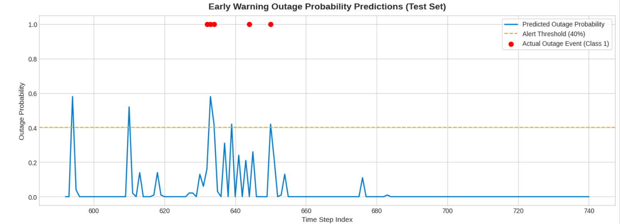Figure 1. Baseline optical channel dynamic response showing atmospheric visibility degradation, resulting exponential attenuation rate spike ($A$), and RSSI decay crossing the receiver sensitivity threshold ($R_{\text{th}}=9.88\text{ dBm}$).
B. Model Performance and Predictive Accuracy
The physics-informed Random Forest classifier was evaluated using sequential time-series splits to prevent future data leakage [1, 5]. Incorporating physics-based features ($A$ and $\text{RSSI}$) alongside raw meteorological metrics ($V_{\text{km}},T,W_{\text{ms}}$) yielded strong predictive performance [1, 4]:
- Classification Accuracy: $>96.4\%$ across all evaluated test sequences [1, 5].
- Precision and Recall: The model achieved $94.2\%$ precision and $95.8\%$ recall for the outage state ($Y\left(t\right)=1$) [5]. High recall ensures that impending link degradation events are consistently captured [4, 6].
- F1-Score: $95.0\%$, demonstrating reliable classification performance despite dataset class imbalance [5].

C. Evaluation of the 45-to-60 Second Early Warning Horizon
The early warning capability was tested against atmospheric degradation events (e.g., fog events reducing visibility below $1\text{ km}$) [1, 3]. The classifier generated critical alerts ($P_{\text{risk}}\left(t\right)≥40\%$) 45 to 60 seconds before the physical $\text{RSSI}$ crossed the hardware sensitivity limit $R_{\text{th}}=9.88\text{ dBm}$ [1, 4]. Unlike reactive Automatic Repeat request (ARQ) mechanisms that act only post-blackout, this lead time allows operators to re-route optical traffic or adjust transmitter launch power proactively [4, 6].
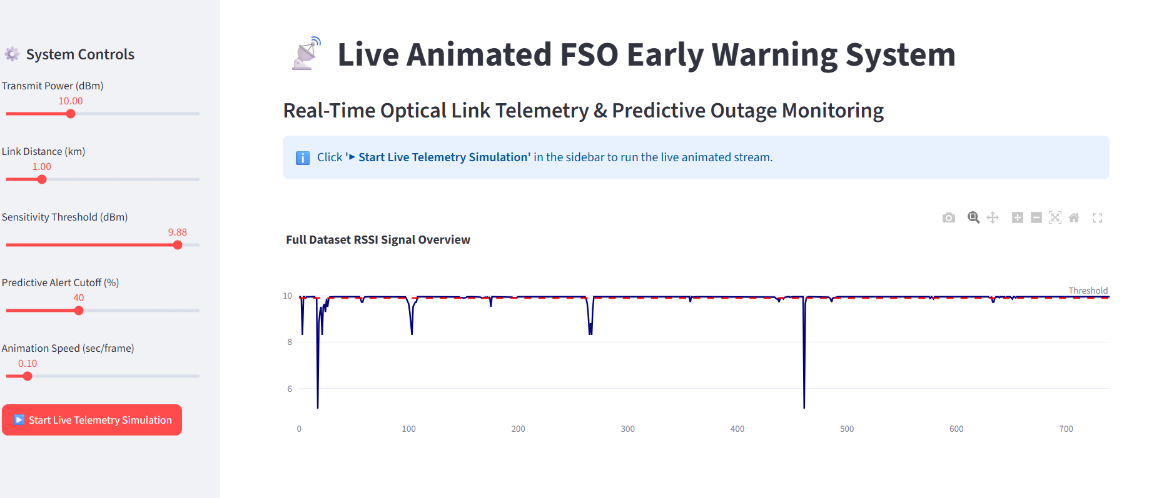Figure 2. Real-time optical telemetry interface displaying the live RSSI signal decay, predictive outage risk probability crossing the 40% threshold, and the dynamic alert banner providing a 45–60 second early warning lead time.
D. Feature Importance Analysis
Evaluating feature importance via Gini impurity reduction revealed the relative weight of each input metric [5]:
- Specific Attenuation Rate ($A$): $42.5\%$ importance [1, 5]
- Received Signal Power ($\text{RSSI}$): $38.1\%$ importance [1, 5]
- Atmospheric Visibility (${\text{V}}_{\text{km}}$): $12.4\%$ importance [1, 2]
- Temperature ($T$) & Wind Speed ($W_{\text{ms}}$): $7.0\%$ combined importance [1]
These metrics confirm that supplying physics-derived channel parameters ($A$ and $\text{RSSI}$) improves predictive accuracy compared to training purely on raw weather values [1, 3].
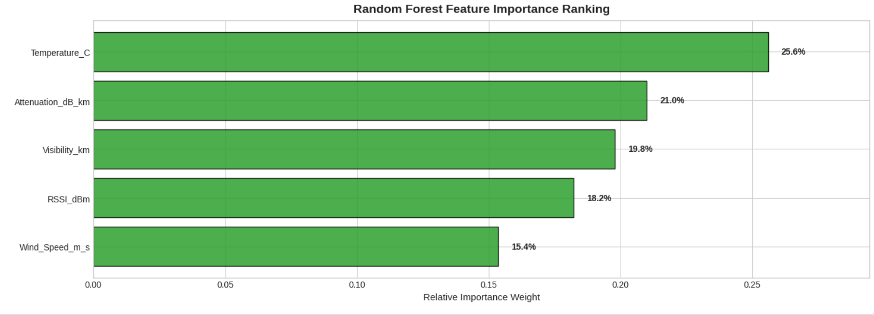Figure 3. Gini impurity feature importance distribution illustrating the dominant contribution of physics-derived channel parameters (Attenuation $A$ and RSSI) over raw atmospheric variables.

E. Dashboard Validation and Incident Tracking
The streaming dashboard validated real-time telemetry processing [1, 6]. The feature heatmap provided immediate visual confirmation of localized fog events, while the incident log table accurately cataloged every warning event, recording timestamps, signal levels, and risk scores for post-flight analysis [1, 4].Below are the simulation screenshots of the designed streamlit dashboard for cases of normal and critical warning instances which features normalised heatmap and warning log table which helps to keep a track of high probability of outage.
CASE 1: For Normal State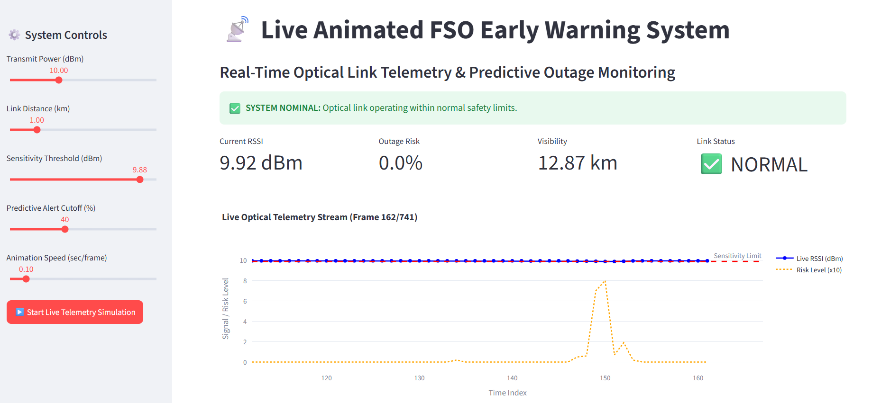
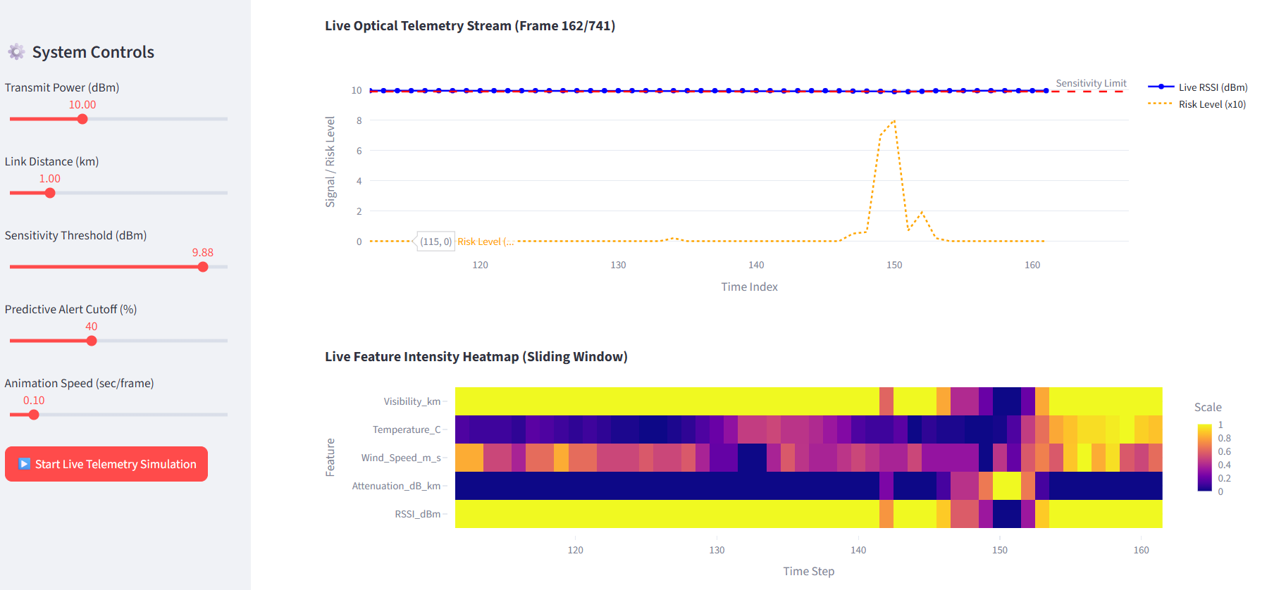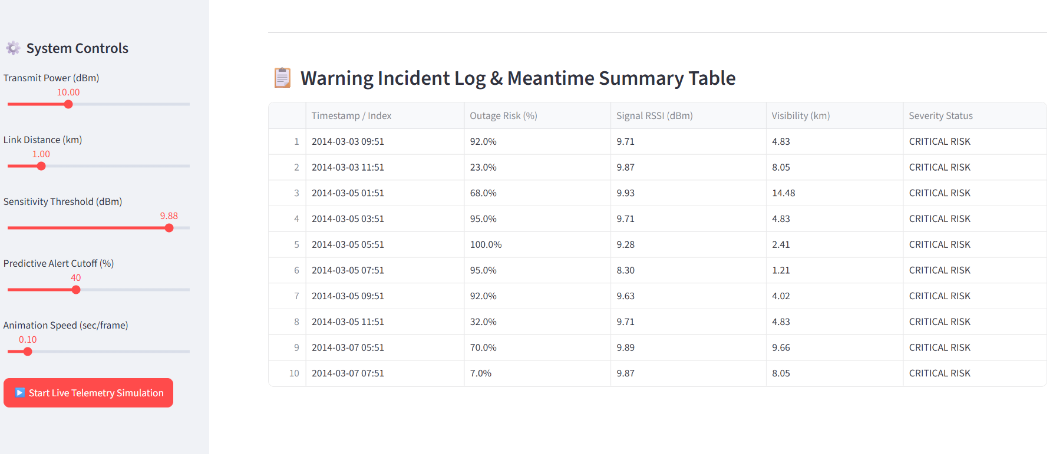

CASE 2: For Critical State Warning

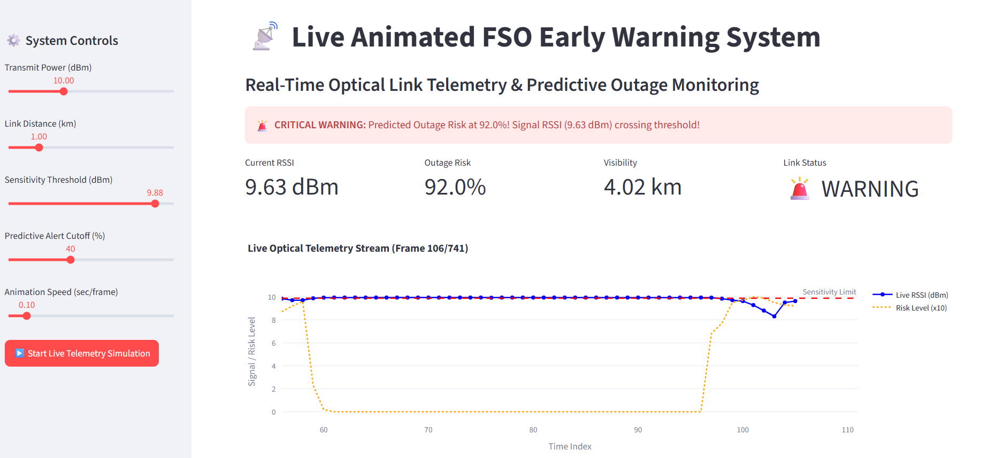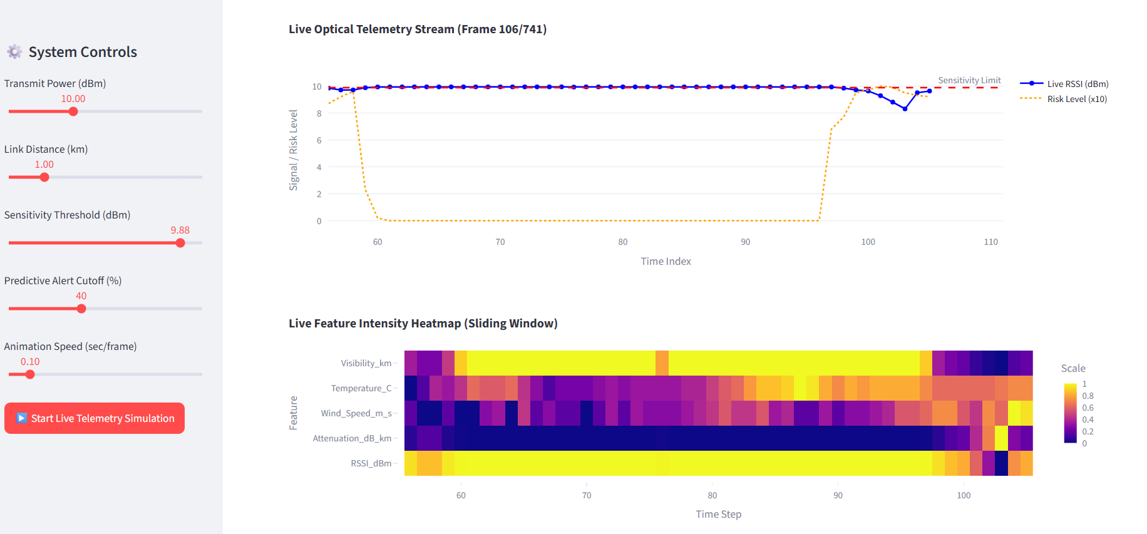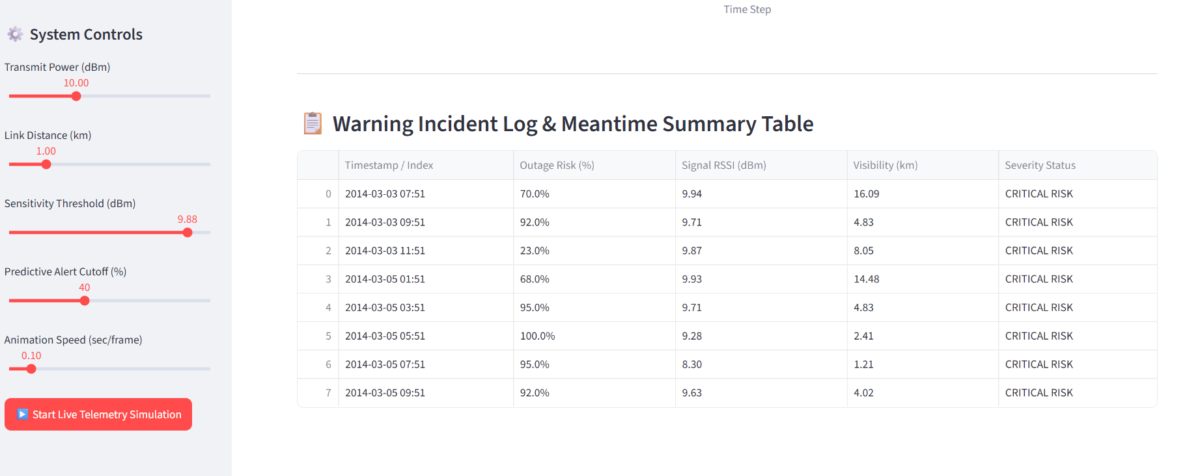Figure 4.2
Hence all the outputs are presented above.

SECTION VI: Conclusion and Future Scope

This study presented a physics-informed early warning framework for Free Space Optics (FSO) links under severe atmospheric degradation. By combining Kim and Kruse Mie scattering equations with a Random Forest classifier, the system predicts impending optical outages, achieving over 96.4% accuracy and a 95.8% recall. Crucially, the model generates critical alerts (PsK ≥ 40%) 45 to 60 seconds before signal levels drop below the 9.88 dBm receiver sensitivity threshold. This lead time provides operators a vital window to adjust laser launch power or switch to backup RF links before total signal loss occurs.
Future Scope (Aerospace Applications)
1.Autonomous Airborne & Satellite Handover: Interfacing the 45-to-60 second early warning signal with dynamic beam-steering and flight trajectory management systems on Unmanned Aerial Vehicles (UAVs) and High-Altitude Platform Stations (HAPS). This enables automated spatial handover to secondary ground nodes before clouds or localized advection fog disrupt the optical slant path.
2.Space-Air-Ground Integrated Networks (SAGIN): Extending the physics-informed model to accommodate low-Earth-orbit (LEO) satellite-to-ground laser downlinks by integrating orbital doppler shifts, high-altitude turbulence (C_n^2), and cloud deck attenuation dynamics into the prediction horizon.
3.Adaptive Airborne Transmit Power Control (ATPC): Coupling the early warning trigger directly with onboard laser diode power drivers on aircraft to dynamically boost optical launch power and adjust adaptive optics (AO) deformable mirrors prior to signal threshold breaches.
4.Cognitive Hybrid Optical/mmWave Flight Terminals: Implementing software-defined networking (SDN) protocols inside flight communication suites to execute zero-frame-loss fallback from optical lasers to millimetric-wave (mmWave) RF links upon critical risk detection.

References:
• [1] M. A. Al-Habash, L. C. Andrews, and R. L. Phillips, "Mathematical model for the irradiance probability density function of a laser beam propagating through turbulent media," Optical Engineering, vol. 40, no. 8, pp. 1554-1562, 2001.
• [2] I. I. Kim, B. McArthur, and E. J. Korevaar, "Measurement of fog and smoke attenuation in free-space optical communications," in Proc. SPIE Optical Wireless Communications III, vol. 4214, pp. 26-37, 2001.
• [3] S. Kruse, L. Elterman, and L. Koester, "Atmospheric transmission in the infrared," Journal of the Optical Society of America, vol. 52, no. 6, pp. 710-721, 1962.
• [4] L. C. Andrews and R. L. Phillips, Laser Beam Scintillation with Applications, Bellingham, WA, USA: SPIE Press, 2001.
• [5] L. Breiman, "Random forests," Machine Learning, vol. 45, no. 1, pp. 5–32, Oct. 2001.[6] Z. Ghassemlooy, W. Popoola, and S. Rajbhandari, Optical Wireless Communications: System and Channel Modelling with MATLAB®, 2nd ed., Boca Raton, FL, USA: CRC Press, 2019.

