DEWI : Data-driven Evaluation of crime against Women in India through AI & ML
RajLaxmi Behera
Dept. of AI & DS
Indira Gandhi Delhi Technical University for Women
New Delhi, India
rajlaxmibehera1110@gmail.com

Abstract—Crime rates against women are one critical and social issue that often remains less discussed in most of crucial areas, making timely action takings difficult for law agencies, government as well as policymakers. To tackle the issue, we are introducing DEWI, an AI & ML based decision-making support to analyze and fore-predict crimes based on historical crime trends. The study includes NCRB dataset along with some other data bases covering the crime rates of period 2001-2022. It includes varied categories of crime studies reported across the country giving a versatile opinion building structure. The data undergoes preprocessing, feature analytics, and EDA to identify future trends and patterns. In this, we are using the past years for training and recent years for testing to reflect real-world forecasting oof future aspects. Many machine learning models are evaluated using regression metrics along with MAE, RMSE and R² score to study the most effective prediction approaches. The study focuses on state-level crime trends along with year studies, providing data-driven insights of policy planning, risk assessment and crime/resource allocation to enhance women’s safety in India.
Keywords— Artificial Intelligence, Machine Learning, Crime Analytics, Risk Assessment, Predictive Analytics, NCRB Dataset, Trend, Regression, MAE, RMSE, EDA, R²score.

Introduction

Background
Crime against women continued to be a critical problem facing in society and public safety concern in India from decades ago running till now-a-days. These crimes include domestic cruelty/violence, dowry offences/death, rape, kidnapping, assault, sexual harassment, and some other forms of social, psychological, economical tortures concluding to various profound consequences. According to the data we did the go through, gives a view of how crime rates are increasing from years and differentiating region wise highlighting the need for some support system.
Manual statistical studies is one of ruling out factor in pasts to study these cases but if we are aware of the technology we know how ML can flip the tables. Unlike statistical methods, machine learning algorithms and models can examine complex relationships among variables helping in more precisions for better future outcomes.
Therefore, we are proposing idea of DEWI, aa machine learning decision support framework for analysing and forecasting crimes helping the society to reform with enlightenment.

Problem Statement
Crimes against women is alive between us from centuries as a challenge in India, affecting the safety, dignity and well-being of women across country along with a harm carrier to the fame of country. Incidents such as violence, offences, sexual harassments, rape, kidnapping, assault and other malpractices against women not only cause severe physical and mental trauma but also impact the social and psychological factors among population for long term. It’s been too long since the victims and their families are facing consequences, even the peer pressure sometimes as if crimes are common according to what prejudice society have developed. Therefore, many cases are either reported late or remain unreported due to fear, social stigma, lack of awareness and support, making timely action takings even harder or maybe worse sometimes.

Although historical crime records are published annually by all type of organisations (e.g. National Crime Records Bureau), but instead of using it as predictive analysis it is primarily used statistical reporting. Not having a intelligence driven system with abilities to identify the emerging crime trends, interconnections, and future risk level guessing limits the scopes of betterment.
This makes it difficult to plan preventive measures effectively. It all shows the need of a system to forecast and provide meaningful insights to support evident planning and safety initiatives.

Objective
Main objective of this research is to develop DEWI (Data-driven Evaluation of Women related crime in India), an intelligent framework for analysis of crime data related to women and supporting them {We named the project DEWI because it is elaborated from the Hindi/Indian word ‘Devi’ means Goddess showing women empowerment}.
Objectives of the research are specified as follows:
- Collect and preprocess crime-related datasets for accurate analysis and reliable predictions to prepare model effectively.
- Performing Exploratory Data Analysis (EDA) to identify some specifically hidden trends, patterns, and relationships in the data.
- Developing and comparing different machine learning models, including Logistic Regression, Decision Tree, Random Forest, SVM, and XGBoost.
- Calculating the performance of the developed models using Accuracy (ANN), Precision, Recall, and F1-Score.
- Evaluating using regression metrics along with MAE, RMSE and R² score to study the most effective prediction approaches.
- Determining the most suitable model for crime prediction and risk analysis based on comparative analysis.

Contribution
Major contributions of the research are:
- An AI specialized intelligent framework will be used to analyse the crime rates against women using machine learning techniques.
- Comprehensive workflow should be developed that integrates data collection, preprocessing, EDA, model training, and performance calculations.
- Manny algorithms, including Regressions, Decision Tree, Random Forest, SVM, and XGBoost, are implemented and compared to identify the most model.
- Visual analytics are added to present crime trends and patterns, enabling better interpretation of the data.
- Aims to support researchers, policymakers, and law enforcement agencies by facilitating data-driven decision-making and promoting the application of artificial intelligence in not only crime analysis but in other different related fields.

WORK
The Structure of this project follows an ordered workflow.
In recent, NCRB integrates crime against women datasets after collecting data, to make unique databases. These datasets already pass through many verifications and initiations to make it unified and ready to access, are readily available on websites. They undergo preprocessing like missing value handling, removing duplications, data cleaning, encoding, and normalizing to ensure the data quality is held properly.

TABLE 1 (Papers Studied)
Ref. | Source | Methodology | Findings
[1] | Keerti & Deshmukh (2025), Analysis and Prediction of Crime Against Women using Machine Learning  Data preprocessing, Random Forest, Decision Tree, SVM | ML models can predict crime patterns effectively after preprocessing | Limited model explainability, no validations
[2] | Dwivedi (2025), Enhanced Approach for Crime Predictive Analysis Using NCRB Dataset  XGBoost, CatBoost, Stacking Ensemble | Ensemble models improve prediction accuracy | Focuses only on prediction accuracy not on interpretations
[3] | Predictive Analysis of Crime Against Women in India (2025)  Random Forest Regressor, XGBoost, LightGBM | XGBoost achieved the best performance and identified crime-prone states | Uses limited historical duration (2017–2022), no explainability
[4] | Gaberd & Al Arimi (2025), A-XGBoost  Improved XGBoost architecture | Robust prediction for crimes against women across datasets | Primarily algorithm-focuses on limited policy interpretation
[5] | Exploratory Data Analysis and Predicting Indian Crime Against Women Using ML Approaches (IEEE, 2025)  EDA + ML prediction | EDA improves understanding of crime trends before modelling | Limited comparison of models
[6] | Evaluating Socioeconomic Factors for Crime Against Women (2025)  Statistical learning with socioeconomic variables | Poverty, education and electricity access influence crime levels | Focuses mainly on socioeconomic factors rather than long-term forecasting
[7] | Gonzalez-Prieto et al. (2021), Machine Learning for Risk Assessment in Gender-Based Crime  ML-based risk prediction using official police records | ML performs conventional statistical methods | Predicts individual recidivism risk rather than population-level trends
[8] | Mandalapu et al. (2023), Crime Prediction Using Machine Learning and Deep Learning: A Systematic Review  Review of 150+ studies | Summarizes ML approach and identifies future research directions | Does not propose a predictive framework
[9] | Basak Utsha et al. (2024), Deep Learning Based Crime Prediction Models  Comparative evaluation of DL models | Highlights strengths and weaknesses of deep learning models | General crime datasets, not women-specific
[10] | Crime Prediction Against Women in Surveillance Videos: A Review (2025)  Review of deep learning methods for surveillance video analysis | Reviews video-based crime detection techniques | Focuses on surveillance videos rather than structured crime records

Research Gap
Already existing studies primarily focuses on comparing ML algorithms or performing descriptive data analytics. Although each work promises to have great performance but most of lack in several fields like validity, explanation, decision support capacity. Even in many observed studies, they ensure accuracy without analysing long-term trends. Earlier reviews have also highlighted the need of improvements. Therefore, introducing DEWI is an innovative idea even though any of the model can’t be considered ideal but this time we are trying to cover most of the drawbacks observed along with any additional feature, if possible.

TABLE 2 (Research Gap Analysis)
Existing Limitations | How DEWI addresses it
Most models have lack of comparative studies of algorithms | Compare all type of models and precisions
Using less data to analysis | Uses long term historical reports
Lack of time-based evaluation | Uses train-test split for realistic forecasting
Focuses on prediction accuracy mostly | Combines predictions with decision making insights
Most of studies focus on per individual risks | Focuses on trends by year analyzing and grouped risk of specific area
Limited discussion on regional crimes | prone areas detailing for safety measures from state-wise go through

Proposed methodology

System Overview
The system consists of a model that helps us in forecast and prediction. First step of the process is to collect crime related datasets from suitable platforms, and then we do handle missing value and remove duplicates to improve data quality. After all these we perform EDA that helps us in exploring trends, hidden patterns and relationship between different variables.
The new processed dataset with high data quality is divided into “training and testing sets” to check predictive forecast quality, and many other machine learning algorithms, including “Logistic Regression, Decision Tree, Random Forest, Support Vector Machine (SVM), and XGBoost”. Performances of each model is assessed using evaluation metrics such as “Accuracy, Precision, Recall, and F1-Score”. Based on the comparative analysis, the best-performing model will be selected. This aims to provide accurate predictions and meaningful insights that can assist researchers and policymakers undertaking the crime patterns and supporting data-driven decision-making.

System Workflow
Data Collection
│
▼
Data Preprocessing
(Missing Values, Encoding,
Duplicate Removal)
│
▼
Exploratory Data Analysis
(Statistical Analysis &
Visualization)
│
▼
Feature Engineering
│
▼
Train-Test Split
│
▼
Machine Learning Models
(Logistic Regression,
Decision Tree,
Random Forest,
SVM, XGBoost)
│
▼
Performance Comparison
(Accuracy, Precision,
Recall, F1-Score)
│
▼
Best Model Selection
│
▼
Prediction & Analysis

Data description.

Data Sources
The dataset used in this research are obtained from publicly available crime statistics related to crimes against women in India. It contains historical records of various categories of crimes reported across India in year-wise and area-wise format. Model that is formed depend on the data studies and variations drastically.

Data Overview
There are 3 sets of data used in research:
  - Dataset1: Crime against women (2001-2022)
This consists of the number of crimes against women happened in different field on yearly basis from 2001 till 2022.
Collected from: https://dhsprogram.com/data/available-datasets.cfm?utm_source=chatgpt.com
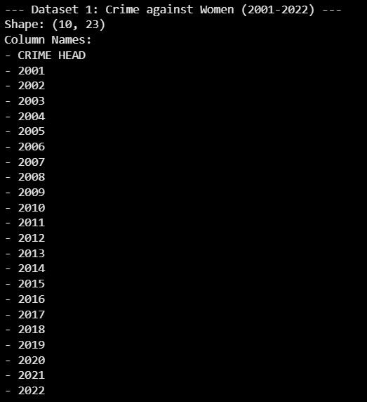
  - Dataset2: CrimesOnWomenData
This consists of crime happened in different regions from 2001 – 2021 in India.
Collected from: https://dataful.in/datasets/21590/
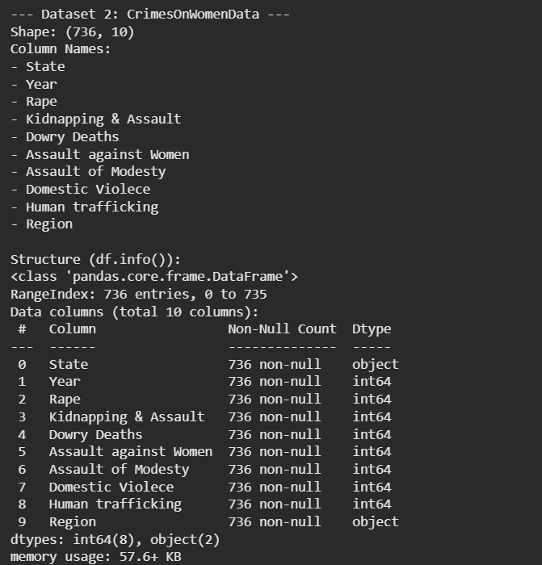

TABLE 3 (Description of Dataset Attributes)
Attribute | Description
State/UT along with directional data | Name of the State or Union Territory where the crime was reported
Year | Particular crime year
Crime Type | Crime Categories commit against women [e.g. rape, assault, trafficking]
Cases Reported | Total number of reported cases per crime category shown

Data Characterstics
The dataset contains both categorical and numerical variables. Categorial data – e.g. Direction, State etc & Numerical data – e.g. Year, crime report counts etc.

Data Preprocessing and Exploratory Data Analysis
Handling Missing Values
Presence of missing value in data harms data consistency and often give errors in data calculations. Therefore, removing or handling missing/null values is important. As per from studies and visualisation our data don’t contain any missing value.
Dataset 1 Shape: (10, 23)
CRIME HEAD 0
2001 0
2002 0
2003 0
2004 0
2005 0
2006 0
2007 0
2008 0
2009 0
2010 0
2011 0
2012 0
2013 0
2014 0
2015 0
2016 0
2017 0
2018 0
2019 0
2020 0
2021 0
2022 0
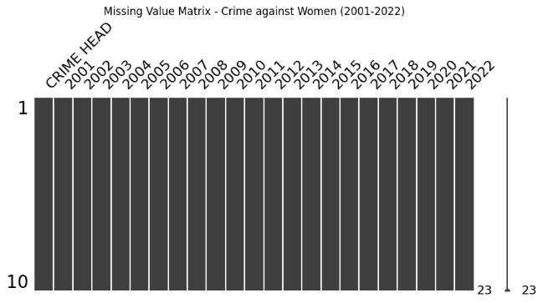
Dataset 2 Shape: (736, 10)
State 0
Year 0
Rape 0
Kidnapping & Assault 0
Dowry Deaths 0
Assault against Women 0
Assault of Modesty 0
Domestic Violence 0
Human trafficking 0
Region 0
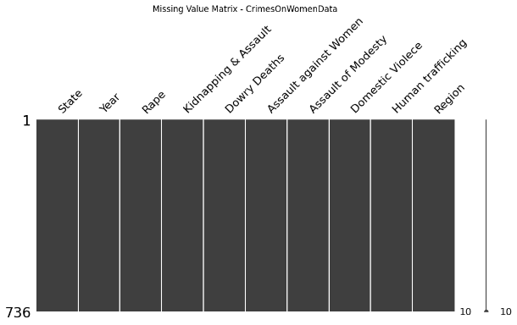

Duplicate Record Removal
Duplicate records can introduce biasness and affect results. Therefore, the dataset was examined for duplicate entries, and redundant records were removed. This ensured that each observation represented unique information. As per our observation our data don’t consist of any duplications.
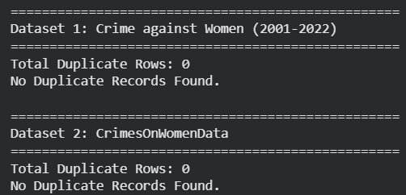
Data Cleaning
Data cleaning consists of the part where we remove duplicates and null values, more similar steps like these. After cleaning we do export a new set with cleaned data for further processing. As per above we don’t have any null or duplicate values, so our new dataset is kind of similar to older one.
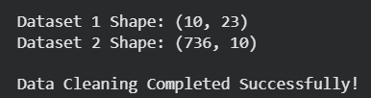
Feature Encoding
In this part, we encode categorial values as numerical values for easy understanding and accessibility by language.
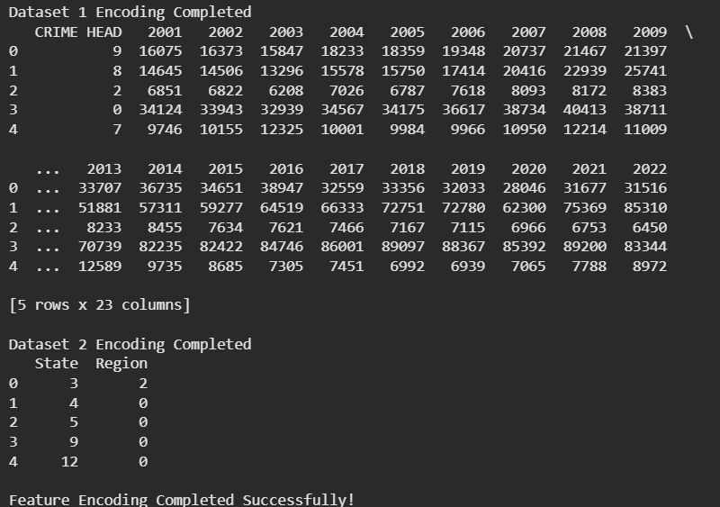
Feature Scaling
Feature scaling is used to normalize the data if needed and to ensure that all numerical variables contribute equally while model training.
Scaling not needed in this project.
Exploratory Data Analysis (EDA)
This is conducted to understand the characteristics of the dataset and identify meaningful patterns before developing predictive models. Various statistical and visualization techniques were employed to analyse the distribution of crime records, detect trends, and examine relationships among different variables.
Crime trend over years:
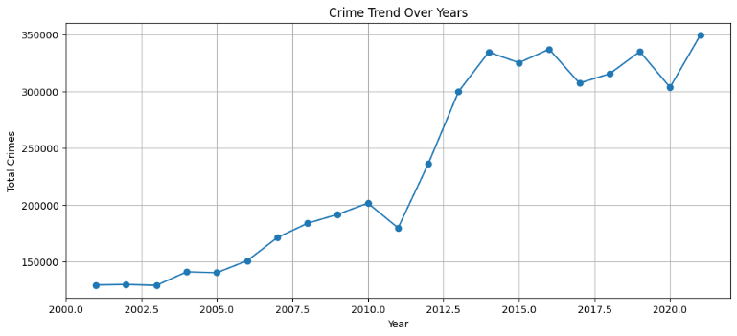

Highest crime frequency states:
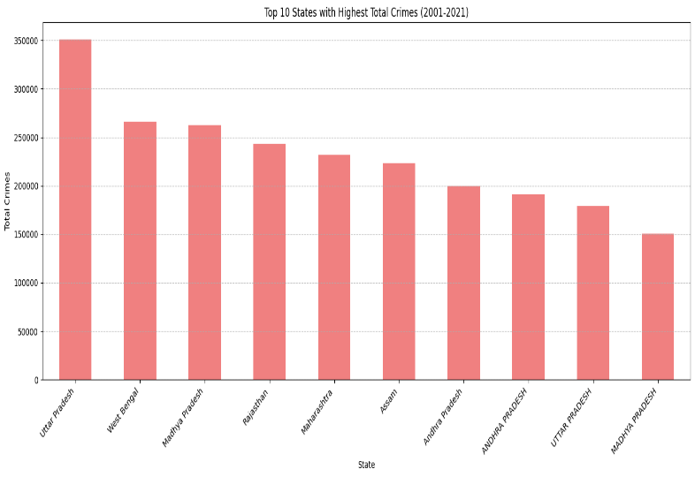
Region-wise crime distribution:
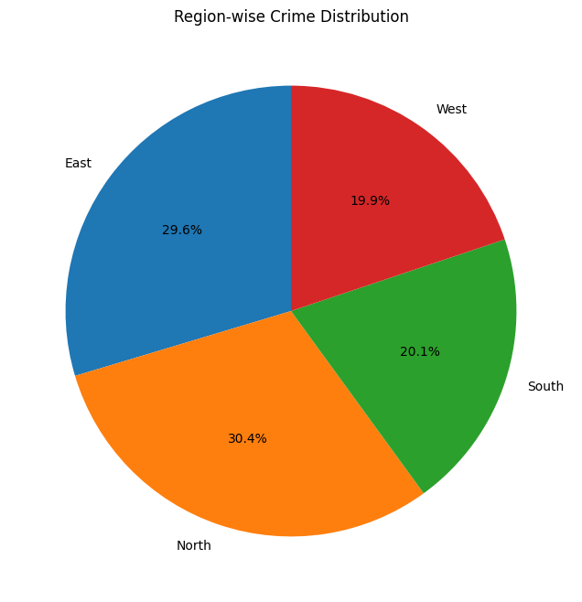
Correlation heatmap of Crimes:
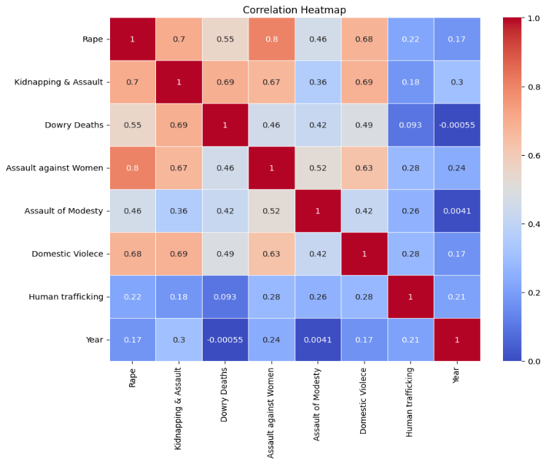
Correlation Heatmap of crime and States:
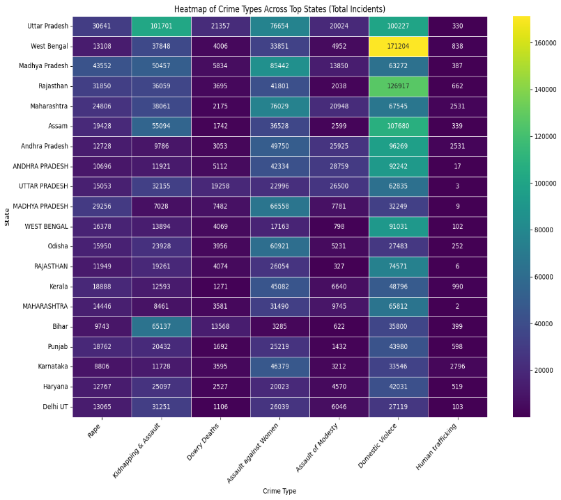
Train-Test Split
After preprocessing, the dataset was divided into training and testing subsets. The training set was used to develop the machine learning practical models, while the testing set was used to test their predictive performance. This helps us to check the efficiency.
For Dataset1:
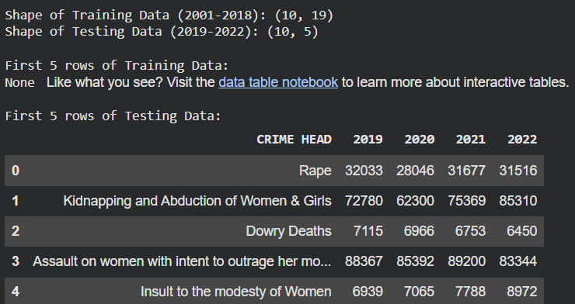
For Dataset2:
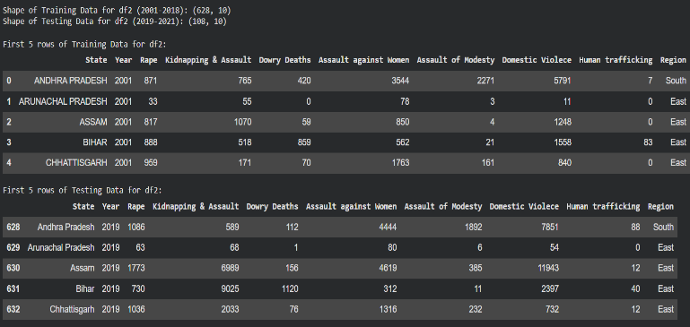
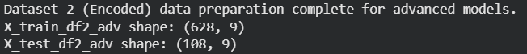

Machine learning models
To predict crime patterns happening, we supervised multiple machine learning algorithms and implemented along with comparing them. Objective of comparison is to evaluate the performance of different techniques and identifying the most suitable model for accurate outputs.

Linear Regression
Linear Regression is a technique in ml used to study the relationship in statistics among the independent and dependent variable. Apart from linear there also exist logistic regression which mainly focuses on dependent variables. Both have different functionality but both give informative data in their own ways related to experimental base.
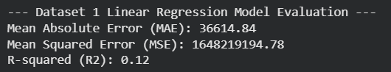
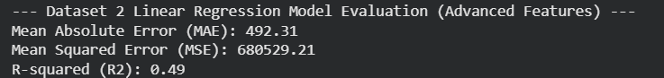

Decision Tree
Decision Tree is a type of algorithm in which it studies the data and split into branches forming nodes, which look like a tree structure. This gives a simple study method to analyze the data.
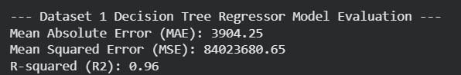
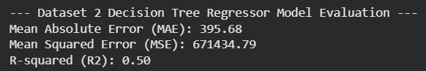

Random Forest
Random Forest is an algorithm that combines multiple Decision Trees to improve prediction accuracy, reduce overfitting. Each tree is studied specifically and prediction go with the majority. Random Forest shows strong predictive performance in this research and served as one of the primary models for comparison.
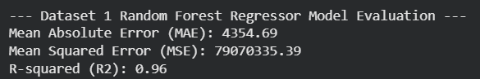
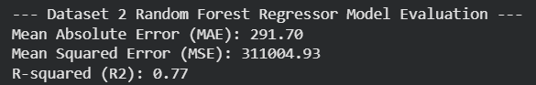

Support Vector Machine (SVM)
Support Vector Machine (SVM) is a ml algorithm used mainly for classification, sometimes regression. It works by finding the optimal hyperplane, the boundary that separate two classes with maximizing the margin in them.
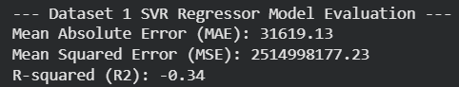
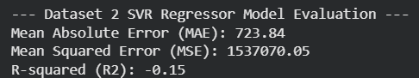

Extreme Gradient Boosting (XGBoost)
XGBoost is an extreme learning algorithm based on gradient boosting. It constructs many trees, after studying each the new one is always made more precising than the older minimizing errors. XGBoost is known for its high accuracy, computational efficiency, and ability to handle complex relationships within data. In this research, XGBoost is known as one of the advanced predictive models compared with the other machine learning algorithms and identified as one of the most effective approaches.
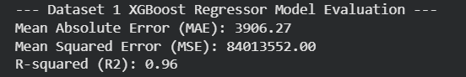
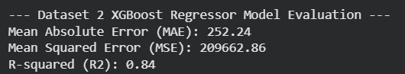

Comparative Model Evaluation
All implemented models were trained using the preprocessed dataset and evaluated on the testing dataset. Their performance was assessed using Accuracy, Precision, Recall, and F1-Score. The comparative evaluation enabled the identification of the best-performing model based on predictive accuracy and overall classification performance. The selected model provides a reliable approach for analyzing crimes on women data and supporting data-driven decision-making.

TABLE 4 (Models ML)
Model | Type | Purpose | Advantages
Logistic & Linear Regression | Classification | Baseline prediction model | Simple, interpretable, computationally efficient
Decision Tree | Classification | Pattern identification | Easy to interpret and visualize
Random Forest | Ensemble Classification | Improved prediction accuracy | Reduces overfitting and handles complex data
Support Vector Machine (SVM) | Classification | Class separation | Effective for high-dimensional data
XGBoost | Ensemble Boosting | High-performance prediction | High accuracy and efficient learning

Result and performance evaluation
This section presents the experimental results obtained from the implementation of machine learning models. These Models were evaluated using the testing dataset to compare their predictive performances individually. It is important because a comparative analysis conducted can help us to identify the most suitable algorithm for prediction.

Evaluation Metrics
To evaluate the performance of ml models, four standard classification metrics are there:
TP, TN, FP, and FN represent True Positive, True Negative, False Positive, and False Negative, respectively
1) Accuracy
Accuracy measures the proportion of correctly classified instances to the total number of instances in the dataset.
$$Accuracy=\frac{TP+TN}{TP+TN+FP+FN}$$

2) Precision
Precision indicates the proportion of correctly predicted positive observations among all predicted positive observations. A higher precision value indicates fewer false positive predictions.
$$Precision=\frac{TP}{TP+FP}$$

3) Recall
Recall measures the ability of the model to correctly identify actual positive cases. It is mostly important when we must have to minimize false negatives.
$$Recall=\frac{TP}{TP+FN}$$

4) F1-Score
The F1-Score is just harmonic mean of Precision and Recall. It provides a balanced evaluation when false positives and false negatives, both matters.
$$F1=\frac{2×Precision×Recall}{Precision+Recall}$$

Model Performance Comparison
TABLE 5 (Comparative Studies)
Df1:
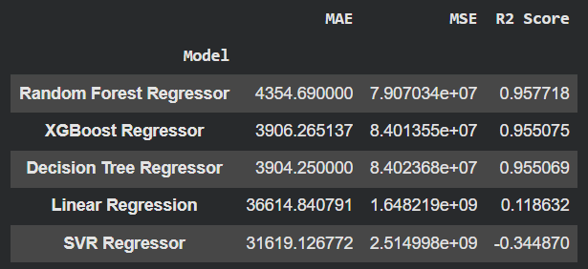
Df2:
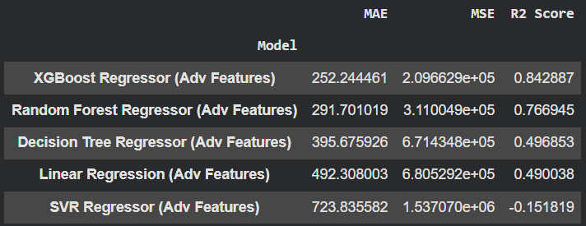

Best Model Selection
Random Forest is selected as the best-performing model for Dataset 1 and XGBoost for Dataset 2.
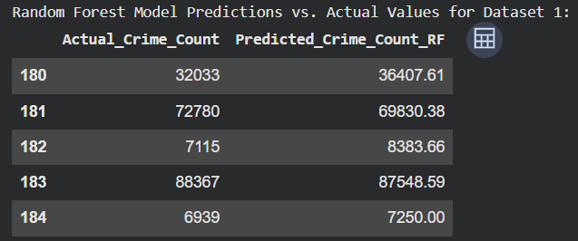
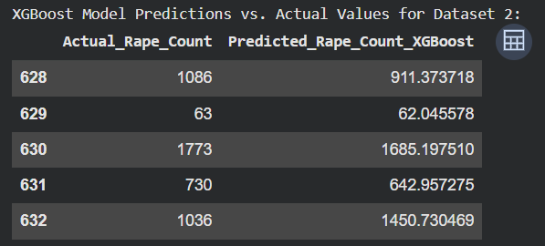

System implementation
System is implemented using Python in a Jupyter Notebook environment with Google Colab. Further details are added below in pointers for better go through:
A. Software Tools
- Python 3.x
- Jupyter Notebook
- Anaconda Distribution
B. Libraries Used
- Pandas
- NumPy
- Matplotlib
- Seaborn
- Scikit-learn
- XGBoost
- TensorFlow/Keras
- Joblib
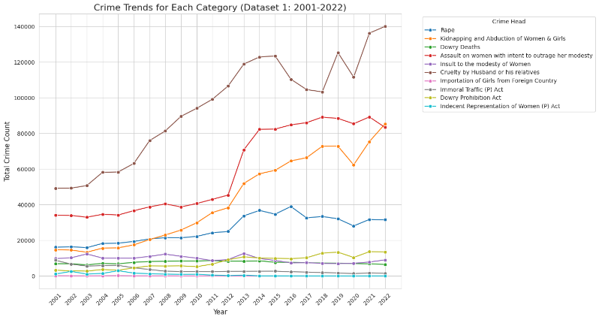

C. Implementation Steps
- Collection of domestic violence and crime-related datasets.
- Data cleaning and preprocessing, handling missing values and duplicates along with encoding categorical variables.
- EDA to understand trends and relationships within the dataset with visualization.
- Train-test data splitting.
- Training of multiple type of machine learning models.
- Evaluation of performance by Accuracy, Precision, Recall, and F1-Score for each model.
- Selection and saving of the best-performing model using Joblib for future prediction.

limitations
Although the work tried to overcome older limitations but as nothing can we considered ideal, here’s some limitations of presented project:
- Performance of the model depends heavily on the quality and completeness of the dataset.
- Datasets used represent historical crime records and trends so, may not capture newly emerging patterns.
- The prediction is based only on the selected features available in the dataset, important social, economic, or psychological factors are not included effecting quality a bit.
- Current implementation focuses on offline analysis and prediction and does not support real-time data processing.
- Proposed work is represented using a limited set of machine learning algorithms, and other advanced deep learning approaches may further improve performance.
- The model has been validated only on the available dataset; its performance may vary when applied to different regions or unseen datasets.

Future work
Although the proposed framework achieved high predictive performance, several improvements can be incorporated in future research to enhance its applicability and effectiveness.
- Integration of larger and more diverse datasets from several sources to improve the model's precision.
- Adding more advanced deep learning factors.
- Addition of socio-economic, demographic, and behaviour factors that may influence to recognize more patterns.
- Developing an explainable AI framework to improve the transparency and interpretability of model predictions.
- Continuous model updates using newly available crime records.
- Developing any easily accessible website or mobile application for researchers, policymakers, and law enforcement agencies.

Result and Conclusion
This research can help us to calculate future upcoming counts to focus on women safety. A bit more good progress in it with ai integration, web building, mob application can have scopes.

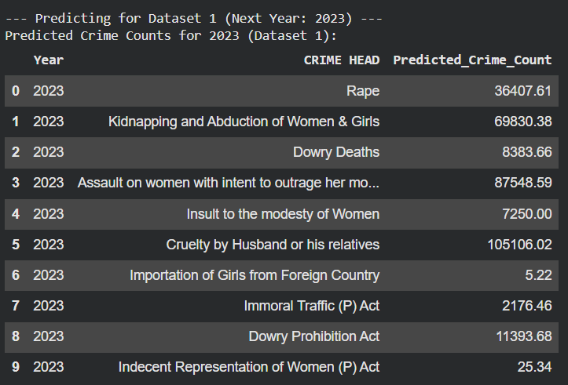
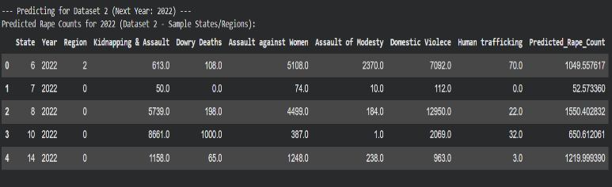

Reference
With proper citation

- World Health Organization (WHO), Violence Against Women: Key Facts, Geneva, Switzerland, Mar. 2024.
- National Crime Records Bureau (NCRB), Crime in India 2022 Statistics, Ministry of Home Affairs, Government of India, New Delhi, 2023.
- N. W. S. Ryan, E. N. Bird, and C. E. Ferguson, "Using Machine Learning Prediction to Create a 15-Question Intimate Partner Violence Measurement Tool," Journal of Interpersonal Violence, vol. 39, no. 5–6, pp. 1254–1278, 2024.
- G. Oatley and B. Ewart, "Predicting Domestic Abuse (Fairly) and Police Risk Assessment," Journal of Experimental Criminology, vol. 20, no. 2, pp. 317–339, 2023.
- S. M. Uddin et al., "Using Machine Learning to Forecast Homicide via Police Data and Super Learning," Scientific Reports, vol. 13, Art. no. 21581, 2023
- M. K. Alharbi and M. A. Alotaibi, "Crime Prediction Using Machine Learning and Deep Learning: A Systematic Review," arXiv preprint arXiv:2303.16310, 2023.
- S. Sharma and P. Gupta, "Deep Learning Based Crime Prediction Models: Experiments and Analysis," arXiv preprint arXiv:2407.19324, 2024.
- F. Pedregosa et al., "Scikit-learn: Machine Learning in Python," Journal of Machine Learning Research, vol. 12, pp. 2825–2830, 2011.
- T. Chen and C. Guestrin, "XGBoost: A Scalable Tree Boosting System," in Proc. 22nd ACM SIGKDD Int. Conf. Knowledge Discovery and Data Mining (KDD), San Francisco, CA, USA, 2016, pp. 785–794.
- L. Breiman, "Random Forests," Machine Learning, vol. 45, no. 1, pp. 5–32, 2001.
- C. Cortes and V. Vapnik, "Support-Vector Networks," Machine Learning, vol. 20, no. 3, pp. 273–297, 1995.
______________________________________________________________

