Universidade de Lisboa

IST

MEEC

Digital Transmission

2nd Practical Work

- Linear Binary Code -
-2^{nt} Phase –

Class: TDig11 Group: Date: 2025/2026
Number: ist1115593 Name: Raj Maharjan
Number: ist1118696 Name: Kristine Saralidze

Work Evaluation: ___________ Professor: Dr. Marko Beko

1. Objectives
In this phase of the work, the goal is to implement, based on the work developed in the previous phase, an automatic error detection and correction mechanism for a telecommunications system. First, the entire message to be transmitted is divided into several blocks () of size.
Next, the message sent to the transmission channel () of size is formed with the aid of the generator matrix (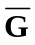). Figure 1 schematizes the aforementioned process.
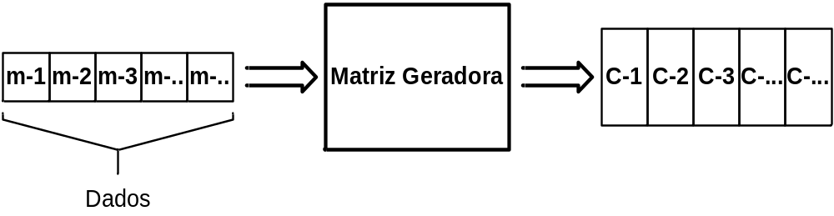Figure 1
After sampling and detecting the received bits, the receiver, through the mechanism developed in the 1st phase, can detect and correct errors of weight 1 and detect errors of weight 2.
To simulate the existence of errors at the receiver (it is assumed that these occur with a low probability, and consequently, errors of weight greater than 3 are assumed to have zero probability), a pseudo-random function will be implemented to generate errors of weight 1.

2. REPORT AND EXECUTION OF THE WORK IN MATLAB.

  - Using the parity-check matrix (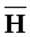) defined in the 1st phase, define the generator matrix (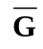).
Save the result of the generator matrix in a variable with the following name: “G0_z_T1_2F_G.mat”
(whererepresents the student number)
This file must be submitted along with the report

  - Import into MATLAB using the function: load(ST_Dados_G0y_T1.mat)”, the syndrome, where corresponds to the number of your laboratory group.

  - Using the generator matrix (), form, from the data in 2.2), the various vectors to be transmitted to the channel ().

Organize the various vectors () into a two-dimensional variable where the number of rows corresponds to the vector which represents the subset of the data.
Example:
The Two-dimensional variable should have the following structure:
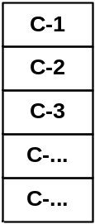
Save the result in a variable with the following name: “G0_z_T1_2F_C.mat”
This file must be submitted along with the report.

  - How many vectors exist, considering the data corresponding to your group?
5 such codewords exist using the data corresponding to my group chosen as group 7. Codewords: 5×255
  - Using the instruction “rand()” generate error vectors () with weight 1, in the same quantity as the vectors to be transmitted.

Organize the various error vectors () into a two-dimensional variable in the same format as in 2.3).
Save the result in a variable with the following name: “G0_z_T1_2F_E.mat”
This file must be submitted along with the report.

  - Determine the resulting received vector ().

Organize the various received vectors () into a two-dimensional variable in the same format as in 2.3)
Save the result in a variable with the following name: “G0_z_T1_2F_R.mat”
This file must be submitted along with the report.

  - From and , determine the resulting syndrome vectors ().

Organize the various syndrome vectors () into a two-dimensional variable in the same format as in 2.3).
Save the result in a variable with the following name: “G0_z_T1_2F_S.mat”
This file must be submitted along with the report.

  - From the various syndrome vectors, determine the transmitted message and verify if the error detection and correction mechanism is correct. Describe the procedure you used, particularly how you determined the error vector from the syndrome.
For detection, we look into the syndrome vectors and which tells us about the error in the received codeword, then after s calculated we move to find the main element and complementary class associated with s. From that we know
c = r + e, hence decoding the codeword, and at last elemention of p = n-k parity check bits, which were concatenated to c.

