Universidade de Lisboa

IST

MEEC

Digital Transmission

3rd PRACTICAL WORK

- Baseband Transmission –
1st Phase

Class: ________ Group:______________ Date: _______________________
Number:1115593 Name:_______Raj Maharjan_________________________
Number: 1118696 Name:______Kristine Saralidze______________________
Work Evaluation: ___________ Professor:________Marko Bekko_________

1. Objective
The objective of this work is to study various line codes used in baseband digital communications.

Line codes convert a sequence of binary digits into a waveform suitable for baseband transmission through a communication channel. Depending on the available channel and the specific application, the resulting waveforms must meet certain requirements to a greater or lesser extent, such as the absence of a DC component, limited bandwidth, and sufficient timing information for clock recovery.
Examples of line codes used in various communication systems include:

• Unipolar NRZ e RZ
• Polar NRZ e RZ
• Bipolar NRZ e RZ (AMI)
• Manchester

In this experiment, the waveforms of some line codes used in baseband digital communications will be observed. The corresponding power spectral densities will also be obtained, and conclusions will be drawn regarding the presence or absence of a DC component and the minimum bandwidth of the transmission channel. Additionally, the influence of noisy, bandwidth-limited channels on the transmitted waveforms will be analyzed.

2. REPORT AND EXECUTION OF THE WORK IN MATLAB.

1ª part - Waveforms
In the next phases of the work, Simulink will be used to generate the waveforms of the mentioned line codes.

  - Generate a binary sequence using the Sampled Read block or the Bernoulli Binary Generator from Workspace from the Communications Blockset library.
Use the Unipolar RZ block from the Line Codes block library provided to obtain this type of line encoding for the sequence.
The simulation parameters should be as follows
• Bit rate of the sequence: R = 1 bit/s
• Samples per bit: Spb = 10.
• Simulation duration: 10 s
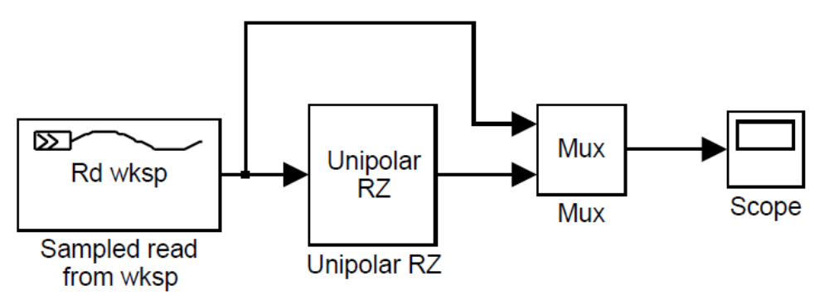
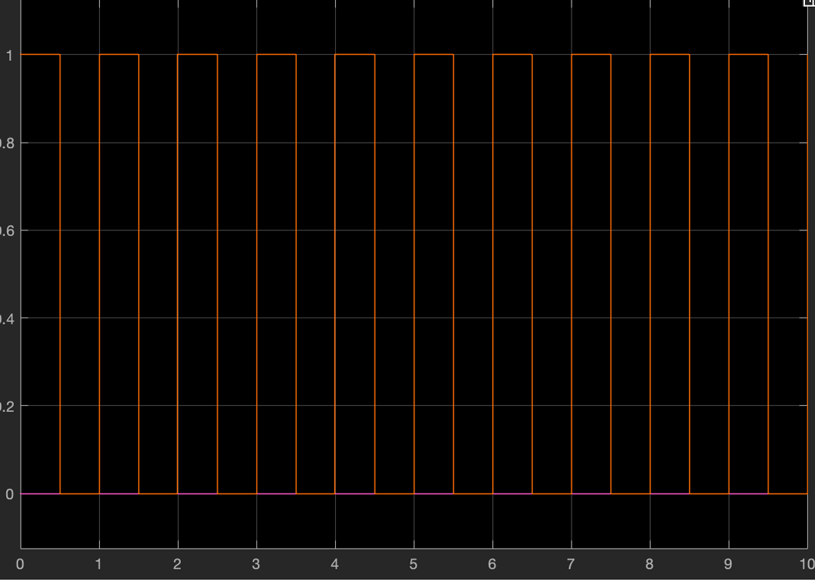
  - Now obtain the waveforms corresponding to the remaining line codes:
(Unipolar NRZ, Bipolar RZ, Polar NRZ e Manchester).
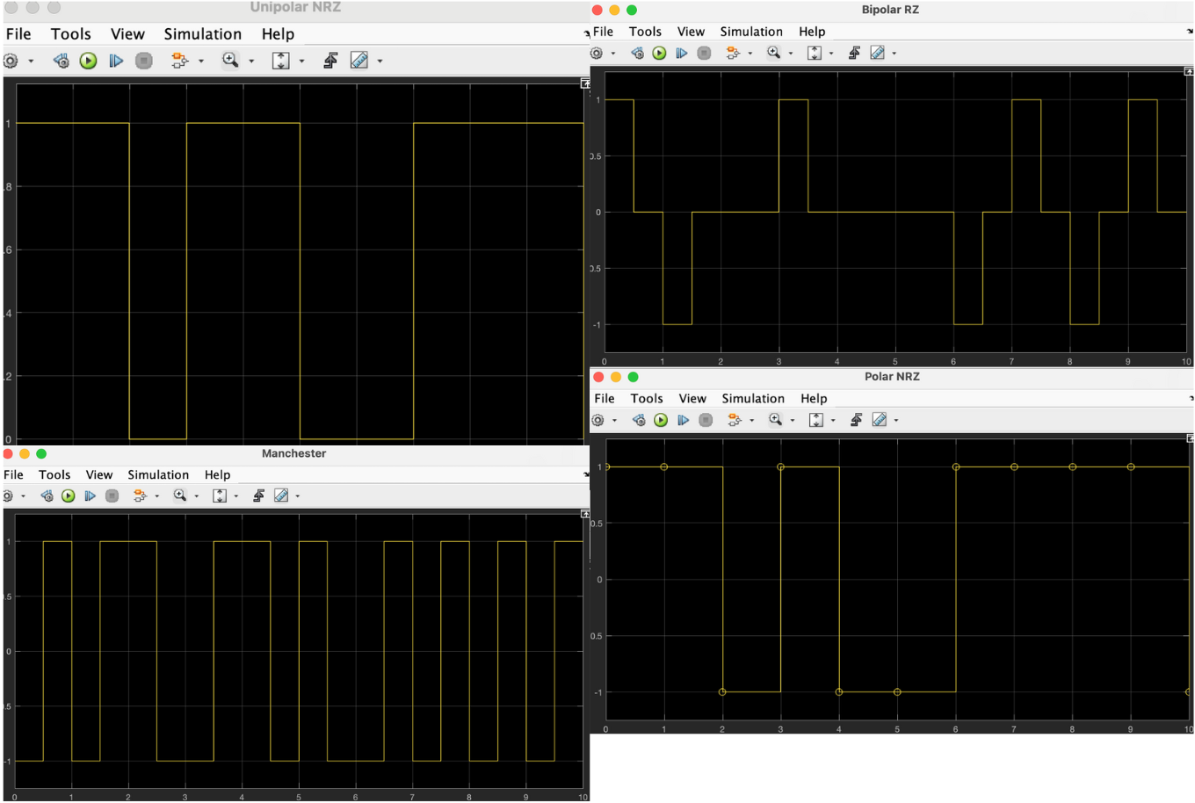

  - By observing the waveforms you obtained, identify which line codes ensure a zero DC component regardless of the input binary sequence. Explain how 0 and 1 are represented in these line codes.
Bipolar RZ and Manchester line codes ensure a zero DC component regardless of the input sequence, because their positive and negative signal levels always balance over time.
Unipolar RZ:
0 = 0V, 1 = +A (constant over full bit duration). Here the signal never goes negative, so DC component is present.
Bipolar RZ (AMI – Alternate Mark Inversion):
0 = 0V for entire bit duration, 1 = pulse that alternates between +A and -A, and returns to zero within the bit period. Here, the positive and negative pulses cancel over time, hence the average value = 0 regardless of bit pattern, i.e. no DC component.
Polar NRZ:
0 = -A, 1 = +A, If number of 1s is not equal to number of 0s, DC component exists.
Manchester:
Each bit contains one positive and one negative half, and there is always a transisition in the middle of the bit. So typically, 0 = +A to -A, 1 = -A to +A. This results in equal positive and negative areas per bit, hence DC component is always 0

  - Calculate the average power per bit for the Polar NRZ line code. Determine how much the remaining line codes need to be amplified to achieve the same power.
For Polar NRZ, avg Power = V²/2
For Unipolar NRZ and Manchester, Amplification factor remains to be 1, while for Bipolar RZ, amplification factor is √2

2ª part – Power Spectral Densities

At this stage, the power spectral densities of the various considered line codes will be obtained.

  - Generate a random binary sequence b, of length 1000 bits (1 second duration), with equally probable symbols.
  - Obtain the x vectors resulting from the simulation with the various considered line codes, taking the value R of value 1000 bit/s and Spb = 10.

  - For each code, visualize the corresponding power spectral density using the Spectrum Scope (or Spectrum Analyzer) block from the DSP System Toolbox in Simulink.

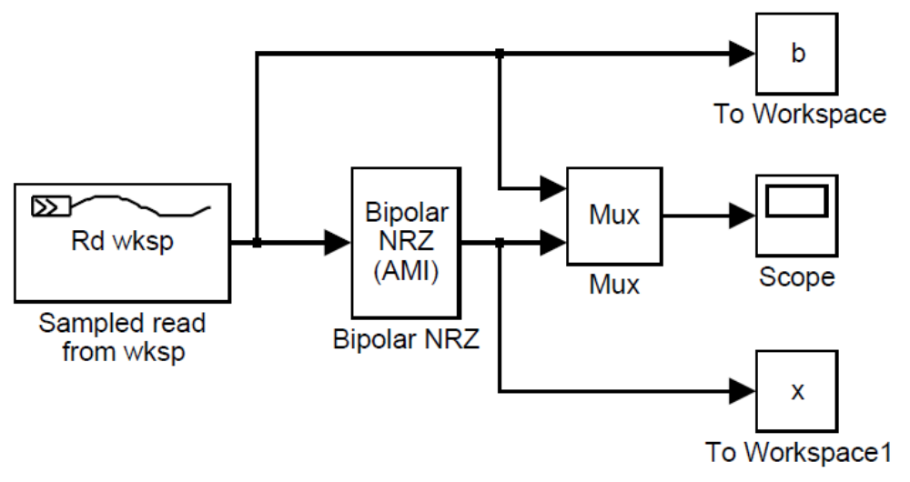
Note: The mention of Bipolar NRZ (AMI) in the previous figure is an error, as the provided blocks are for Unipolar NRZ, Unipolar RZ, Bipolar RZ, Polar NRZ, and Manchester. The MUX block is not necessary; to obtain the corresponding power spectral density, the input to the Spectrum Analyzer should be the output of the line code.
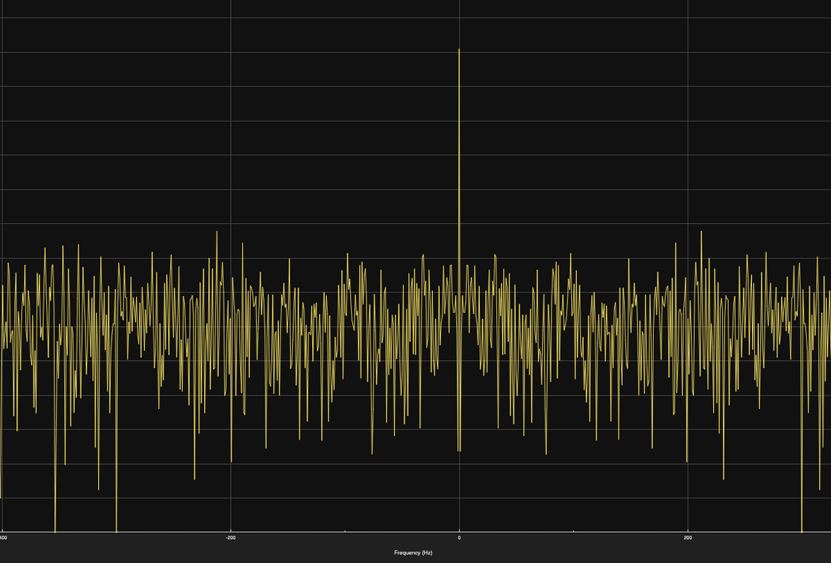

  - Fill in the following table:
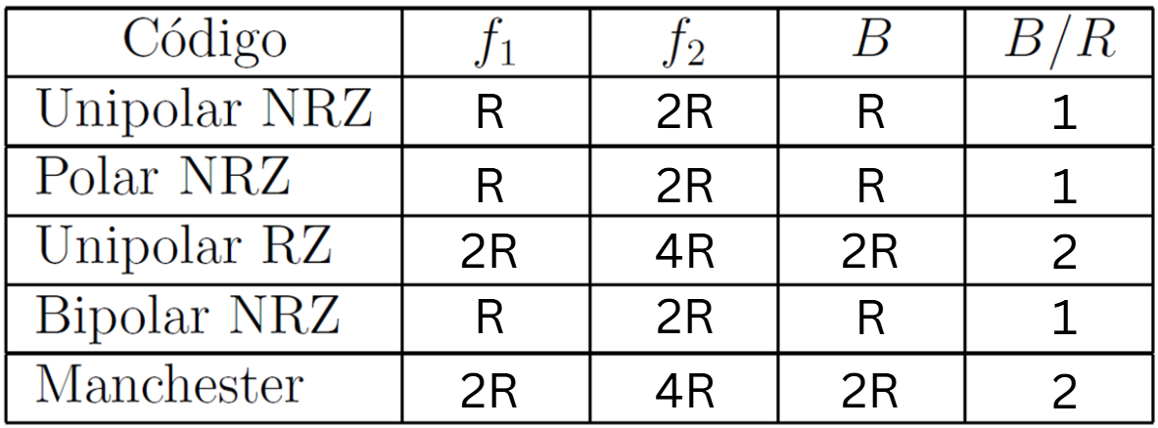
f1 and f2 are the frequencies of occurrence of the first and second spectral nulls, respectively, and B is the minimum transmission bandwidth (=f1).

Line codes have different bandwidths. Why? Try to explain.
Ans: RZ formats require more transitions within the bit period (due to returning to zero), which increases the frequency content and bandwidth.

  - To study the dependence of the bandwidth B on the bit rate repeat the previous table for bit rates of 5 kbit/s and 20 kbit/s.
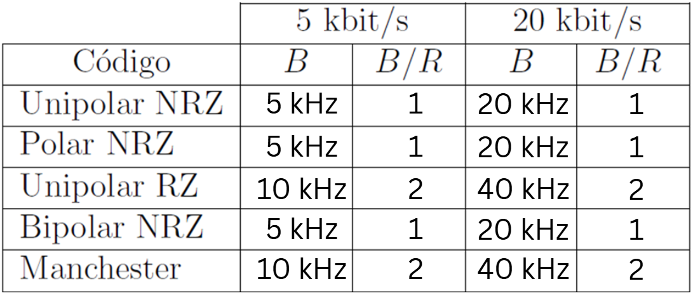
  - What do you conclude from the values in the tables? What conclusions can you draw about each of the mentioned line codes by observing their power spectral density? Justify your answer.
Line codes like RZ (Return-to-Zero) increase the number of transitions per bit period, doubling the bandwidth compared to NRZ (Non-Return-to-Zero). Increasing R compresses the time for each bit, requiring faster signal transitions, which increases the frequency content of the signal.

3ª part – Effect of the Transmission Channel

In this section, the baseband transmission of the Unipolar NRZ and Manchester line codes will be simulated. The transmission channel is modeled by a low-pass filter with gain G and bandwidth B and a white Gaussian noise generator with zero mean and average power N. Note: There is no Simulink block called "Communications Channel." You need to construct it using two consecutive blocks: one corresponding to the filter and the other to the noise generator (the Simulink noise generator module can usually serve this purpose).

Create a random binary sequence of length 1000 bits (with equally probable symbols).

  - Obtain the x samples corresponding to a random binary sequence of length 1000 bits (with equally probable symbols) for the Unipolar NRZ and Manchester codes. Consider R = 1000 bit/s, fs = 100R (i.e., Spb = 100). What is the minimum channel bandwidth required to transmit these two codes?

B-NRZ = 500 Hz B-Manchester = 1000 Hz

Note: The bandwidth B for these signals is measured from f=0 Hz to the first null of the signal spectrum.

  - Pass the obtained x o sequences through a noise-free channel with unit gain and a bandwidth B = 4 kHz, observing the input x and the output y for both cases. Comment on the waveforms obtained at the channel output.
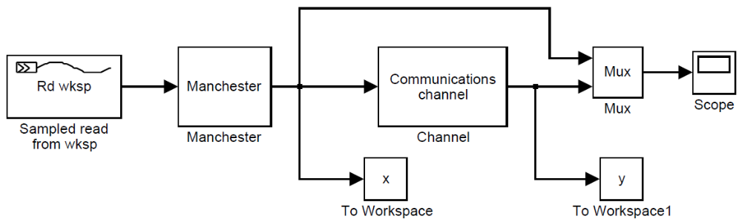
The low-pass filter attenuates high-frequency components of the Unipolar NRZ signal, resulting in a smoother waveform. Whilst for Manchester high-frequency components are attenuated. The transitions become less sharp, and the signal appears smoother. Due to the limited bandwidth, some distortion in the waveform may be observed, as the channel cannot transmit all the spectral components of the Manchester signal.
  - Para observar melhor o efeito da largura de banda finita do canal repita o passo anterior para B = {2000, 1000, 500} Hz. Comment on the obtained results.
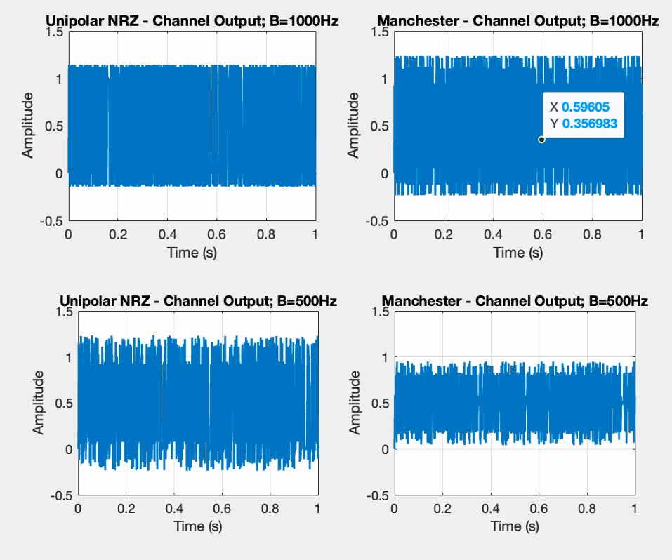
For B=2000Hz, both Unipolar and Manchester record distortion but are not visible when plotted, but B=1000Hz, we know significant distortion is observed because the channel bandwidth is now only (B=R), which is insuf icient to transmit all spectral components of the Manchester signal (which contains significant energy at 2R). Whilst for Unipolar NRZ distortion becomes noticeable.
The output waveform becomes most distorted for both encoding schemes when B=500Hz
  - Now observe the effect of additive noise in the channel, maintaining unit gain and a bandwidth B = 4 kHz, but using N = {0, 0.01, 0.1, 1}.
For N = 0: Clean output signals; distortion is only due to the channel’s limited bandwidth.
For N = 0.01: Slight noise-induced variations in the waveform, but the signals remain decodable.
For N = 0.1: Significant noise interference; distinguishing between 1 and 0 becomes harder, especially for Manchester encoding.
For N = 1: Severe noise distortion; the signal is almost entirely buried in noise, making it practically undecodable.
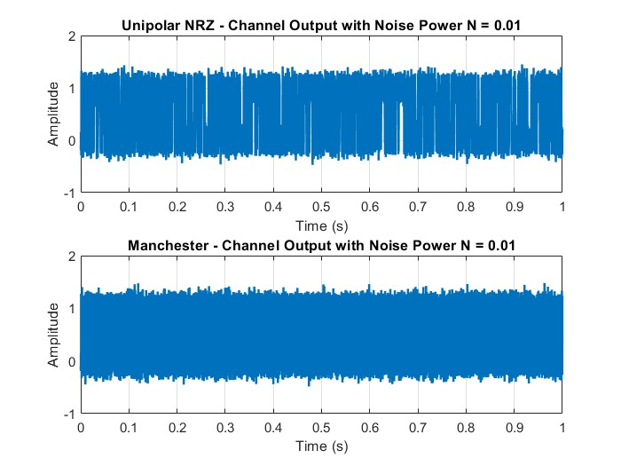
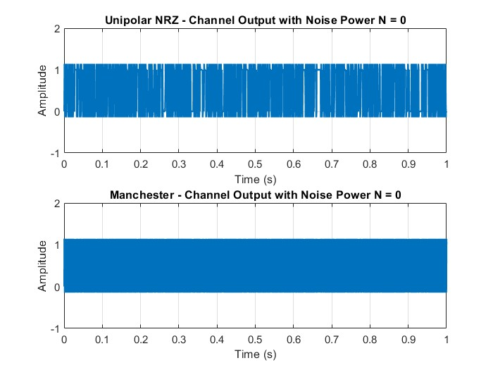
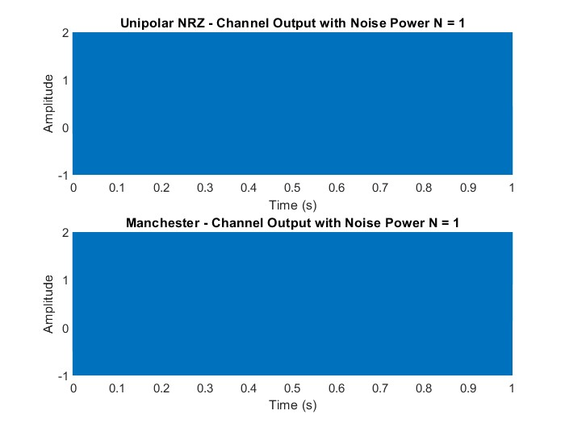
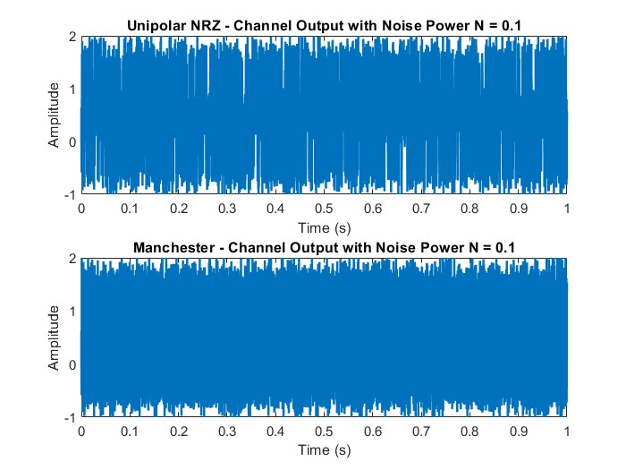

  - Now we will observe the effect of Gaussian white noise on the power spectral density.
Create a random binary sequence of length 1000 bits (with equally probable symbols).

  - Create the x samples for the Unipolar NRZ code only (consider R = 1000 bit/s).

  - Pass the x sequence through the channel (consider G = 1, B = 4 kHz and N = {0, 0.01, 0.1, 1}) and plot, on the same graph, the power spectral densities of x and y for the various values of N = {0.01, 1}.
Comment on the results obtained.
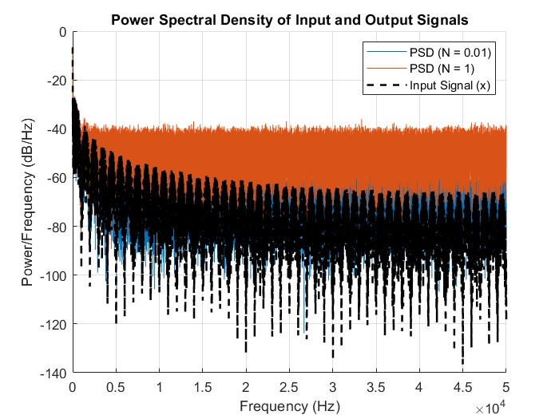
Input Signal x : The PSD of the Unipolar NRZ signal x has its energy concentrated around lower frequencies, with nulls at multiples of the bit rate R due to the rectangular pulse shape. The PSD reflects the ideal characteristics of the input signal without distortion.
Output Signal y :
For N = 0.01 : The output PSD closely matches the input PSD but shows a slightly elevated noise floor.
For N = 1 : The PSD becomes dominated by noise, with the noise floor significantly higher, masking the spectral characteristics of the original signal.

  - Visualize the eye diagram at the input and output of the channel using the Discrete Eye Diagram Scope block from the Communications Toolbox in Simulink.

  - Save the MATLAB code file with the following name:
y_T5
where y corresponds to the student number.

