Universidade de Lisboa

IST

MEEC

Digital Transmission

3rd PRACTICAL WORK

- Error Probability in Baseband Digital Transmission Systems –
2nd Phase

Class: ________ Group:______________ Date: _______________________
Number: 1115593 Name:_______Raj Maharjan_________________________
Number: 1118696 Name:_______Kristine Saralidze______________________
Work Evaluation: ___________ Professor:__Marko Bekko_______________

1. Objective

In this work, the behaviour of various types of detectors used in digital receivers will be studied, focusing on the identification of signals immersed in additive Gaussian noise. The study will include measuring error probabilities and visualizing the eye diagrams of the signal at the receiver. The work will be conducted in MATLAB/Simulink.

2. Theoretical Preliminaries

The goal is to transmit a digital sequence represented by baseband pulses, generically denoted as g(t), 0 ≤ t≤ T, rough a channel that only introduces white Gaussian noise w(t) — the so-called AWGN (Additive White Gaussian Noise). The symbol rate, or the number of symbols transmitted per second, is, 1/T. At the receiver, the simplest, but not the most efficient, way to recover the binary sequence is by sampling the waveform every T seconds, using the sample values ​​x(T) to determine which binary symbols are correspond to them, depending on whether these values ​​are above or below a certain decision threshold (see Figure 1). 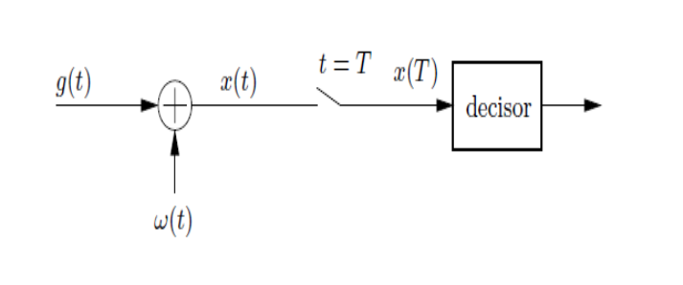
Figure 1: Signal, noise, sampler, and decision-maker.

The probability of the decision-maker making an error depends on the difference in amplitudes of the received pulses, ΔV, and the noise power, σ². Specifically, it is given by the expression:
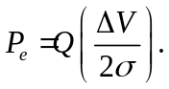
The pulse detection method shown in Figure 1 is not optimal. In fact, to minimize the error probability, or equivalently, to maximize the signal-to-noise ratio at the decision instant, the sampler should be preceded by an appropriate filter, the so-called matched filter, as shown in Figure 2.
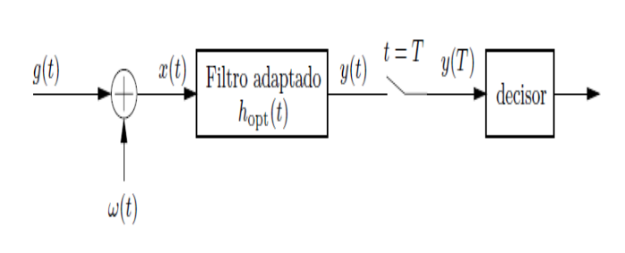
Figure 2: The matched filter.

"Matched" to the pulse g(t), this optimal filter has the impulse response:
h_{opt}(t) = kg(T − t),
where k is simply a proportionality constant.

Consider the following example. Let g(t) be a unipolar RZ pulse of amplitude A, with a 50% duty cycle and duration T (corresponding to the bit 1, for example), as represented in Figure 3.
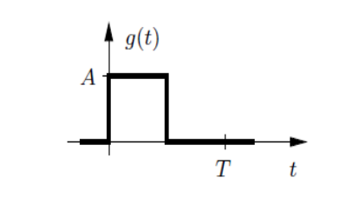
Figure 3: Transmitted pulse g(t).

The receiver filter matched to this waveform thus has (with k = 1), the impulse response shown in Figure 4.
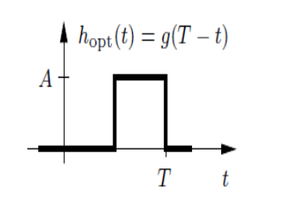
Figure 4: Optimal impulse response, h_{opt}(t).

The application of g(t) to this filter produces the output waveform represented in Figure 5. The sampling instant is the point in time when a decision is made regarding which bit, 0 or 1, was transmitted. Choosing the correct instant leads to the maximum possible signal-to-noise ratio in the presence of white Gaussian noise. 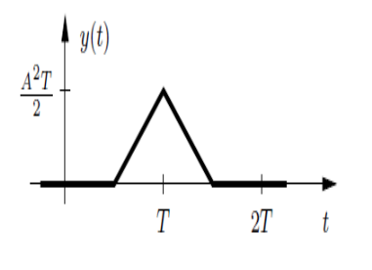
Figure 5: Response of the matched filter.

In this example, the sampling instant should be taken at t = T, as it is at this moment that the output of the matched filter reaches its maximum value. This value corresponds to the bit energy, E_{b}, which in this case is, E_{b} = A²T/2.
The probability of a bit error associated with the optimal detector at the sampling instant T, for polar pulses with any waveform, is given by:
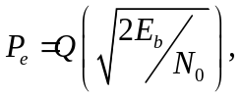
Where N₀ is the one-sided power spectral density of the noise w(t).
(Challenge: Prove the validity of the above expression for the case ofg(t))

An alternative way to perform optimal detection is to use the correlator circuit, whose structure is shown in Figure 6.
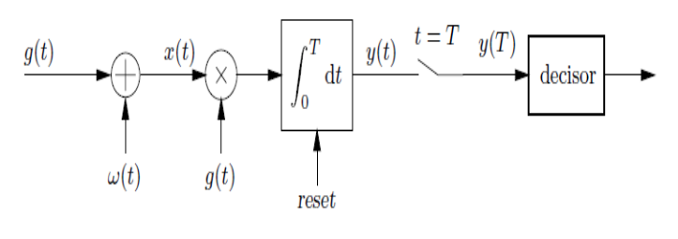
Figure 6: The correlator.

At the sampling instant, t = T the output value of the correlator is the same as the output of the matched filter. After the sampling instant, the output of the integrator is reset so that the integration for each symbol period always starts from zero.

In the case of transmitted pulses being rectangular (the most common scenario), the correlator can be simplified to the circuit typically referred to as Integrate&Dump (I&D), which is shown in Figure 7.
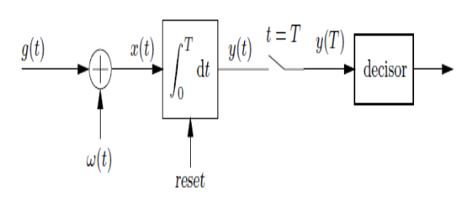

Figure 7: The Integrate&Dump filter.

he response of the I&D filter to the pulse g(t) is illustrated in Figure 8. This is the simplest form an optimal detector can take, making it the easiest to implement physically.
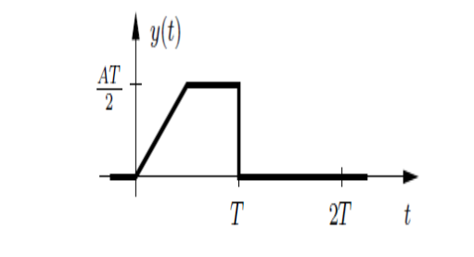
Figure 8: Response of the Integrate&Dump filter to the pulse g(t).

3. EXPERIMENT

In this work, the behaviour of various detectors used in digital receivers will be studied in the scenario where a sequence of pulses passes through an AWGN channel. Throughout these experiments, the following conditions will remain constant:

- Transmitted data: Random binary sequence of 1000 bits.
- Binary data rate: r_{b}=1 kbit/s
- Line code: Polar NRZ (pulses with amplitude ±V).
- Simulation frequency (sampling rate): f_{s}=100r_{b}=10⁵ Hz (i.e )

In the resolution, you should:
- Present illustrative figures of the signals at different points in the system.
- Justify the implementation of the blocks.
- Measure the error probabilities for various channel noise powers and visualize the eye diagram at the receiver.
1st part - Detection by Sampling
In the first phase of the work, the behaviour of the system will be analysed, considering that the receiver performs a simple sampling of the signal.
a) Assemble the following simulation diagram. Generate a binary sequence in the workspace or using the Bernoulli Binary Generator block from the Communications Blockset library
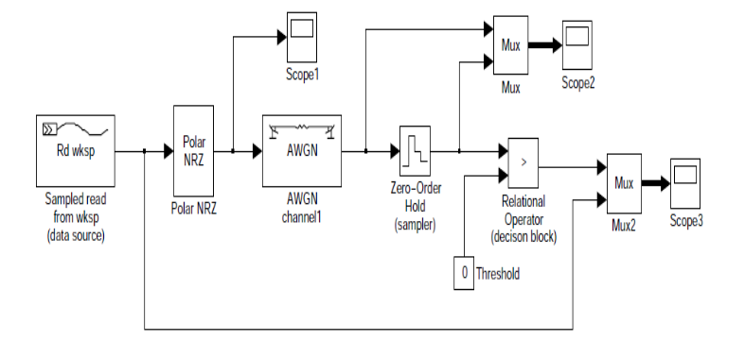

b) Run the simulation for 10 ms and observe the waveforms displayed on the various oscilloscopes. This is a hypothetical situation where no low-pass filter is present in the receiver, and the channel noise power is 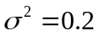 W.
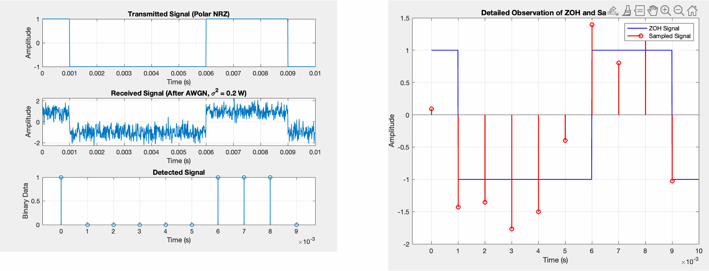
c) The sampler (Zero-Order Hold block) performs sampling at the beginning of each bit. Confirm this through a detailed observation on the corresponding oscilloscope.
In a real system, does this sampling method (near the bit transition) pose any issues? Justify your answer.
Ans: No, in real world systems using such sampling methods depends on the synchronization of both parties and as we know their is also the possibility of drift in such systems which introduces ISI, as even a small deviation in sampling causes interference which accumulates. Using Nyquist channel the lobes after the sampling are prominent and hence even a fraction of difference can cause a ripple effect.
d) Calculate the theoretical error probabilities for this system for the noise power values indicated below:

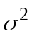 | P_{e}(theoretical) | P_{e}(estimated)
0.2 | 0.0008 | 0.0130
0.4 | 0.0023 | 0.0390
0.8 | 0.0577 | 0.1193
1.6 | 0.1311 | 0.2020

e) Now simulate the system for 1 second (1000 bits transmitted) and record the various estimated error probabilities for the noise levels indicated in the previous table. What do you observe?
Ans: The basic observation is that as the noise is increased the probability of error also increases i.e. more bits will be incorrectly decoded due to the added noise, noise makes it harder for the receiver to accurately detect the transmitted bits, especially at higher noise levels.
f) Set as 0.2 and include the Discrete Eye Diagram Scope block from the Communications Toolbox in Simulink to visualize the eye diagram at the input of the decision-maker. Is there a specific decision instant that minimizes the error probabilities? Justify your answer.
Ans: Ideal decision instant occurs at the midpoint of the bit period, where the eye diagram is most open, leading to the lowest error probability. But we’ve already selected the decision instant to be > 0, which is the midpoint of the bit period, hence maximizing the Eye openining in the eye diagram.
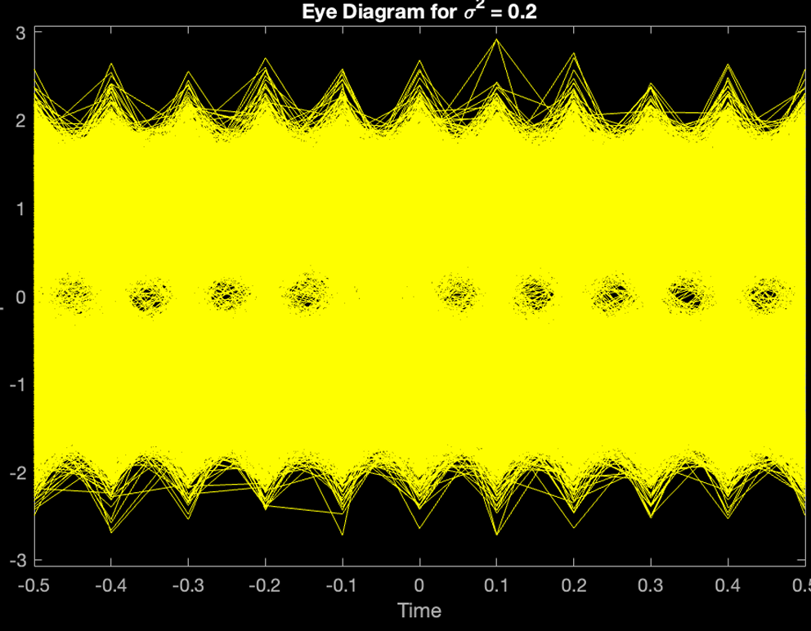

Note 1: As a rule of thumb, if you need to "obtain" an error probability P, you should simulate 100/P bits. For example, if the theoretical error probability is on the order of 0.01, then you should generate 10,000 bits.

2nd part - Detection with Matched Filter
In this exercise, a matched filter will be included at the receiver's input, and the improvements introduced by it will be analysed. In the Polar_NRZ block, select 100 samples per bit.

a) What will be the impulse response of the matched filter for the transmitted pulses, h_{opt}(t)? Represent it.
h_{opt}(t) = c × p(T₀ − t) where → c = constant & p(.) = Pulse shape at receiver

b) Sketch the response of the matched filter to the data sequence 0,1,0,0,1,1.
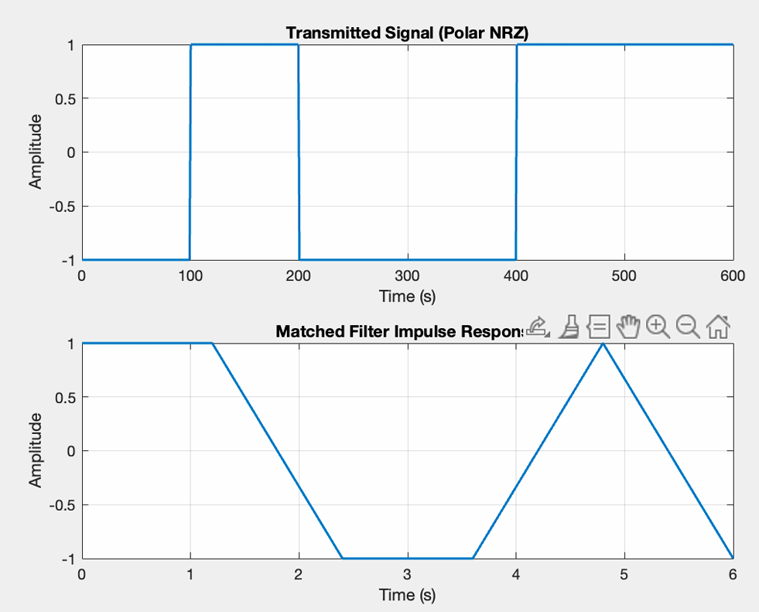

c) Introduce the matched filter into your system (hint: it is a discrete FIR filter whose impulse response corresponds to the discretization of the impulse response obtained in part (a); you can also use the Digital Filter block). Remove channel noise and observe the waveforms before the filter, after the filter, and after the sampler. Are the waveforms as predicted earlier?
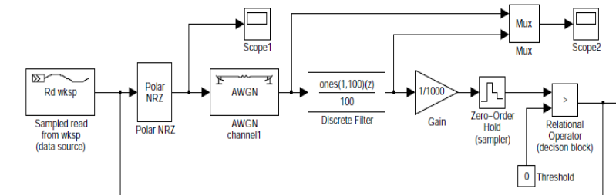

d) Calculate the theoretical error probabilities for the receiver with the matched filter for the noise power values indicated in the following table and compare them with the simulated values.

 | P_{e}(theoretical) | P_{e}(estimated)
20 | 0.4115 | 0.5020
40 | 0.4372 | 0.5480
80 | 0.4555 | 0.5239
160 | 0.4685 | 0.5000

Note that since we are considering a sampling frequency f_{s}, all elements of the communication system will have a maximum bandwidth of B=f_{s}/2. That is, note that:
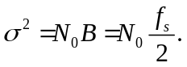
e) Now simulate the system for 1 second (1000 bits transmitted) and record the various estimated error probabilities for the noise levels indicated in the previous table. What do you observe?

f) How much would the amplitude of the transmitted pulses need to be increased in the case of the simple detector (with only a sampler) to match the performance of the detector with the matched filter?
To achieve the same error probability as the matched filter, the amplitude of the transmitted pulses must be increased by a factor of 2, which would mean
α =1 ⇒ r_{b}= 2B_{T}/(1 + α) → r_{b}=2B_{T}

g) Include the Discrete Eye Diagram Scope block from the Communications Toolbox in Simulink to visualize the eye diagram at the input of the decision-maker for 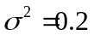 and 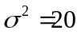. What is the decision instant that minimizes the error probability? Justify your answer.
Decision instant that minimizes the error probability is at the center of the eye, where the signal amplitude is most distinct from noise.
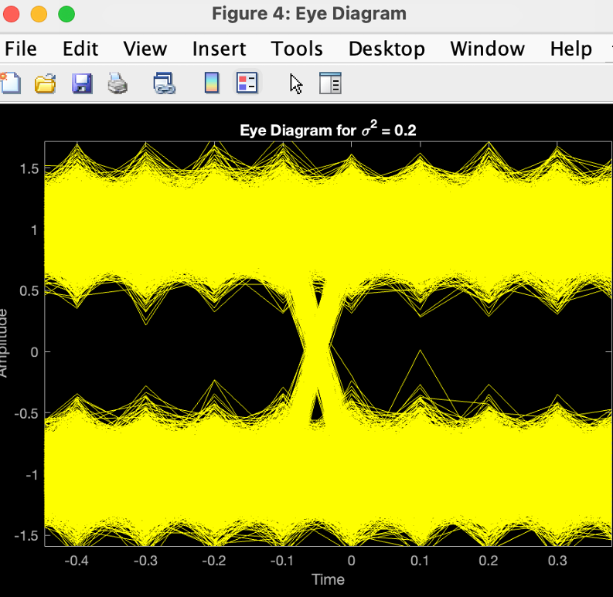

Note 2: If the simulation duration is 10 seconds, 10,001 bits will be generated since the bit rate is 1000 bps. In this case, and given there is a delay of 1 bit (at instant 0, the output is always 0), the bit error probability can be calculated as: sum(abs(sent(1:10000,1)-double(received (2:10001,1)))/10000, where the double function is optional in most MATLAB versions. This note also applies to Part 3.

3rd part - Detection with Integrate&Dump Filter

As the final experiment, the matched filter will be replaced with an Integrate & Dump circuit, and its performance will be compared to the previous filter. Note that since the transmitted pulses are rectangular, the Integrate & Dump filter is equivalent to a correlator.

a) Sketch the response of the Integrate&Dump filter for the data sequence 0,1,0,0,1,1
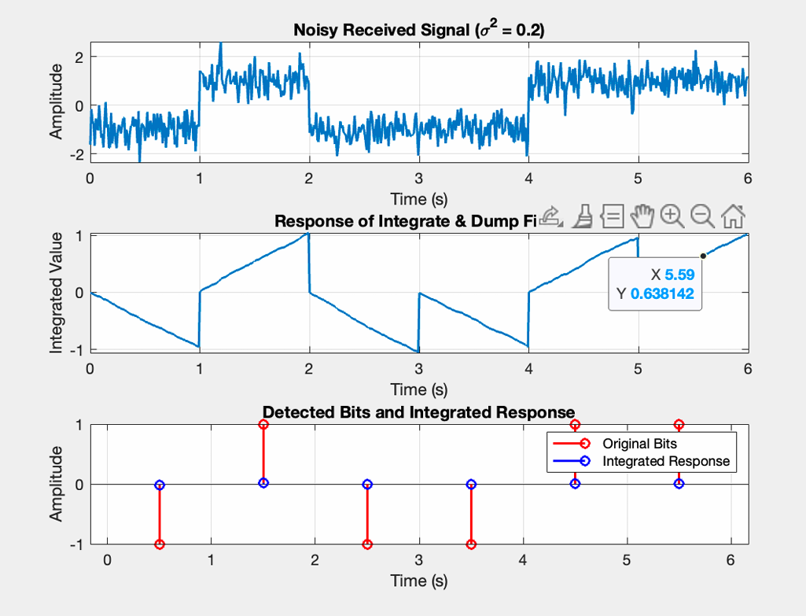
b) Remove the channel noise (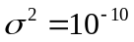) and observe the waveforms before and after the filter. Are the waveforms consistent with those obtained previously?
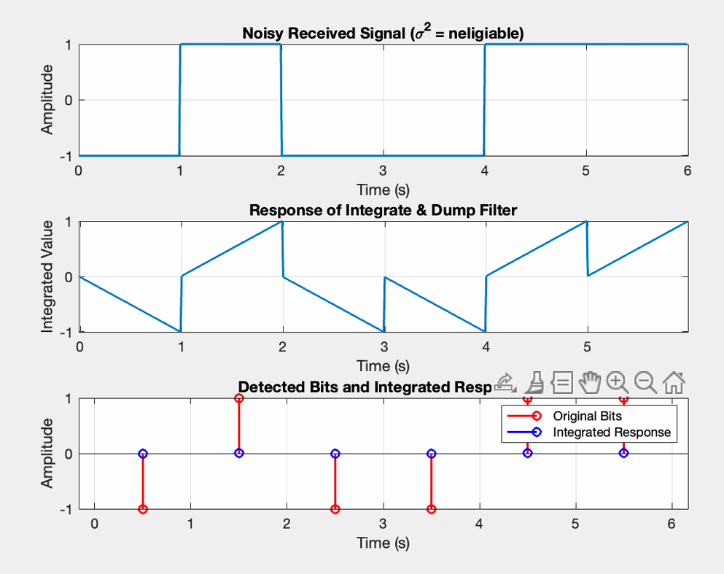
c) Calculate the theoretical error probabilities for the detector with the I&D filter for the noise power values indicated in the following table:

 | P_{e}(theoretical) | P_{e}(estimated) | E_{b}/N₀ (dB)
20 | 0.4115 | 0.0108
40 | 0.4371 | 0.0553
80 | 0.4554 | 0.1336
160 | 0.4684 | 0.2182

Note that

d) Simulate the system for 10 seconds (10,000 bits transmitted) and record the various estimated error probabilities for the noise levels indicated in the previous table. Is the performance of the Integrate & Dump filter equivalent to that of the matched filter?

e) From the obtained results, plot the performance curves of the sampling detector and the I&D detector (curves P_{e} as a function of E_{b}/N₀).
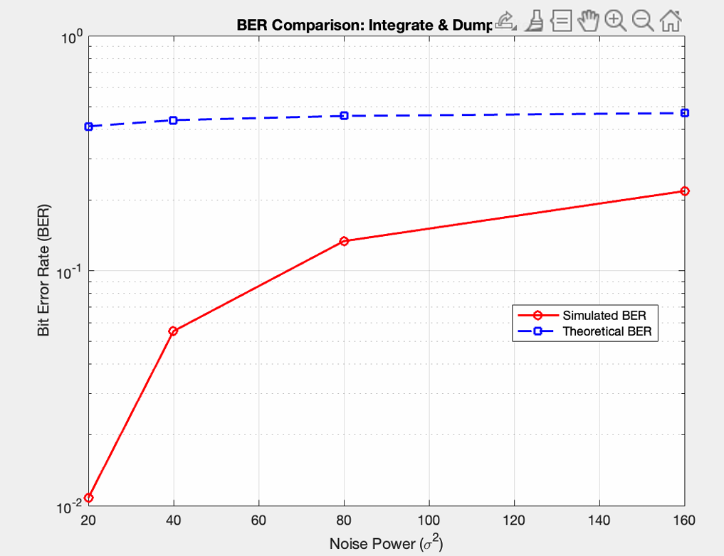
f) How much would the amplitude of the transmitted pulses need to be increased in the case of the simple detector (with only a sampler) to match the performance of the detector with the Integrate&Dump filter?
The amplitude of the pulses in the simple sampler would need to be increased by √T

g) Include the Discrete Eye Diagram Scope block from the Communications Toolbox in Simulink to visualize the eye diagram at the input of the decision-maker for and . What is the decision instant that minimizes the error probability? Justify your answer.

Save the MATLAB/Simulink code file with the following name:
y_T6
where y corresponds to the student number.

