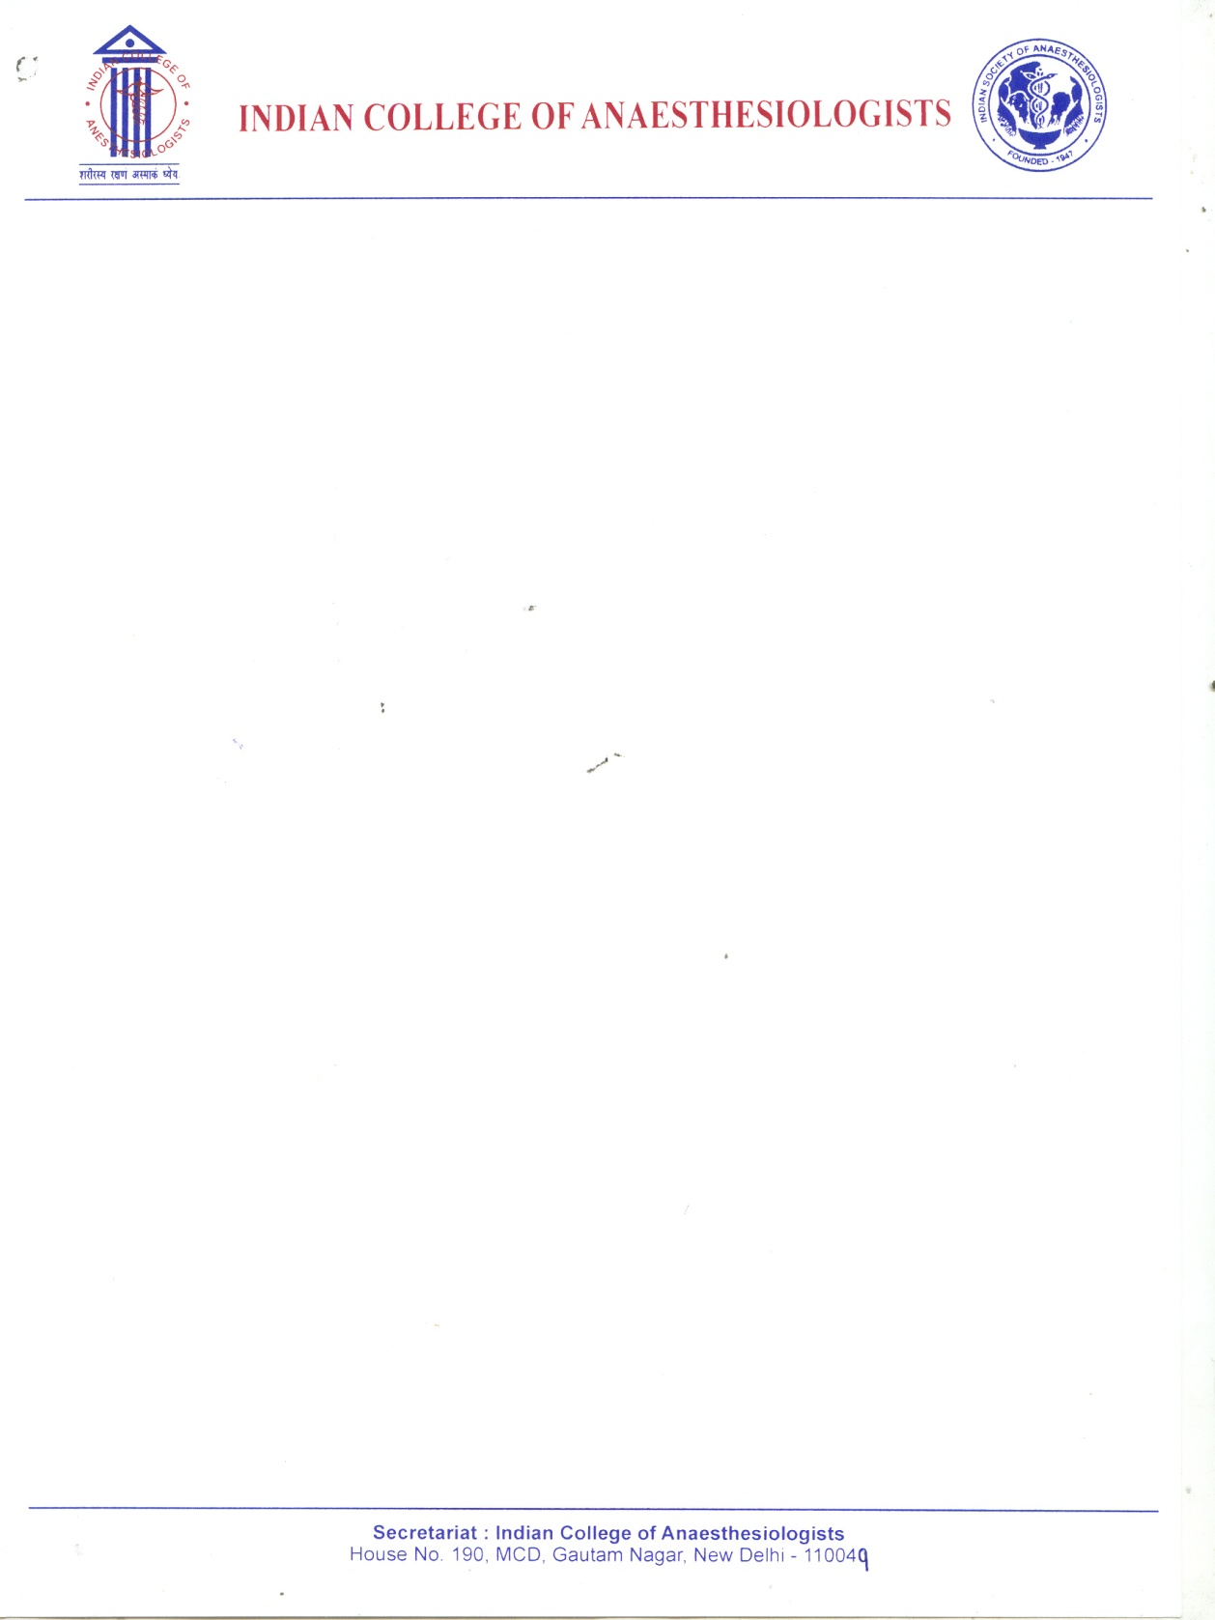 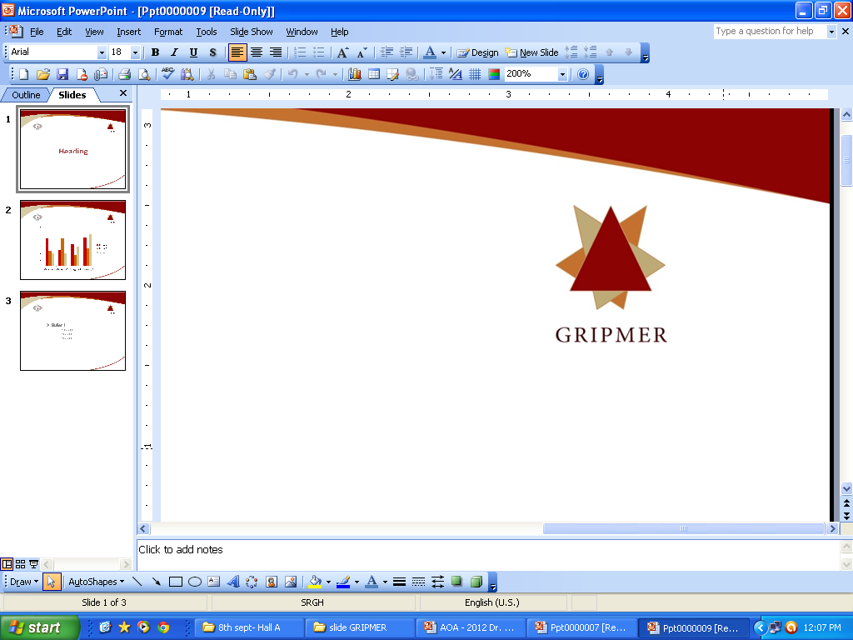  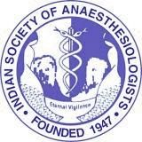

**ANAESTHESIA UPDATE 2016  
*Under the aegis of*  
“Indian College of Anaesthesiologists”  
‘Sub-specialty Anaesthesia:**

**Applied Sciences & Case Didactics’  
 Sunday, 31st January 2016**

***8:00am to 6:00pm***

***Organised by***

**Department of Anaesthesiology, Pain and Perioperative Medicine**

**Sir Ganga Ram Hospital, Rajinder Nagar, New Delhi –110 060**

**Venue: Auditorium, Sir Ganga Ram Hospital, New Delhi**

##### Registration Form

Name: ………………………………………………………………………………………………….......

Designation: ………………………………………………………………………………………………

Institution: ………………………………………………………………………………………………...

Contact No: ……………………..………………………………………………………………………..

E-mail: ……………………………………………………………………………………………………

# REGISTRATION FEE:

# Upto January 20, 2016 : Rs. 500 /- After January 20, 2016 : Rs. 1000/-

***Mode of Payment* :** Cash / Cheque / Demand Draft

*(Payment by Draft / Cheque in favour of* ***“ Department of Anaesthesiology, SGRH ”***

*payable at New Delhi)*

Cheque / D.D No.: Drawn on: Amount:

**For online registration:** Beneficiary Bank : Syndicate Bank, Sir Ganga Ram Hospital, New Delhi -110060

A/C No. 91111010001732 Bank IFSC Code SYNB 0009111

***Secretariat:***

Dr. Bimla Sharma, Organising Secretary

Dr. Shikha Sharma, Co-organising Secretary

*‘Anaesthesia Update 2016’*

Department of Anaesthesiology, Pain and Perioperative Medicine

Sir Ganga Ram Hospital, Rajinder Nagar, New Delhi –110 060.

Teleph. (Off): 011-42252513, Mobile: 9810135366, 9810382283

E-mail: [anaesthesiasgrh@gmail.com](mailto:anaesthesiasgrh@gmail.com), Website: www.sgrh.com

***Signature***