1. { x : 3 , y : 4 } Into the temperature collection for the test database.

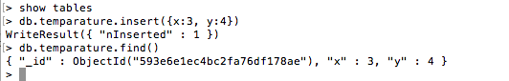

It must exist in every document

It must be unique inside the collection

It is automatically Indexed.

1. What operations could cause an existing document to be moved on disk? Check all that apply.

It will assign the document an ObjectId for its _id field, and then insert it.

1. Description: We have initialized documents in the user’s collection of the form: { _id : ObjectId("50897dbb9b96971d287202a9"), name : "Jane", likes : [ "tennis", "golf" ], registered : false, addr : { city : "Lyon", country : "France" } }

Delete all documents in the collection where city is "Lyon" and registered is false.

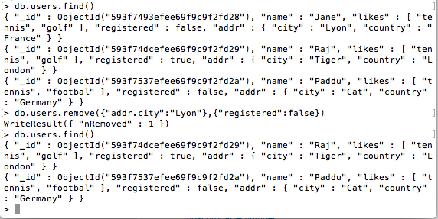

db.users.remove({"addr.city":"Lyon"},{"registered":false})

1. Which of the following are disadvantages to setting multi=false (as it is by default)?

Updates that the user may have intended to match multiple documents will exit prematurely, after only one update

1. Description: We have initialized documents in the user’s collection, one of which is the following: { _id : "Jane", likes : [ "tennis", "golf" ], registered : false, addr : { city : "Lyon", country : "France" }

In the shell, add that this user likes "football". You should not need to pass "tennis" or "golf" to the update query at all. What are the basic building blocks of the wire protocol? Check all that apply.

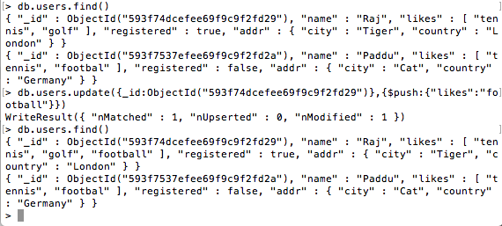

Update is required.

db.users.update({_id:ObjectId("593f74dcefee69f9c9f2fd29")},

{$push:{"likes":"football"}})

1. Which of the following are user commands (as opposed to admin commands)? Check all that apply.

Count, Aggregate, MapReduce, FindAndModify

1. When running the command db.serverStatus() in the shell, what does the “ok” field represent?

That the command was sent and received properly by the mongod

1. If you’re looking for problems with database performance, what is a good place to look, when you run db.currentOp()?

“secs_running”: (look for long times)

1. db.collection.remove({}), which removes all messages in a collection, is it the same as db.collection.drop(), which drops the collection?

False

1. Which of these statements is true?

In MongoDB collections are usually created implicitly.