**Steps to create bucket and transfer files from local to GCS using gsutil**

1. Open the Cloud Storage browser in the Google Cloud Console.
2. Click **Create bucket** to open the bucket creation form.

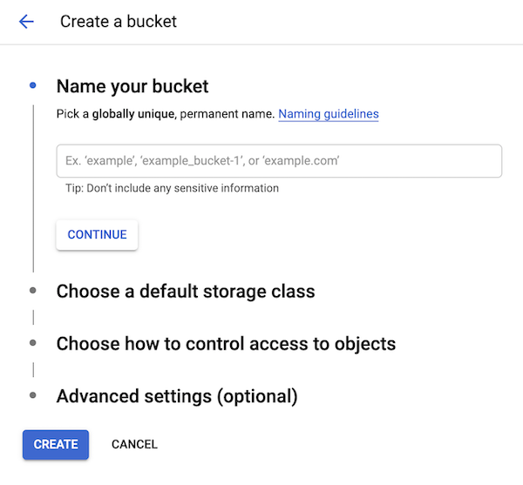

1. Enter your bucket information and click **Continue** to complete each step:
   * Enter a unique **Name** for your bucket.
     + Do not include sensitive information in the bucket name, because the bucket namespace is global and publicly visible.

▸See bucket naming requirements.

* + Choose **Standard** for **Storage class** and **us-east1 (South Carolina)** for **Location**.
  + Choose **Set object-level and bucket-level permissions** for **Access control model**.

1. Click **Create**.

**Transfer files from local storage to GCS using gsutil**

Use the following command to upload a file from your local computer to your Google Cloud Storage bucket

gsutil cp local-location/filename gs://bucketname/

You can use the -r option to upload a folder.

gsutil cp -r folder-name gs://bucketname/

You can also use the -m option to upload large number of files which performs a parallel (multi-threaded/multi-processing) copy.

gsutil -m cp -r folder-name gs://bucketname