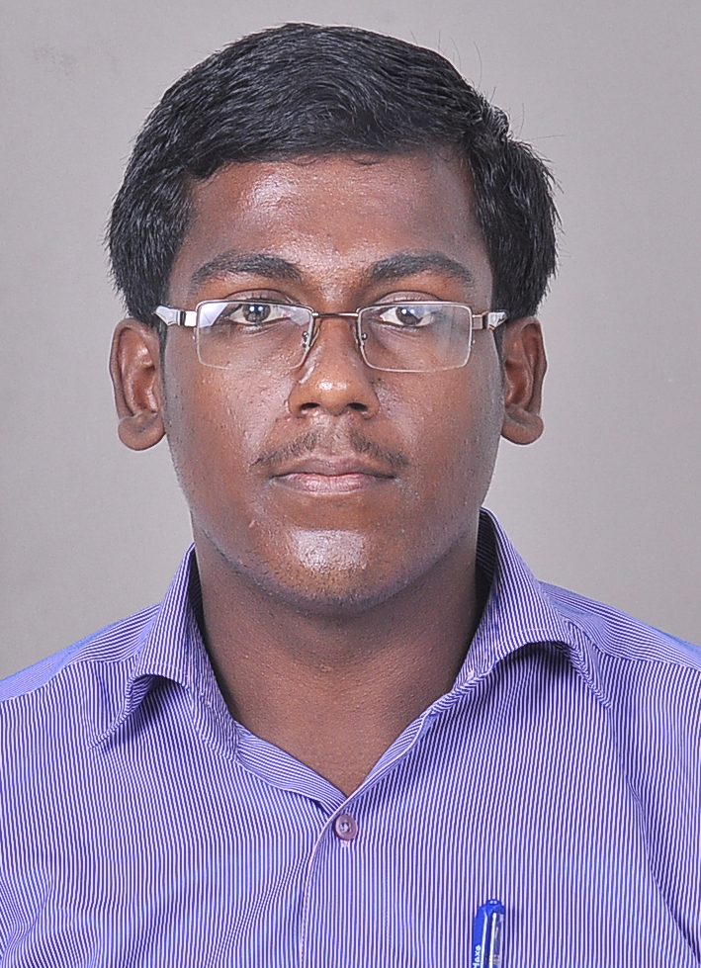
A.RAJASEKAR
8903619178
rajasekar03101997@gmail.com.
16M, sakthi Nagar,
Near Hollycross School,
Salem.

Objective

To pursue an ambitious job in an Organization where I learn, search and follow through my skills for my career exploitation and growth of the Organization.

Qualification:
Examination | School/college | Year of passing | Percentage
B.Tech | KSR institute for engineering and technology | 2012-2016 | 65%
H.S.C | Sakthi Matric Hr.Sec School | 2010-2012 | 75%
S.S.L.C | Sakthi Matric Hr.Sec School | 2009-2010 | 86%

Career Summary:
2 years experience in the content writing field at Glassynet company. Good in coordinating with seniors and taking orders. Excellent in analysis, ratings and forecasts and rigorous benchmarking of the business environment.
Personal Qualities:
- Strong motivational skills.
- Ability to give the best result in Critical Situations.

Key Roles & Responsibility Handled:
- Implementing suggestions in the plan.
- Ensuring that work should be done on time.

Achievements as an Employee:
- Receive much appreciation for Excellent work
- Done work on Time(TAT)
Area of interest: Computers, Photoshop, Aftereffects
Mini-Project: CGPA Calculator
Main project: Online Student Feedback Form
Seminar: Attend a Seminar on “Recent Trends in Information Technology “that was held at Selvam College of Technology, Namakkal.
Workshop Attended:
- One-day workshop on “BIGDATA & ORACLE” organized by Microsoft Research community held at Chennai
- One-day workshop on “CLOUD MIDDLEWARE & VIRTUALIZATION” organized by department of Information technology held at University College of Engineering, Villupuram
- One-day workshop on “MULTIMEDIA” organized by department of Information technology held at KSR Institute for Engineering and Technology, Villupuram
- One-day workshop on “PHYTON & GOOGLE APPS” held at VIT University, Vellore
Paper’s Presented:
- Presented a Paper on “CLOUD COMPUTING” held at University College of Engineering, Villupuram.
- Presented a Paper on “CLOUD COMPUTING BASED ON P2P” organized by INARR & CIU held at India International Center, New Delhi.
In-Plant Training: Poras Technology, 207 Gandhipuram, Coimbatore & Kaashiv InfoTech, Anna Nagar, Chennai.
Certification:
- Completed “BEC Preliminary” course in Cambridge University.
- Completed “CISCO CERTIFIED NETWORK ASSOCIATE” course in IT Gateway Solution.

Student Membership:
- DIGITA (Department Association) & ISTE chapter (Indian Society for Technical Education).
Achievements:
- Awarded for 100% attendance during 1st, 2nd, 3rd, 5th and 6th semester.
- Awarded for “LIMCA BOOK OF RECORDS & WORLD RECORD” organized by Kaashiv Infotech Team held at Coimbatore.
Leadership skills:
- Acted as OFFICE BEARER in Department Association during the academic year 2013-2014.
- Acted as CLASS REPRESENTATIVE during the fourth Semester.
- EVENT ORGANIZER in SPRING FEST 2k13 Symposium.
Personal Details:
Parents’ Name : Mr.A.Anbu Dhasan & Mrs.A.Indira Gandhi
Date of Birth & Age : 10.03.1993 & 28 years
Strength : Optimistic
Languages known : English &Tamil

Signature

(Raja Sekar A.)

