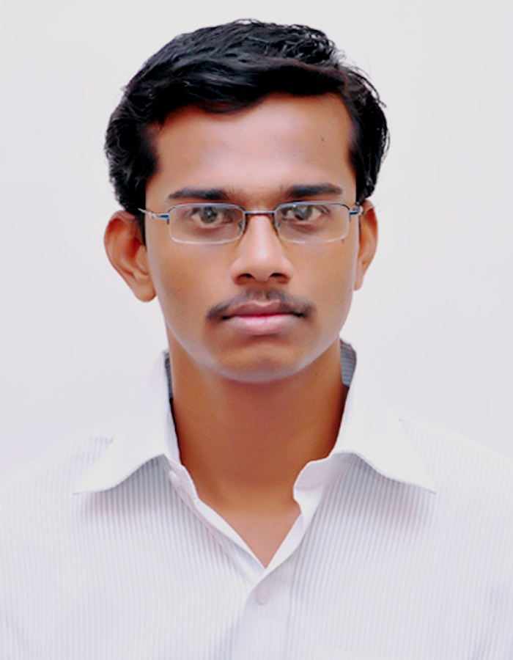

PRABHU

Address :  No.10, 7th cross, Brindhavanam,  Pondicherry – 605 013.  India | Mobile Number : +0091-7339618912  EMAIL Id : prabhu12.prabhu12@gmail.com

Career Profile

Objective
Seeking an environment, which will help me to enhance my knowledge and allow me to prove my capabilities towards the growth of organization and satisfaction thereof.
Educational Qualification
Bachelor Of Computer Application (BCA)

System engineer From Indian Institute of Hardware Technology, IIT-Bangalore

Diploma in Information Technology.

EXPOSURE TO COMPUTER
Computer Application | Microsoft office (word,excel,Power point,access,outlook express)
Operating Systems | All Windows os,mac,redhat linux
Technical skills | installation of all software, troubleshoot, LAN & WAN connect
Computer language | Visual Basic, c,c++,java,

work experince

- Mphasis an hp company (5 Years) Experience.
- Acer Technology 3 years Experience

previous work position

Acer Technology in Technical Support Executive executive(TSE) & Management information system(MIS) Executive.

Mphasis an hp company in customer support officer(CSO).

EDUCATIONAL QUALIFICATION

Qualification | Name Of the Institution | Year Of Passing | % Of Marks
BCA | DR.C.V.RAMAN UNIVERSITY | 2012 | 71.66%  1st Class
System Engineer | Indian Institute of Technology(hardware & networking),  (Affiliated To IIT-Bangalore) | May 2008 | 90.00% &  A GRADE
Diploma in IT | Tcps Info Tech  (Affiliated To NLPC & An ISO Certified) | Jun 2007 | 79.77%
H.S.C | State Board of School Examinations | Mar 2006 | 56.41%
S.S.L.C | State Board of School Examinations | Apr 2004 | 76.20%

PERSONAL DETAILS

Sex | MALE
Father Name | KANDHI SRINIVASAN
Mother Name | INDRABAYE
Nationality | INDIAN
Reglion | HINDU
Date Of Birth | 12.06.1987
Martial Status | SINGLE
Passport Number & Type | J5783182 & ECNR Passport
Blood Group | B POSITIVE
Ethnic identity | INDIAN

DECLARATION:

I hereby declare that the above mentioned facts are true to the best of my knowledge.

DATE :

PLACE: PRABHU

