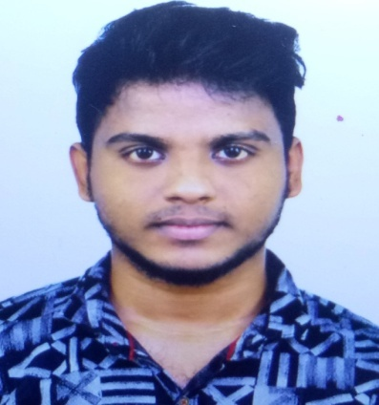
NAME : SANTHASEELAN.S
E-MAIL : shanthsr24@gmail.com
PHONE : 7358661039
ADDRESS : NO. 5 a, Duraikannu salai,
old pallavaram,
Chennai-600117.

CARRIER OBJECTIVE:

To work in a challenging and competitive environment and to use all the skills and competencies to achieve self-developmental as well as organizational goals.
ACADEMIC PROFILE:

COURSE | % | PASSED OUT YEARS | INSTITUTE/  SCHOOL | UNIVERSITY/  BOARD
BE (ECE) | 62 | 2020 | Jerusalem college of engineering | Anna university
Class XII | 71.2 | 2016 | St.Vincent Pallotines mat.hr.sec School | Stateaboard
Class X | 87.2 | 2020 | Good shepherd mat.hr.sec.School | StateBoard
TECHNICAL SKILL SET:

- Languages/Technologies: CoreJava, Automation Testing.
- Development tools : Eclipse IDE, Selenium Webdriver-Eclipse.
- Version Control tool : GIT.
- Operating System : Windows 7,8,10.
- FrameWorks : POM, JUnit, TestNG, Data Driven, BDD-Cucumber.
- Domain Knowledge : E-Commerce.
PROFESSIONAL SUMMARY:

- Trained Software Proficiency in Core Java.
- Good experience in Automation Testing using Selenium WebDriver with java Programming.
- Good knowledge in taking X path in all ways.
- Experience on developing a framework using a design pattern- Page Object Model.
- Trained in working with BDD Framework using Cucumber tool.
- Good Experience in DataDriven framework.
- Excellent interpersonal skills,and ability to work in a new environment with others.
- Strong team player with good communication, analytical and problem solving skills.
CERTIFICATION:

- Certified Core Java and Software Testing Training in Green’s Technology
PROJECT WORK:

- Toxic Gas Detection and Monitoring in Sewage using NODEMCU.
- Description: This project describes about the safety system to overcome the gaseous hazards in sewage.
WORKSHOPS AND INTERNSHIPS:

- Workshop on PCB Design and Fabrication at Jerusalem College of Engineering, Chennai.
- National level Workshop on IOT at Jerusalem College of Engineering, Chennai.
CO-CURRICULAR AND VOLUNTEER ACTIVITIES:

- Member of NSS in our college, along with that I have attended various camps and done many social services and also received best volunteer award.
- District level football player and college football team captain.
- Participated in various Inter college Tournaments for our college football team.
PERSONAL DETAILS:

Father’s Name : A.Sathiyaseelan
Mother’s Name : S.RathiDevi
Date Of Birth : 25-05-1999
Gender : Male
Nationality : Indian
Languages Known : English,Tamil.
DECLARATION:

I hereby declare that all the information furnished above are true to the best of my knowledge.
Place: Chennai
Date:
(SANTHA SEELAN S)

