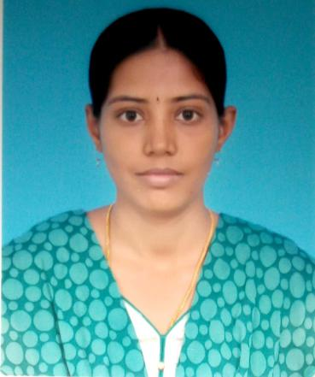  VISHNUPRIYA S  Android Developer  vishnupriya.sa@gmail.com  PH - 9941944376  Contact Address:  2/1-B, First Main Road,  Kalaimagal Nagar, Ekattuthangal,  Chennai-600032  Personal Data:  DOB: 07/05/1991  Sex: Female  Nationality: Indian  Marital Status: Married  Languages Known: Tamil, English, Telugu  Potential:  Smart Worker,  Adaptability,  Knowledge and  Focus on work, Communication. | OBJECTIVE  Looking for innovative, challenging employment that will utilize  my professional skills and offer advancement opportunity.  EDUCATION  2017-2019 - MCA at Mahendra Engineering College Salem. Affiliated by Anna University Chennai. With an aggregate of 82%.  2009-2012 - B. Sc Information Technology at Gobi Arts and Science College  Gobichettipalayam, affiliated by Bharathiar University Coimbatore. With  an aggregate of 78%.  2008-2009 - H.S.C in Govt High School with an aggregate of 72%.  2006-2007 - S.S.L.C in Govt High School with an aggregate of 82%.  TECHNICAL SKILL  - Android development and architecture.  - Core Java, MS SQL, Firebase Database.  - App Publishing (Play Store & App Store).  - GIT version control implementation.  - Innovating new things in Applications.  AREA OF INTEREST  - Mobile Application Development  TRAINING  - Android mobile App Development course Completed in SSSI Computer  Education from May-2018 to July-2018 (3 months).  - Certificate course in Web Page Designing in Bharathiar University held  In May 2010.  .
WORK EXPERIENCE
- Presently working as Associate-Technical in Botree Software International Pvt Ltd from August 2021 to till.
- Worked as a Software Engineer in Selfservit Solutions Pvt Ltd from August 2018 to March 2021.
- Worked as a Sub Editor in NEWS Department in Raj Television from the period of August 2012 to January 2015.

JOB RESPONSIBILITIES
- Analysed the possible solutions using my experience, judgement and precedents.
- Creating the more Flexible Application for customer satisfaction and user-friendly to end user.
- I take full Responsibility for Creating the application and publishing in Play store and Appstore
- Experience for creating the Mobile Application development and give the best quality of product.
- Gathering the requirements from the client give my best Application for them.
- I give my best dedication in my work and delivered the Application on time.
- Handling the trouble shooting the bugs and code enhancements.
- Independently manage the full Application process with my skills and experience.

PROJECT EXPERIENCE
Application: Customer App (L&T Equipcare, My Schwing, Powercare, My Dealer Quest, etc.)
- This application is developed the purpose of the large manufacturing Industries and their client (Who bought the machines in that industry).
- Customer to track their Machines performance and monitoring the operator performance and their current location.
- Customer can add the operator and their location by using this Application itself and link the operator to some machines and track the machines.
- If any problem occurred in machines (or) any machine parts are needed, Customer can create their complaint against their machines. An Industries saw their complaints and solve the problem Immediately.
- Firebase server used for stored their database and Android Studio is used for development.
- This product is also developed for engineer support, Knowlegebase is provided for service engineering shared them experiences (like audio, video, image, and document format).
- Push chat also provided for raising the tickets against their machine. Against the ticket chat will enable for rectify the doubts each other’s.

DECLARATION

I hereby declare that the above information is true to the best of my knowledge and belief.
Yours truly,
Place:
Date: (Vishnupriya.S)

