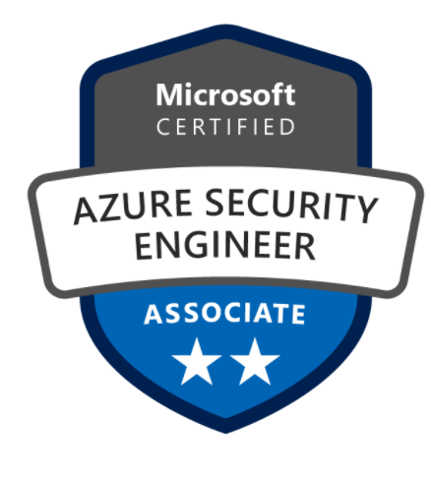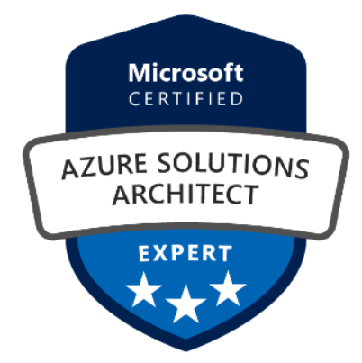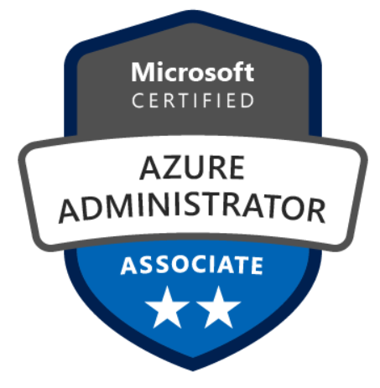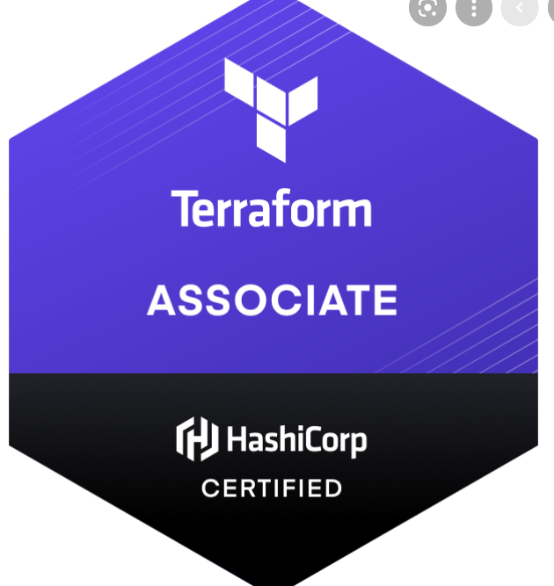
Vivek.M
Contact: 8807867149 | E-Mail: vivekmurugan28@gmail.com

An accomplished professional, seeking challenging assignments in an organization and to become an integral part in IT industry

PROFILE SUMMARY

- 5 years of experience in handling AZURE Infrastructure Admin / Azure Security , Windows admin, Incident Management, Problem Management, Root Cause Analysis, Reporting & Documentation.
- Handled a team of 6 members as a Shift Lead and guided them to perform their roles properly.
- Ensure Incident Management response and resolution in SLA
- Performing end-to-end incident& problem management. Responsible for time-critical User Service/ Infrastructure restoration, technical troubleshooting within complex IT systems environment. Working with customers, internal IT, infrastructure teams and third party data providers throughout the service restoration process.
- Documented and tracked the timeline of events that occurred in the process of resolution of each incident and helped the support them for identifying the root cause analysis.
- Managing weekly Change Advisory Board (CAB) meetings. Ensures that all CAB meetings are scheduled and facilitated effectively, including the timely generation and distribution of meeting agendas and minutes.
- Expertise in monitoring and troubleshooting the critical incidents.
- Expertise in production support, Coordinating Incident Bridge calls for quick and prompt resolutions.
- Strong ability to communicate clearly and appropriately with executive and management level business partners, non-technical end users, technical subject matter experts and vendors.

CORE COMPETENCIES

- Incident Management
- Root Cause Analysis
- Troubleshooting
- High Priority Incidents
- Windows Activities
- Terraform
- Cloud Security

ORGANIZATIONAL EXPERIENCE

July 2020- Present | Nokia Solution Pvt.Ltd
Type: Azure Cloud Security Engineer
Tools & Environment: Azure Terraform and Dev-ops Support
Role & Responsibilities: Cloud Administrator for Azure and Azure Security Specialist.
Responsibilities: Azure Security Specialist and Azure Automation

- Experience in Azure Security Center
- Experience on Azure Terraform deployment
- Configuration Qualys or similar cloud threat protection products
- Creating custom templates and rules,
- Data connector configurations using Sentinel
- Azure Security Center deployment
- Configuration on Security policies,
- Configuration on security alerts
- Configuring cloud security posture management
- Perform security assessments of Azure recommdation
- Experience on Vulnerabilities report
- Configuration on azure automation account
- Analyze security requirements for cloud implementation and integration
- Application Gateway
- Azure Load Balancers
- Azure Key Vault
- Experience working with cloud security and governance tools and server virtualization technologies.
- Data protection, cryptography, key management, identity, and access management (IAM), network security)
- Azure Logic App
- Configuration and creation for Custom Policies
- Azure blue print
- Experience on HUB and Spoke

Nov 2019- June2020 | ILink Systems Pvt Ltd.
Client:Prolifiq Pvt.Ltd
Type: Infrastructure support and management
© Hexaware Technologies Limited. All rights reserved.
Tools & Environment: Azure and Dev-ops Support
Role & Responsibilities: Cloud Administrator for Azure and Monitoring VMware admin.
Responsibilities: AZURE Infrastructure Admin
- Creating and managing the IAM users, groups, Roles, Policies.
- Managing Ansible controller
- Configuring Ansible and managing.
- Help Development Teams automate the environment setup using Ansible
- Installing and configuration of Jenkins CI tool.
- Server maintenance activities.
- Writing Python scripts(using YAML) with Cloud Formation templates to Automate installation of Auto scaling, EC2, VPC, and other service
- Support regarding CI/Build tools, Environments and Automation.
- Creating and managing the VNET. (Peering, Subnet Creation, NSG configuring)
- Experience in migration the Virtual machine form on premises to Azure.
- Configuration site to site and point to site connectivity.
- Creating and managing the Azure VM’s,
- Configuring and managing the Availability set.
- Having Knowledge on Azure DNS.
- Configuring the Load balancer.
- Configuring and managing the Traffic Manager.
- Creating and Configuring the Azure Backup.
- Creating and configuring the Azure Storage. (Blob, Table, Queue).
- Configuring the Azure Recovery and replication options.
Having Knowledge in Azure AD services.

March 2018– May2019| Hexaware Technologies Pvt. Ltd. Chennai.
Client: Kerzner& POMS(Cloud Project)

Kerzner:
The Company's gaming business is focused on owning, developing or managing casino properties in attractive markets where the Company can capitalize on its development and operating expertise.
POMS: Post Office Management System he implementation of this system in postal department improves the process of work and manages work more effectively. It makes it easier to handle post details, money order details, sales and bills, subscriber details, and much more.

Type: Infrastructure support and management
© Hexaware Technologies Limited. All rights reserved.
Tools & Environment: Azure and VSphere
Role & Responsibilities: Cloud Administrator for Azure and Monitoring VMware admin.
Responsibilities: AZURE Infrastructure Admin
- Creating and managing the IAM users, groups, Roles, Policies.
- Creating and managing the VNET. (Peering, Subnet Creation, NSG configuring)
- Experience in migration the Virtual machine form on premises to Azure.
- Configuration site to site and point to site connectivity.
- Creating and managing the Azure VM’s,
- Configuring and managing the Availability set.
- Having Knowledge on Azure DNS.
- Configuring the Load balancer.
- Configuring and managing the Traffic Manager.
- Creating and Configuring the Azure Backup.
- Creating and configuring the Azure Storage. (Blob, Table, Queue).
- Configuring the Azure Recovery and replication options.
- Having Knowledge in Azure AD services.

Responsibilities: Monitoring Windows Admin.
- Creating and managing DNS records.
- Installing and configuring windows server 2008/2008R2/2012R2.
- Managing DNS server and creating records.
- Configuring and Managing the DHCP server.
- Configuring and Managing Printer server.
- Creating and Managing the OU.
- Checking disk space alert
- Creating a Backup using Veembackup console
- Monitoring the All the Virtual Machine memory utilization.

Tool Used:
- Solar winds
- Veembackup
- Service Aide

FEB 2016– March 2018 | HCL Technologies Pvt. Ltd. Payroll of Adecco info Tech Chennai.
Client: Western Union Business Solutions
Western Union Business Solutions is a business unit of The Western Union Company. WUBS is a global leader in foreign exchange and international payments. Enable companies of all sizes to send and receive cross-border payments and manage their foreign exchange needs.
Tool Used:
- Nagios
- SCOM
- Harbor Net
- Solar Winds
- Cherwell
- ION
- NNMI
- AMT

Key Result Areas: Incident Management:

- Monitoring the successful completion of the jobs daily which were scheduled for accurate flow of data from one application to another.
- Addressing the issues raised by the Users/helpdesk/NOC and resolving them within the SLA.
- Coordinate cross department communications when required to assist in resolution of Incidents/ Problem/ Changes.
- Follow-up on escalations and issue tracking.
- Ensure that the correct Technical teams are engaged and proper focus is paid to outages and recovery.
- Responsible to ensure Severity 1 & 2 SLA's are met. Ensure proper management of Sev1 & Sev2 queries/ monitoring.
- Send Alert notifications to the Site Support and the Monitoring teams about any network related issues.
- Provide updates to the Management of daily outages.
- Developed a top 10 server incident list monthly remediation plan reducing repeating server repeat incidents by 60%.
- The core role was to keep the applications and the servers up 24/7 and to be in touch with administrators and users to help them and to resolve server and application related issues.
- Understanding the issues and involve the technical teams for troubleshooting.
- Preparing chronology &notifications for severity incidents and sending them to the business.
- Preparing & documenting change reports on every weekend.
- Preparing root cause analysis for the incidents occurred for further documentation.
- Weekly call with NOC team and discuss with management on every week Tuesday
- Daily meetings with management for Incident Auditing & problem tickets for all the tracks.
- Coordinated cross functional meetings to determine root cause of problems and improve workflow processes.
- Partnered with multiple groups to implement solutions of known errors and increase efficiencies.
- Reduced costs by over 20% by eliminating reoccurring incidents from the IT environment and reducing the call volume.
- Implemented enhancement in problem analytics specifically in root cause determination, data analysis and problem trending.
- Collaborated with cross functional teams and vendors to create a quality root cause analysis to minimize repeat failures.
- Optimized Problem Management service to deliver quality outcomes that lead to high levels of customer satisfaction.
- Maintained appropriate Problem Management training material and process documentation.
- Identified and implemented improvements to services by enhancing the linkage with other ITSM services.

- Apr’15– Feb’16 | NITYO info tech client CITI crop service Indian pvt.ltd.in End user configuration and LAN Engineer
Client: CITI crop service Indian pvt.ltd
project has installed in 400 users- pointsec is an enterprise security solution which protects data at rest on a mobile device against intrusion by employing the use of strong authentication and encryption and Point sec encrypts the entire disk sector-by-sector, including the system files, temp files, and even deleted files.
Key Result Areas:

- Monitor the alerts, create the ticket and assign the ticket to the tracks accordingly.
- Daily activities include checking email alerts, Notification mails and creating tickets to the concerned team based on the alerts.
- Address various L1 issues and resolve the incidents within the SLA.
- Prepare all daily, weekly incident reports and send it to the management.
- Regular scheduling of weekly meetings and discuss on handling the incidents with the team.
- Preparing & documenting change reports on every weekend.
- Preparing root cause analysis for the incidents occurred for further documentation.
- Assigning and Managing the ticket volume among the team
- Managing user accounts, groups, print queues and controlling access rights using Active Directory.
- Coordinating with various vendors like HP, Lenovo, Dell for hardware related issues.
- Managing Software and Hardware Inventory
- Using AD – Creating User account, Creating and giving permissions for Home folder and share folders
- Patch updating using Windows update WSUS
- Disk Quota enabling
- Running daily DCFC.

Certificate

70-533 Implementing Microsoft Azure Infrastructure Solutions certified.
AZ-500 Cloud Security certified.

EDUCATION

- B.E (ECE) from SKP Institute of Technology , Anna University, chennai with 62% in 2014
- Diploma (ECE) from DR M.G.R Polytechnic college Arani in 88 % in 2011
- 10th from Town Matriculation Higher Secondary School, Polur with 58% in 2008

IT SKILLS

- Operating System: Windows XP, Window 7, 8.8.1 / Linux
- Networking Technologies TCP/IP, ADS, DHCP, DNS, Citrix – XEN, VDI
- Antivirus Tool McAfee (Scanning virus over the network)
- Ticketing Tools Service Now, Resolve IT, ION ,Ipass,cherwell,
- Messaging MS Outlook client configuration and support
- Remote Tool Net meeting, VNC Viewer, Ultra VNC, Web – EX and RDP
- Hardware HP, IBM, Lenovo, Dell
- Monitoring Tool SCOM, Habornet, Nagios, solarwinds,AMT NNMI

IT’S Project Involvements in CITI BANK

project has been completed in 500 pc -wipe utility ensures the complete elimination of confidential data by overwriting every sector of the host hard drives. This product also wipes and erases data from external/removable hard drives, diskettes, memory cards, and USB drives

PERSONAL DETAILS

Date of Birth: 28thSeptember 1992 | Languages Known: English, Tamil

