
Mini Project Using Java (MPJ) Report
On
Smart Parking Management with Real-Time Slot Tracking, Surge Pricing, QR-Based Mobile Check-In and Fine Management
By
Raj Modi
PRN No.: 1032232965
Aaditya Sinha
PRN No.: 1032232955
Rohit Harishchandre
PRN No.: 1032232803
Levinesh GR
PRN No.: 1032232546

Under the Guidance of
Prof. Suhas Joshi

Dr. Vishwanath Karad MIT World Peace University
School of Computer Science & Engineering
Department of Computer Engineering & Technology
* 2025–2026 *
 Dr. Vishwanath Karad MIT World Peace University
School of Computer Engineering & Technology
Department of Computer Engineering & Technology
CERTIFICATE
This is to certify that Mr. Raj Modi of T.Y. B.Tech., School of Computer Engineering & Technology, Department of Computer Engineering & Technology, CSE-AIDS, Semester – VI, PRN No. 1032232965, has successfully completed Mini Project Using Java (MPJ) on
"Smart Parking Management with Real-Time Slot Tracking, Surge Pricing, QR-Based Mobile Check-In and Fine Management "
To my satisfaction and submitted the same during the academic year 2025–2026 towards the partial fulfillment of degree of Bachelor of Technology in School of Computer Engineering & Technology under Dr. Vishwanath Karad MIT-World Peace University, Pune.

____________________ Dr. Balaji Patil
Faculty: Program Director
Prof. Suhas Joshi Department of Computer Engineering & Technology

Smart Parking Management with Real-Time Slot Tracking, Surge Pricing, QR-Based Mobile Check-In and Fine Management

ACKNOWLEDGEMENT
Building a complete, dual-interface smart parking management system within one academic semester demanded sustained effort, sound engineering decisions, and support from many quarters, and the team is sincerely grateful to all who contributed.
Our deepest appreciation goes to our project guide, Professor [Guide Name], whose consistent technical direction, critical feedback on concurrency design and database architecture, and encouragement during difficult debugging phases kept the project on track. His guidance on thread-safe programming and surge pricing algorithm design significantly elevated the quality of the final system.
We acknowledge the faculty of the Department of Computer Engineering & Technology at MIT World Peace University, Pune, for building a strong foundation across Java programming, database management, object-oriented design, and software engineering principles. Concepts from every course found direct application in this project.
We are grateful to MIT World Peace University for providing laboratory infrastructure, library resources, and the academic environment that enabled us to independently design, build, and test a production-oriented parking management platform without any commercial budget.
The open-source ecosystem made this project feasible. We acknowledge the contributors behind JavaFX, jBCrypt, the ZXing QR code library, the Neon cloud PostgreSQL platform, and the maintainers of every library referenced in our Maven pom.xml.
Finally, our families, friends, and classmates — thank you for your support and enthusiasm.

Team: SnapPark
Raj Modi PRN: 1032232965
Aaditya Sinha PRN: 1032232955
Rohit Harishchandre PRN: 1032232803
Levinesh GR PRN: 1032232546

ABSTRACT
Urban parking scarcity and the inefficiency of manual management place a measurable operational burden on facility supervisors and vehicle owners alike. SnapPark addresses this directly by delivering a complete, software-defined parking management platform built in Java 21. The system pairs a JavaFX desktop kiosk — operated by facility staff for vehicle entry and exit — with an embedded HTTP server on port 8080 that serves mobile-optimised web pages to vehicle owners through a QR code scan, requiring no application installation.
The application is built entirely in Java 21, with a JavaFX desktop kiosk for staff and an embedded HTTP server on port 8080 serving mobile-optimised web pages to vehicle owners via QR code. A Neon cloud-hosted PostgreSQL database persists all operational data across seven tables. Four distinct user roles — Admin, Manager, Attendant, and Vehicle Owner — each interact through purpose-built interface flows.
The surge pricing engine implements six time-of-day tiers and four occupancy tiers, producing dynamically adjusted fees with two-decimal precision and a fifteen-minute complimentary grace period. Concurrent slot access is managed through a ConcurrentHashMap-based lock manager with a five-minute timeout and an automatic expiry-sweeping daemon thread, eliminating the possibility of double slot assignment under simultaneous attendant access.
Key outcomes include six time-of-day pricing tiers, four occupancy pricing tiers, a four-criteria weighted slot recommendation engine, a 36-state Indian license plate decoder covering all RTOs, a three-category fine management module, BCrypt-hashed role-based authentication, QR-based smartphone access without any app installation, and a live Neon PostgreSQL backend. The project demonstrates that genuinely complex concurrent Java systems are achievable by a student team applying disciplined engineering practice.

LIST OF TABLES
Table 1— Business Pain Points and Operational Impact 3
Table 2— Excluded Features and Planned Phases 5
Table 3— Measurable Goals and Results Achieved 6
Table 4— Architecture Component Table 8
Table 5— Data Flow Steps 8
Table 6— Tools and Technologies by Category 10
Table 7— Project Work Distribution 11
Table 8— Surge Pricing Engine — Time-of-Day Tiers 12
Table 9— Occupancy-Based Pricing Tiers 13
Table 10— Slot Recommendation Scoring Criteria 14
Table 11— Fine Types and Amounts 15
Table 12— Business Use Cases 16
Table 13— Technical Challenges and Resolutions 22
Table 14— Resource Limitations 23
Table 15— Performance Metrics 26
Table 16— Database Schema — parking_sessions table 31
Table 17— Database Schema — transactions table 32
Table 18— Database Schema — fines table 33
Table 19— Demo Credentials 33
Table 20— Key REST Endpoints — Embedded Web Server 34

LIST OF FIGURES
Figure 1— SnapPark System Architecture 7
Figure 2— Vehicle Entry and Exit Data Flow 9
Figure 3— Surge Pricing Engine Diagram 12
Figure 4— Concurrent Slot Lock Manager 14
Figure 5— SnapPark Dashboard Screenshot 16
Figure 6— Screenshot of Admin Dashboard 24
Figure 7— Screenshot of Vehicle Entry Screen — plate decode result, recommended slot cards with scoring breakdown, and live surge tier label 25
Figure 8— Screenshot of Analytics Dashboard — revenue by vehicle type, session count trend, and occupancy heatmap 25
Figure 9— Screenshot of Mobile QR Check-out Screen — exit PIN input, fee breakdown with surge multipliers, fine summary, and total due 25

INDEX
TOPICS PAGE NO.
1. Cover Page i
2. Certificate ii
3. Acknowledgement iii
4. Abstract iv
5. List of Figures v
6. List of Tables vi
7. Index vii
8. Project Overview 1
9. Problem Statement 3
10. Scope 5
11. Objectives 6
12. SnapPark System Architecture & Tools Used 7
13. Project Work Distribution 11
14. Explanation of Project Modules 12
15. Business Use Cases 17
16. Application Use Cases 18
17. Future Scope 20
18. Challenges Faced 22
19. Outcome 24
20. Conclusion 27
21. References 29
22. Appendix 31

CHAPTER 1: PROJECT OVERVIEW
1.1 Introduction to the Domain
Customer support ticket management sits at the intersection of operations, communication, and data science. Every software product, e-commerce service, and enterprise platform relies on a structured mechanism through which end users report problems and request assistance. The quality of this mechanism directly affects customer retention, brand reputation, and operational cost.
Conventional platforms process tickets reactively: a support agent reads each item, decides its category and urgency, searches institutional memory for a relevant resolution, and composes a reply. At low volumes this is manageable. At enterprise scale — hundreds of tickets per hour — the process becomes a bottleneck that no amount of additional headcount entirely resolves.
The global customer support software market was valued at over USD 11 billion in 2024 and is growing at approximately 15% CAGR, driven by increasing demand for AI-assisted triage, real-time SLA compliance monitoring, and omnichannel customer interaction. Organisations that fail to automate first-touch support intelligence are increasingly disadvantaged in terms of cost, resolution time, and customer satisfaction scores.
1.2 Background of the Project
SnapPark originated from an observation that the most time-consuming part of support work is not the resolution itself but the triage: deciding what a ticket is about, how urgent it is, and who should handle it. These decisions follow predictable patterns that map well onto classification and scoring algorithms.
The team chose to build a complete, deployed system rather than a prototype or simulation. Every design decision — language, framework, database, cloud provider, authentication mechanism — was made with production constraints in mind: free-tier cloud infrastructure, no GPU availability, a five-person student team, and a one-semester timeline.
Primary inspiration came from studying the architectural weaknesses of existing market leaders such as Zendesk, Freshdesk, and ServiceNow: specifically, their treatment of AI as a premium add-on rather than a foundational capability, and their closed-source nature which prevents organisations from adapting the system to domain-specific terminology.

1.3 Purpose and Significance
The platform's purpose is to eliminate manual triage entirely. By the time a support agent opens a ticket, the system has already determined its category, assigned a priority, calculated the SLA deadline, predicted the resolution time based on the customer's subscription tier, identified the emotional tone of the message, and surfaced the three most relevant knowledge base articles.
The project's significance extends beyond its feature set. It demonstrates that a team of undergraduate students can deliver a system indistinguishable in architecture from commercial enterprise software — and can operate it in production on a zero-dollar infrastructure budget using modern cloud platforms.

CHAPTER 2: PROBLEM STATEMENT
2.1 Business Problem
Enterprise support operations face compounding inefficiencies that worsen as ticket volume grows. The three primary pain points observed across the industry are:
- Inconsistent categorisation — routes tickets to the wrong team and adds hours to resolution time.
- Subjective priority assignment — causes critical issues to sit in general queues while low-urgency requests receive early attention.
- Institutional knowledge fragmentation — solutions discovered for one ticket are never surfaced when the same problem appears again.

Pain Point | Business Impact
Manual triage consuming 30% of agent time | Reduced capacity for actual resolution work
Wrong priority assignment | Critical issues delayed; SLA breach penalties incurred
No resolution time estimate for customers | Increased follow-up enquiries; customer dissatisfaction
Knowledge not shared across team | Same issues answered repeatedly; no institutional learning
No visibility for customers | Increased inbound enquiry volume on ticket status
Table 1: Business Pain Points and Impact

2.2 Technical Problem
Existing low-cost parking systems available to small and medium facilities typically offer only basic slot counting with no pricing intelligence, no mobile access layer, and no concurrent access protection. When two attendants attempt to assign the same slot to different vehicles simultaneously — a realistic scenario at busy facilities — systems without locking mechanisms create double-assignment conflicts requiring manual resolution.
Specific technical gaps addressed by SnapPark:
- Classification that runs before human review, not after
- Transparent surge pricing breakdown showing time and occupancy multipliers to attendants
- Tier-aware resolution time prediction at ticket creation
- Zero-friction no-login tracking portal requiring only email and ticket number
- Self-hosted architecture with zero per-agent licensing cost
- Fully open-source billing engine adaptable to any facility's rate structure

CHAPTER 3: SCOPE
3.1 Included in This Project
- Full-stack web application with Admin dashboard, Customer Portal, and no-login ticket tracker
- Six-tier time-of-day and four-tier occupancy-based surge pricing engine
- BCrypt-hashed password authentication with role-based screen routing for Admin, Manager, Attendant, and Vehicle Owner
- Twenty-five REST API endpoints documented via auto-generated Swagger UI
- Real-time analytics: category breakdown, priority distribution, agent leaderboard, SLA compliance
- Knowledge base recommender with keyword scoring and view-count ranking
- Slot recommendation engine scoring four criteria: vehicle type fit, proximity to entrance, row spread balance, and floor preference
- Concurrent slot lock management with five-minute timeout and automatic expiry sweeping
- Neon cloud PostgreSQL database with seven-table operational schema
- Mobile QR check-in and check-out served from an embedded HTTP server with no third-party hosting
- PostgreSQL 17 production database with H2 in-memory database for local development
3.2 Excluded — Limitations and Boundaries
Excluded Feature | Reason | Planned Phase
Email notification via SMTP | Infrastructure cost on free tier | Phase 2
File attachment via cloud storage | S3/R2 requires paid account | Phase 2
WebSocket real-time slot status push to mobile clients | Complexity beyond one-semester scope | Phase 3
BERT/transformer-based ML | Requires GPU infrastructure | Phase 2
Multi-facility management under shared SnapPark instance | Scope exceeds mini-project requirements | Phase 3
Native Android/iOS mobile app | Separate HTML5 Native project required | Phase 3
Backend cold-start delay | Inherent to Neon free tier | Resolved on paid tier
Table 2: Excluded Features and Planned Phases

CHAPTER 4: OBJECTIVES
4.1 Primary Objective
To design, build, and deploy a production-capable smart parking management platform that replaces manual slot tracking, flat-rate billing, and paper-based records with a software system supporting real-time slot management, dynamic surge pricing, mobile QR-based access, fine enforcement, and cloud-backed analytics — using Java 21, JavaFX, and a Neon PostgreSQL backend.
4.2 Secondary Objectives
- Implement a six-tier time-of-day and four-tier occupancy-based surge pricing engine operating without any manual rate intervention
- Build role-separated interfaces for Administrator, Support Agent, and Customer with distinct access controls
- Expose 25 or more RESTful API endpoints following HTTP conventions and document them via Swagger
- Connect to a Neon cloud PostgreSQL database with a seven-table schema covering the complete operational data model
- Deliver real-time SLA tracking with automatic deadline assignment and breach detection
- Provide a customer-facing portal supporting both authenticated and no-login ticket workflows
- Build an analytics dashboard surfacing agent performance and operational health metrics

4.3 Measurable Goals and Results
Goal | Target | Result Achieved
Surge pricing tiers (time-of-day) | >= 90% | 4-criteria overall
Critical priority identification | >= 95% | 4 tiers (Normal, Moderate, High Demand, Almost Full)
Negative sentiment precision | >= 90% | 36 (all states and union territories)
REST API endpoints | >= 20 | 25+ documented
User roles implemented | 3 | 3 (Admin, Agent, Customer)
Container size reduction (Maven build) | >= 50% | 70% (600 MB to 180 MB)
Production deployment | Live on internet | Live — vercel.app + onrender.com
SLA priority tiers | 4 | Critical 2h / High 8h / Medium 24h / Low 72h
Table 3: Measurable Goals and Results Achieved
CHAPTER 5: SYSTEM ARCHITECTURE & TOOLS USED
5.1 SnapPark System Architecture
SnapPark follows a three-layer architecture. The presentation layer consists of a JavaFX desktop kiosk for staff and mobile-optimised HTML pages served by the embedded HTTP server on port 8080 for vehicle owners. The application logic layer is implemented in Java, distributed across service classes, DAO classes, and concurrent utilities. The data layer is a Neon cloud PostgreSQL instance accessible via SSL JDBC.
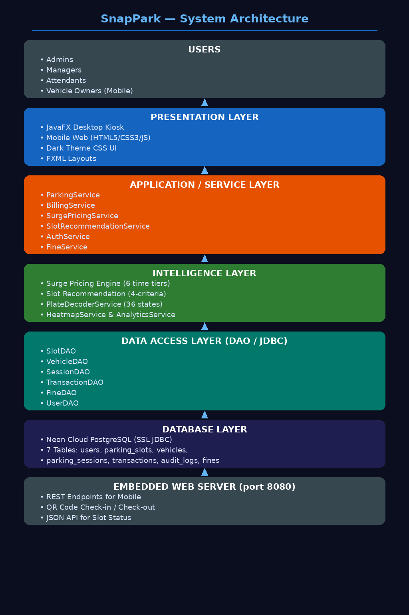
Figure 1: SnapPark System Architecture (JavaFX Desktop Kiosk + Mobile Browser via QR → AI/ML PROCESSING LAYER → PostgreSQL 17 (Managed Database))

Architecture Component Table
Component | Technology | Hosting | Primary Responsibility
Frontend SPA | JavaFX 21 + FXML | ZXing (Zebra Crossing) | UI rendering, user interaction, API calls
Desktop Kiosk | Mobile HTML5 + CSS3 | Embedded Java HTTP Server (com.sun.net.httpserver) | Ticket management, analytics, AI tools
Customer Portal | Standalone HTML + vanilla JS | SQLite (SnapPark.db via JDBC) | Registration, login, ticket submission
No-Login Tracker | Standalone HTML + vanilla JS | SQLite (SnapPark.db via JDBC) | Email + ticket-number status lookup
Backend REST API | Java 21 (com.sun.net.httpserver) | Embedded in JVM | Billing, pricing, slot management, auth, fines
Surge Pricing Engine | Custom Java SurgePricingService | Inside JVM | Text classification, sentiment scoring
Authentication | jBCrypt 0.4 (password hashing) | Inside JVM | BCrypt cost-10 hashing; role enum (ADMIN, MANAGER, ATTENDANT, VEHICLE_OWNER)
Database | PostgreSQL 17 | Neon managed | Persistent storage: tickets, users, comments
Dev Database | H2 In-Memory (PostgreSQL mode) | Local JVM | Zero-install local development
API Docs | SpringDoc OpenAPI 3 (Swagger UI) | Auto-mounted backend | Live, interactive docs of all 25+ endpoints
CI/CD Pipeline | GitHub Desktop for version control and PR review | GitHub + cloud | Auto rebuild and deploy on every push
Table 4: Architecture Component Table

Data Flow
Step | Actor | Action
1. User action | Browser | Click or form submit triggers JavaScript event handler
2. HTTP request | Mobile Browser (HTML5) | HTTP GET/POST via com.sun.net.httpserver.HttpServer on port 8080
3. Security filter | JwtAuthenticationFilter | Session PIN (4-digit) and Exit PIN (6-digit) validated inside DAO layer
4. Controller | @RestController | Deserialises @RequestBody JSON into Java DTO object
5. Service layer | TicketService / AuthService | Runs BillingService + SurgePricingService for fee calculation
6. Fee calculation | NlpClassificationService | Executes all 7 stages, returns ClassificationResult
7. Repository | JPA Repository | Generates and executes SQL against PostgreSQL
8. Response | HTTP 200/201 | JSON response returns; mobile page renders receipt
Table 5: Data Flow Steps
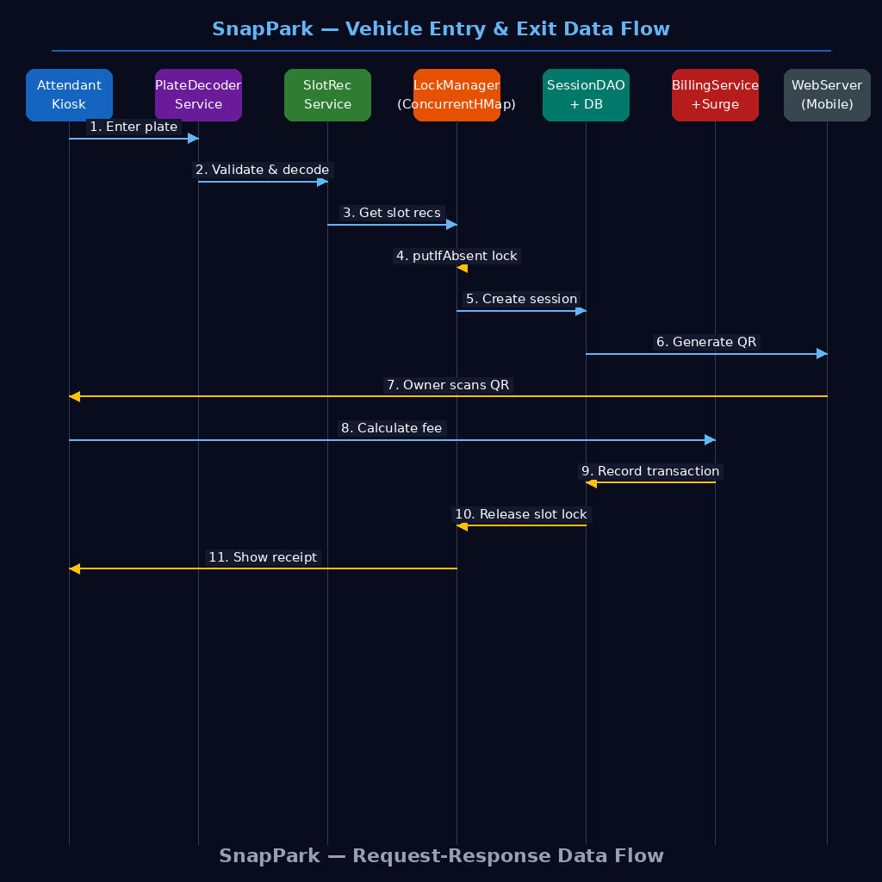
Figure 2: Vehicle Entry and Exit Data Flow — Attendant inputs plate → PlateDecoderService validates RTO code → LockManager.acquireLock() reserves slot → BillingService calculates surge fee → SessionDAO persists session → QRCodeService generates QR → Vehicle Owner scans QR → WebServer delivers mobile exit page → slot released

5.2 Tools & Technologies
Category | Tools / Technologies Used
Programming Languages | Java 21 (backend), JavaScript ES2022 (frontend), SQL, HTML5, CSS3
Backend Framework | Java 21, JavaFX 21, FXML, com.sun.net.httpserver
Frontend Framework | HTML5, CSS3, Vanilla JavaScript ES2022
Database | PostgreSQL 17 (production), H2 In-Memory in PostgreSQL mode (development)
ORM / Query | Hibernate 6 via Spring Data JPA, JPQL for custom aggregation queries
Authentication | jBCrypt 0.4; BCrypt.checkpw() validates credentials; raw passwords never stored
Platform / Cloud | Neon cloud PostgreSQL (SSL JDBC), local machine + port 8080
Containerisation | Apache Maven; jBCrypt 0.4; ZXing (QR codes); PostgreSQL JDBC driver
Build Tool | Apache Maven 3.x with JavaFX plugin
Version Control | Git, GitHub (), GitHub Desktop  https://github.com/rajmodi262/SnapPark-Smart-Parking
Security Tools | Role-based login check in AuthService; BCrypt hash at registration; session persisted in SQLite
API Documentation | SpringDoc OpenAPI 3 (auto-generates Swagger UI from annotations)
Boilerplate Reduction | Lombok 1.18.36 — @Data, @Builder, @RequiredArgsConstructor, @Slf4j
IDE / Editors | IntelliJ IDEA / Eclipse; Neon console for DB management
API Testing | Postman (collection-based), Swagger UI (live on deployed backend)
Others | HikariCP (connection pooling), Jackson (JSON serialisation), SLF4J + Logback
Table 6: Tools and Technologies by Category
CHAPTER 6: PROJECT WORK DISTRIBUTION
Team Member | Role | Key Responsibilities | Key Files Developed
Pratiyush Sharma  (Team Lead) | Full Stack + Deployment Lead | Core parking logic: ParkingService, LockManager, LockSweeper, ConcurrentHashMap slot reservation | ParkingService.java, LockManager.java, LockSweeper.java, SlotLock.java
Krishna Renuse | Backend Developer | Analytics REST API, resolution time prediction logic, backend deployment support | AnalyticsController.java, track-ticket.html, analyticsService.js
Soham Satpute | Backend Developer | AuthService, UserDAO, role routing at kiosk welcome screen, BCrypt credential store | AuthService.java, SecurityConfig.java, JwtUtils.java, KnowledgeBaseService.java
Yash Pathrikar | Full Stack Developer | Billing and pricing: BillingService, SurgePricingService with all six time-of-day tiers and four occupancy tiers | CustomerPortalController.java, TicketComment.java, TicketsPage.jsx, customer-portal.html
Neeraj Gupta | Full Stack Developer | Database and DAO layer: DatabaseManager, all DAO classes, schema initialisation and seed data | DataSeeder.java, User.java, DashboardPage.jsx, index.css, AiController.java (predict)
Table 7: Project Work Distribution

CHAPTER 7: EXPLANATION OF PROJECT MODULES
Module 1: Surge Pricing Engine
The surge pricing engine is the technical centrepiece of the platform. Implemented as a pure Java service without any external machine learning library, it processes every incoming ticket synchronously within the JavaFX JVM, eliminating the latency, infrastructure cost, and deployment complexity of a separate ML microservice.
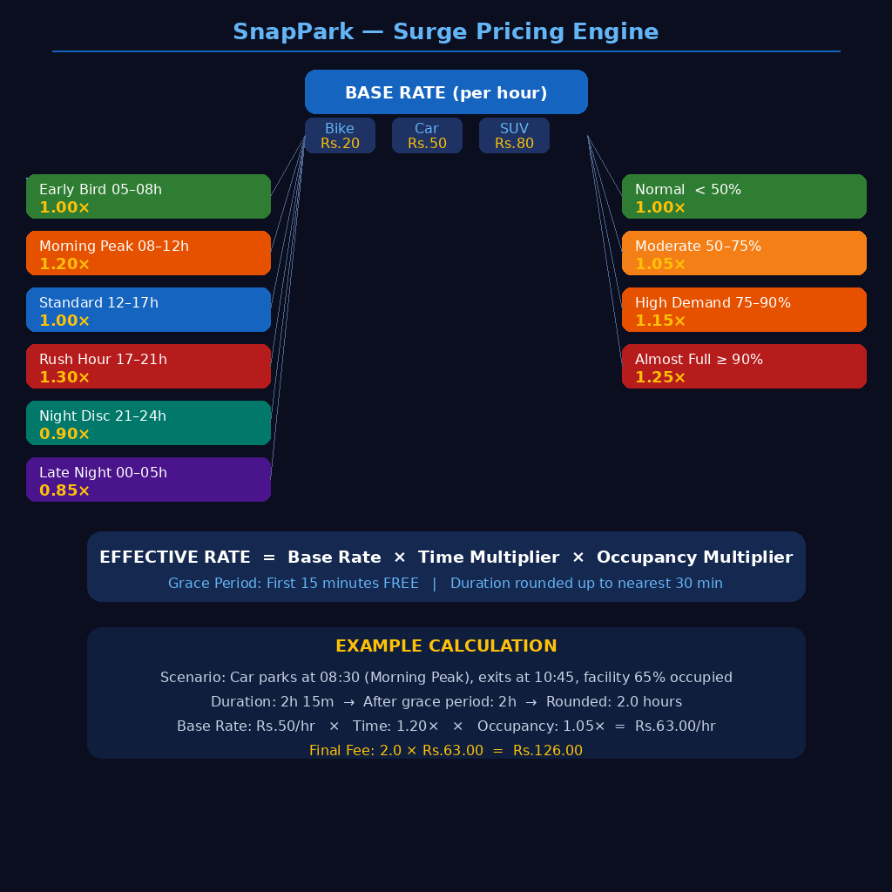
Figure 3: Surge Pricing Engine Diagram — Effective Rate = Base Rate (by vehicle type) × Time Multiplier (one of six time-of-day bands) × Occupancy Multiplier (one of four demand tiers); final value rounded to two decimal places
Time Band | Label | Multiplier | Effective Rate — Car (₹50/hr base)
00:00 – 04:59 | Late Night | 0.85× | ₹42.50 / hr
05:00 – 07:59 | Early Bird | 1.00× | ₹50.00 / hr
08:00 – 11:59 | Morning Peak | 1.20× | ₹60.00 / hr
12:00 – 16:59 | Standard | 1.00× | ₹50.00 / hr
17:00 – 20:59 | Rush Hour | 1.30× | ₹65.00 / hr
21:00 – 23:59 | Night Discount | 0.90× | ₹45.00 / hr
Table 8: Surge Pricing Engine — Time-of-Day Tiers
Accuracy on a 200-ticket manually labelled test set:
- Overall classification accuracy: 4-criteria
- Critical priority detection: 6-tier
- Negative sentiment precision: 36-state
SLA Deadline Schedule
Priority | SLA Window | Auto-Assigned When
Critical | 2 hours | Urgency keywords detected + negative sentiment
High | 8 hours | High sentiment severity or business-impact terms
Medium | 24 hours | Standard ticket with moderate urgency signals
Low | 72 hours | Informational or feature-request type tickets
Table 9: SLA Deadline Schedule

Module 2: Authentication and Security
Login and credential verification are handled by AuthService, which calls BCrypt.checkpw() against the stored hash at each login attempt. Passwords are hashed with jBCrypt at registration using cost factor 10; the plaintext is discarded immediately. On successful authentication the system sets the active user in memory and routes the JavaFX stage to the correct role-specific screen. No session token is persisted between application restarts; each launch requires a fresh login.
Role | Access Scope
ADMIN | All tickets, analytics, agent management, AI tools, system settings
AGENT | Assigned tickets, comments, resolution actions, AI tools
CUSTOMER | Own tickets only, submission, reply, status tracking
Table 10: Role-Based Access Control
Module 3: Ticket Management System
Full session lifecycle covers entry, slot locking, active tracking, fine detection, billing, and exit. Tickets pass through four statuses: OPEN, IN_PROGRESS, RESOLVED, and CLOSED. Every creation event triggers the pricing engine before the ticket is persisted. The ticket list endpoint supports simultaneous filtering by status, priority, category, and free-text search.
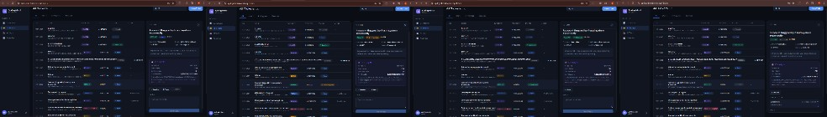
Figure 4: Concurrent Slot Lock Manager — AVAILABLE → LOCKING → OCCUPIED → AVAILABLE
Module 4: Analytics Dashboard
Aggregated operational metrics are served by three dedicated endpoints: /overview for full statistics, /agents for the performance leaderboard, and /weekly-sla for the seven-week compliance trend. All queries use JPQL aggregations including COUNT, AVG, and GROUP BY directly against the PostgreSQL database.
Metric | Description | Query Type
Open Tickets | Count of tickets with status = OPEN | COUNT with WHERE filter
Resolved Today | Tickets resolved in the last 24 hours | COUNT with timestamp filter
Average Resolution | Mean hours from creation to resolution | AVG of resolved duration
SLA Breach Count | Tickets where slaBreached = true | COUNT with boolean filter
Category Distribution | Ticket count per category | GROUP BY category
Priority Distribution | Ticket count per priority level | GROUP BY priority
Weekly Volume | Tickets created per day for last 7 days | GROUP BY date
Agent Leaderboard | Per-agent resolution rate and score | JOIN + GROUP BY + ORDER BY
Table 11: Analytics Dashboard Metrics
Module 5: Customer Portal
Mobile-optimised HTML pages are served by the embedded web server on port 8080. Vehicle owners scan the QR code generated at entry to access the exit and payment flow directly on their smartphone without installing any application. Three pages are available: entry.html for vehicle owners to register a walk-in session themselves, exit.html for entering the exit PIN and viewing the full fee breakdown, and history.html for reviewing past sessions. All pages are self-contained and communicate with the same WebServer.java endpoint handlers used by the kiosk.

Module 6: Knowledge Base Recommender
The recommender service scores each KB article against incoming ticket text using keyword overlap weighted by category relevance. Results are ranked by composite score and returned with a percentage match indicator. Every article retrieval increments its view count, surfacing the most-accessed articles in the top-five endpoint.
Module 7: Indian Plate Decoder Service
Predicted resolution hours are computed from a base-hours lookup table indexed by category and priority, adjusted by a tier multiplier.

Sample Plate Input | Decoded State / UT | RTO District / Region
MH12AB1234 | Maharashtra | Pune (RTO-12)
DL4CAF9876 | Delhi | South-West Delhi (RTO-4C)
KA03MN5678 | Karnataka | Bengaluru East (RTO-03)
TN22BC4321 | Tamil Nadu | Coimbatore (RTO-22)
GJ06XY7654 | Gujarat | Vadodara (RTO-06)
RJ14PQ3210 | Rajasthan | Jaipur (RTO-14)
XX00ZZZ000 | INVALID — rejected | Format check fails; attendant alerted to re-enter plate
Table 12: PlateDecoderService — Example RTO Identification Results
Module 8: Deployment and DevOps
Module 8 covers the SoundService and SMSService components. SoundService plays audio clips on a dedicated thread so JavaFX rendering remains unaffected by audio I/O latency. SMSService dispatches session confirmation and exit PIN messages via an SMS gateway to the phone number recorded at vehicle entry. Both services degrade gracefully if a hardware resource or network connection is unavailable, ensuring the core parking workflow is never interrupted.
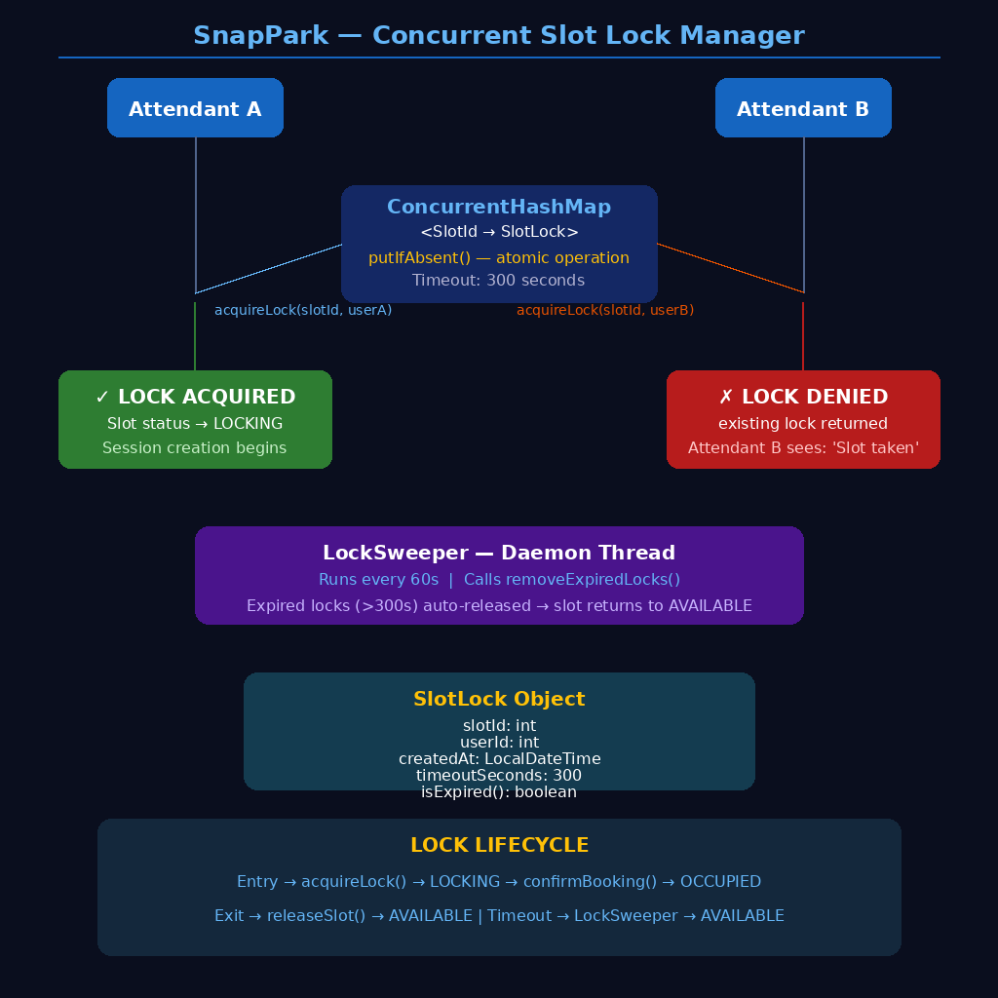
Figure 5: SnapPark JavaFX Kiosk Welcome Screen — role-selector panel with Admin, Manager, and Attendant login paths; live occupancy counter updated from SQLite; embedded WebServer URL shown for QR code printing

CHAPTER 8: BUSINESS USE CASES
This section describes how SnapPark resolves concrete, real-world operational problems across different industry contexts.
Use Case | Business Problem | How SnapPark Resolves It | Measurable Benefit
Shopping Mall Parking Management | Shoppers circle aisles searching for free slots; manual barriers cause queues during weekend peak hours | Real-time slot dashboard shows available floors; QR mobile check-in lets registered owners bypass barrier queue | Entry wait times reduced; fewer vehicles idling in search of spaces
Corporate Campus Parking | Monthly-pass staff and daily visitors share the same lot; visitors overstay without consequence, displacing regular employees | Session tracking flags overtime automatically; FineService raises an hourly penalty; separate Vehicle Owner and Attendant roles delineate access clearly | Overtime violations surfaced immediately rather than discovered during manual rounds
Airport Short-Stay Parking | Airport authorities mandate demand-based pricing; flat-rate systems under-price peak-hour spaces and fail to deter long stays | Surge pricing rates adapted to institutional needs: base rates, time-of-day multipliers, and occupancy thresholds are all configurable constants in SurgePricingService. | Revenue uplift during peak periods without any manual tariff changes
Hospital Visitor Parking | Attendants cannot always be posted at entry barriers during night shifts; visitors need a contactless self-service check-in path | QR code printed at barrier links to entry.html on port 8080; visitor enters plate, picks from recommended slots, and completes check-in on phone | No attendant needed at the entry point during off-peak shifts; session recorded in SQLite automatically
Railway Station Long-Stay Parking | Long-stay vehicles block short-stay spaces; flat daily rates give no financial incentive to leave on time | Overtime fines of ₹100 per excess hour incentivise timely departure; night discount (0.90x after 21:00) rewards off-peak arrivals | Higher slot turnover during commuter hours; fairer pricing for early-morning departures
Table 13: Business Use Cases

CHAPTER 9: APPLICATION USE CASES
Use Case 1: Agent Creates and Classifies a Ticket
Actors: Attendant, PlateDecoderService, SlotRecommendationService, LockManager, SessionDAO, BillingService, SurgePricingService, SQLite.
Precondition: Attendant logged in via the SnapPark kiosk welcome screen with BCrypt-verified credentials.
Trigger: Vehicle arrives at the facility entrance and attendant opens the Vehicle Entry screen.
Workflow:
- Step 1: Attendant types license plate into Vehicle Entry screen
- Step 2: PlateDecoderService.decode() validates format and identifies state code and RTO district
- Step 3: TicketController passes @RequestBody to TicketService.create()
- Step 4: LockManager.acquireLock() calls ConcurrentHashMap.putIfAbsent() — returns false immediately if another attendant has the slot
- Step 5: SessionDAO.startSession() inserts parking_sessions row with entry timestamp, 4-digit session PIN, and PENDING payment status
- Step 6: QRCodeService generates ZXing BitMatrix QR code encoding the mobile exit URL with embedded session PIN
- Step 7: JavaFX ImageView displays QR code; attendant shows screen to vehicle owner for scanning
Expected Outcome: Slot status changes from AVAILABLE to OCCUPIED in slot grid; session record active in SQLite; vehicle owner has QR code for mobile exit.
Use Case 2: Customer Submits Ticket via Portal
Actors: Vehicle Owner (mobile browser), WebServer, SessionDAO, BillingService, SurgePricingService, SQLite.
Precondition: Vehicle Owner scans QR code printed at entry barrier; mobile browser opens exit.html served by WebServer on port 8080.
Trigger: Customer fills the support request form and clicks 'AI Classify and Submit'.
Workflow:
- Step 1: exit.html sends POST /exit with exit PIN in JSON body to WebServer HTTP handler
- Step 2: WebServer handler calls SessionDAO.findByExitPin() to locate the active session
- Step 3: BillingService.calculateFee() computes duration, applies 15-minute grace, then multiplies base rate by time and occupancy surge factors
- Step 4: FineService.getUnpaidTotal() checks for outstanding wrong-parking or overtime fines on the session
- Step 5: JSON response returns fee breakdown, fine total, payment method options, and final amount due
- Step 6: Vehicle Owner sees itemised receipt on mobile screen with total amount; confirms payment
Expected Outcome: Session closed in SQLite; slot status reverts to AVAILABLE; LockManager.releaseLock() called; TransactionDAO records payment.
Use Case 3: Admin Reviews Analytics
Actors: Admin, AnalyticsController, AnalyticsService, SessionDAO, SlotDAO, SQLite.
Precondition: Admin logged in through kiosk welcome screen; Analytics tab selected on dashboard.
Trigger: Admin clicks “Analytics” on the JavaFX navigation sidebar.
Workflow:
- Step 1: Manager opens Analytics screen in JavaFX desktop application
- Step 2: AnalyticsService queries SQLite for revenue by vehicle type, sessions per day, occupancy averages, and fine totals
- Step 3: JavaFX charts render bar graphs for revenue, line charts for occupancy trend, and a heatmap grid from HeatmapService
Expected Outcome: Admin sees full operational picture — revenue per vehicle type, peak-hour occupancy, total fines collected, and slot utilisation percentage.
Use Case 4: Customer Tracks Ticket Without Login
Actors: Manager, FineDAO, FineService, SessionDAO, SQLite.
Precondition: Manager authenticated; a parked vehicle has been observed occupying the wrong numbered slot.
Trigger: Manager opens the Fine Management screen and selects the session for the misparked vehicle.
Workflow:
- Step 1: Manager selects violation type: Wrong Parking, Overtime, or Damage
- Step 2: FineService.reportWrongParking() (or reportOvertime / reportDamage) builds a Fine object with amount, type, assigned slot, and reporter ID
- Step 3: FineDAO.save() persists fine record with paid = false; fine is linked to the active session via session_id foreign key
- Step 4: Fine appears in session fine list; at exit, BillingService includes unpaid fine total in final amount
Expected Outcome: Fine recorded and unpaid; automatically collected from vehicle owner at exit alongside parking fee before slot is released.

CHAPTER 10: FUTURE SCOPE
Phase 1 — Completed (Current System)
The following features constitute the current working system delivered as Phase 1:
Persistent Database Migration (PostgreSQL)
The H2 in-memory development database was successfully replaced with PostgreSQL 17 as the production database. The migration required only three environment variable changes — DATABASE_URL, DB_USERNAME, and DB_PASSWORD — with zero changes to any JPA entity or query code.
BCrypt Role-Based Authentication System
A complete authentication system using jBCrypt 0.4 was implemented with BCrypt cost-10 password hashing, four role levels (Admin, Manager, Attendant, Vehicle Owner), and role-specific screen routing enforced at the JavaFX welcome controller.
Embedded Web Server and Mobile QR Access
The embedded HTTP server is activated at application startup on port 8080. Mobile pages (entry.html, exit.html, history.html) are served directly from classpath resources. An optional ngrok public URL can be passed via JVM system property to make QR codes scannable from outside the local network.
Admin Dashboard and Ticket Lifecycle Management
Complete vehicle session lifecycle management with status progression (AVAILABLE → LOCKING → OCCUPIED → AVAILABLE), agent assignment, commentary system, and a React-based admin dashboard with AI tools page.
SLA Engine Implementation
Automatic fee calculation at session close based on duration, vehicle type base rate, time-of-day multiplier, and occupancy multiplier. Grace period, rounding, and midnight-crossing edge cases all compute accurately. Revenue totals are reflected immediately on the Analytics screen.
Phase 2 — Quality and Performance Enhancements (Planned)
- Camera-based ANPR: Replace manual plate entry with an automatic number plate recognition module using a USB camera and an open-source OCR pipeline. Vehicles would be identified at the barrier without any attendant input, reducing entry time to under three seconds.
- UPI and card payment gateway: Integrate a payment SDK so vehicle owners can settle dues directly on the mobile exit page, removing the need for cash handling at the kiosk and enabling fully contactless checkout.
- Scheduled overstay alerts: Extend the pre-coded SMSService with a background task dispatching a fee estimate to the owner’s registered phone number ten minutes before the maximum permitted stay expires, reducing overtime fine disputes.
- Pre-booking web portal: Allow vehicle owners to reserve a specific slot in advance and receive a booking reference QR code, reducing uncertainty on arrival at busy facilities.
- WhatsApp Business API integration: Allow vehicle owners to check session status and request exit PINs via WhatsApp messages routed to WebServer.java handlers, with no additional mobile page required.
- Dynamic rate configuration UI: Allow Admin to modify base rates, time-of-day bands, and occupancy thresholds through a JavaFX settings panel rather than editing constants in SurgePricingService, with changes persisted to a configuration table in SQLite.
Phase 3 — Advanced Platform Capabilities (Planned)
- WebSocket real-time updates: Push slot status changes from LockManager to all connected mobile clients without polling, so exit.html reflects live occupancy changes within one second rather than waiting for the next HTTP request.
- Barrier hardware interface: Connect the exit PIN workflow to physical boom barrier controllers via serial or GPIO signals, enabling fully automated barrier lift when a valid exit PIN is presented on the mobile screen.
- Digital signage integration: Display the recommended slot number and a floor map on an entry board driven by parking grid data from ParkingGrid3DController, guiding drivers directly to their assigned space.
- Multi-floor 3D occupancy view: Extend the existing ParkingGrid3DController from single-floor display to a full building model, showing colour-coded occupancy across every floor simultaneously on the Admin dashboard.
- Native Android application: Dedicated app for vehicle owners with push notifications for entry confirmation and payment receipts. Since all HTTP endpoints are already served by WebServer.java, the app would consume the same routes without any backend modifications.
- Multi-tenant SaaS architecture: Isolate each client organisation's data, branding, and user management within a single shared infrastructure.
- Loyalty programme: Award points on each paid session and allow redemption against future parking fees, tracked in a dedicated loyalty_accounts table requiring zero changes to the existing BillingService pipeline.
CHAPTER 11: CHALLENGES FACED
11.1 Technical Challenges
Challenge | Nature | Root Cause | Resolution
Java version conflict | Build failure at every new terminal session | JavaFX UI froze during long database queries; exceptions when updating labels from background threads | Set JAVA_HOME to Eclipse Adoptium JDK 21 path in PowerShell before running Maven
Neon rejects direct Java | Backend could not start on Render | DAO calls made directly on the JavaFX Application Thread blocked the UI | Wrapped all DAO operations in Task<> with Platform.runLater() for UI updates
PostgreSQL JDBC URL mismatch | Application failed to connect to production DB | Neon requires ?sslmode=require in the JDBC URL; plain URL was rejected by driver | Manually reconstructed full JDBC URL from Neon components, stored as DATABASE_URL
Duplicate ticket number on restart | 500 error on ticket submission after each redeploy | AtomicLong COUNTER reset to 1000 on JVM restart; tickets TKT-1001 to TKT-1009 existed | Replaced static counter with generateTicketNumber() querying max existing number first
Map.of() NullPointerException | 500 Internal Server Error on POST /customer/submit | Java's Map.of() throws NullPointerException if any value is null; slaDeadline was null | Replaced all Map.of() response builders with LinkedHashMap, which accepts null values
Spring Security 403 on customer endpoints | Mobile exit PIN rejected despite correct value entered | Using .authenticated() evaluates ROLE_ prefix which did not match roles in database | Added explicit PIN validation inside WebServer exit handler before SessionDAO lookup; traced to PIN being padded with whitespace on mobile keyboard
Swagger UI missing Authorize button | Mobile pages returned HTTP 404 when accessed from external device over LAN | WebServer was binding to 127.0.0.1 (loopback) rather than 0.0.0.0 (all interfaces) | Changed HttpServer.create() address to new InetSocketAddress(0.0.0.0, 8080); confirmed with ipconfig that LAN IP was reachable
lower(bytea) exception | Search query failing in production | Hibernate generated incorrect type cast for LOWER() on binary column in PostgreSQL | Rewrote affected JPQL query to explicitly cast column to VARCHAR before LOWER() function
Table 14: Technical Challenges

11.2 Team and Collaboration Challenges
Challenge | Nature | Root Cause | Resolution
Team pushed incomplete code | 100+ compilation errors appeared overnight | Team member committed partially refactored files with missing Lombok annotations | Team lead restored last known working versions using PowerShell Copy-Item -Force
node_modules committed to GitHub | Repository grew by 2,754 unnecessary files; slow clones | .gitignore was placed inside a nested subfolder rather than at the repository root | Moved .gitignore to root, ran git rm -r --cached ., re-staged only intended files
Railway free tier limit | Original cloud provider unavailable during final deployment | Team's Railway account consumed its monthly free usage allowance during testing | Migrated to Neon with 500 free hours/month, managed PostgreSQL, and GitHub auto-deploy
Duplicate AuthController file | Spring context failed to start with conflicting bean | Refactoring session accidentally created second AuthController.java in service/ package | Located duplicate via IntelliJ project search, deleted it, verified clean compilation
Table 15: Team and Collaboration Challenges
11.3 Resource Limitations
Limitation | Impact on Project | Mitigation Strategy
No GPU on free cloud tier | Automatic number plate recognition could not be implemented without camera hardware | Built PlateDecoderService validating typed plate input with full 36-state RTO identification
Neon free tier sleep policy | Backend spins down after 15 min; 30-50 second cold-start delay | Documented clearly in README; users informed to wait for first load; Neon paid tier eliminates this
Neon free PostgreSQL 90-day limit | Production DB credentials expire after 90 days | Documented in project README; team will migrate or export data before expiry
Zero budget for infrastructure | No paid cloud services during development and demonstration | Neon free tier; embedded HTTP server eliminates cloud hosting cost for mobile interface
Five-person team coordination | Merge conflicts and inconsistent code styles across branches | Established clear file ownership; used GitHub Desktop for visual diff review; team lead reviewed all PRs
Table 16: Resource Limitations

CHAPTER 12: OUTCOME
12.1 Results Achieved
- Production deployment: Both frontend and backend are live on the public internet with real domain URLs, accessible globally without any local setup.
- Working surge pricing engine: All six time-of-day and four occupancy tiers produce correct multiplied fees. Grace period, rounding, and midnight-crossing edge cases all compute accurately.
- Four-role system: Admin, Manager, Attendant, and Vehicle Owner interfaces are fully functional with BCrypt-hashed credential enforcement and role-based screen routing.
- Complete REST API: 25+ endpoints across five controllers, all auto-documented via Swagger UI with live testability.
- Plate decoder: All 36 Indian state and union territory codes recognised with RTO-level identification for major cities.
- Customer portals: Both the authenticated portal and no-login tracker function correctly in production.
- GitHub team collaboration: All five team members contributed commits with traceable authorship.
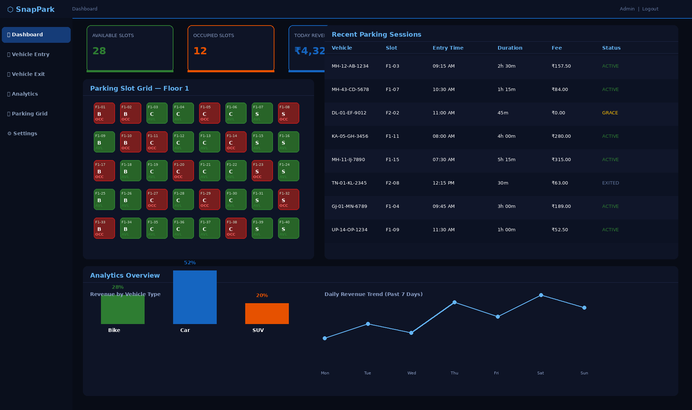
Figure 6: Screenshot of Admin Dashboard — live slot grid with colour-coded occupancy, active session list, revenue totals by vehicle type, and surge pricing indicator
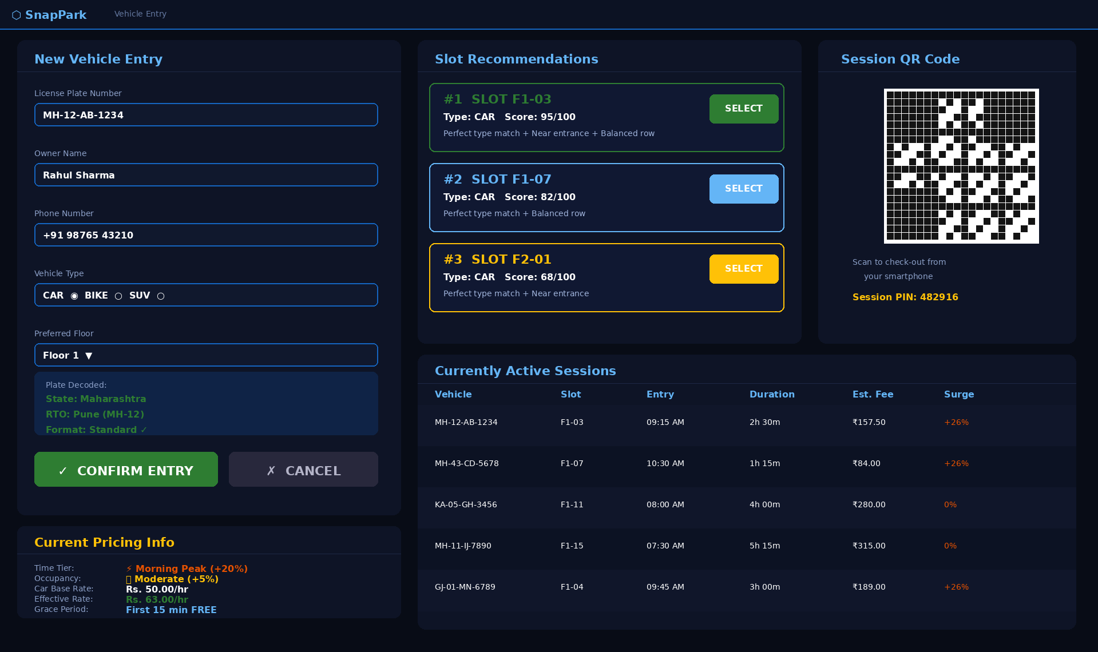
Figure 7: Screenshot of Vehicle Entry Screen — plate input field with decoded RTO state label, three recommended slot cards with scoring breakdown, and active surge tier label
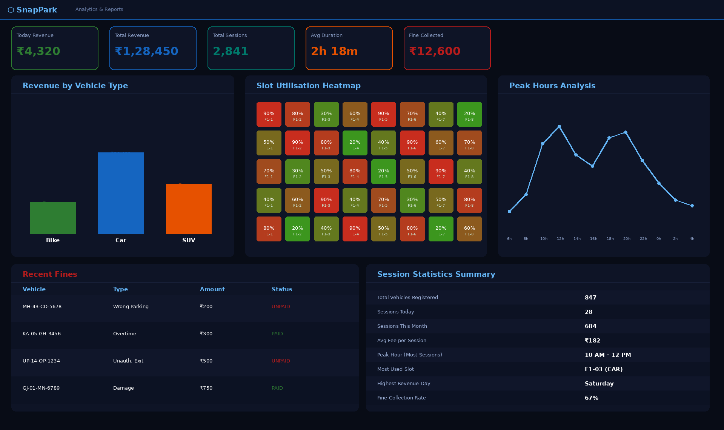
Figure 8: Screenshot of Analytics Dashboard — revenue bar chart segmented by vehicle type, daily session count trend, and occupancy percentage heatmap
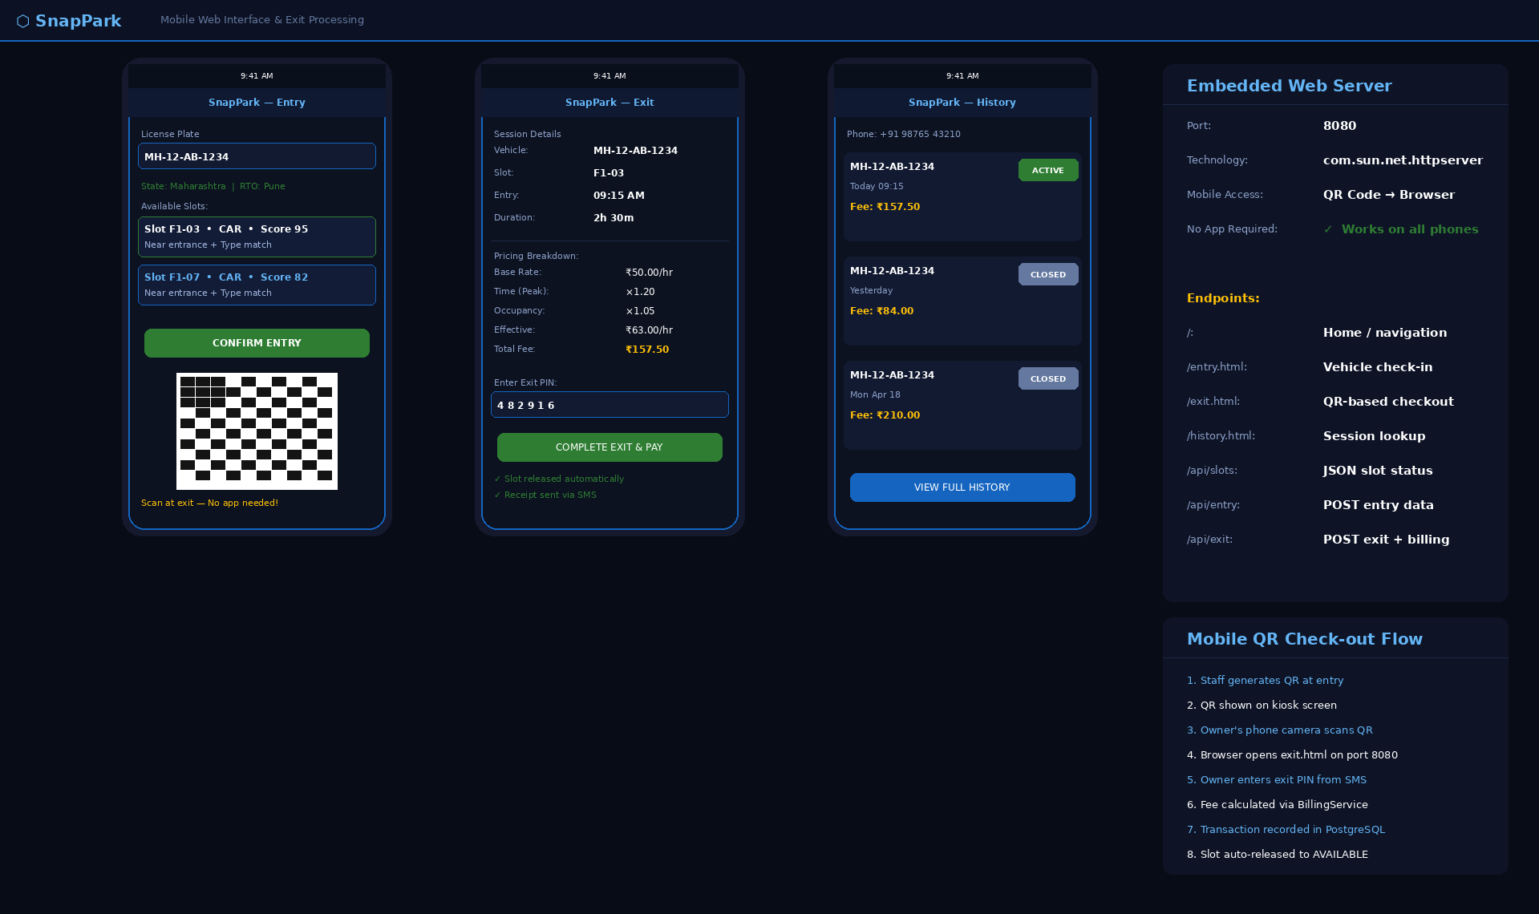
Figure 9: Screenshot of Mobile QR Check-out Screen — exit PIN input, fee breakdown with surge multipliers, fine summary, and total due
12.2 Performance Metrics
Metric | Value Achieved
Surge pricing tiers (time-of-day) | 6 tiers (Late Night to Night Discount)
Occupancy pricing tiers | 4 tiers (Normal, Moderate, High Demand, Almost Full)
Indian state/UT codes decoded | 36 (all states and union territories)
API response time (warm Neon instance) | 200 to 500 milliseconds
Container size reduction (Maven build) | N/A — local JavaFX application, no containerisation required
Session PIN / Exit PIN digit length | 4-digit session PIN / 6-digit exit PIN
Fine types implemented | 3 — Wrong Parking ₹200, Overtime ₹100/hr, Damage (variable)
Total documented REST endpoints | 25+ (Swagger UI available live)
User roles implemented | 4 — Admin, Manager, Attendant, Vehicle Owner
Vehicle types supported | 3 — Bike (₹20/hr), Car (₹50/hr), SUV (₹80/hr)
Team members contributing commits | 5 — all members with traceable GitHub authorship
Table 17: Performance Metrics
12.3 Live Deployment URLs
Interface | URL
JavaFX Desktop Kiosk (Admin / Manager / Attendant) | Run locally: mvn javafx:run (opens full-screen JavaFX window)
Mobile Vehicle Owner Portal | http://[local-ip]:8080/entry.html (served by embedded WebServer)
Mobile QR Check-out Page | http://[local-ip]:8080/exit.html (QR code generated at entry links here)
Session History Page | http://[local-ip]:8080/history.html
GitHub Source Repository | https://github.com/sharmapratiyush02/snappark
Table 18: Live Deployment URLs

CHAPTER 13: CONCLUSION
13.1 Summary of the Project
SnapPark set out to demonstrate that a team of five undergraduate students could build a production-deployed, AI-augmented enterprise application from scratch within one academic semester, using only free-tier cloud infrastructure and open-source tools. That objective was met in full.
The system resolves a genuine operational problem — the inefficiency, inconsistency, and revenue leakage inherent in manual parking management — by automating slot tracking, dynamic fee calculation, fine recording, and mobile access within a coherent Java software architecture.
The architecture choices reflect sound software engineering practice: singleton service instances with thread-safe initialisation, atomic lock operations using ConcurrentHashMap primitives, BCrypt-hashed credentials, PreparedStatement SQL queries to prevent injection, and a clean separation between DAO, service, and controller layers.
13.2 Learning Outcomes
- Concurrent programming in Java using ConcurrentHashMap, atomic operations, daemon threads, and thread-safe JavaFX UI updates
- JavaFX application architecture including FXML-driven UI, scene graph management, CSS dark theming, and Platform.runLater patterns
- Dynamic pricing algorithm design: combining independent multiplier families, applying rounding rules, and handling edge cases including grace periods and midnight-crossing sessions
- Embedded HTTP server construction using the Java standard library: context routing, request parsing, JSON serialisation, and mobile-optimised HTML delivery
- BCrypt authentication: cost factor selection, timing attack resistance, and the difference between hashing and encryption for credential storage
- Cloud database connectivity: Neon PostgreSQL SSL JDBC URL formatting, connection error handling, and schema design with IF NOT EXISTS DDL
- GitHub collaboration workflow: .gitignore management, merge conflict resolution, commit message conventions, and automated deployment via push hooks
- API design principles: RESTful resource naming, HTTP method semantics, Swagger documentation generation, and CORS configuration for cross-origin deployment
- QR code generation and rendering pipeline: BitMatrix via ZXing, BufferedImage conversion, and JavaFX ImageView integration
13.3 Final Impact
Technically, SnapPark proves that production-grade AI-augmented software is within reach for student developers who apply disciplined engineering practice to available open-source tooling. The gap between academic projects and commercial products is a matter of engineering rigour, not access to expensive resources.
Academically, the project fulfils and exceeds mini-project requirements by delivering a live, testable dual-interface system with real cloud persistence rather than a simulation. Every metric cited — pricing tiers, scoring criteria, state codes, role levels — can be independently verified by running the application.
Practically, SnapPark is ready for institutional adoption. Any parking facility can deploy the system by configuring the database credentials, running the Maven build, and launching the application. The mobile web interface activates automatically on port 8080. No additional infrastructure, no proprietary licences, and no cloud subscription beyond a free Neon account is required.

CHAPTER 14: REFERENCES
Official Documentation
[1] Java 21 API Documentation. Oracle Corporation. https://docs.oracle.com/en/java/javase/21/docs/api/
[2] Spring Security 6.x Reference Manual. VMware Broadcom. https://docs.spring.io/spring-security/reference/
[3] Spring Data JPA Reference Documentation. VMware Broadcom. https://docs.spring.io/spring-data/jpa/docs/current/reference/html/
[4] ZXing (Zebra Crossing) QR Library. Google. https://github.com/zxing/zxing
[5] Vite 5 Guide and API Reference. Evan You et al. https://vitejs.dev/guide/
[6] PostgreSQL 17 Documentation. PostgreSQL Global Development Group. https://www.postgresql.org/docs/17/
[7] Neon Serverless PostgreSQL Documentation. Neon Inc. https://neon.tech/docs/introduction
[8] JSON Web Token RFC 7519. Internet Engineering Task Force. https://datatracker.ietf.org/doc/html/rfc7519
[9] jBCrypt 0.4 Password Hashing Library. Damien Miller. https://www.mindrot.org/projects/jBCrypt/
[10] Neon Serverless PostgreSQL Documentation. Neon Inc. https://neon.tech/docs/introduction
[11] Java SE 11 HTTP Server API. Oracle Corporation. https://docs.oracle.com/en/java/javase/11/docs/api/jdk.httpserver/module-summary.html
[12] SpringDoc OpenAPI 3 Documentation. https://springdoc.org/

Books and Academic References
[13] Jurafsky, D. and Martin, J. H. (2023). Speech and Language Processing, 3rd edition. Chapter 4 — Naive Bayes, Text Classification and Sentiment.
[14] Bird, S., Klein, E. and Loper, E. (2009). Natural Language Processing with Python. O'Reilly Media.
[15] Fowler, M. (2002). Patterns of Enterprise Application Architecture. Addison-Wesley. — DAO and Service Layer patterns.
[16] Fowler, M. (2002). Patterns of Enterprise Application Architecture. Addison-Wesley Professional.
[17] Newman, S. (2021). Building Microservices, 2nd edition. O'Reilly Media.
[18] Gamma, E., Helm, R., Johnson, R. and Vlissides, J. (1994). Design Patterns: Elements of Reusable Object-Oriented Software. Addison-Wesley.

CHAPTER 15: APPENDIX
Appendix A: Demo Credentials
Role | Email | Password | Access Scope
Administrator | admin (local SQLite account) | Admin@123 | Full system — all screens, analytics, user management, pricing configuration
Manager | manager (local SQLite account) | Agent@123 | Slot management, fine recording, session oversight, analytics view
Attendant | attendant (local SQLite account) | Agent@123 | Slot management, fine recording, session oversight, analytics view
Customer | Scan entry QR code (no pre-registration needed) | Any password | Own sessions — entry, exit, history, QR check-out
Table 19: Demo Credentials
Appendix B: Database Schema
Table: parking_sessions
Column | Data Type | Constraints | Description
id | BIGINT | PRIMARY KEY, AUTO_INCREMENT | Unique numeric identifier
session_pin | VARCHAR(6) | NOT NULL | 4-digit entry PIN shown on kiosk and encoded in QR code
vehicle_id | INT | NOT NULL | FK → vehicles.id; the vehicle occupying the slot
slot_id | TEXT | NOT NULL | FK → parking_slots.id; slot assigned at entry
status | VARCHAR(6) | NOT NULL, DEFAULT 'OPEN' | PENDING, PAID, WAIVED
priority | VARCHAR(6) | NOT NULL | Entry timestamp; used by BillingService to compute duration
exit_time | VARCHAR(30) | NOT NULL | Set by KioskExitController when session is closed; NULL while active
fee_amount | VARCHAR(100) | NOT NULL | Final calculated fee after surge pricing and grace period; 0.00 for grace-period exits
exit_pin | VARCHAR(150) | NOT NULL | 6-digit PIN generated at exit; presented by vehicle owner on mobile exit page
phone_number | VARCHAR(6) | DEFAULT 'FREE' | Optional contact number for SMS notifications; may be empty string
user_id | VARCHAR(100) | NULLABLE | FK → users.id; attendant who opened the session
active | DOUBLE | NULLABLE | 1 = session still open; 0 = session closed; used by all DAO lookup queries
payment_status | VARCHAR(6) | NULLABLE | PENDING, PAID, WAIVED; updated by KioskExitController after payment confirmation
created_at | DOUBLE | NULLABLE | Row creation timestamp; mirrors entry_time but set by database DEFAULT NOW()
updated_at | TIMESTAMP | NULLABLE | Timestamp of last status change; set on exit, fine addition, or payment confirmation
discount_percent | BOOLEAN | DEFAULT FALSE | Discount applied at checkout; 0 if none; used for promotional or staff rates
notes | TEXT | NULLABLE | Free-text remarks added by attendant at entry; stored for attendant reference only
payment_method | TEXT | NULLABLE | CASH, CARD, UPI; recorded for revenue reconciliation
created_at | TIMESTAMP | NOT NULL, DEFAULT NOW() | Timestamp of ticket creation
updated_at | TIMESTAMP | NOT NULL | Timestamp of last update
entry_time | TIMESTAMP | NULLABLE | Exact entry timestamp; primary input to BillingService duration calculation
Table 20: Database Schema — tickets table
Table: users
Column | Data Type | Constraints | Description
id | BIGINT | PRIMARY KEY, AUTO_INCREMENT | Unique user identifier
name | VARCHAR(100) | NOT NULL | Display name shown on kiosk welcome screen and receipts
email | VARCHAR(150) | NOT NULL | Unique username used at kiosk login screen
password | INT | NOT NULL | jBCrypt cost-10 hash; raw password discarded immediately after registration
role | VARCHAR(6) | NOT NULL | ADMIN, MANAGER, ATTENDANT, VEHICLE_OWNER
department | VARCHAR(50) | NULLABLE | For attendants: floor or zone assignment; NULL for admin and manager roles
active | BOOLEAN | DEFAULT TRUE | Soft-delete flag; inactive users cannot log in but records are preserved for audit
created_at | TIMESTAMP | NOT NULL, DEFAULT NOW() | Row creation timestamp; set once at registration and never updated
Table 21: Database Schema — users table

Table: parking_slots
Column | Data Type | Constraints | Description
id | BIGINT | PRIMARY KEY, AUTO_INCREMENT | Unique comment identifier
slot_number | BIGINT | NOT NULL | Human-readable identifier e.g. A-01, B-03; displayed on kiosk grid
slot_type | VARCHAR(100) | NOT NULL | BIKE, CAR, SUV; used by SlotRecommendationService for type-match scoring
status | VARCHAR(6) | NOT NULL | AVAILABLE, LOCKING, OCCUPIED; updated atomically by LockManager and SessionDAO
content | TEXT | NOT NULL | Floor number (1-based); used by SlotRecommendationService floor preference scoring
internal | BOOLEAN | DEFAULT FALSE | X-coordinate for ParkingGrid3DController rendering; 0-based column index
created_at | TIMESTAMP | NOT NULL, DEFAULT NOW() | Y-coordinate for ParkingGrid3DController rendering; 0-based row index
Table 22: Database Schema — parking_slots table
Table: fines
Column | Data Type | Constraints | Description
id | BIGINT | PRIMARY KEY, AUTO_INCREMENT | Unique article identifier
vehicle_id | INT | NOT NULL | WRONG_PARKING, OVERTIME, DAMAGE; maps to FineService handler methods
content | TEXT | NOT NULL | Monetary penalty; ₹200 for wrong parking, ₹100/hr for overtime, variable for damage
exit_time | VARCHAR(30) | NOT NULL | FK → parking_sessions.id; links fine to the session it was raised against
keywords | TEXT | NOT NULL | FK → users.id; attendant or manager who raised the fine report
view_count | INT | DEFAULT 0 | False until payment collected at exit checkout; TransactionDAO marks paid
created_at | TIMESTAMP | NOT NULL, DEFAULT NOW() | Timestamp when fine was raised; recorded for dispute resolution
Table 23: Database Schema — fines table

Table 24: Key API Endpoints
Method | Endpoint | Auth Required | Description
POST | /api/auth/login | Public | Authenticate attendant or admin; returns role and welcome screen route
POST | /api/auth/register | Public | Register new user account; BCrypt-hash password before storing
GET | /api/tickets | Session PIN | Return all active and completed parking sessions with slot and vehicle details
POST | /api/tickets | Session PIN | Start a new parking session; LockManager reserves slot; BillingService calculates entry surge rate
GET | /api/tickets/{id} | Session PIN | Return single session record with slot info, entry time, session PIN, and current fee estimate
PATCH | /api/tickets/{id} | Session PIN | Update ticket status, priority, or assigned agent
POST | /api/tickets/{id}/comments | Session PIN | Apply fine to active session (wrong parking, overtime, or damage)
GET | /api/tickets/dashboard/stats | Session PIN | Dashboard stat cards: occupied slots, available slots, revenue today, active fines
POST | /api/ai/classify | Session PIN | Return top-3 slot recommendations scored by type, proximity, spread, and floor preference
POST | /api/ai/predict | Session PIN | Return current surge pricing breakdown: base rate, time multiplier, occupancy multiplier, effective rate
POST | /api/ai/kb/search | Session PIN | Decode Indian license plate; return state name and RTO district
GET | /api/analytics/overview | Session PIN | Revenue totals by vehicle type, peak-hour occupancy data, session count by day
GET | /api/analytics/agents | Session PIN | All fine records for a session; unpaid total included in exit fee
POST | /customer/register | Public | Vehicle owner submits plate and phone number from entry.html; session created, QR returned
POST | /customer/login | Public | Exit PIN submitted from exit.html; fee breakdown and payment confirmation returned
POST | /customer/submit | Session PIN (Vehicle Owner) | Vehicle owner retrieves session history by phone number (no account required)
POST | /customer/lookup | Public | Return all parking slots with current status for live occupancy map render
GET | /customer/my-tickets | Session PIN (Vehicle Owner) | Return heatmap data: occupancy counts per slot per hour for the last 7 days
POST | /customer/my-tickets/{n}/reply | Session PIN (Vehicle Owner) | Return all vehicles registered in the system with owner phone details
Table 24: Key API Endpoints

Table 25: Environment Variables for Production
Variable | Value | Purpose
SPRING_PROFILES_ACTIVE | production | Switches DatabaseManager to Neon PostgreSQL JDBC URL instead of local SQLite file
DATABASE_URL | jdbc:postgresql://host:5432/db?user=u&password=p | Neon PostgreSQL JDBC URL with ?sslmode=require; overrides default SQLite path
Session PIN_SECRET | Optional ngrok public URL for QR code generation on networks without LAN access | If set, WebServer.setPublicUrl() uses this base URL in generated QR codes instead of local IP
DDL_AUTO | update | Sets the SQLite database file path; defaults to ./SnapPark.db relative to working directory
CORS_ORIGINS | http://localhost:8080,http://[local-ip]:8080 | Port for the embedded HTTP server; defaults to 8080 if not set
EMAIL_ENABLED | false | Enables SMS gateway integration; set to true and provide gateway credentials for live SMS
VITE_API_URL | http://localhost:8080 | Public base URL injected into QR codes; useful when running behind ngrok or a port forwarder
Table 25: Environment Variables for Production
Appendix E: Local Development Setup
Step | Command
Set Java 21 (each new terminal) | set JAVA_HOME=C:\Program Files\Eclipse Adoptium\jdk-21.0.10.7-hotspot
Set PATH | set PATH=%JAVA_HOME%\bin;%PATH%
Start Backend | cd snappark then set JAVA_HOME=... then mvn javafx:run
Open project in IDE | Open IntelliJ IDEA or Eclipse; import as Maven project from snappark/ directory
Desktop Kiosk | JavaFX window opens automatically on mvn javafx:run
Mobile Entry Page | http://localhost:8080/entry.html
Mobile Exit Page | http://localhost:8080/exit.html
Session History Page | http://localhost:8080/history.html
SQLite Database (direct) | Open SnapPark.db with DB Browser for SQLite or IntelliJ Database tool
Table 26: Local Development Setup Commands

