**GCD of two numbers**

Vi gcd.x

struct num

{

long a;

long b;

};

program gcd_prog{

version gcd_vers{

long gcd_fn(num)=1;

}=1;

}=0x30000001;

**[khaja@mars distsyslab]$ rpcgen gcd.x**

**[khaja@mars distsyslab]$ ls**

**client Echos.h Echos.x gcd_svc.c Makefile.Echos**

**Echos_client.c Echos_server.c gcd_clnt.c gcd.x server**

**Echos_clnt.c Echos_svc.c gcd.h gcd_xdr.c**

**GCD CLIENT CODE**

**Vi gcd_client.c**

**#include "gcd.h"**

**void**

**gcd_prog_1(char *host,num number)**

**{**

**CLIENT *clnt;**

**long *result_1;**

**num gcd_fn_1_arg;**

**gcd_fn_1_arg.a=number.a;**

**gcd_fn_1_arg.b=number.b;**

**#ifndef DEBUG**

**clnt = clnt_create (host, gcd_prog, gcd_vers, "udp");**

**if (clnt == NULL) {**

**clnt_pcreateerror (host);**

**exit (1);**

**}**

**#endif /* DEBUG */**

**result_1 = gcd_fn_1(&gcd_fn_1_arg, clnt);**

**if (result_1 == (long *) NULL) {**

**clnt_perror (clnt, "call failed");**

**}**

**printf("gcd is %d",*result_1);**

**#ifndef DEBUG**

**clnt_destroy (clnt);**

**#endif /* DEBUG */**

**}**

**int**

**main (int argc, char *argv[])**

**{**

**char *host;**

**num n;**

**if (argc < 2) {**

**printf ("usage: %s server_host\n", argv[0]);**

**exit (1);**

**}**

**host = argv[1];**

**n.a=atol(argv[2]);**

**n.b=atol(argv[3]);**

**gcd_prog_1 (host,n);**

**exit (0);**

**}**

**Server code**

**Vi gcd_server.c**

int gcd(int a ,int b){

if (b==0)

return a;

return gcd(b,a%b);}

#include "gcd.h"

long *

gcd_fn_1_svc(num *argp, struct svc_req *rqstp)

{

static long result;

/*

* insert server code here

*/

result=gcd((*argp).a,(*argp).b);

return &result;

}

Execution :-

$cc -o gcd_server gcd_server.c gcd_svc.c gcd_xdr.c –lnsl

$cc -o gcd_client gcd_client.c gcd_clnt.c gcd_xdr.c –lnsl

$./gcd_server &

[4] 5086

$ ./gcd_client 10.2.0.5 10 12

gcd is 2[khaja@mars gcd]$

**Simple message program**

**Vi msg.x**

program msg_prg{

version msg_ver{

string message() = 1;

} = 1;

} = 0x20000001;

Step -2

Compile the program :- rpcgen –a msg.x

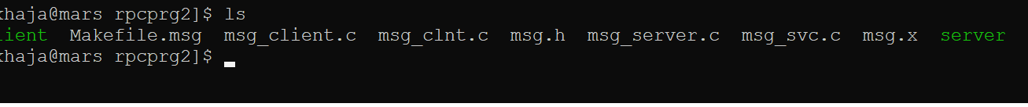

Open vi msg_client.c

#include "msg.h"

void

msg_prg_1(char *host)

{

CLIENT *clnt;

char * *result_1;

char *message_1_arg;

#ifndef DEBUG

clnt = clnt_create (host, msg_prg, msg_ver, "udp");

if (clnt == NULL) {

clnt_pcreateerror (host);

exit (1);

}

#endif /* DEBUG */

*result_1 = (char *)malloc(sizeof(char)*25);

result_1 = message_1((void*)&message_1_arg, clnt);

if (result_1 == (char **) NULL) {

clnt_perror (clnt, "call failed");

}

#ifndef DEBUG

printf("\n Server Response is %s \n",*result_1);

clnt_destroy (clnt);

#endif /* DEBUG */

}

int

main (int argc, char *argv[])

{

char *host;

if (argc < 2) {

printf ("usage: %s server_host\n", argv[0]);

exit (1);

}

host = argv[1];

msg_prg_1 (host);

exit (0);

}

**Vi msg_server.c**

#include "msg.h"

#include<stdio.h>

#include<stdlib.h>

#include<string.h>

char **

message_1_svc(void *argp, struct svc_req *rqstp)

{

static char * result;

/*

* insert server code here

*/

result = (char *)malloc(sizeof(char) * 25);

strcpy(result,"Hello - this is a response from rpc server ");

return &result;

}

Next compile the both programs :-

cc msg_client.c msg_clnt.c -o client

cc msg_server.c msg_svc.c -o server

Next run the server

./server &



output

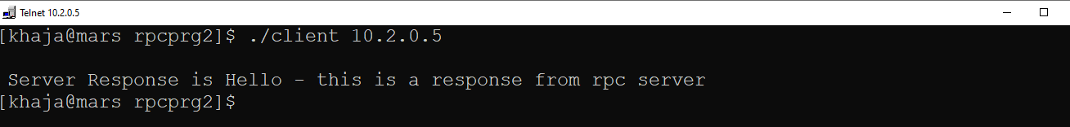

**Rpc Program to Add two numbers**

**Vi add.x**

struct num{

int a;

int b;

};

program add_prog{

version add_ver{

int addition(num)=1;

}=1;

}=0x20000002;

**Vi add_client.c**

/*

* This is sample code generated by rpcgen.

* These are only templates and you can use them

* as a guideline for developing your own functions.

*/

#include "add.h"

void

add_prog_1(char *host)

{

CLIENT *clnt;

int *result_1;

num addition_1_arg;

#ifndef DEBUG

clnt = clnt_create (host, add_prog, add_ver, "udp");

if (clnt == NULL) {

clnt_pcreateerror (host);

exit (1);

}

#endif /* DEBUG */

**printf("\n enter the two number to add \n");**

**scanf("%d %d",&addition_1_arg.a,&addition_1_arg.b);**

**result_1=(int *) malloc(sizeof(int));**

result_1 = addition_1(&addition_1_arg, clnt);

if (result_1 == (int *) NULL) {

clnt_perror (clnt, "call failed");

}

#ifndef DEBUG

**printf("\n the sum of %d \t %d is %d\n",addition_1_arg.a,addition_1_arg.b,*result_1);**

clnt_destroy (clnt);

#endif /* DEBUG */

}

Int main (int argc, char *argv[])

{

char *host;

if (argc < 2) {

printf ("usage: %s server_host\n", argv[0]);

exit (1);

}

host = argv[1];

add_prog_1 (host);

exit (0);

}

**Vi add_server.c**

/*

* This is sample code generated by rpcgen.

* These are only templates and you can use them

* as a guideline for developing your own functions.

*/

#include "add.h"

int *

addition_1_svc(num *argp, struct svc_req *rqstp)

{

static int result;

/*

* insert server code here

*/

**result=argp->a+argp->b;**

return &result;

}