VBCS (Oracle visual builder cloud service):

1. Oracle Visual Builder Cloud Service (VBCS) is a Platform as a Service (PaaS) offering. It provides a cloud-based environment for developing, deploying, and collaborating on web and mobile applications.
2. Oracle VBCS is a low-code development platform provided oracle. Which enables developers to build web and mobile applications quickly Using drag-drop. Without complex coding.

Instance lunch using Private Endpoints:

1. Private endpoints are connected to private resources that resides in VCN (virtual Cloud Network) without the need of connectivity Agent.

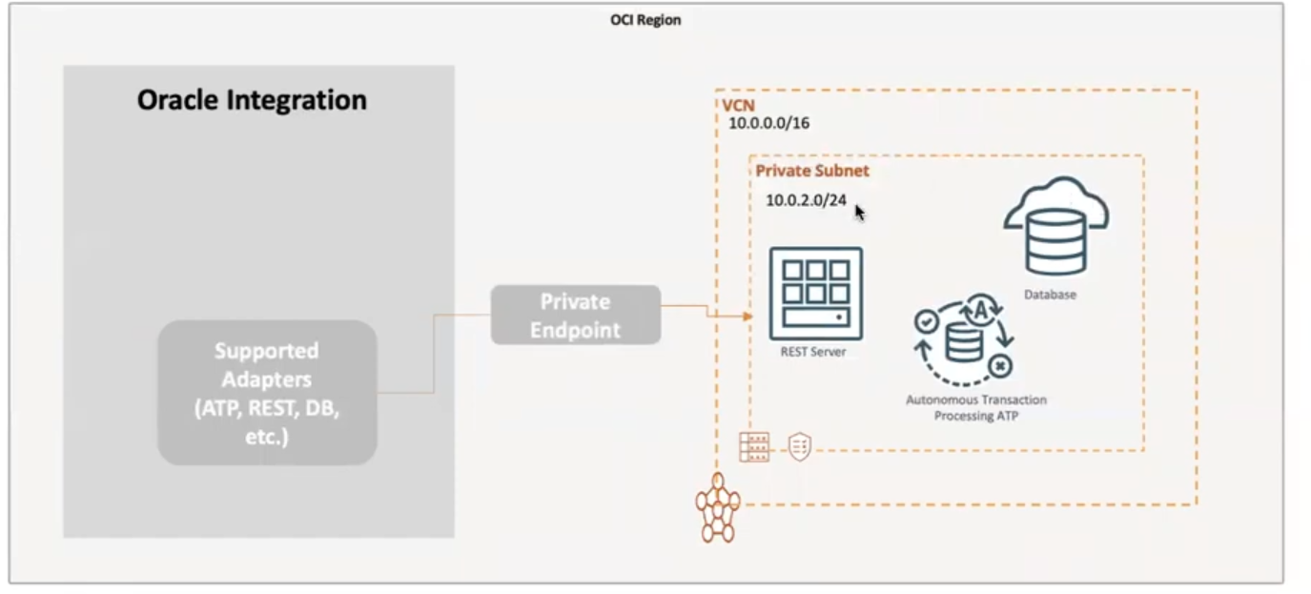

Data Providers in VBCS

1. ADP (Array Data Provider):
2. SDP (Service Data Provider):
3. BDP (Buffer Data Provider):
4. Multi-Service Data Provider: