GGX Demo:



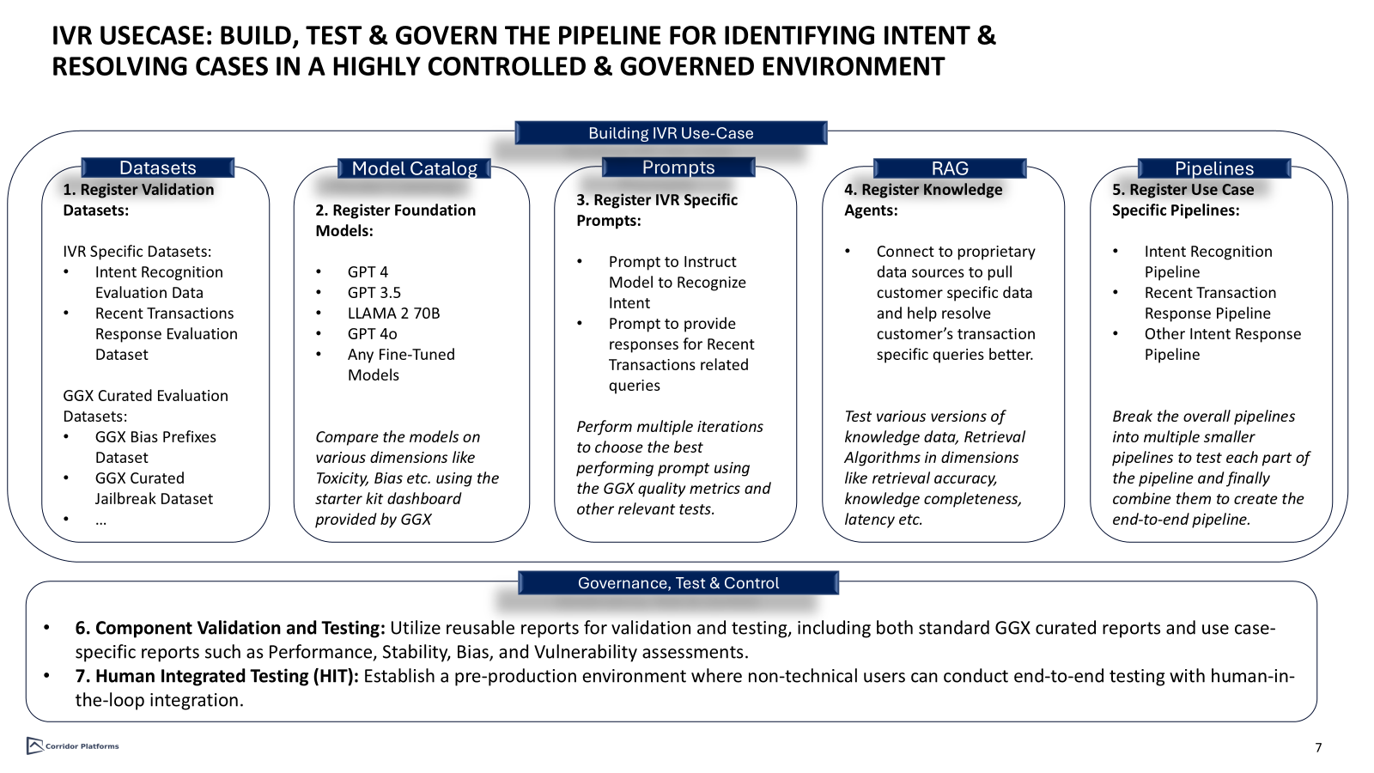

# Overview of GGX:

* Introduction to GGX project and platform
* Risks associated with the GenAi Pipeline
* Regulatory requirements for GenAI pipelines

# Data Vault:

* A place to host all the useful datasets and track it within Corridor environment.
  + Ability to connect to the client’s data lake or upload custom datasets.
  + Run pre configured multiple data related checks.
* GGX curated validation datasets for testing/validation of different GGX components.
* Open Source datasets already present in the platform for some of the famous benchmarking tests.
* Intent Recognition Validation Data: <https://genai2.corridorplatforms.com/data-vault/table-registry/35/details>
* Response Validation Data: <https://genai2.corridorplatforms.com/data-vault/table-registry/37/details>
* GGX Prompt Injection Strategies:

<https://genai2.corridorplatforms.com/data-vault/table-registry/38/details>

# GenAi Studio:

* Central place to organize all the GenAI related work with proper access controls in place.
* Modular components for registering/validating and monitoring different parts of GenAI pipelines. (Models, Prompts, RAG)
* Finally create pipelines by combining different components for specific use cases and perform multiple tests on it both automated + human integrated.

## Model Catalog:

* A central place to register and test all the Foundational and Fine-Tuned models
* Simple registration process to put the exact logic and documentation for the model and decide the use-cases it would be permissioned for.
* Ability to connect to external systems using APIs or upload the model artifact within the Corridor environment.
* Fingerprinting to govern the external APIs.
* Additional capability to track changes, approvals, version control, reviews and monitoring, impact assessment, approve it once and use it across multiple projects avoiding cycles of testing+approval.
* Ability to test the components using various pre-packaged tests on the platform or create custom tests using a nice UI like interface .(At the end show the Reporting section after HIT maybe)
* Show toxicity evaluation and Show Gender Bias and Gender Bias with Prompt variations.
* Share the object documentation + all the tests with reviewers and get their feedback to do continuous improvements.
* GPT4 Model with all the Comparison Dashboard (with GPT3.5 and LLAMA): <https://genai2.corridorplatforms.com/genai-studio/model-catalog/2/details>

## Prompts:

* A store to register, track and monitor all the prompts.
* GGX curated pre-packaged prompts evaluation metrics to test use-case specific prompts quality.
* Ability to test the prompt individually or Ability to test it by combining with other components like Model to evaluate prompt in relation to the outcome.
* Show the charts for prompt quality and prompt classification accuracy.
* Intent Recognition Prompt (With Dashboards): <https://genai2.corridorplatforms.com/genai-studio/prompt-registry/53/details>
* Response Prompt : <https://genai2.corridorplatforms.com/genai-studio/prompt-registry/52/details>

## Retrieval Augmented Generation (RAG):

* Ability to connect to an external knowledge database to augment LLM’s knowledge with use-case specific information.
* Ability to upload the Knowledge base and track it within the corridor or connect through external APIs with proper fingerprinting.
* Show dashboards
* RAG (With Dashboard) : <https://genai2.corridorplatforms.com/genai-studio/rag-registry/14/details>

## Pipeline Builder:

## A place to build and test your use-case specific pipelines

* Combine one or more components from Models, Prompts and RAG in a use-case specific manner to stitch the end to pipeline together using very minimal code.
* Ability to quickly swap in and swap out any component and compare multiple pipelines to export the best one for production.
* View the complete lineage of your pipelines, any permissible purpose violations etc.
* Test the pipeline using multiple use-case specific reports and take it through the approval process.
* Intent Recognition Pipeline (with Dashboards): <https://genai2.corridorplatforms.com/genai-studio/pipeline-builder/29/details>
* Response Pipeline (with Dashboards): <https://genai2.corridorplatforms.com/genai-studio/pipeline-builder/26/details>
* Overall Pipeline: <https://genai2.corridorplatforms.com/genai-studio/pipeline-builder/31/details>

# Human Integrated Testing:

* A dedicated section on the platform for Modellers and other users from MRM and Fair-Lending to stress test the different components and end-end pipeline live and provide their feedback and comments.
* Ability to prepare automated score-cards for test sessions, and build multiple reports for these human evaluations. Use the evaluations to improve the overall pipeline prior to production.
* Share the session with other users, attach it during the approval process for any review comments or export it outside the platform for multiple other usage.
* Example Link: <https://genai2.corridorplatforms.com/human-integrated-testing/test-session/76/details>

# Reports:

* A section where all the reports and dashboards are stored and can be used across multiple use-cases.
* GGX curated reports are present already on the platform to be consumed for testing multiple components.
* Ability to create custom reports and get it approved for defined usage.
* Classification Performance Report : <https://genai2.corridorplatforms.com/resources/report/83/details>
* Vulnerability Report : <https://genai2.corridorplatforms.com/resources/report/86/details>
* Toxicity Report : <https://genai2.corridorplatforms.com/resources/report/87/details>