Hi,

Following functionality is implemented only on our local server in new scoping tool project.

We have added scope of requirement section with calculation in scoping section.

We have also added reports section in report.

We have also working on when submit scope request then sending email customer and sales. 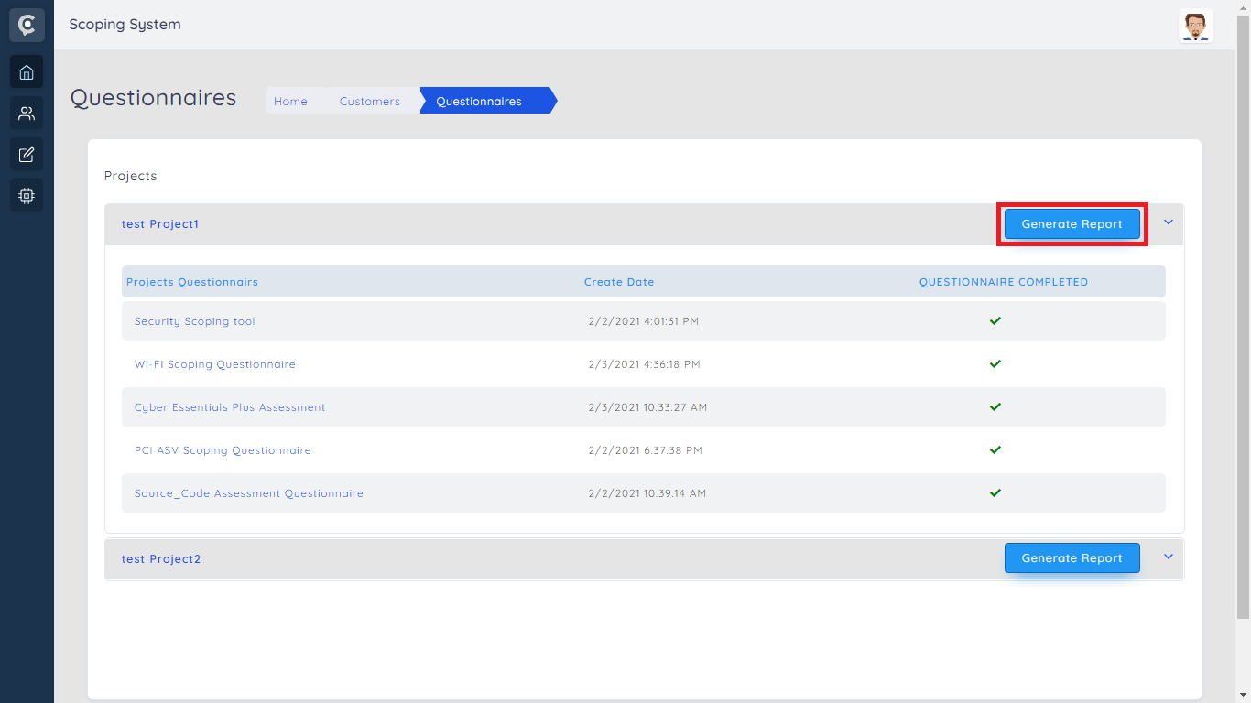

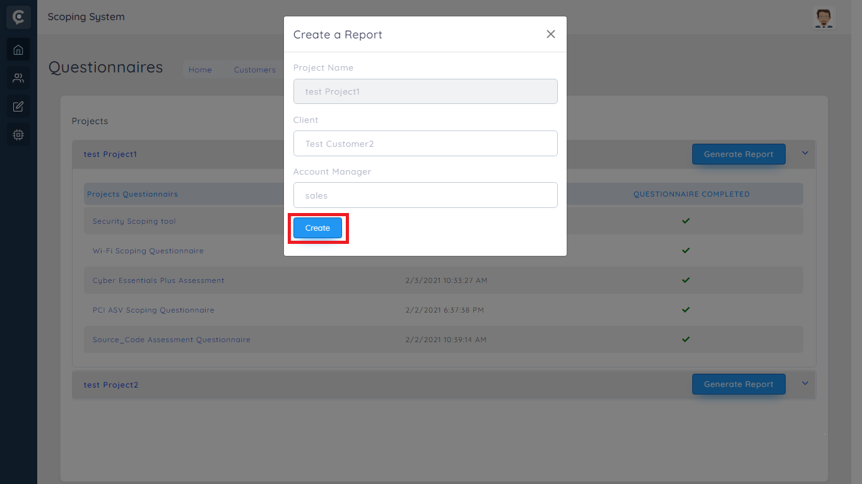

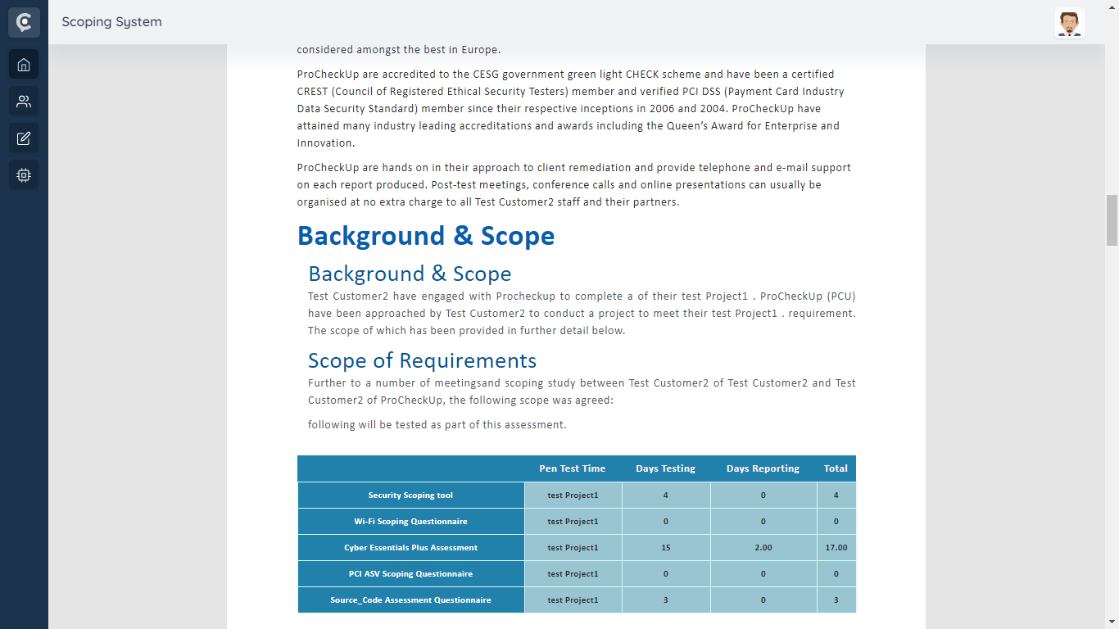

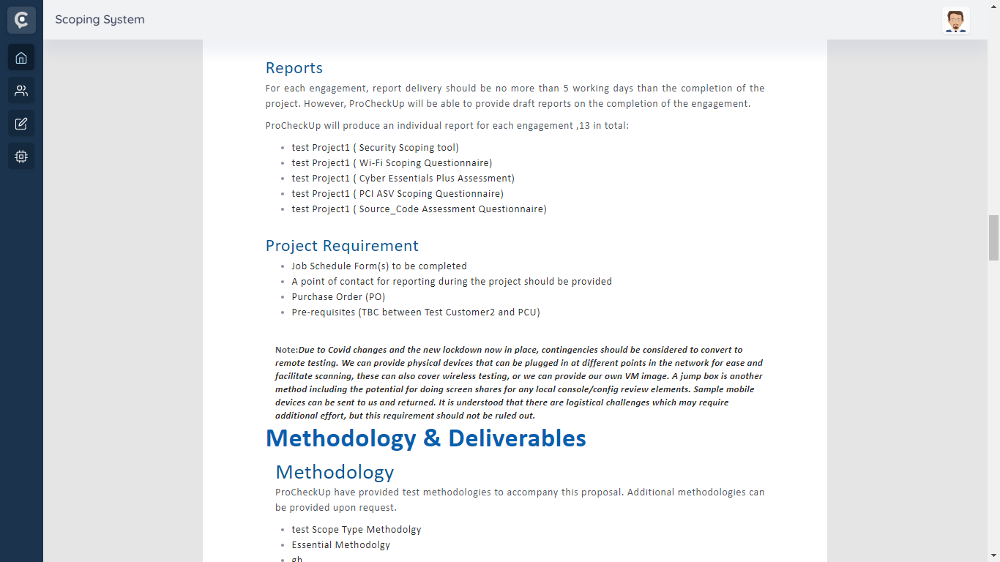

Note: - since it is partially implemented, we have not upload it to live.