1. For the salesman’s customer interface

<https://scoping.procheckup.com/Questionnaire/CustomerQuestionnair/fe7f4857-4a69-4e26-a9e2-a9cf0be86cdb>

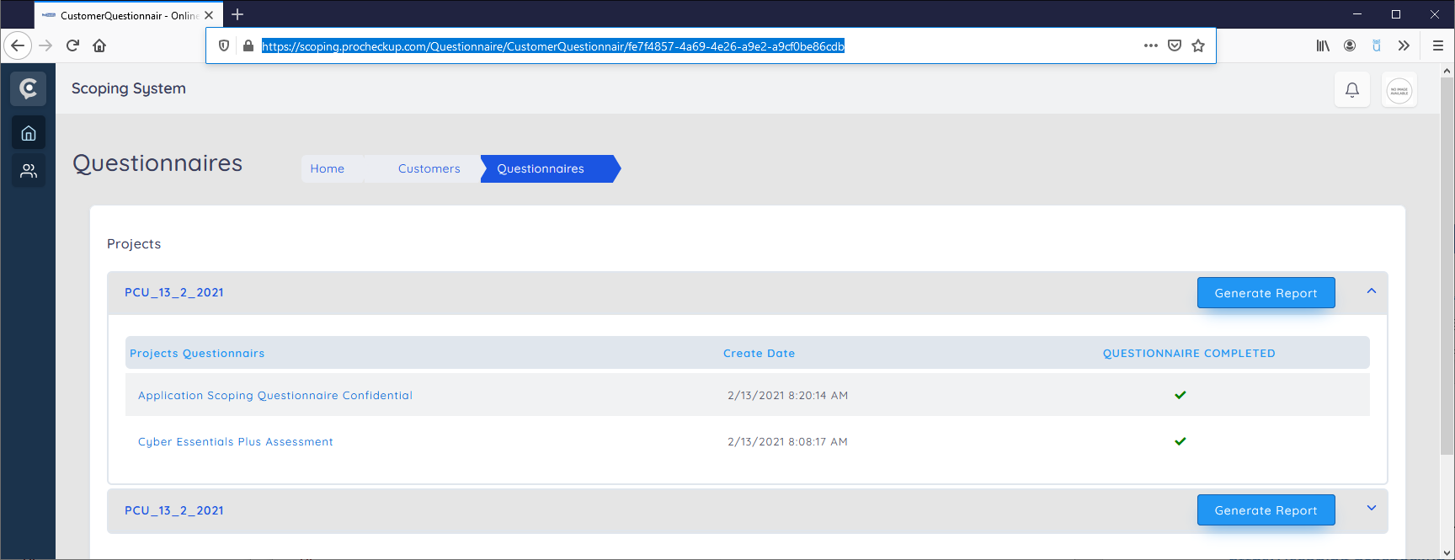

Rename “Generate Report” to “Generate Proposal”

Add option for each project to upload proposal, when selected displays a file browser and then uploads a selected file. (this is not illustrated as it is too obvious)

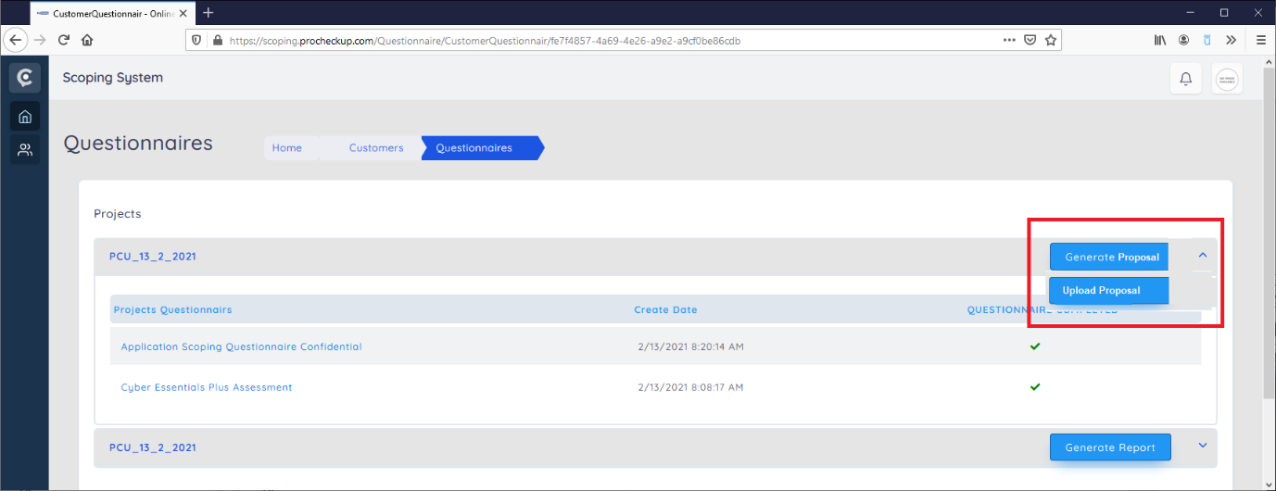

1. From the customer interface , for the received proposals screen

<https://scoping.procheckup.com/Customers/ReceivedProposal>

Needs to be changed , so that the received proposals are displayed in relation to the projects and the questionnaires completed as the below.

