Hi, Following issues is fixed on live server <https://portal.procheckup.com>

Add a search bar here, for the ‘Replacement Vuln’ area (mapping vulns): (Done)

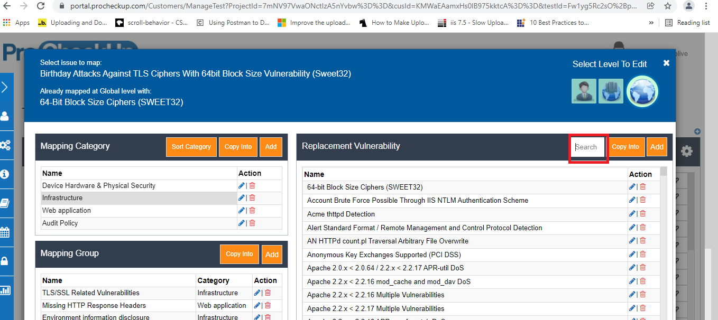

Add a new box here called ‘Process Monitor’, this link should take you to a new page (please create this page) where processes can be monitored and killed if needed. This option should only be available to admin on Portal: (Done)

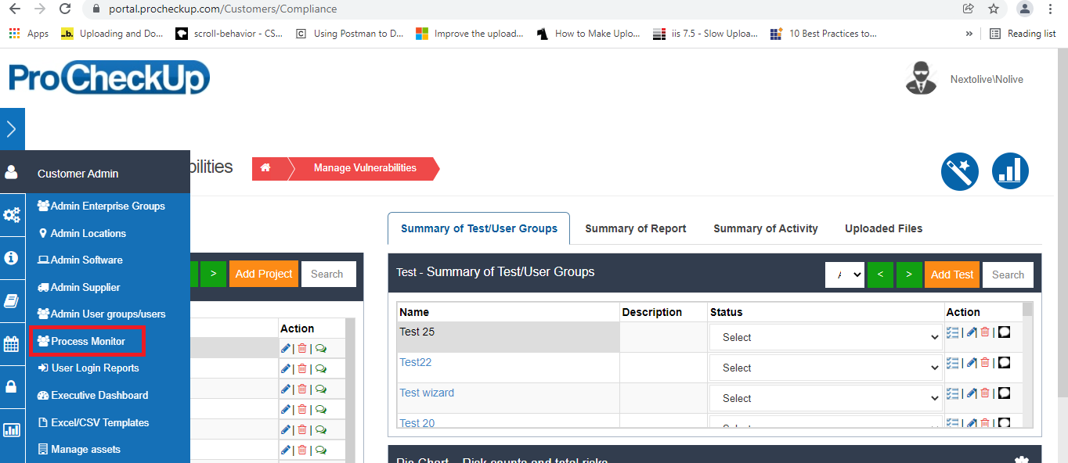

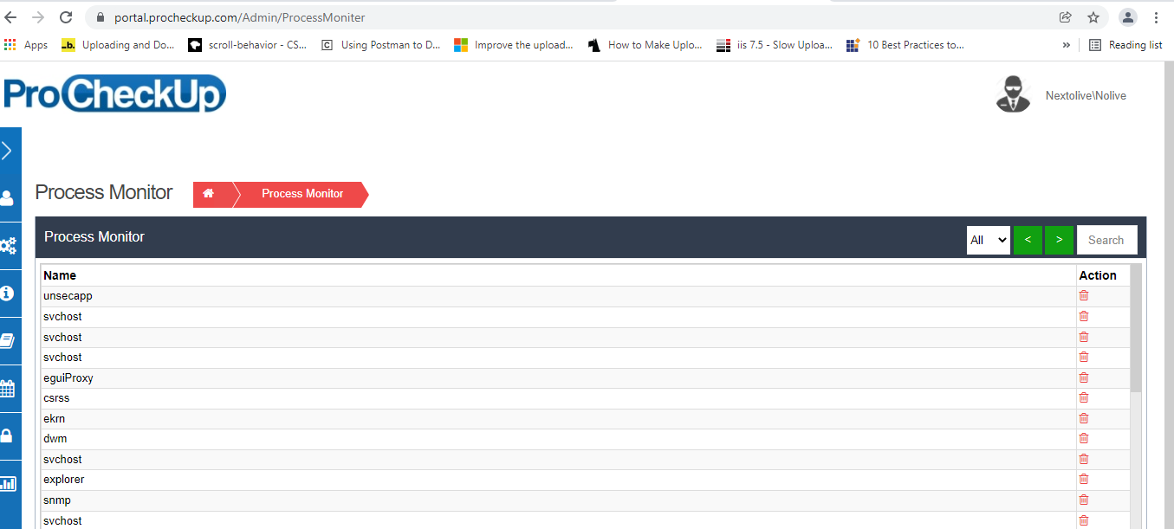

Working on other issues.