Hi,

Following functionality is implemented only on our local server in new scoping tool project.

1. Logging in as the salesman

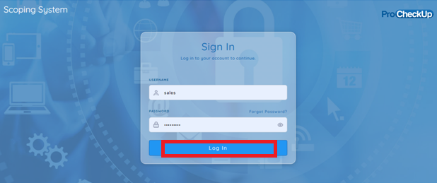

1. Click on project waiting for review

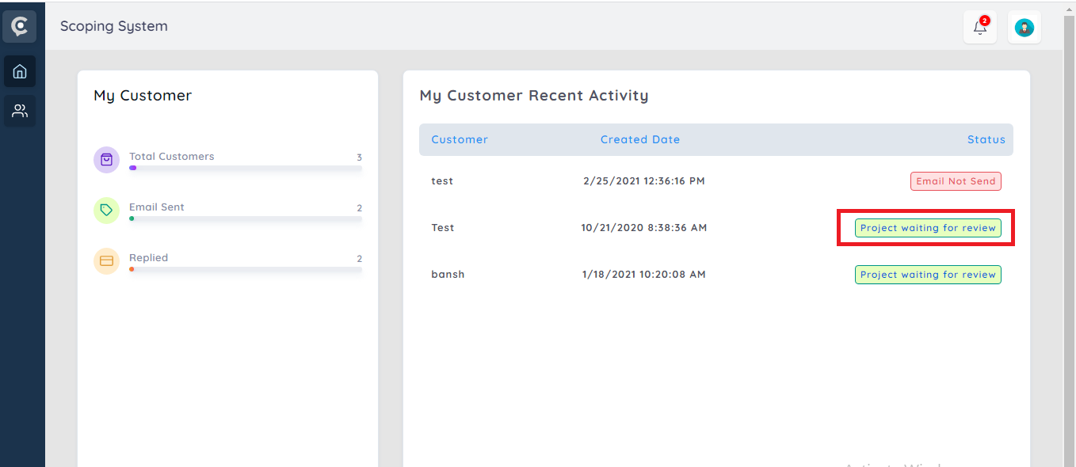

When the salesman uploads a proposal:-

There should be a record of the proposals sent, within the questionnaire management screen organized per individual project:-

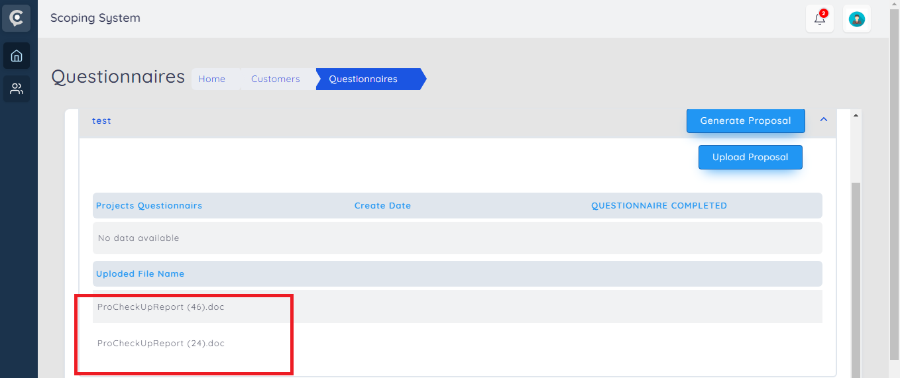

3)Then logging in as a customer:-

The customer should receive a e-mail message stating that that a proposal has been sent to them:-

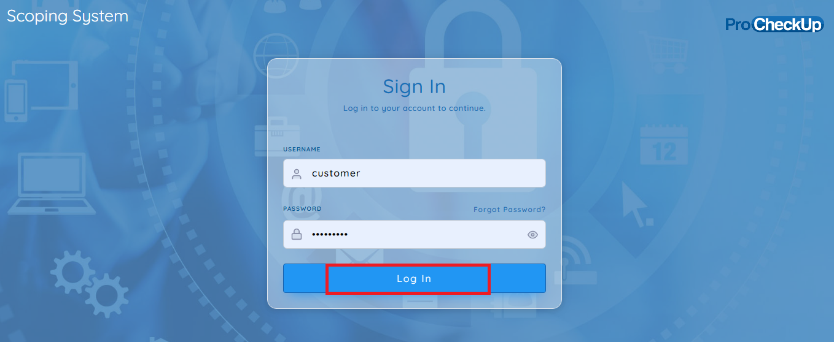

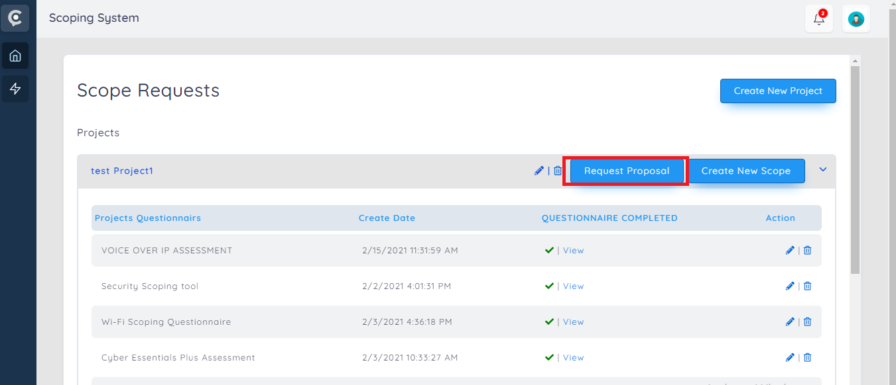

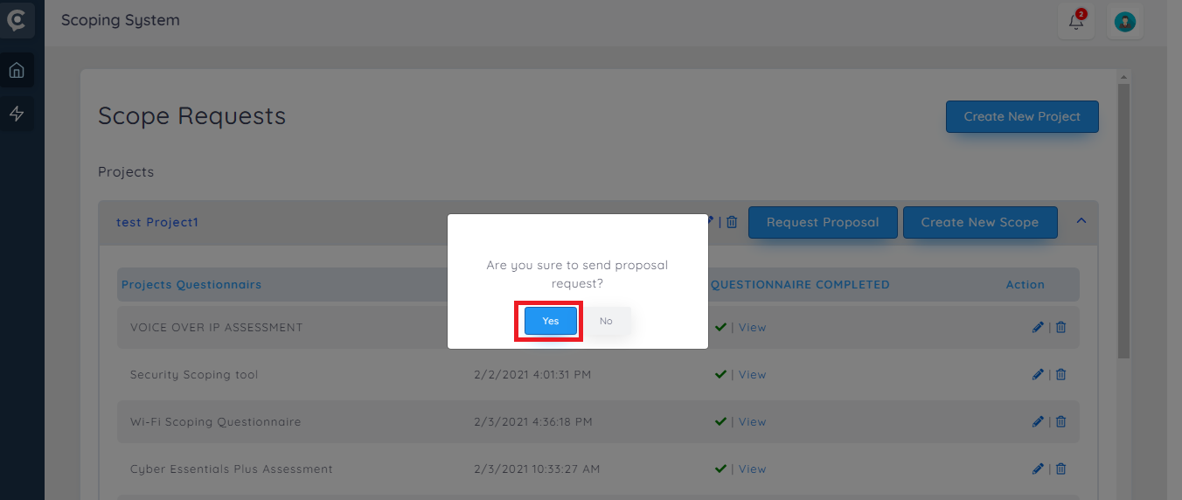

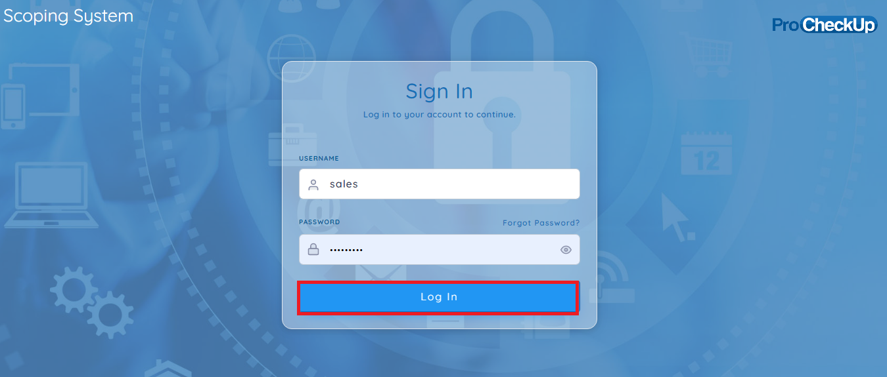

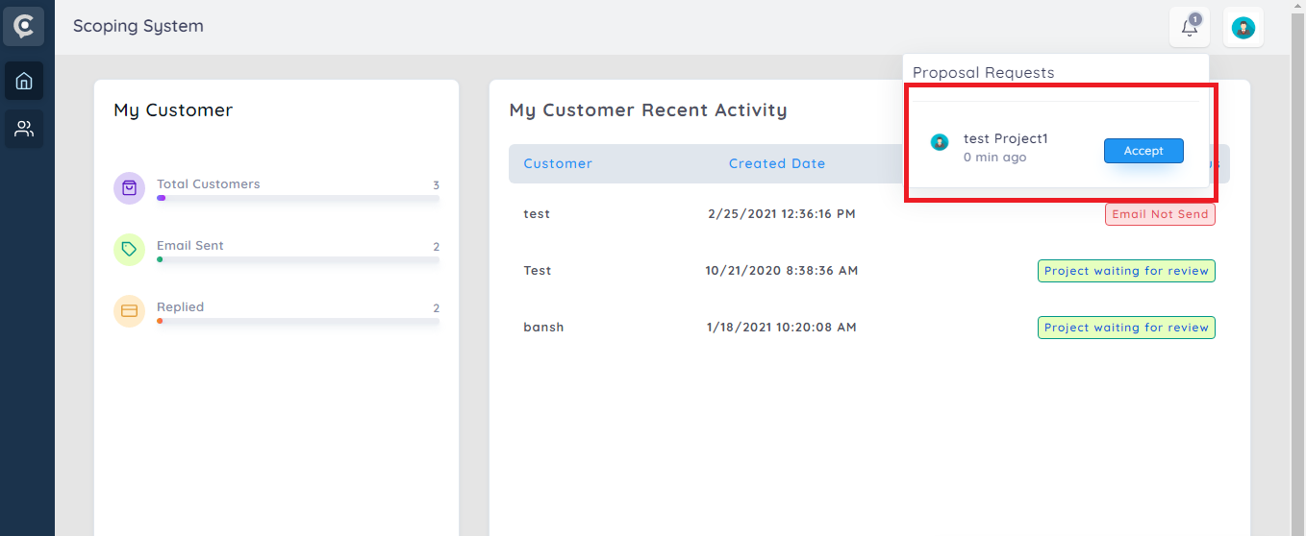

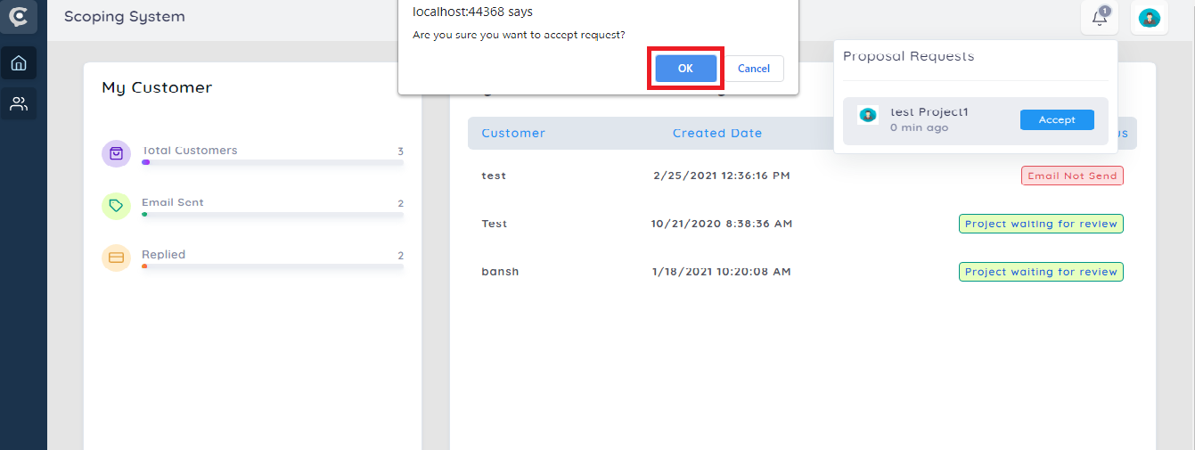

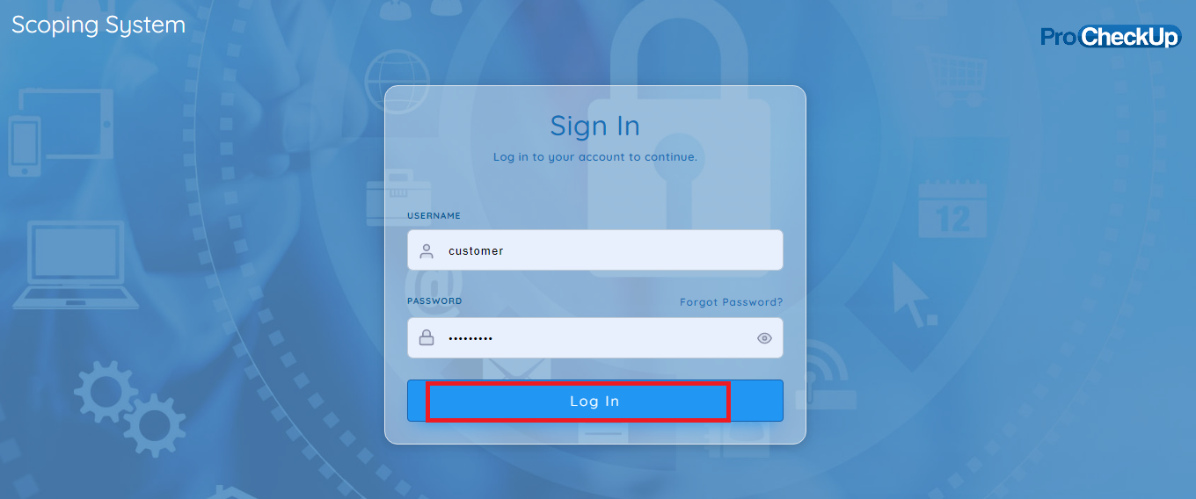

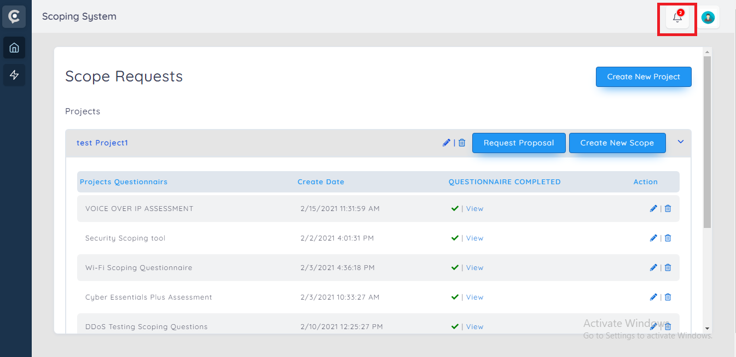

Note : Since it is partially implemented , we have not uploaded it to live server.