1. Bug – reset password does not work in admin console

Tried to reset password (Passw0rd!) of customer [richard@computer.uk.net](mailto:richard@computer.uk.net) in the admin console with administrator account logged in:-

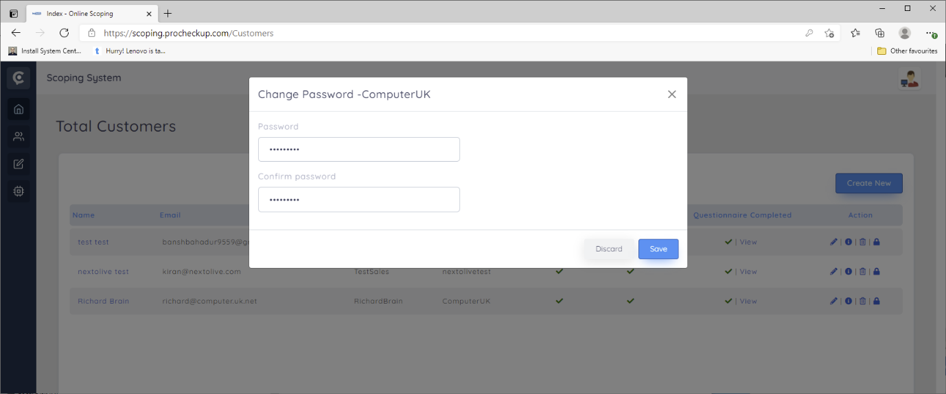

The tried to login as [richard@computer.uk.net](mailto:richard@computer.uk.net) with no luck

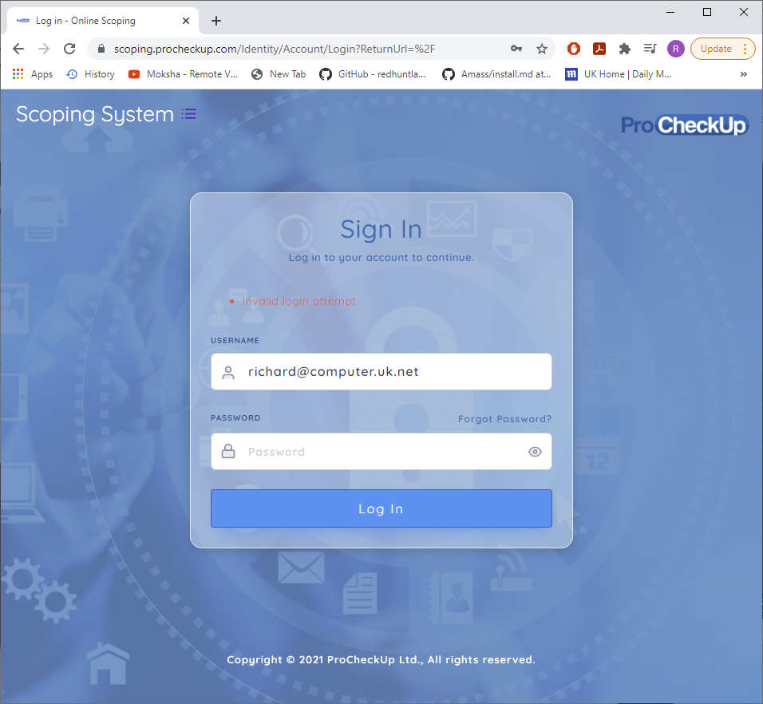

Same issued occurred with resetting sales users passwords

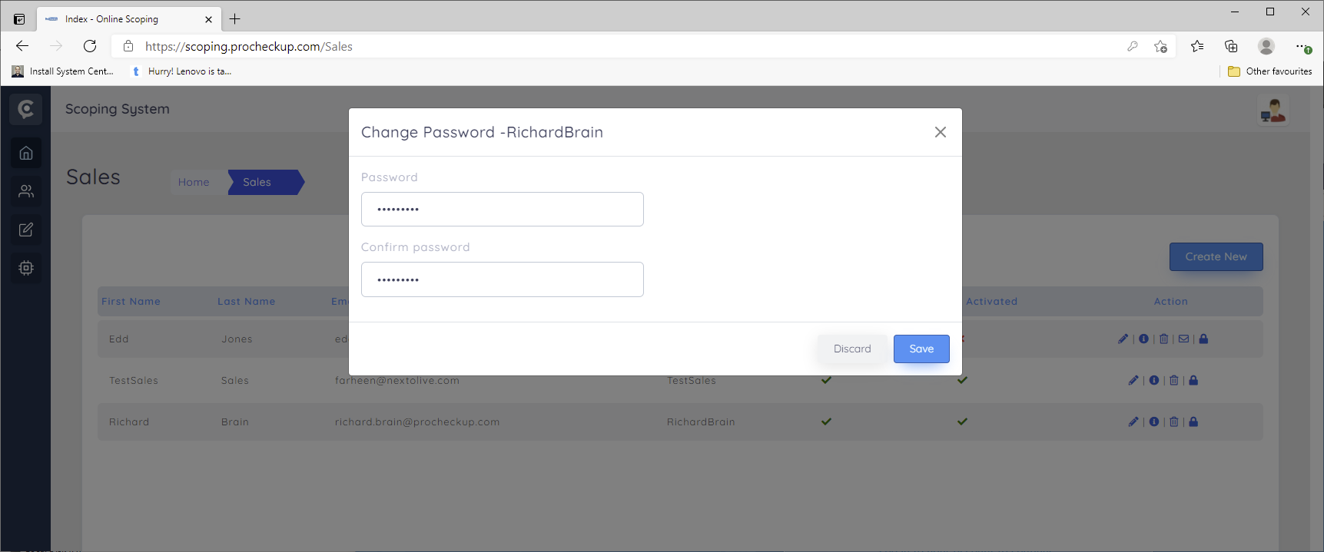

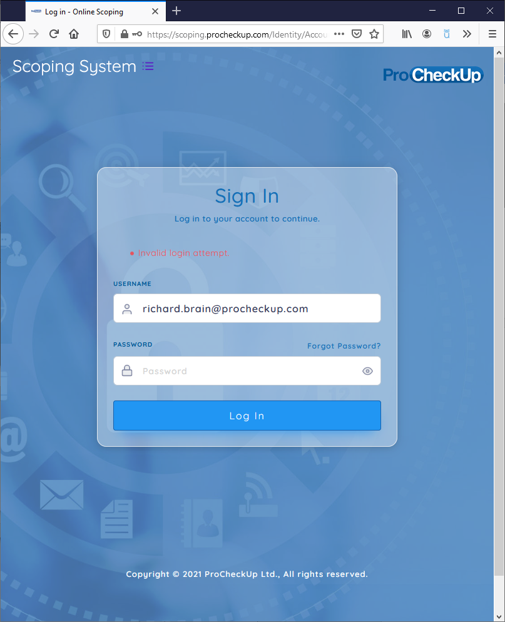

1. After logging in as a customer first time , “No data available” is displayed.

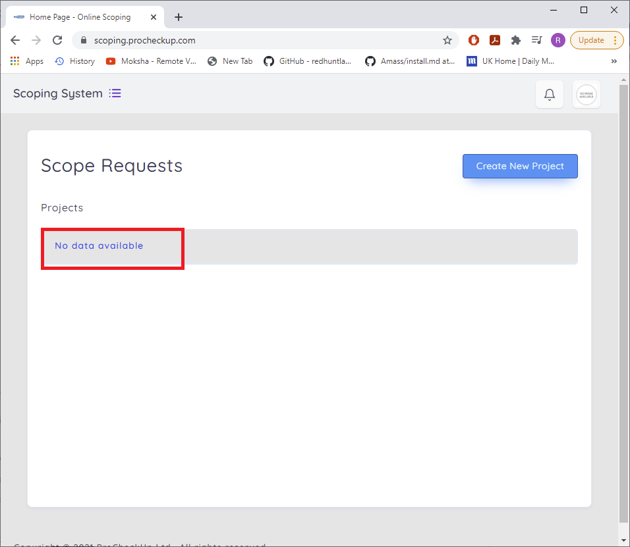

Instead can “Please Create New Project” be displayed?

1. For the following menu as a customer logged in, can the names be changed?

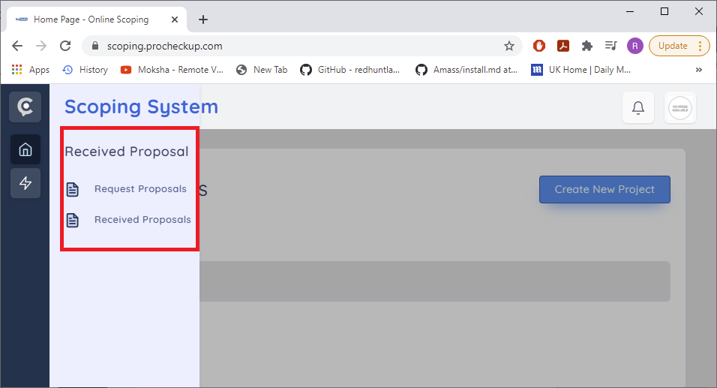

The menu name should be

“Scope management”

The sub items should be

Create/Request Scope

Scope Responses

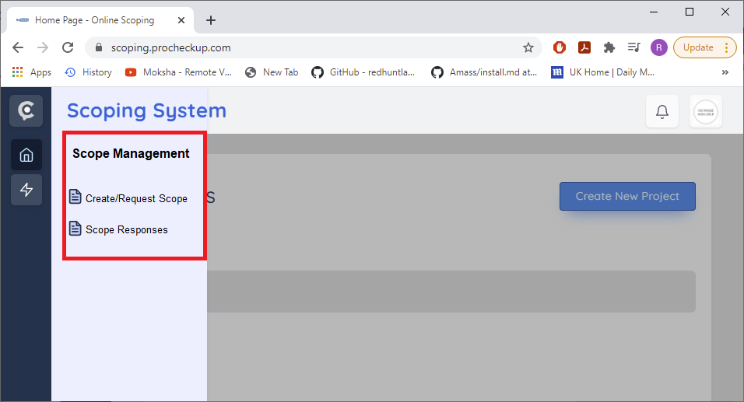

1. As the salesman the sent proposal is then accepted which then shows:-

<https://scoping.procheckup.com/Questionnaire/CustomerQuestionnair/943b4feb-e863-4325-8ae2-3f6ac59dbada>

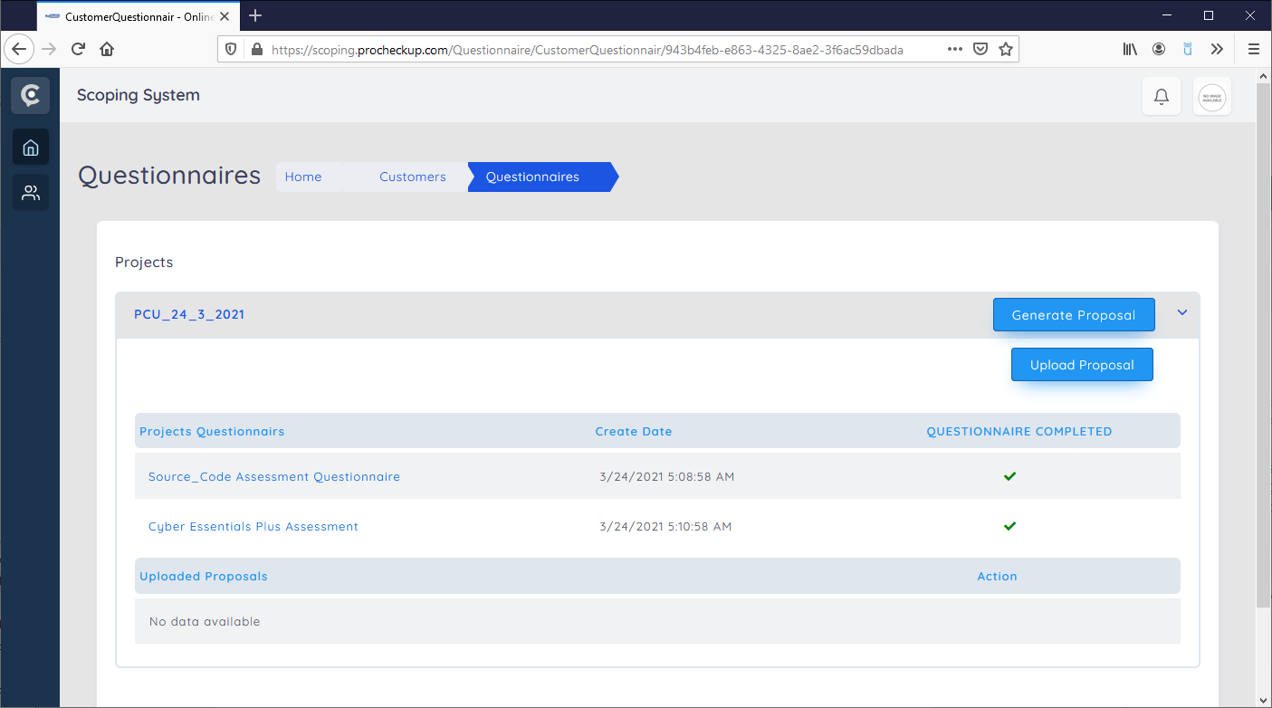

When the proposal is accepted by the sales man, the display of the respected logged in customer is unexpected and becomes blanked out. I would have thought the is expected tick to be displayed?

<https://scoping.procheckup.com/Customers/RequestProposal>

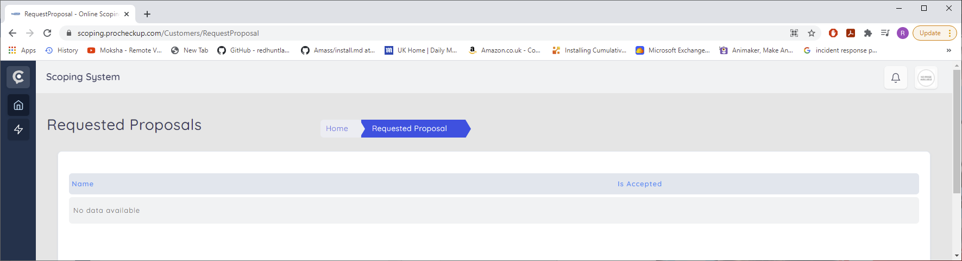

1. On create proposal, can a return button be added, to return to the prior screen

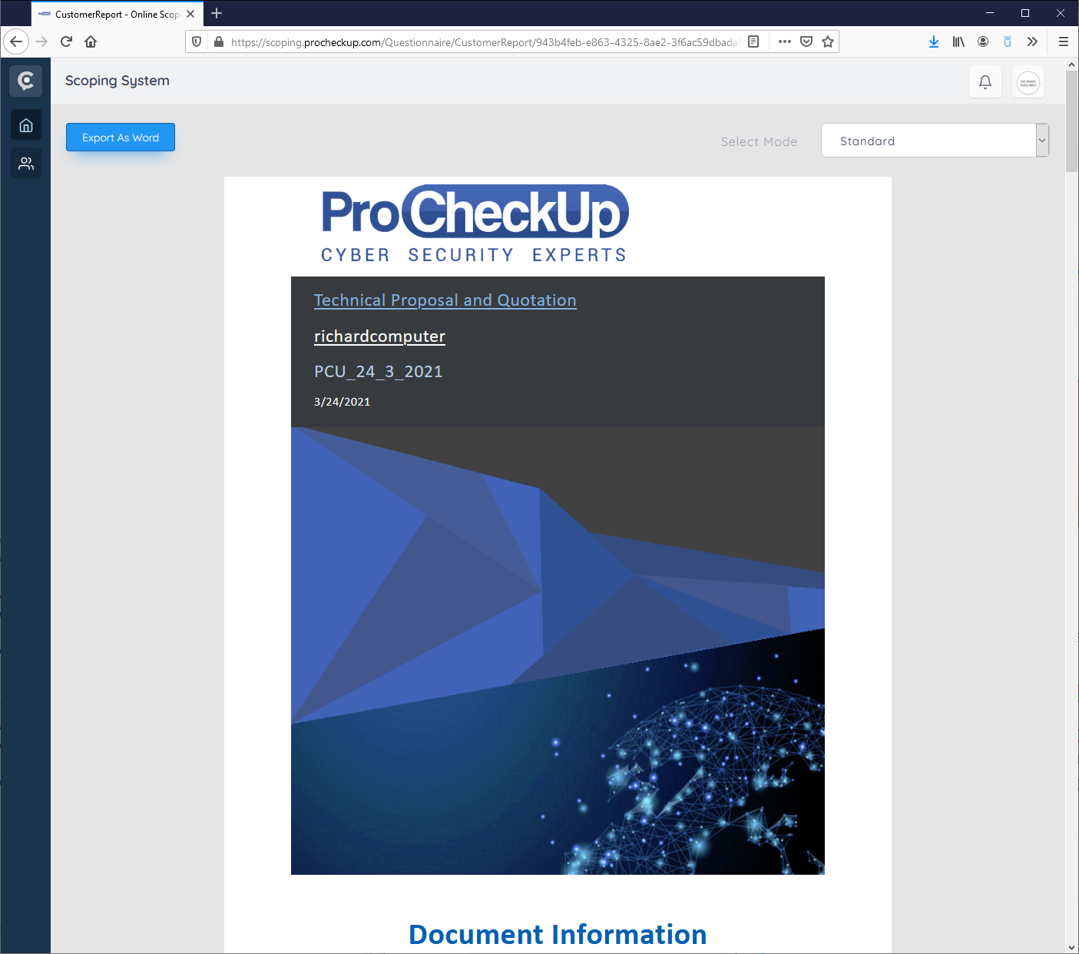

1. After the proposal is uploaded by a logged on customer, a button need to be added to download the associated methodologies.

