Hi,

Following functionality is implemented on live server in scoping tool project.

<https://scoping.procheckup.com>

1. We have added a button to send emails to customer from sales login.

13/2/2021 When logging in as a salesman [richard.brain@procheckup.com](mailto:richard.brain@procheckup.com) / Passw0rd!

For the customer management screen, can an icon be added to send the customer a e-mail link

<https://scoping.procheckup.com/Customers>

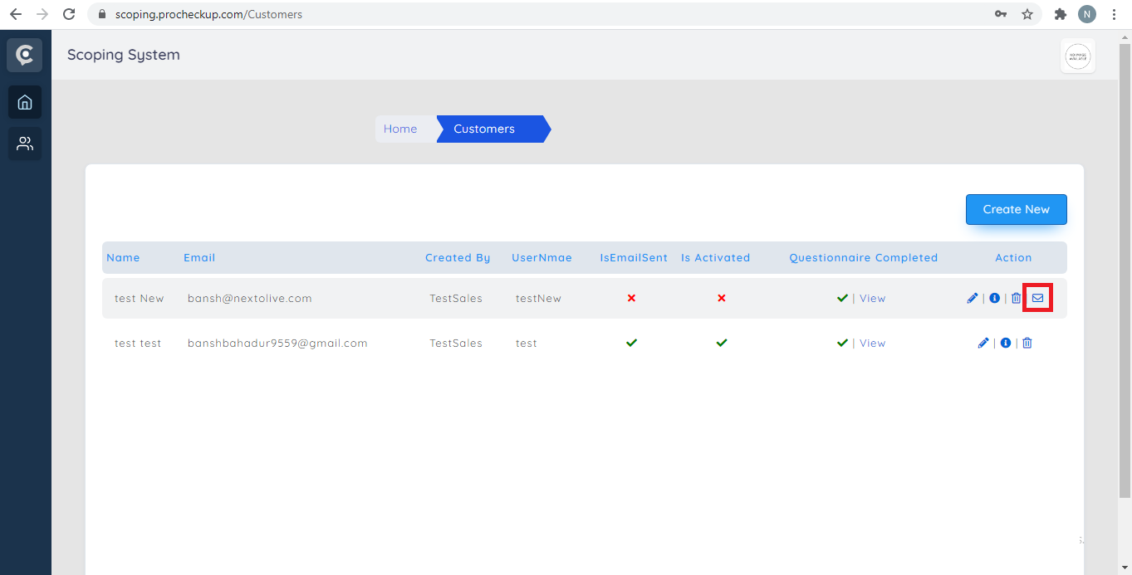

2) We have also added tick boxes in section 9.

13/2/2021 THIS HAS ALREADY BEEN REQUESTED, CERTAIN options within the “APPLICATION SCOPE” should use tick boxes, not entry boxes. All of section 9 should use tick boxes.

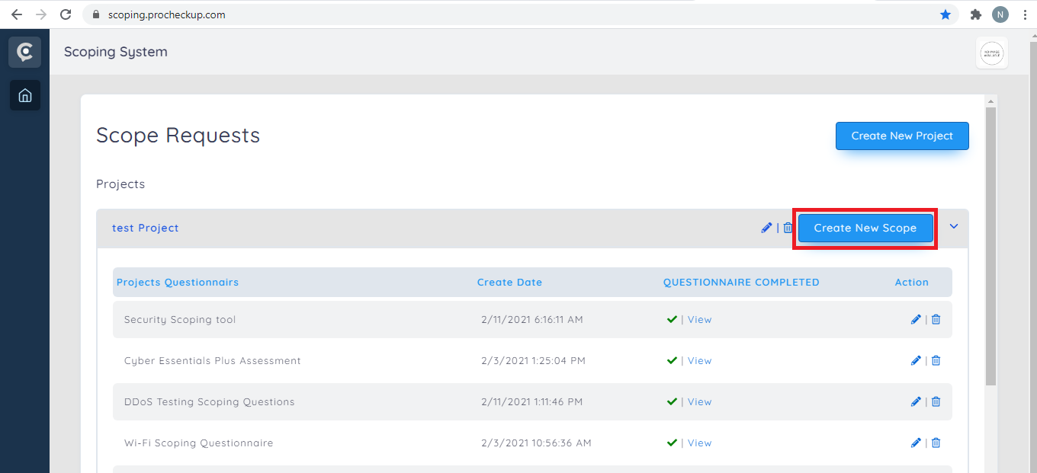

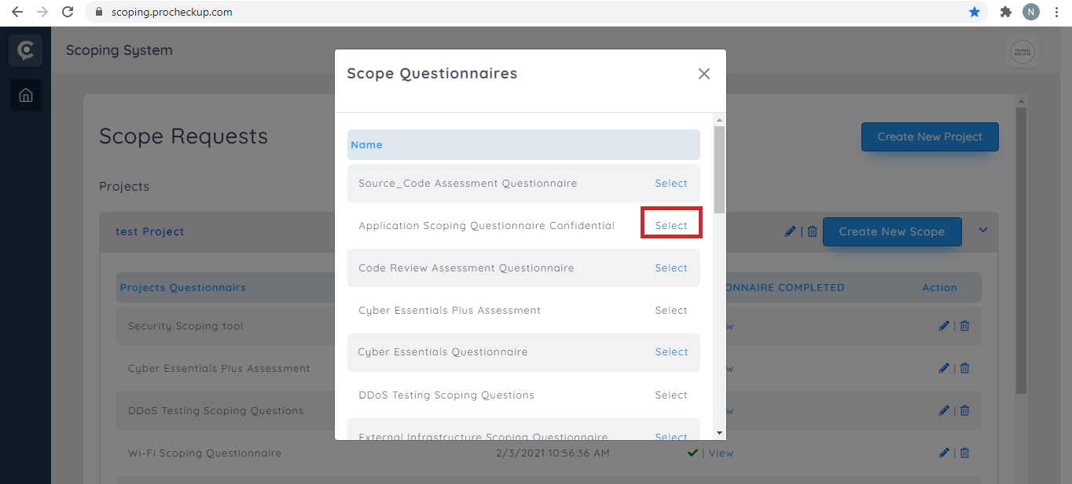

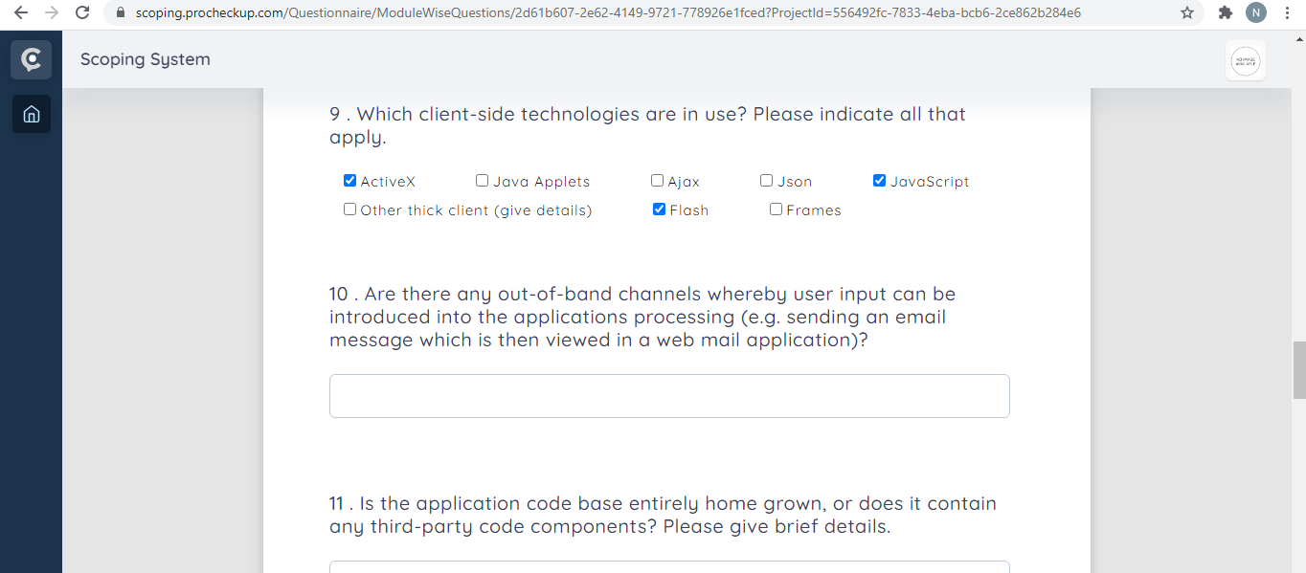

3) We have added scope type methodology input in admin section in all questionnaires.

As a customer the scope type methodology/ Scope type methofology filenname inputs are visible. Which ONLY admins should be able to change, they should not be visible to customers. (can this be done with all scope questionnaires?)

