1. For the customer management screen

[Index - Online Scoping (procheckup.com)](https://scoping.procheckup.com/Customers)

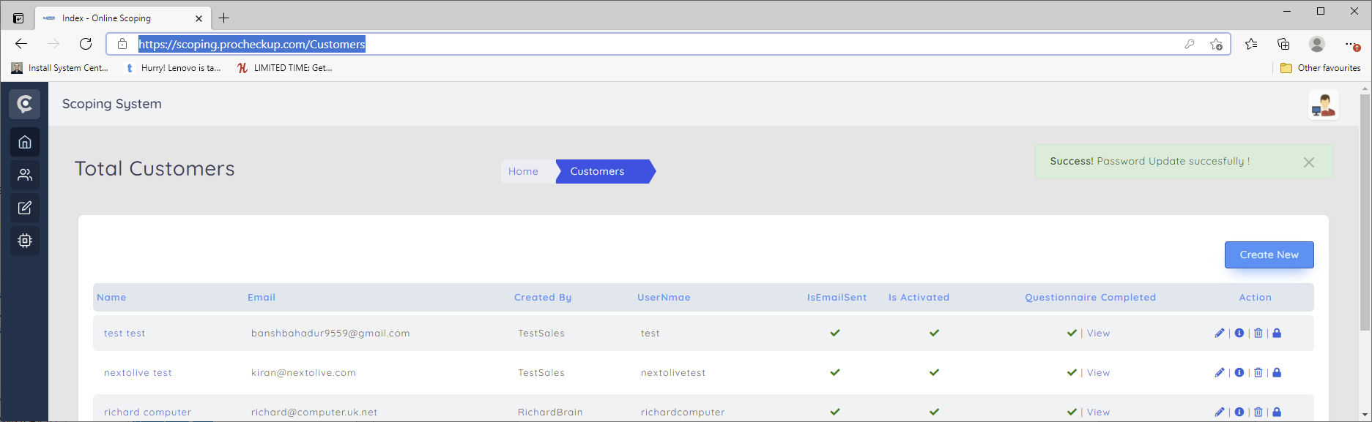

Can multifactor authentication be enabled/disabled as an option?

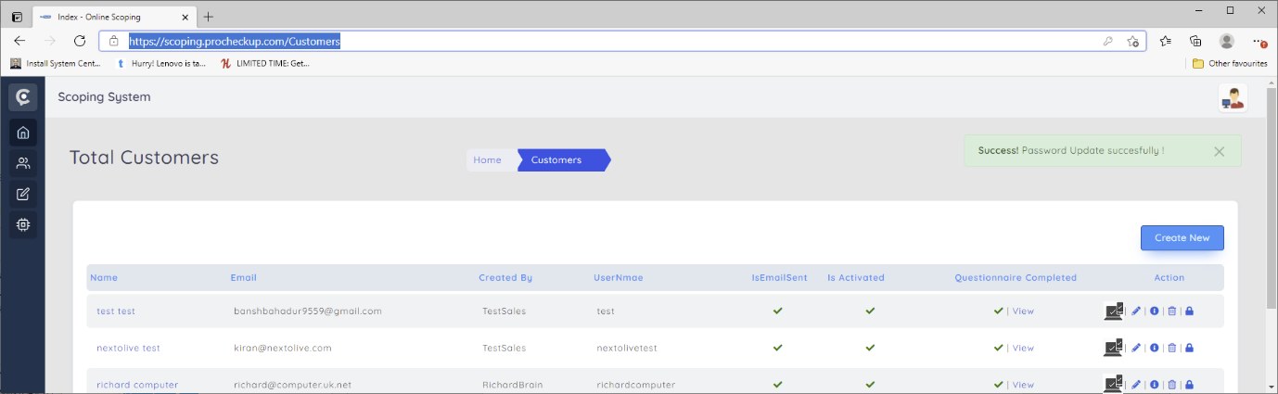

1. For the sales management screen

<https://scoping.procheckup.com/Sales>

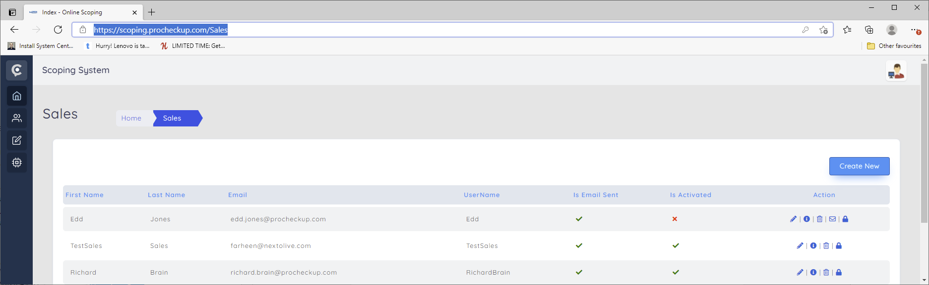

Can multifactor authentication also be enabled/disabled as an option?

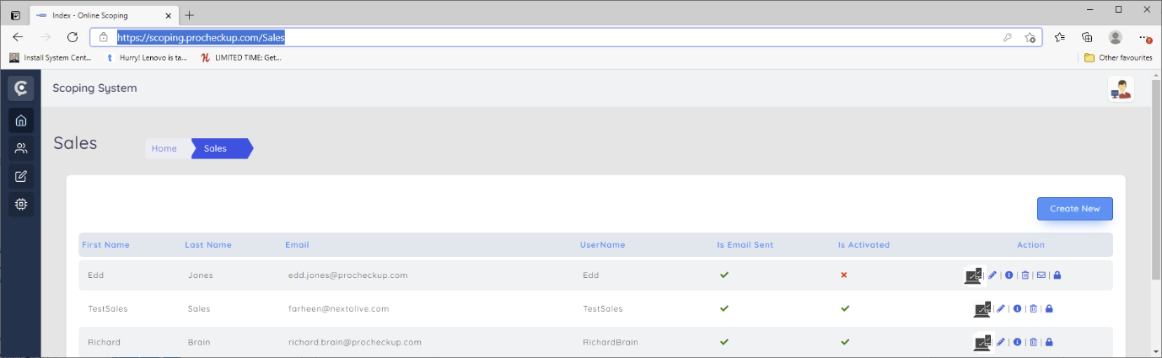

1. The customers screens neeed improving for clarity.

For the create/Request scope screen

<https://scoping.procheckup.com/Customers/RequestProposal>

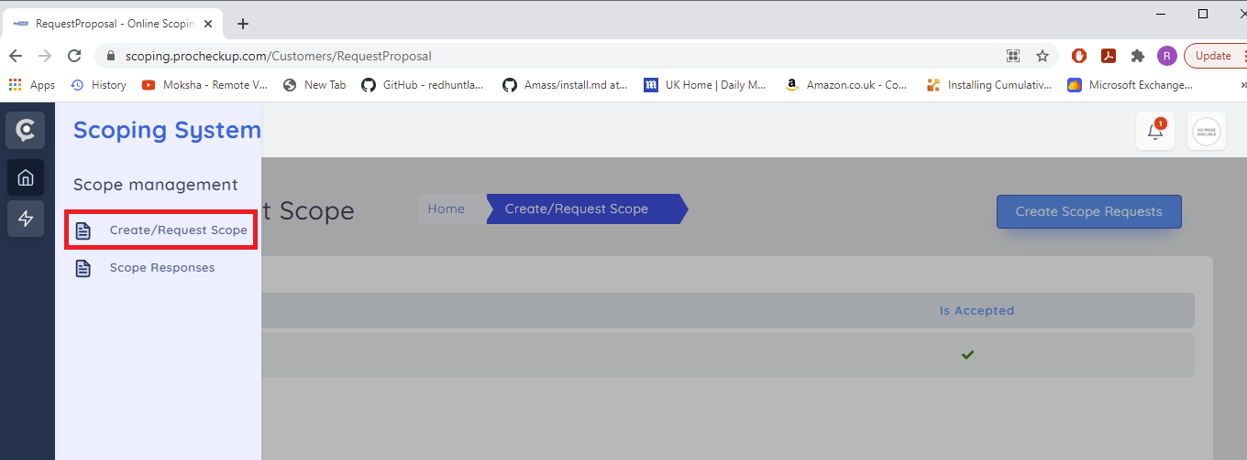

Can the screen been changed to that of the dashboard home screen

<https://scoping.procheckup.com/>

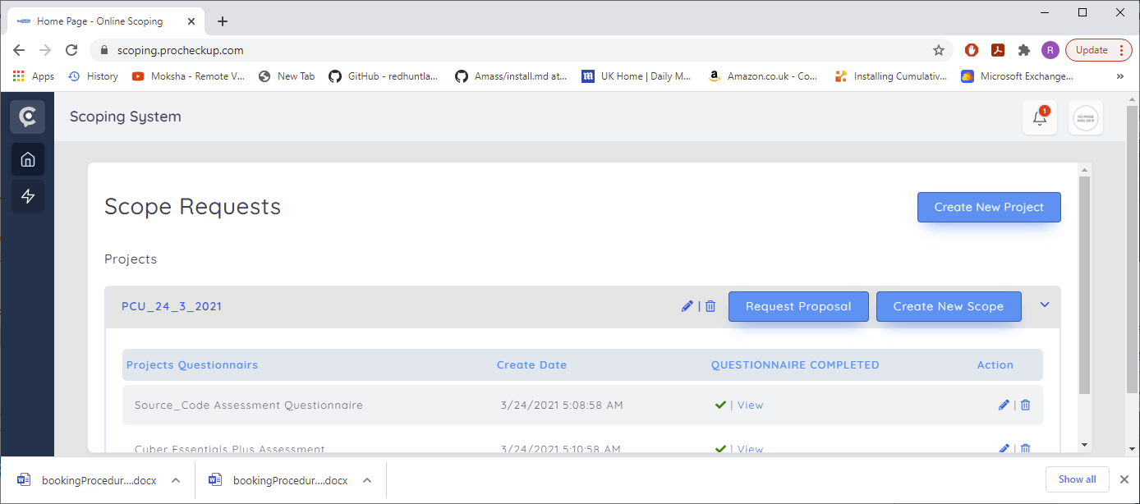

So that <https://scoping.procheckup.com/Customers/RequestProposal>

Displays the following screen:

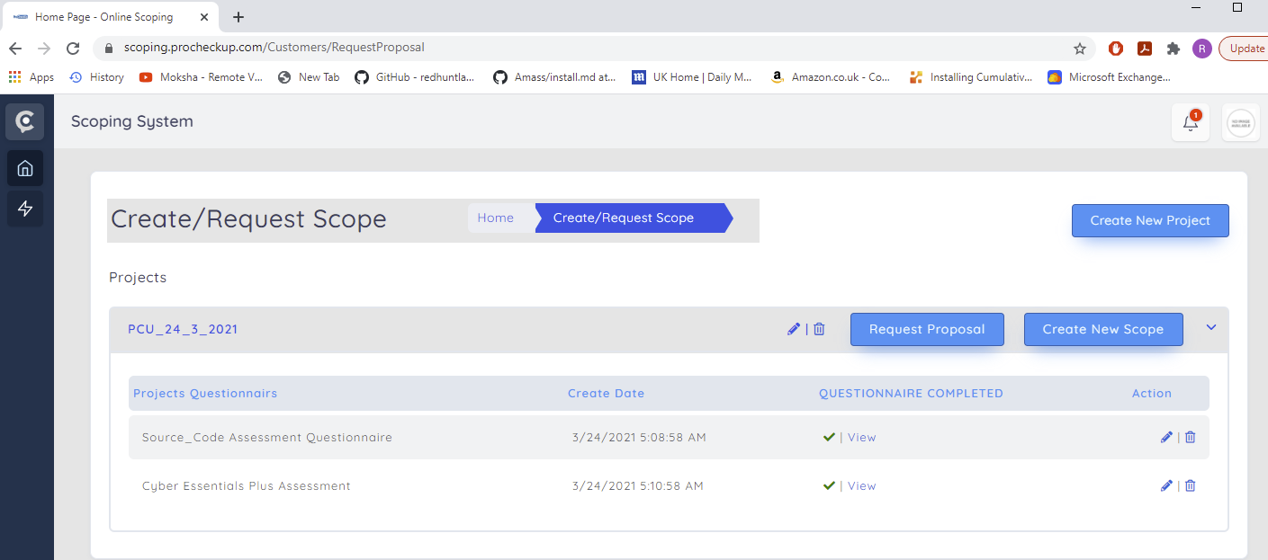

1. And that scope responses now displays the following hybrid screen

Annoyed that this was done as requested on the 23/3/2021

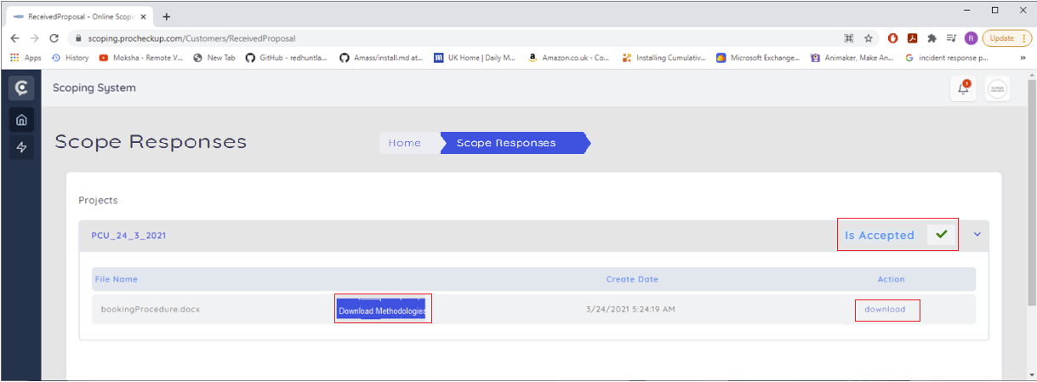

Is accepted tick box has been added, as is two different download buttons, one for the downloading the uploaded sales proposal and one for downloading the multiple methodologies associated with the different scopes the customer submitted.

1. The above downloaded methodologies are defined within the scopes, consisting of the methodology and the sample report.

For example logging in as administrator

<https://scoping.procheckup.com/Questionnaire/UpdateAllQuestionnaires/9eb229a8-c20b-42b5-9d1a-2887e1616223?QuestionnaireId=9eb229a8-c20b-42b5-9d1a-2887e1616223>

At the end of the source code assessment questionnaire

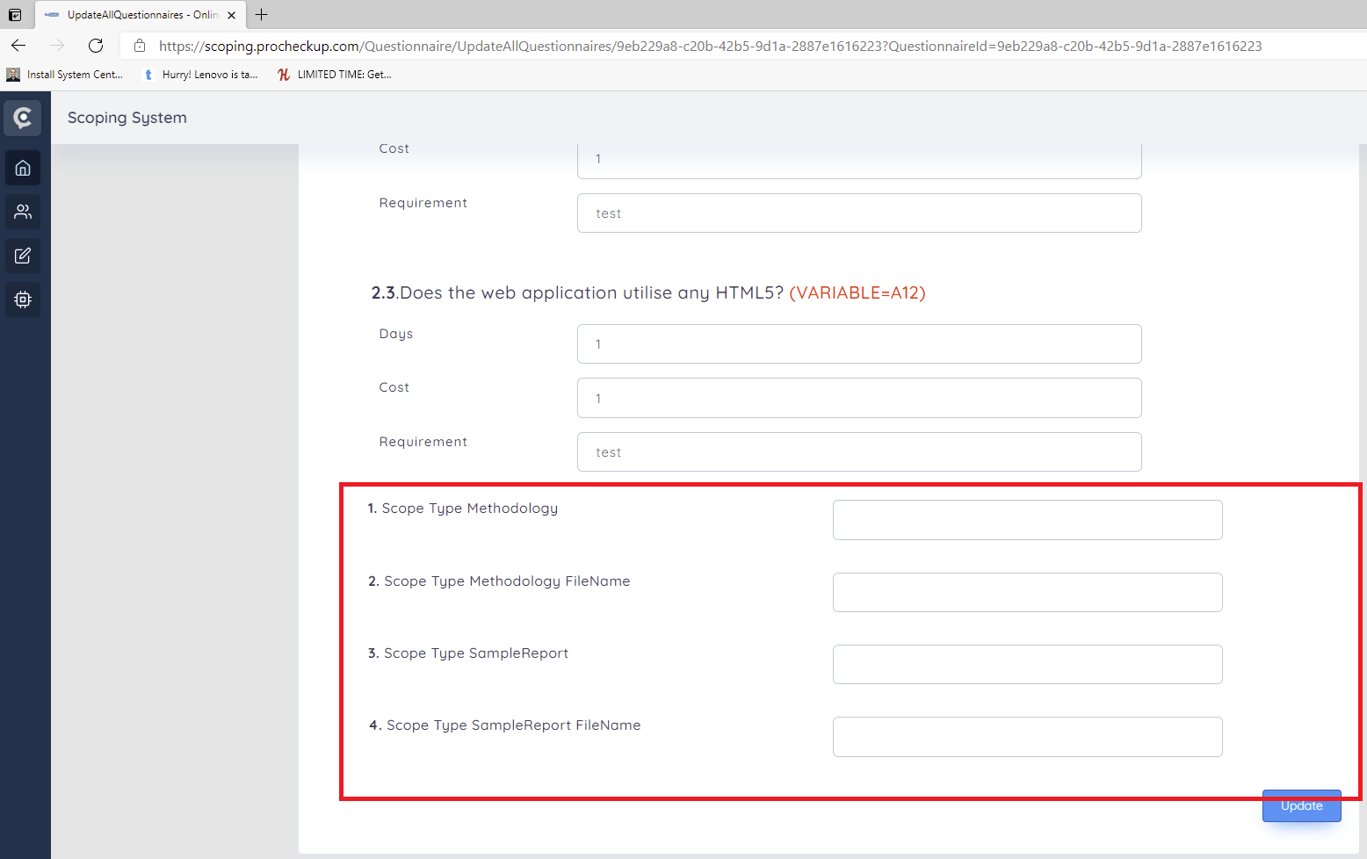

Can the various methodology and sample report documents be managed in the same way as the portal? With a document management screen allowing .docx or pdf documents to be uploaded and updated. And then downloaded by the customer?

For instance the portal admin screen

[admin.portal.procheckup.com/Administration/AdminLearnAboutPCIDashboard](http://admin.portal.procheckup.com/Administration/AdminLearnAboutPCIDashboard)

