



**SAGAR INSTITUTE OF**

**RESEARCH AND TECHNOLOGY**

## Topic Name:- Data Science With Python

**Submitted By :-** Name – YASH NEMA RollNo. – 0133CY221145 Dept. – CSCY-B

**Submitted To :-**

### Abhishek Bharadwaj Sir

<--Data Science-->

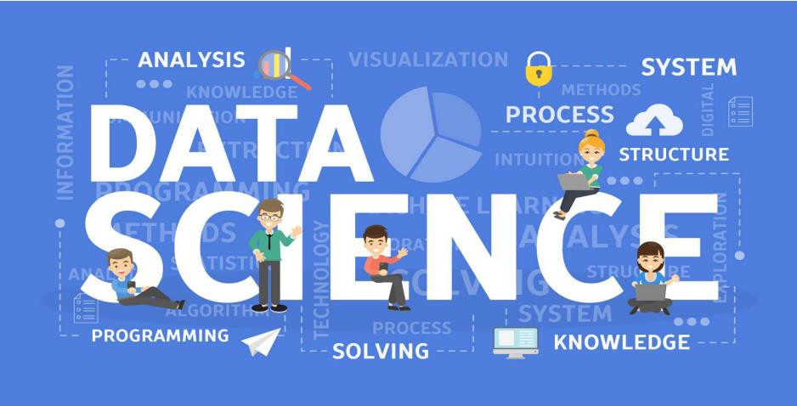



# <--Introduction to Data Science

Data Science is an interdisciplinary field that involves the extraction of knowledge and insights from structured and unstructured data. It combines techniques from statistics, mathematics, computer science, and domain-specific knowledge to analyze and interpret complex data sets.

The primary goal of data science is to turn raw data into actionable insights, supporting decision- making processes and driving innovation .

# Key components of data science include:

1. **Data Collection**: Gathering raw data from multiple sources like databases, APIs, or sensors.
2. **Data Cleaning:** Ensuring the data is accurate, consistent, and usable by handling missing values, duplicates, and errors.
3. **Exploratory Data Analysis (EDA):** Using statistical tools and visualizations to understand data patterns and relationships.
4. **Machine Learning:** Applying algorithms to make predictions, classifications, or recommendations based on data.
5. **Data Visualization:** Presenting insights in a clear and visually appealing manner using tools like Tableau, Power BI, or Python libraries.
6. **Communication:** Explaining findings to stakeholders in an understandable way to drive data-driven decisions.

# Why is Data Science Important?

## preencoded.pngWorks in Real-Time

1

Some industries, like finance or healthcare, need instant results. Data Science can analyze information as it happens, allowing quick actions like monitoring patient health or analyzing stock markets.

## Predictive Analytics

Using past data, Data Science can help predict things like sales trends, customer behavior, or when a machine might break down. This helps businesses prepare better.

2

## Helps Make Better Decisions

Data Science helps businesses and organizations understand what’s happening and predict what could happen in the future. This means decisions are based on facts, not just guesses.

3

1

2

3

4

5

6

### Data Collection

A retail store collects sales data, customer reviews, and website activity.

### Data Cleaning

Clean the data by removing errors, fixing missing values, and organizing it in a usable format.

### Data Exploration

Understand the data by visualizing it and looking for patterns, trends, or outliers.

### Modeling

Use machine learning or statistical techniques to create models that can make predictions or classifications.

### Evaluation

Test the model to see how well it works. This includes checking its accuracy and ensuring it’s reliable.

### Deployment

Put the model into a real-world environment where it can be used by people or systems.



# Applicationsof Data Science

1. **Healthcare:** Predictive Analytics: Forecasting disease outbreaks, patient admissions, and identifying high-risk patients.
2. **Finance:** Fraud Detection: Identifying unusual patterns and anomalies in financial transactions.
3. **Retail and E-commerce:** Recommendation Systems: Offering personalized product recommendations to customers.
4. **Manufacturing and Supply Chain:** Predictive Maintenance:

Anticipating equipment failures and minimizing downtime.

# Data Science Life Cycle

* 1. 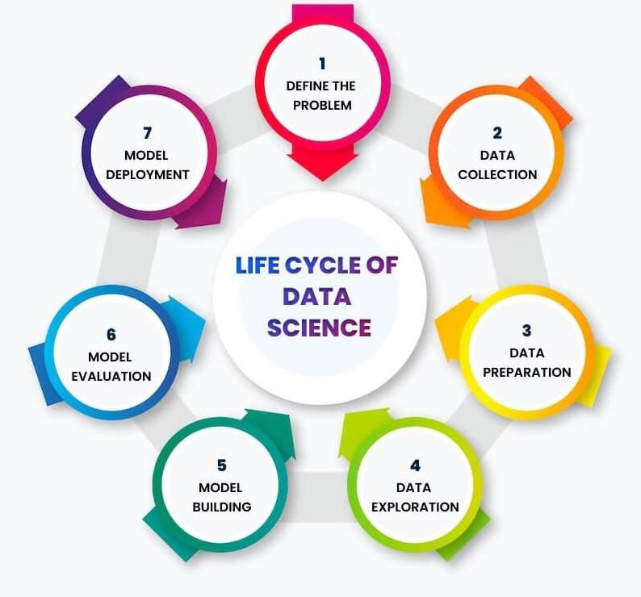Understanding the Business Problem
  2. Data Collection
  3. Data Cleaning
  4. Exploratory Data Analysis (EDA)
  5. Model Building and Evaluation
  6. Communicating Results
  7. Deployment & Maintenance

Challenges in Data Science

## Data Quality:

* 1. Poor quality data can significantly impact the accuracy and reliability of analyses and models.

## Data Privacy and Security:

* 1. Safeguarding sensitive information is a critical concern.

## Lack of Data Standardization:

* 1. Data may be collected in different formats and units, making it challenging to integrate and analyze effectively.

## Scalability:

* 1. As datasets grow in size, the computational and storage requirements for analysis and modeling increase.

## Interdisciplinary Skills:

* 1. Data science requires expertise in statistics, mathematics, programming, and domain-specific knowledge.

# Future Trends

## Automated Machine Learning (AutoML):

* 1. AutoML tools and platforms continue to advance, making it easier for non-experts to build and deploy machine learning

models.

## AI Ethics and Responsible AI:

* 1. With increased awareness of biases and ethical considerations in AI models, there will be a greater focus on developing and implementing ethical guidelines and frameworks for responsible AI.

## Edge Computing for AI:

* 1. Edge computing involves processing data closer to the source rather than relying on centralized cloud servers. I

## Natural Language Processing (NLP) Advancements:

* 1. NLP will continue to advance, allowing machines to better understand and generate human-like language.

## DataOps and MLOps:

* 1. DataOps and MLOps practices involve applying DevOps principles to data science and machine learning workflows.

**Thank You**