**Portfolio:**

Assuming young guy who wants a car with high cc power and he also wants to check its mileage no matter it is low or high.

**Source:**

**//which helps not to include mtcars in each var**

**attach(mtcars)**

**//plot the cars (x= disp and y = mileage)**

**plot(disp, mpg, xlab="Displacement", ylab="Mileage", main="MPG vs displacement in cubic inch")**

**//some features of the graph**

**text(disp, mpg, row.names(mtcars), cex = 0.6, pos = 4, col="red")**

**Output:**

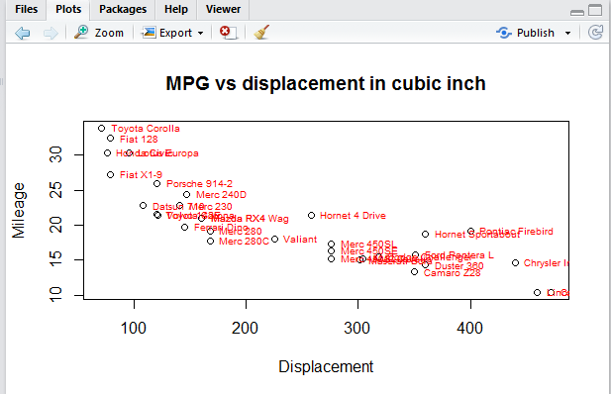

**attach(mtcars)**

**plot(hp, gear, xlab="Horsepower", ylab="gear", main="MPG compared with engine displacement")**

**text(hp, gear, row.names(mtcars), cex = 1, pos = 4, col="black")**

