Topic: Travel Scholarship and Code Competition
Keywords: Nanocomposite, Interface, Representative Volume Element
GENERATING REPRESENTATIVE VOLUME ELEMENT (RVE) FOR FINITE ELEMENT ANALYSIS OF RANDOM FIBER COMPOSITES/NANOCOMPOSITES
Rajni Chahal¹, Ashfaq Adnan^{2*}, Ajit Roy^{3*}
¹PhD Student, Department of Mechanical & Aerospace Engineering, The University of Texas at Arlington
²Associate Professor, Department of Mechanical & Aerospace Engineering, The University of Texas at Arlington
³Materials & Manufacturing Directorate, Nanoelectronic Materials Branch, Air Force Research Laboratory, U.S.A.
…
*Corresponding Authors: aadnan@uta.edu, ajit.roy@us.af.mil

ABSTRACT:

Typical electronics packages are assembled by integrating various parts on printed circuit boards (PCB). Traditional interconnect materials in electronics packages are not suitable for DoD electronics because in many DoD extremely transient conditions, mechanical failures of the whole packages invariably occur due to interconnect junction failures. The long-term objective of the research is to computationally investigate the effect of high strain rate loadings on the thermal and mechanical damage/failure of carbon nanotube reinforced polymer nanocomposites, while retaining their electrical functionality. In pursuit of our research goal, we first seek to obtain the elastic response of the nanocomposites.
In particular, Carbon nanotubes (CNTs) are dispersed in polymer matrix similar to a random fiber network. Currently available computational studies consider a Representative Volume Element (RVE) constituted of CNTs with “assumed” orientation and distribution in the polymeric matrix. It has been reported in the literature¹ that various parameters, such as length, diameter, orientation, distribution, and volume fraction of fiber, etc., are critical in depicting the mechanical behavior of a network, or any network based composite. Thus, it becomes necessary to generate a model which can take care of these parameters in order to predict a realistic response of random fiber composites.

MODEL GENERATION USING MATLAB CODE:

In the present study, we have developed a Matlab code to statistically generate a computational model for evaluating properties of random fiber composites, such as CNT based polymer nanocomposites. Matlab uses algorithms that make the results appear to be random and independent. The results also pass various statistical tests of randomness and independence². Using this technique, we can create a two-dimensional network of CNTs spread on a polymer matrix. Our code explicitly includes the parameters such as length, diameter, orientation, distribution, and volume fraction of fiber. Straight or curved fibers with random curvatures has been generated to closely approximate CNT network in polymer (Figure 1A & 1C).
For example, to obtain i number of straight random fibers in a network, random number generator is used to locate fiber centers (x_{i}, y_{i}) on a 2 D plane of pre-determined dimension (RVE dimension). Knowing the length of fibers (L) and considering fiber orientation (θ_{i}) to be random, following geometric formulation can be included to obtain the fiber co-ordinates (X_{i}, Y_{i}):

(1)
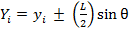 (2)

These coordinates have been further joined to form straight random fibers.
Interface properties significantly affect the properties of any composite material. To take this into account, we have developed a model to create CNT/polymer interfaces of some thickness specified by the user as shown in Figure 1E & 1F. RVE dimensions are also set as a variable in the model to allow users to choose the optimum dimensions for the analysis.
The second part of the code allows users to calculate fiber volume fraction and generate a Color Map (Figure 1B) for qualitative visualization of CNT distribution in interested regions in a composite. Based on approach discussed in Statistical Geometry of Fibrous Network³, scanning lines can be used to detect fiber presence in a composite. This concept is used to calculate the fiber volume fraction in composite, when the whole composite area is scanned.

Finally, in Color Map, each color represents average fraction of CNT in a particular region/grid. Color grid dimensions are also a variable to the program. If this dimension is equal to the RVE dimension, there will be only one color in the color map, value corresponding to which will signify fraction of CNTs in nanocomposite.

CODE INPUT
CODE OUTPUT

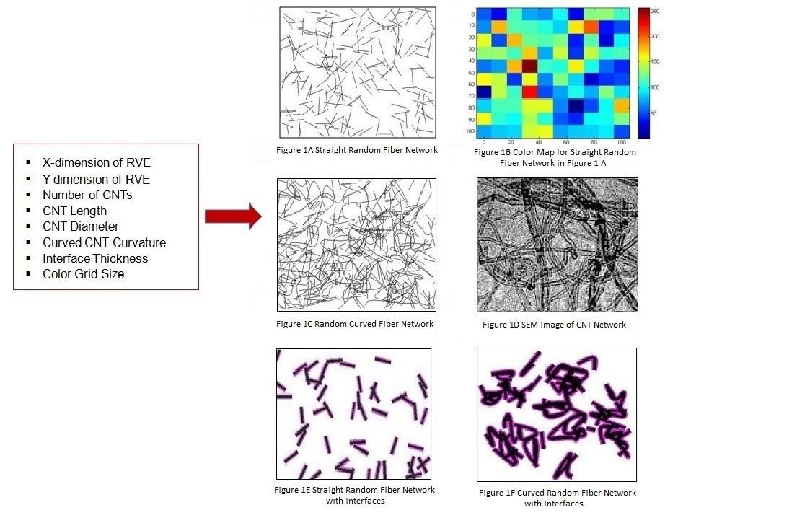
Interfaces
CNT
Matrix

Figure 1 Code Inputs and Outputs

Note that our predictive model (Figure 1C & 1F) closely resembles the SEM image of CNTs shown in Figure 1D.
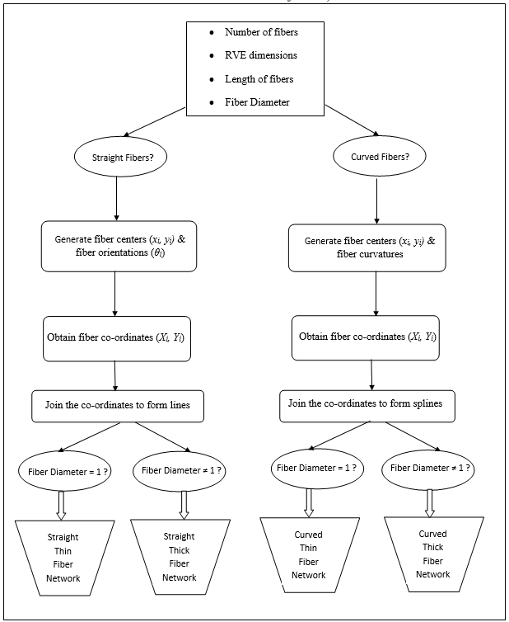
Figure 2. Flow Chart of Logic used to generate Straight & Curved Fibers Network
Figure 2 is describing the logic used to generate thin and thick straight as well as curved random fibers.
This model in raster format is further processed through Scan2CAD⁴ to convert it into vector format. Raster data is a field based data model that represents image geography as a continuum though using grid cells or pixels. When raster image is magnified enough, it becomes pixelated. This image cannot be imported directly in FEM software for analysis. Converting it into vector format helps replacing interested identities in an image by mathematical lines or curves, and they can be magnified thousands of times, making vector image suitable for finite element analysis.
Obtained vector image is readable by many other FEM softwares. However, it needs to be processed through AutoCAD⁵ to make it compatible with Abaqus. The Final FE model of the RVE (Figure 3) is assembled in Abaqus using Embedded Finite Element Method⁶. This method is used to embed the fibers in matrix. Embedded elements allow the introduction of CNTs within a matrix without removing the matrix material where the fiber resides. This method is convenient since it avoids one to reproduce the complementary matrix part of composite, in case fiber geometry and/or its distribution inside the composite is complex, such as in random fiber composites.
Figure 3 shows the final finite element model that can be used to evaluate mechanical properties of CNT reinforced polymer nanocomposite. Highlighted part in red color is representing CNTs.

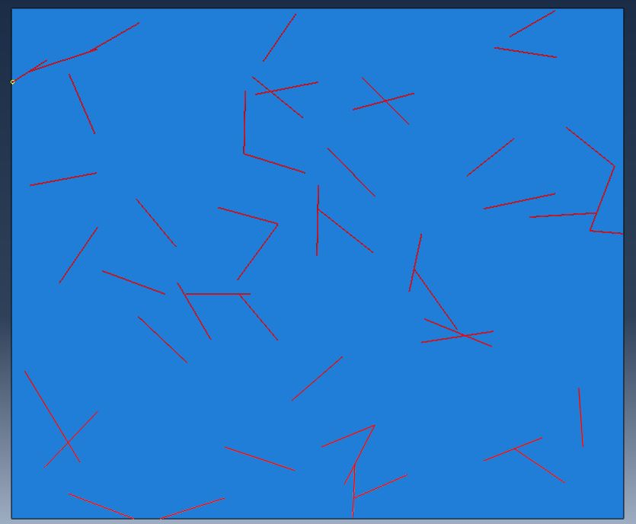

Figure 3 Final FEM Model for Analysis

This code is also useful as it can be used for the analysis of any random fiber composite. The model is not only limited to evaluate mechanical properties of composites, but also can be exploited to obtain electrical besides thermal properties of composite material. It can be employed to count fiber volume fraction in a composite. Moreover, it is simple enough to use and understand. Any freely available raster to vector conversion software can be used to convert our Matlab generated models to finite element software importable geometries.

APPENDIX:

This appendix is aimed to help users to choose right code. Comments are added for users to understand code & variables used.
- VolumeFraction.m: Finding fiber volume fraction in composite & generating text file to be used in colormaps.m.
- Colormaps.m: Generates Color Map.
- StraightThickThinFibers: Generates straight fibers which could be thin or thick depending upon user’s input.
- CurvedThickThinFibers: Generates curved fibers which could be thin or thick depending upon user’s input.
- StraightFiberInterfaces: Generates straight fibers and interfaces.
- CurvedFiberInterfaces: Generates curved fibers and interfaces.
- circles.m: Function file for generating curved fibers and/or interfaces. This file is necessary to be in the current directory to generate curved fibers with or without interfaces.

CODE IMPLEMENTATION:

Following are the four steps to generate RVE of random fibers composite/nanocomposite for finite element analysis. Please notice that only 1st step can be completed using the code provided.

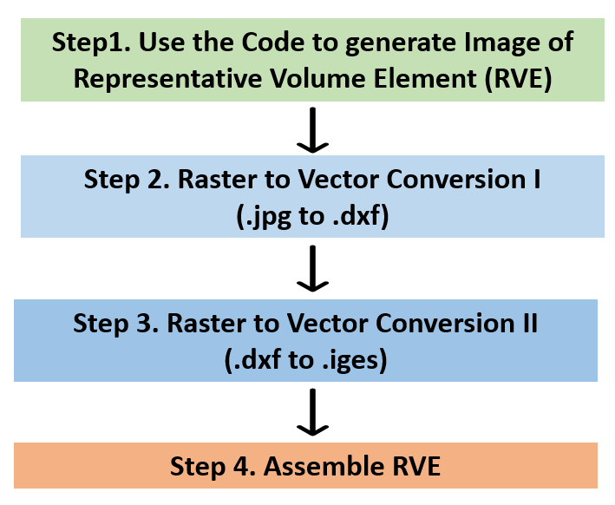

Figure 4. Steps to generate RVE for Finite Element Analysis of Random Fiber Composites/Nanocomposites

STEP 1: USE THE CODE TO GENERATE IMAGE OF REPRESENTATIVE VOLUME ELEMENT (RVE)

There are number of codes provided. Please refer to the Appendix to figure out when to use which code. For instance, if the user is interested in analyzing randomly distributed thin/thick curved fiber composite with their interfaces, following steps should be followed:

- Save the code circles.m keeping the name unchanged, as it is the function file. This file is necessary to generate curved fibers with or without interfaces.
- Save the code CurvedFiberInterfaces.
- Choose values of variables to change model parameters. All the variables encountered and their description is given in the Table 1.
- Run the code.
- Figure (1) will generate entities with radius r2 equal to fiber radius and interface thickness.
- Figure (2) will generate fibers of radius r1.
- Subtract Figure (2) from Figure (1) using matlab command imsubtract to obtain image for interfaces only.
- Save the Figure (2) and subtracted image in jpg format.

These images are our model in raster format that has to be converted to vector format in Step 2 in order to prepare it for Step 3, where it will be assembled to make RVE for FE analysis.

For instance, Figure 5 shows output from the code StraightThickThinFibers.m, where fiber diameter, d1 is chosen = 1 pixel (thin fibers).

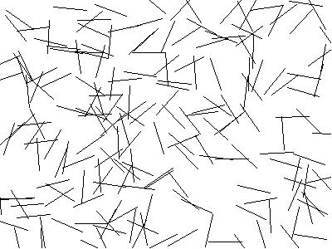

Figure 5. Straight Random Thin Fibers (Fiber Diameter = 1 pixel)

Variable | Description
N | Number of Fibers
r1 | Radius of Fiber
r2 | Radius of Fiber + Radius of Interface/ Interface Thickness
L | Fiber Length
L | X-dimension of RVE
M | Y-dimension of RVE
Th | Fiber Orientations (Random in the Code)

Table 1. Code Variables & Their Description

STEP 2. RASTER TO VECTOR CONVERSION I

The model through Matlab code is in raster format and is needed to be further processed through Scan2CAD⁴ to convert it into vector format. Raster data is a field based data model that represents image geography as a continuum though using grid cells or pixels. When raster image is magnified enough, it becomes pixelated. This image cannot be imported directly in FEM software for analysis. Converting it into vector format helps replacing interested identities in an image by mathematical lines or curves, and they can be magnified thousands of times, making vector image suitable for finite element analysis.
Roughly, following steps should be followed in Scan2CAD to convert Matlab Image (.jpg) to vector format (.dxf):

- Go to File menu and import the Raster file, e.g., Image obtained from Code StraightThickThinFibers.m.
- From Type, make appropriate choice which is giving you favorable results.
- Click on VEC tab to obtain vectors of the imported raster file.
- Play around with Threshold values to obtain agreeable results.
- Click on File menu and export the vectors in dxf format. Figure of vectors has not been added since they look similar to Figure 5 after conversion.

The final Model in Vector format will be in dxf file format as exported from Scan2CAD. This format is readable in many other FEA softwares, such as COMSOL, etc. But, in order to import it to Abaqus, it needs to be further processed into iges file format, brief details of which will be described in Step 3.

STEP 3. RASTER TO VECTOR CONVERSION II

Follow the below mentioned steps to convert dxf file to iges file format:

- Import saved dxf file to AutoCAD software.
- Select IGESEXPORT and drag and select the part/whole region to be saved as iges format. Again, Figure of vectors has been skipped as they look similar to Figure 5 after conversion.

STEP 4. ASSEMBLE RVE

In Abaqus, following steps should be followed in order to obtain the RVE:

- Import previously saved iges file from Import Part option. Please notice that it is only the random fibers that we have generated so far, and that matrix in which they should be embedded has to be created separately.
- Create matrix of dimensions L * M as it is expected to be your RVE dimensions. Remember that random fibers were also generated on a 2D sheet of dimension L * M.
- Now, use Embedded Finite Element Method⁶ to embed Part 1 (imported fiber geometry) to Part 2 (created matrix) using appropriate constraints. Embedded Finite Element Method is used to embed the fibers in matrix. Embedded elements allow the introduction of CNTs within a matrix without removing the matrix material where the fiber resides. This method is convenient since it avoids one to reproduce the complementary matrix part of composite, in case fiber geometry and/or its distribution inside the composite is complex, such as in random fiber composites.
- Figure 6 shows the final finite element model that can be used to evaluate mechanical properties of random fiber reinforced polymer composite/nanocomposite. Highlighted part in black color is representing fibers, while yellow dots are nodes to mesh the model.

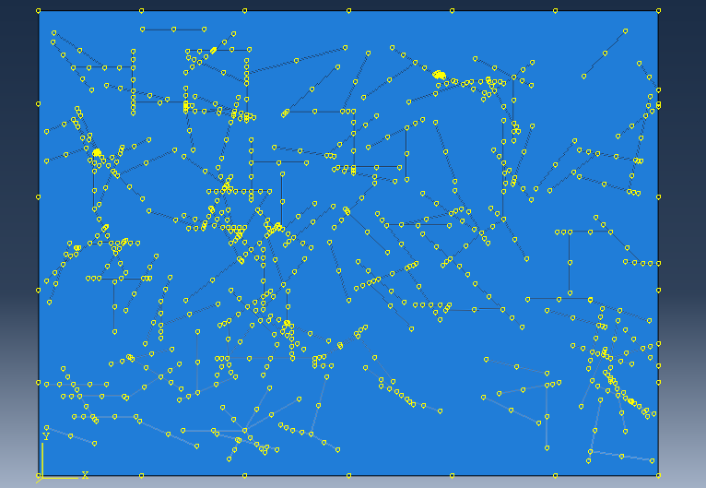

Figure 6. Final RVE for Finite Element Analysis

REFERENCES:

- R.C. Picu, Soft Matter, 2011, 7, 6768.
- https://www.mathworks.com/help/matlab/math/random-numbers-in-matlab.html.
- H. Corte, J.O. Kallmes, Statistical Geometry of a Fibrous Network, 1961.
- http://www.scan2cad.com/.
- https://www.autodesk.com/products/autocad.
- https://tramununte.files.wordpress.com/2015/10/abaqus-analysis-users-manual-vol-4.

