Part-1

Graph-1 : Solution 1

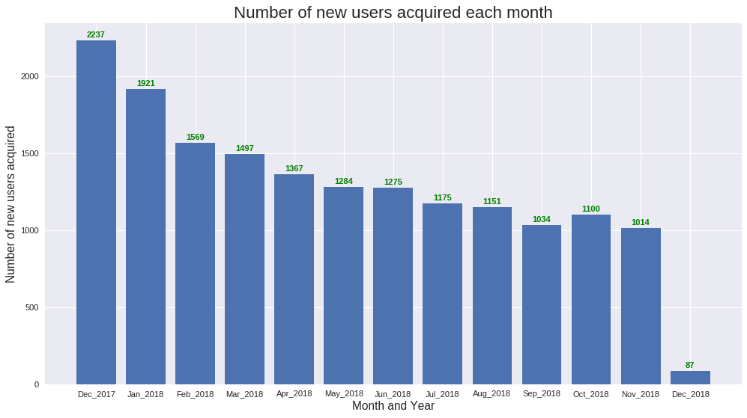

Graph-2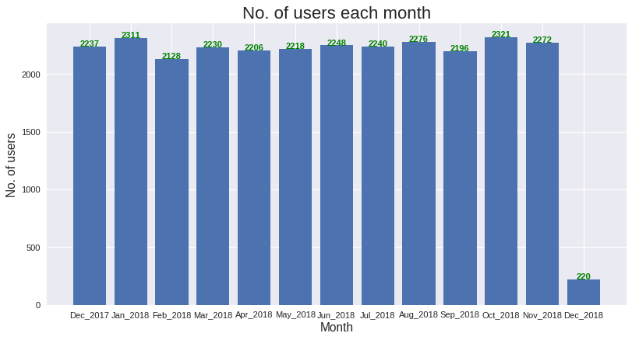

Part-2

C:\Users\Rajneesh\Pictures\Screenshots\Graph-2.png

Part-3

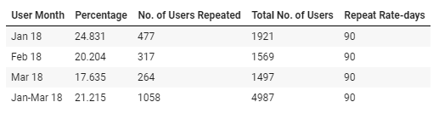

Part-5

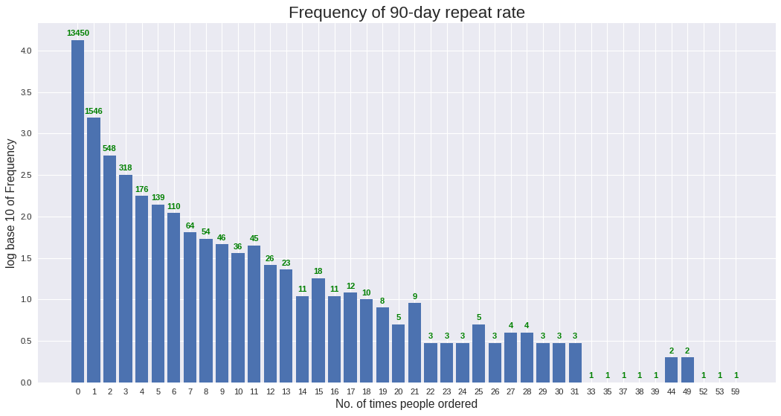

Extra EDA:

Table - Source

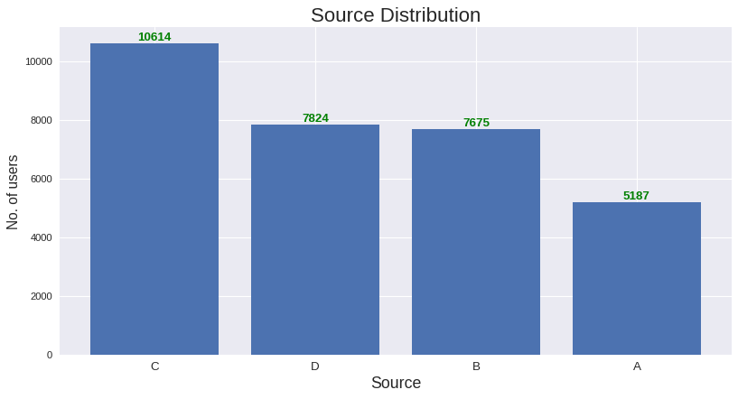

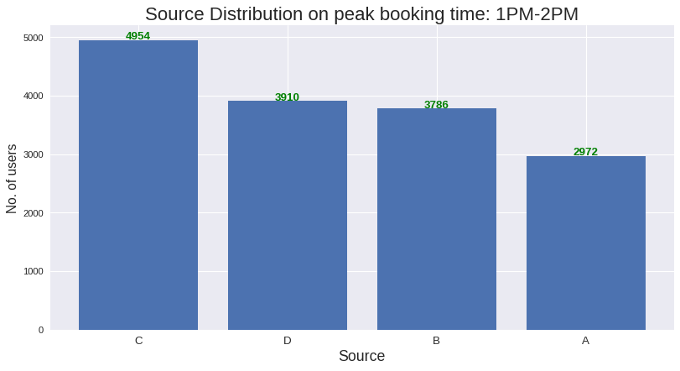

Table -Booking Hour

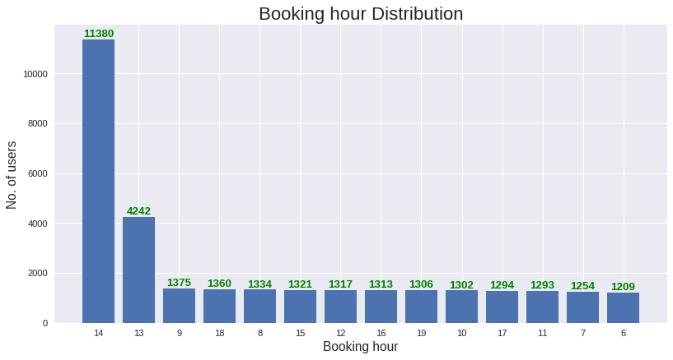

Table - Gaps between Booking and Ordering

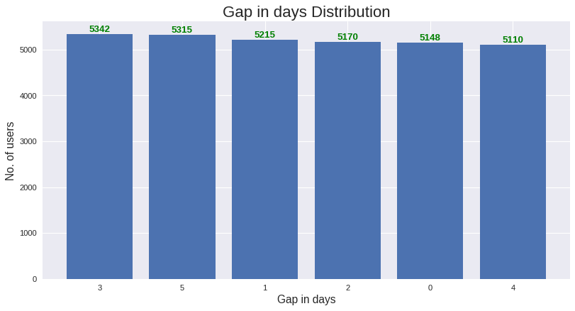

By graphs, we conclude:

* Note that in second graph, that no. of users (both old and new) each month is in small range of about 2100-2300.This is sign of steady income throughout. (till Nov’18)
* No. of new users gained each month is in decline. Seems like popularity of service among new users is decreasing slowly, i.e. Less new users now prefer to join. (Part-1: Graph 1)
* 13450/16711 ~= 0.8. Means, 80% percent of new users has ordered only once, ie. No repeat. And 179 users ordered more than 10 times = 1.07% very frequent users. (part-5)
* Gap in days between is evenly distributed.
* Booking hour 13 and 14 i.e. 1PM to 3PM is peak time, especially during 1PM-2PM, which is around recess time in offices. “Food Service company” will be a reasonable guess.
* Source ‘C’ – (33.91%) is most sought after, then ‘D’ (24.99%) and ‘B’ (24.52%) nearly same, and least ‘A’(16.57%). Same distribution follows in peak booking time as well.