Task 1
Grade Checker
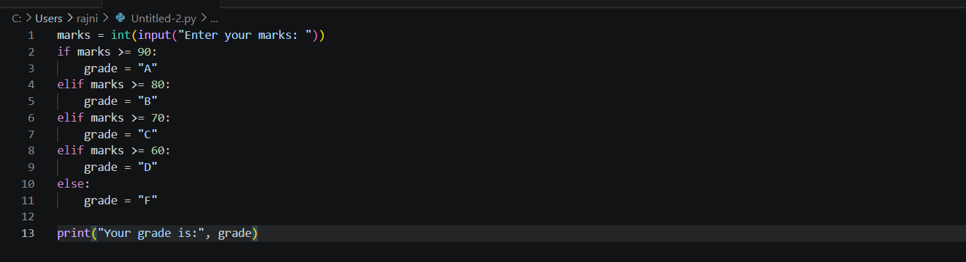

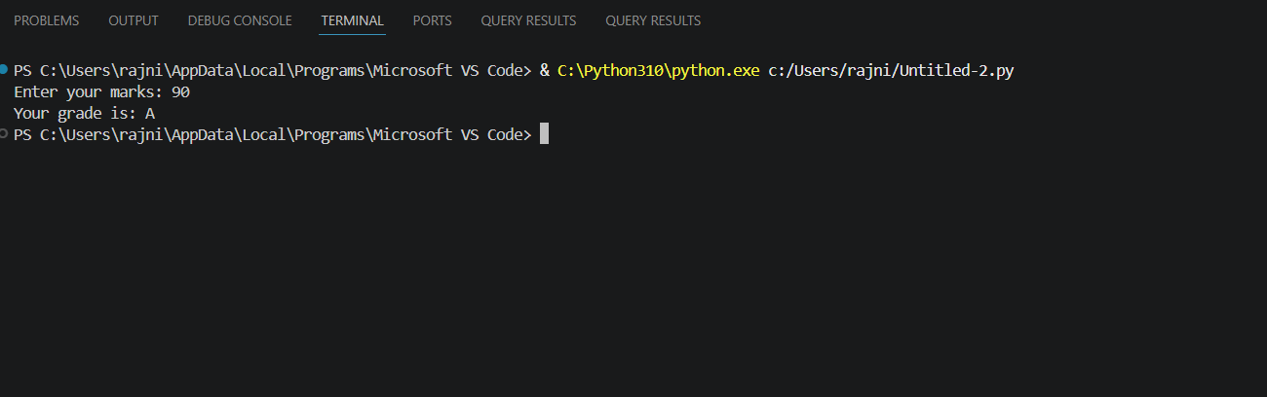

Task 2
Student Grades
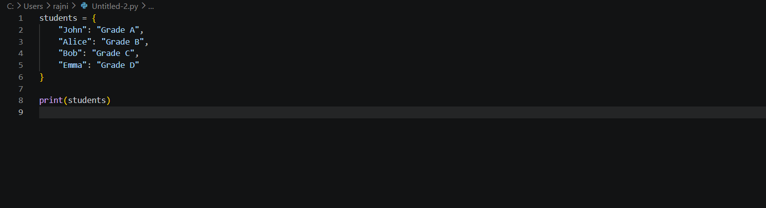
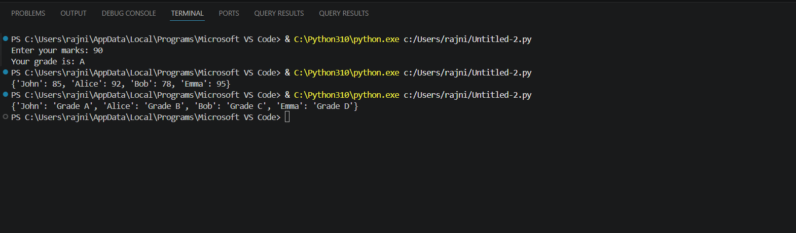

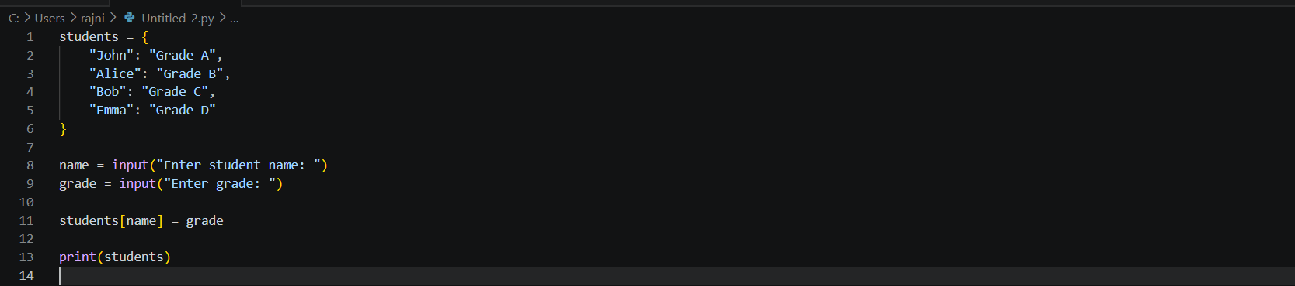

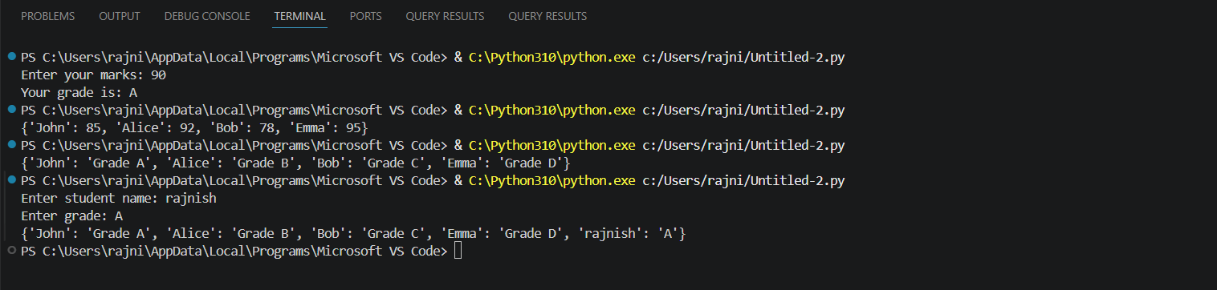

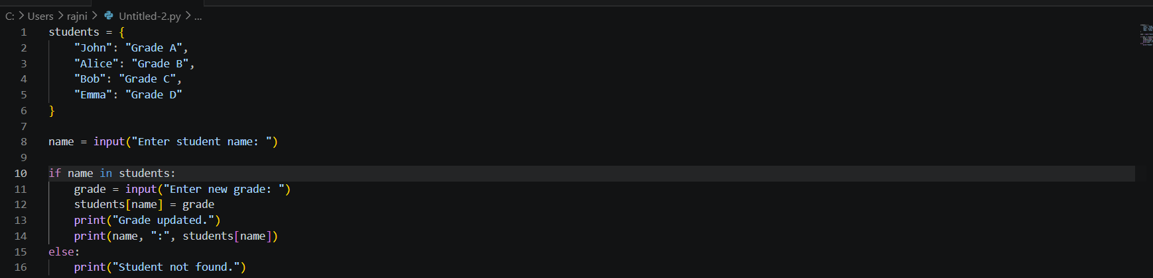
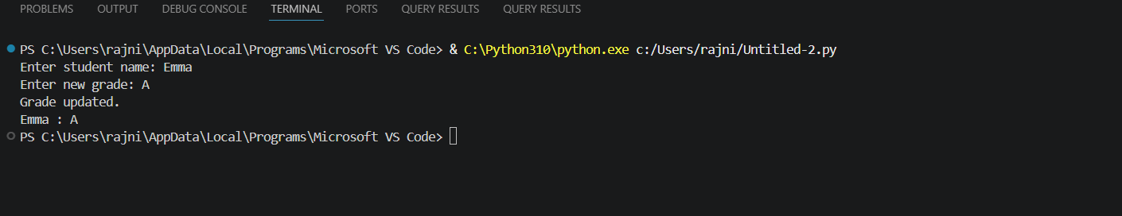
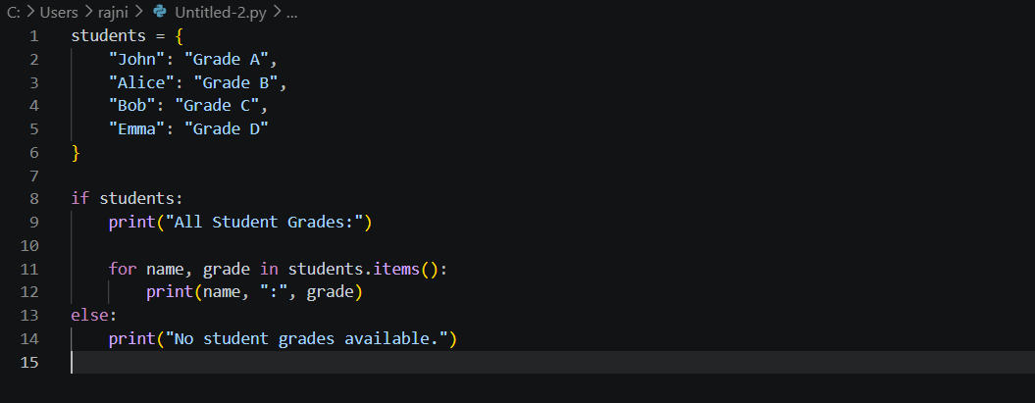
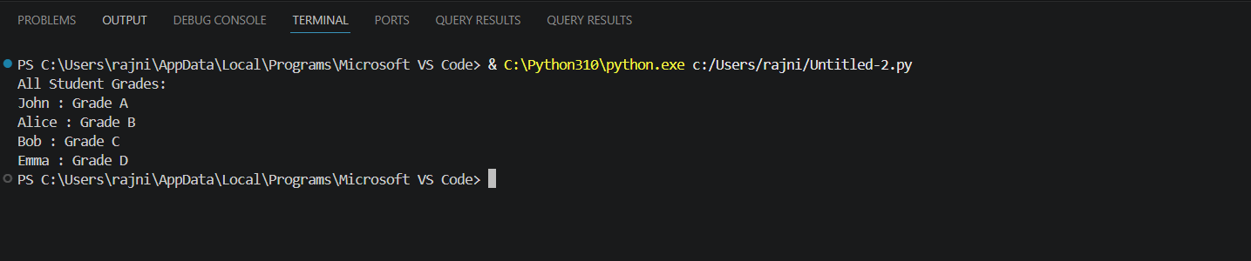
Task 3
Write to a File
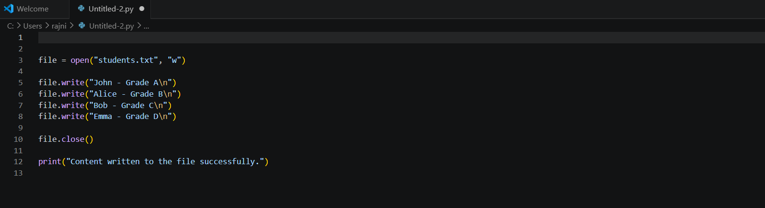
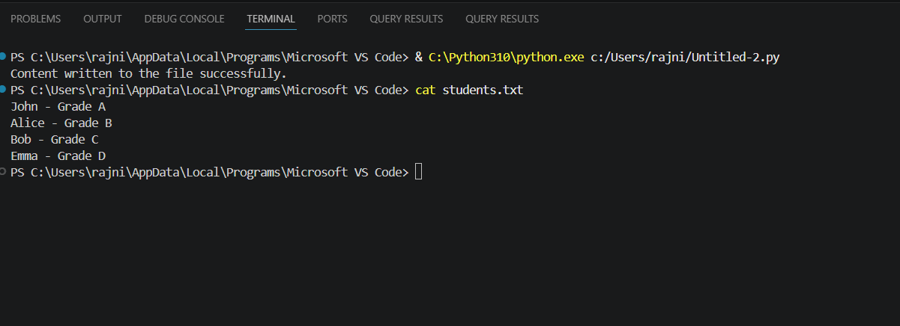

Task 4
Read from a File
