LEGAL CONTRACT
RISK ANALYZER

Final Project Report
A Modular ML Pipeline for Clause-Level Risk Detection in Commercial Contracts

Project Team
Anushka
Rajnish
Sachin
Vishal

13 May 2026

Table of Contents

Right-click and select Update Field in Word to populate the table of contents.

Contents at a glance
Abstract
1. Introduction
2. Background and Related Work
3. System Architecture
4. Dataset and Risk Labeling
5. Stage 1+2: Clause Extraction and Classification
6. Stage 3: Risk Detection
7. Stage 4: Report Generation
8. Discussion, Limitations, and Future Work
9. Conclusion
References

Abstract
We present the Legal Contract Risk Analyzer, a four-stage ML pipeline that reads a legal contract, extracts and classifies its clauses, assesses per-clause risk, and produces a structured risk report. Stage 1+2 is a fine-tuned DeBERTa-base QA model that jointly extracts clause spans and assigns them to one of 41 CUAD categories. Stage 3 is an Ens-F DeBERTa-v3 ensemble (CE + CORN) with signing-party text injected as segment A, wrapped in a LangGraph ReAct agent that uses a FAISS precedent index and same-contract sibling lookup. Stage 4 produces a structured report via deterministic aggregation, a 108-entry recommendation lookup, and a Qwen3-30B executive summary. Training labels for Stage 3 were produced by reconciling three independent LLM labelers (Qwen 30B, Gemini 2.5 Flash, Claude Sonnet) with targeted human review, yielding 4,375 labeled clauses. Stage 1+2 reaches Span IoU 0.358 versus the rule-based baseline's 0.090, a 4× improvement in span boundary precision. The production Ens-F classifier reaches macro F1 = 0.610 on a 452-row hard-labeled test split; the constrained agent improves this to 0.626 — a +0.016 gain over DeBERTa alone.

1. Introduction

1.1 Problem and motivation
Manual legal contract review is slow and inconsistent. A mid-market vendor agreement contains 20–40 negotiable clauses spanning indemnification, liability caps, IP assignment, and termination — each requiring expert reading from the signing party's perspective. The CUAD dataset annotates 13,101 clause spans across 510 commercial contracts and 41 clause categories, but provides no risk labels. The gap between this clause exists and this clause is risky for this signing party is the gap our system targets.

1.2 Objectives and scope
In scope, the system shall:
- Extract and classify clauses end-to-end from a contract PDF, DOCX, or plain text.
- Assign each risk-bearing clause a LOW / MEDIUM / HIGH label with an explanation.
- Emit a structured JSON report containing an executive summary and per-clause recommendations.
Out of scope:
- Cross-contract pattern analysis.
- Jurisdiction-specific reasoning.
- Production deployment or integration with commercial CLM tools.
- Final legal advice — the system is positioned as triage, not adjudication.

1.3 Contributions and report organization
This report makes three primary contributions:
- A combined DeBERTa-base QA pipeline that jointly extracts and classifies clauses with 4× the span-boundary precision of the rule-based baseline.
- A multi-labeler reconciliation protocol that produced 4,375 risk-labeled clauses with full disagreement provenance, combining Qwen 30B, Gemini 2.5 Flash, Claude Sonnet, Gemini 2.5 Pro, and four human reviewers.
- An Ens-F DeBERTa-v3 risk classifier wrapped in a LangGraph ReAct agent whose override is constrained to convergent tool evidence — improving on DeBERTa alone by +0.016 macro F1 while avoiding the 0.072 macro-F1 collapse seen with unconstrained LLM override.

2. Background and Related Work

2.1 Legal contract analysis and the CUAD dataset
CUAD (Contract Understanding Atticus Dataset) [1, 13] is a corpus of 510 commercial contracts annotated by trained law students and reviewed by 3–4 additional annotators. It frames contract review as span extraction in SQuAD format: 41 standardized clause-type questions, the contract as context, the answer being the exact span or empty if absent. Of 22,450 train and 4,182 test QA pairs, 67.9% are negative (clause absent). The license is CC-BY-4.0. CUAD does not include risk labels; producing them is part of this project.

2.2 Transformer architectures and RAG in domain-specific tasks
The Stage 3 risk classifier uses DeBERTa-v3-base [2]. Key advantages on this corpus:
- ELECTRA-style replaced-token-detection pre-training outperforms DeBERTa-base on classification tasks at the same ~86M-parameter backbone.
- The SentencePiece 128k tokenizer is ~15–20% more efficient than v1 on legal text: p99 sequence length 292 vs 358 tokens.
- Identical VRAM footprint to v1 — no infrastructure cost to switch.
For retrieval-augmented context we use sentence-transformers/all-MiniLM-L6-v2 [3] (22M parameters, 384-dim embeddings) with FAISS IndexFlatIP over L2-normalized vectors — exact cosine similarity, microseconds per query at our corpus size. The retrieval-augmented generation pattern [12] is used here not to ground the LLM's text output but to ground override decisions: the agent may disagree with the supervised classifier only when retrieved precedents and same-contract siblings produce convergent contradicting evidence.

2.3 Hybrid ML systems and agent-based reasoning
We use LangGraph [6] to implement a ReAct loop [5] over two retrieval tools, with the supervised classifier's (label, confidence) injected into the agent's system prompt as a default signal. The agent is permitted to override the classifier only when retrieval produces clear convergent contradicting evidence. This pattern sits between two extremes:
- Fully supervised classification cannot resolve party-direction ambiguity from clause text alone.
- Fully agentic reasoning systematically downgrades HIGH labels — Qwen3-30B's prior on legal risk is too conservative for CUAD's labeling convention.
For the Stage 4 executive summary we use Qwen3-30B (Q4_K_XL quantization) hosted in a local llama.cpp server. The summary is a single non-tool-calling LLM call; per-clause recommendations come from a hand-curated 108-entry lookup table (36 risk-bearing CUAD types × 3 risk levels). This hybrid keeps deterministic logic where determinism is achievable and confines LLM use to text generation where free-form output is needed.

3. System Architecture

3.1 Pipeline overview
The system is a modular pipeline of three stage groupings communicating through typed Python dataclasses. The diagram below shows every stage with its constituent tasks.
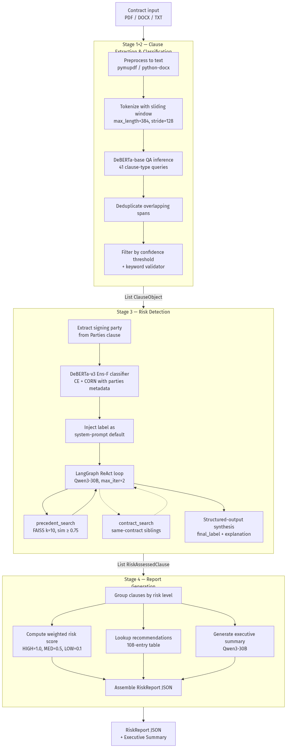
Figure 1. Main project block diagram — every pipeline stage and its constituent tasks.

3.2 Inter-stage data contracts
All stages communicate through three typed dataclasses defined in src/common/schema.py. These are the single source of truth for inter-stage data formats.
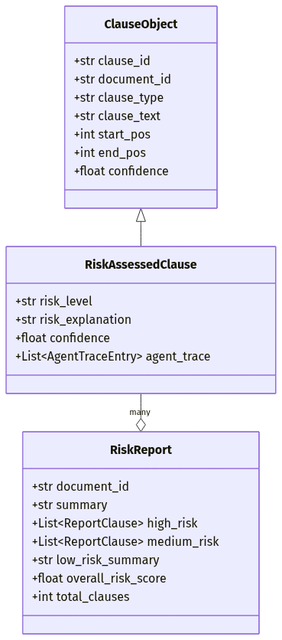
Figure 2. Inter-stage data contracts.
Boundary | Input | Output
→ Stage 1+2 | {document_id, contract_text, queries[41]} | List[ClauseObject]
Stage 1+2 → 3 | List[ClauseObject] | List[RiskAssessedClause]
Stage 3 → 4 | List[RiskAssessedClause] | RiskReport

3.3 Service layer and runtime
Runtime concerns that apply across all stages:
- FastAPI service layer (app/) exposes the pipeline over HTTP. Long-running stages run in asyncio.run_in_executor() threads so the event loop never blocks.
- Configuration: one YAML file per stage (configs/stage{1,3,4}_config.yaml). The LLM factory in src/common/utils.py::make_llm supports openai_compatible, gemini, and anthropic providers — provider swap is a one-line config change.
- Inference target: A100-class GPU with Qwen3-30B (Q4_K_XL, ~20 GB VRAM) hosted in a local llama.cpp server on port 10006, OpenAI-compatible API.
- Reproducibility: data splits pinned at seed=100, training pinned at seed=42 — independent processes. Same code + same data + same seed on the same GPU produces results within ~0.1 F1.

4. Dataset and Risk Labeling

4.1 CUAD overview and statistics
CUAD contains 510 commercial contracts annotated for 41 clause types, yielding 13,101 positive spans. Five clause types are pure metadata — Document Name, Parties, Agreement Date, Effective Date, and Expiration Date — and are not risk-bearing. Of 6,702 positive spans extracted by Stage 1+2, 4,410 are risk-bearing after metadata exclusion; the remaining 2,292 route to the Stage 4 report header. Per-clause-type frequencies are highly skewed: Governing Law appears in 85% of contracts, while Source Code Escrow and Joint IP Ownership have fewer than 15 examples each.
Statistic | Value
Contracts | 510
Clause types (metadata / risk-bearing) | 5 / 36
Positive spans (raw / risk-bearing) | 6,702 / 4,410
License | CC-BY-4.0

4.2 Multi-labeler synthetic labeling pipeline
CUAD provides no risk labels. We produced them through a multi-round reconciliation process. Each labeler ran independently at temperature 0 with the signing-party perspective anchored in the prompt and three calibration examples (LOW / MEDIUM / HIGH). The figure below shows the full flow.
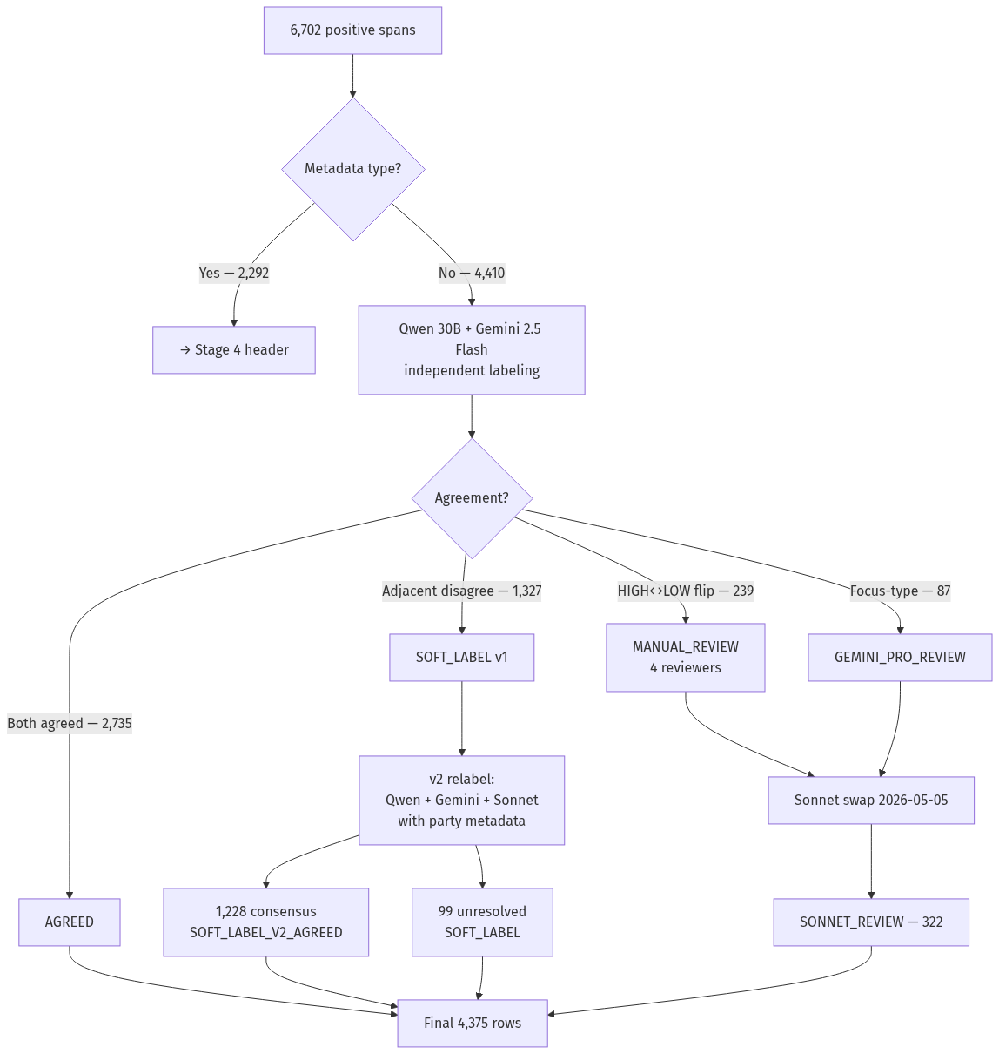
Figure 3. Risk-labeling reconciliation from 6,702 spans to the final 4,375-row dataset.
The protocol proceeded in three rounds:
- Round 1 — Initial labeling. Qwen 30B and Gemini 2.5 Flash labeled all 4,410 risk-bearing spans. Outcome: 2,735 AGREED, 1,327 adjacent disagreements (LOW↔MEDIUM or MEDIUM↔HIGH) stored as soft probability vectors, 239 extreme HIGH↔LOW flips, and 87 focus-type disagreements (Uncapped Liability, Liquidated Damages, Irrevocable License).
- Round 2 — Reconciliation. HIGH↔LOW flips were sent to four human reviewers (60 rows each). Focus-type disagreements went to Gemini 2.5 Pro as a tiebreaker.
- Round 3 — v2 relabel and Sonnet swap. The 1,327 soft rows were re-labeled with the contract's parties string injected into the prompt and Claude Sonnet as a third voter; 1,228 of 1,327 (92.5%) reached three-way consensus and 99 remained soft. Post-training analysis revealed the four human reviewers had 17–53% pairwise agreement with Sonnet and systematically under-labeled MEDIUM, so the 322 human / Gemini-Pro labels were swapped for Sonnet labels.

Labeling attempts that did not work:
- Two labelers initially proved insufficient — 38.3% disagreement rate.
- A third labeler attempt with Groq Llama-3.3-70B failed: 2,036 of 2,402 attempts were rate-limited to ERROR.
- Copilot labels (likely GPT-4 via chat UI, uncontrolled temperature) are retained as a reference column but excluded from training because they were unconditioned and uncalibrated.

4.3 Final training set and known data issues
label_source | Rows | Type | Origin
AGREED | 2,726 | hard | Qwen + Gemini Flash agreed (v1 pass)
SOFT_LABEL_V2_AGREED | 1,228 | hard | 3-way Qwen + Gemini + Sonnet consensus with party metadata
SONNET_REVIEW | 322 | hard | Sonnet replacing inconsistent human / Gemini-Pro labels
SOFT_LABEL | 99 | soft | 3-way disagreement — probability vector [0.5,0.5,0] or [0,0.5,0.5]
Total | 4,375 | — | Train 3,472 / val 437 / test 466 (stratified, seed=100)

Hard-label class mix on the train split is LOW 42.8% / MEDIUM 37.1% / HIGH 20.1% — a 2.13× imbalance handled with class weights rather than resampling.
Known data issues and how each was handled:
- Qwen `conf=0.0` artifact. 11.7% of Qwen's first-pass rows return confidence 0.0 despite a coherent label and reasoning — a JSON-truncation symptom from llama.cpp. Labels are preserved; confidence is floored to 0.5 before soft-label weighting.
- Fragment clauses. Nine training rows had <15 character clause_text (e.g., "us.", "120 days") — annotation artifacts in CUAD itself. Removed pre-training.
- Cross-split text duplicates. 10 duplicate groups span multiple splits (22 rows, 0.50%) — boilerplate kept on purpose, since the classifier should handle boilerplate correctly.
- Rare clause types. 8–10 of 36 risk-bearing types have fewer than 5 rows of at least one risk class in the test split, making per-type F1 statistically noisy.

5. Stage 1+2: Clause Extraction and Classification

5.1 Overview
Stages 1 and 2 were combined into a single DeBERTa-base QA model that simultaneously extracts clause boundaries and assigns them to one of 41 CUAD clause categories, using CUAD in its native SQuAD-style QA format. Each clause type maps to a standardized question template; the model returns either a span answer or an empty no-answer per (contract, question) pair. The model is evaluated across two independent dimensions — extraction quality (Exact Match, Token F1, Span IoU) and classification quality (per-class F1 across 41 types) — with a rule-based spaCy + regex pipeline as a non-ML comparison point. Training and evaluation ran on Google Colab (A100) and Kaggle.

5.2 What Was Built

5.2.1 Data preprocessing (preprocess_cuad.py)
The preprocessing pipeline loads CUAD v1 from a local JSON file and converts it into tokenized sliding-window datasets ready for fine-tuning.
- Dataset splitting — 90/10 train/test on raw data (seed=42). Validation is 10% of the 90% train portion (~1,000 samples). Test set is kept at its natural unbalanced distribution and re-balanced to 1:2 only at evaluation time.
- QA-level balancing — CUAD is ~98% negative QA pairs. Training balanced at 1:1 positive-to-negative, validation balanced at 1:2 for a reliable early-stopping signal.
- Tokenization — DeBERTa-base tokenizer with max_length=384, stride=128, return_overflowing_tokens=True for multi-window coverage. NO_ANSWER_SENTINEL = -1 distinguishes true negatives from [CLS] at position 0.
- Sentinel reset — a two-step process where -1 marks negative windows during balancing, then is reset to 0 before saving. Prevents the model from learning to always predict [CLS] for no-answer windows.

5.2.2 DeBERTa fine-tuning (pipeline.py)
Fine-tuning configuration via HuggingFace Trainer:
- Epochs 3, batch size 4 per device, gradient accumulation 2 (effective batch 8).
- Learning rate 5e-6, weight decay 0.01, warmup steps 1,300, max grad norm 1.0.
- Evaluation every 500 steps, early stopping with patience 3 on validation Exact Match.
- fp16 disabled — produced NaN losses on DeBERTa (covered under Issues).
- Best model loaded at end of training automatically.
A custom `compute_metrics` function mirrors inference logic by comparing the best non-CLS span score against the CLS score with a +1.0 margin, so the early-stopping signal matches the final evaluation.

5.2.3 Inference pipeline (ClauseExtractorClassifier)
The inference class runs all 41 CUAD question templates against a given contract and returns structured ClauseObject instances.
- Sliding window inference — contracts tokenized with stride=128, max_length=384. Best span is selected globally across all windows per clause type (not per-window).
- CLS-vs-span decision — per-clause-type thresholds control how much a span must beat CLS to be accepted. Rare clause types use stricter thresholds (2.5–3.0); common types use the default 1.0.
- Post-prediction keyword validation — CLAUSE_VALIDATORS enforces semantic checks. For example, an Audit Rights prediction is kept only if the extracted text contains audit, inspect, examine, records, or books.
- Overlap resolution — when two predictions overlap by >50% of the smaller span, the lower-confidence prediction is dropped.
- Output schema — each clause emitted as a ClauseObject with clause_id, clause_text, clause_type, start_pos, end_pos, confidence (sigmoid-normalized), confidence_logit (raw), and document_id.

5.2.4 Rule-based baseline (baseline.py)
A non-ML baseline using spaCy NER and regex patterns, covering all 41 clause types, provides a comparison point.
- Contract text is split into sections using a regex-based section-header detector.
- Each section is matched against clause-type-specific regex patterns.
- spaCy NER (en_core_web_sm) boosts confidence when supporting entities are found (GPE → Governing Law, DATE → Effective Date). NER confirms but does not initiate matches — prevents false positives.
- Multi-type sections — the baseline emits one clause per matched type per section. A section matching both Indemnification and Insurance contributes to both. MIN_CONFIDENCE = 0.55 suppresses noisy low-confidence matches.

5.2.5 Evaluation (evaluate.py)
Evaluation covers two independent dimensions from the same model output:
- Extraction quality — Exact Match, Token-level F1, Span IoU (overlap between predicted and ground-truth character spans).
- Classification quality — Accuracy, Macro F1, per-class F1 across 41 clause types.

5.3 Issues Faced
Issues encountered during development and how each was resolved:
- Class imbalance in CUAD (critical). Raw training collapsed to always-predict-no-answer. Fix: QA-level downsampling to 1:1 in training, 1:2 in validation; window-level balancing with NEG_RATIO=2; test set kept at natural distribution then re-balanced 1:2 only at evaluation.
- Sentinel vs CLS position collision. Standard QA uses position 0 for no-answer, which collides with [CLS]. Fix: NO_ANSWER_SENTINEL = -1 as a distinct marker during balancing; reset to 0 only after balancing and before training; sanity checks assert zero remaining sentinels.
- fp16 training instability. DeBERTa's disentangled attention with relative position encodings produced NaN attention weights under fp16. Fix: disabled fp16 entirely; added max_grad_norm=1.0; lowered learning rate to 5e-6.
- Evaluation metric mismatch during training. Default Trainer compute_metrics ignored the CLS-vs-span decision, making early stopping based on a misleading signal. Fix: custom compute_metrics that mirrors inference logic (CLS score vs best span score with +1.0 margin).
- Long contract handling. Many clauses sat past the first 384-token window. Fix: sliding-window tokenization with stride=128; global best-span selection across all windows at inference; window-overlap logic finds the first answer span overlapping each window during preprocessing.
- Span boundary noise. Tokenizer off-by-one errors produced 1–2-token spans. Fix: filter windows where token_end - token_start < 2 as no-answer; filter inference answers shorter than 5 characters; reject answers containing @ (OCR email artifacts).
- False positives on rare clause types. Confident predictions were semantically wrong (e.g., Audit Rights firing on financial-reporting clauses). Fix: per-clause-type confidence thresholds (rare types 2.0–3.0 instead of default 1.0); CLAUSE_VALIDATORS post-prediction keyword check.
- Baseline emitting only best match per section. Original baseline kept only the single best clause per section. Fix: emit one clause per matched type per section; gate with MIN_CONFIDENCE = 0.55.
- Dataset path resolution across environments. Hardcoded paths broke between Colab, Kaggle, and local. Fix: get_data_path() in constants.py with environment auto-detection; overridable via CUAD_DATA_PATH.
- Macro F1 collapse on rare classes. 9 clause types score 0.000 F1 (both models) due to <5 positive examples in the test set. Context: not a bug — a real dataset limitation; flagged for Stage 3 to handle via RAG retrieval rather than direct extraction.

5.4 Results

5.4.1 Stage 1 standalone evaluation
Evaluation on the balanced test set (5,475 examples, 1:2 positive-to-negative ratio):
Metric | Value | Notes
Test set total | 5,475 | 1,825 positives / 3,650 negatives
Exact Match | 83.25% | Span-level
Token F1 | 85.80% | Span-level
Classification accuracy | 0.9286 | CLAUSE vs NO_CLAUSE
Macro F1 | 0.9188 | CLAUSE vs NO_CLAUSE

Per-class: CLAUSE precision 0.91 / recall 0.87 / F1 0.89; NO_CLAUSE precision 0.94 / recall 0.96 / F1 0.95. The model is better at identifying true negatives than true positives, as expected given CUAD's natural class imbalance.

5.4.2 Extraction quality vs baseline
Metric | DeBERTa | Baseline | Δ
Exact Match (%) | 63.70 | 62.84 | +0.86
Text F1 (%) | 65.50 | 66.31 | −0.81
Span IoU | 0.3582 | 0.0903 | +0.2679

The headline result is Span IoU: DeBERTa's predicted spans are 4× more precisely aligned to true clause boundaries than the regex baseline. The baseline returns line-level spans rather than precise clause text, which structurally suppresses IoU even when classification F1 looks comparable.

5.4.3 Classification quality vs baseline
Metric | DeBERTa | Baseline | Δ
Accuracy | 0.7226 | 0.7757 | −0.0531
Macro F1 | 0.3425 | 0.4385 | −0.0960
Weighted F1 | 0.7004 | 0.7359 | −0.0355

The baseline outperforms DeBERTa on overall classification metrics. CUAD is dominated by keyword-anchored clauses — types like Governing Law, Renewal Term, Insurance, and Most Favored Nation — that exact phrase matching detects reliably. DeBERTa's advantage is contextual understanding, which pays off on more complex types.

5.4.4 Per-class F1 breakdown
Summary across all 41 clause types:
- DeBERTa wins — 14 clause types. Strengths are contextual clauses: Agreement Date (0.894 vs 0.508), Expiration Date (0.525 vs 0.308), Non-Compete (0.421 vs 0.267), Minimum Commitment (0.595 vs 0.250), Volume Restriction (0.538 vs 0.000), Affiliate License-Licensor/Licensee (0.353/0.429 vs 0.000/0.000).
- Baseline wins — 18 clause types. Strengths are keyword-anchored: Governing Law (0.918 vs 0.333), Renewal Term (0.815 vs 0.095), Most Favored Nation (1.000 vs 0.000), Insurance (0.909 vs 0.320), Liquidated Damages (0.750 vs 0.400).
- Tie (both 0.000) — 9 clause types are rare or structurally ambiguous: Notice Period To Terminate Renewal, Exclusivity, No-Solicit Of Customers, Price Restrictions, Joint IP Ownership, Unlimited/All-You-Can-Eat-License, Irrevocable Or Perpetual License, Covenant Not To Sue, Indemnification.

5.5 Key Takeaways
- DeBERTa's primary advantage is span boundary precision (Span IoU 0.36 vs 0.09), not per-class classification F1 — Stage 3 receives more accurately bounded clause text.
- The rule-based baseline is competitive or better on keyword-anchored clauses and remains useful as a fallback or ensemble component.
- Nine zero-F1 clause types are the hardest types and warrant special treatment downstream — RAG retrieval or few-shot context rather than direct extraction.
- The sentinel pattern (NO_ANSWER_SENTINEL = -1) is a reusable design for any QA task with heavy class imbalance — prevents CLS-collision bugs.
- Per-class confidence thresholds and keyword validators significantly reduced inference false positives without needing model retraining.

6. Stage 3: Risk Detection

6.1 Overview
Stage 3 assesses per-clause risk on a LOW / MEDIUM / HIGH scale from the signing party's perspective. It consists of an Ens-F DeBERTa-v3 ensemble (two-model: cross-entropy + CORN, both with signing-party text injected as segment A) followed by a LangGraph ReAct agent. The agent receives DeBERTa's (label, confidence) injected into its system prompt as a default signal, then uses two tools — precedent_search (FAISS over the labeled training corpus) and contract_search (same-contract sibling clauses) — to produce a final label with explanation. The agent is constrained to override DeBERTa only when retrieval produces clear, convergent contradicting evidence. Training labels come from the 4,375-row synthetic dataset described earlier; the locked test split is 452 hard-labeled rows.

6.2 What Was Built

6.2.1 Training data preparation (build_training_dataset.py)
The training dataset builder consolidates the master label review CSV into a single JSON with one row per labeled clause.
- Reads data/review/master_label_review.csv and routes each row by category: AGREED / SOFT_LABEL_V2_AGREED / SONNET_REVIEW → hard label; SOFT_LABEL → soft probability vector; METADATA and ERROR → dropped.
- Constructs soft-label vectors confidence-weighted from labeler scores, with Qwen's conf=0.0 artifact floored to 0.5.
- Filters fragment clauses (<15 chars).
- Writes data/processed/training_dataset.json — 4,375 rows total (4,276 hard + 99 soft) with a signing_party field populated for every row.

6.2.2 Train/val/test splits (build_splits.py)
- Strategy — StratifiedGroupKFold: group by contract (zero leakage), stratify by clause_type (every type represented in every split).
- Final split — train 3,472 / val 437 / test 466 (80 / 10 / 10).
- Seed — 100. Selected because it was the only seed in [0, 1, 7, 13, 17, 21, 42, 100, 123, 777] that gave full 36/36 clause-type coverage in both val and test.
- Persisted — data/processed/splits.json checked into the repository.

6.2.3 DeBERTa-v3 fine-tuning (train.py)
- Model — microsoft/deberta-v3-base (~86M-parameter backbone), full fine-tune (no LoRA, no freezing).
- Loss — single nn.CrossEntropyLoss(weight=class_weights) applied to probability-vector targets. Hard rows carry one-hot vectors; soft rows carry probability distributions; both flow through one code path.
- Class weights — Option B effective_counts (denominator includes soft-label probability mass).
- Hyperparameters — AdamW; batch 16; lr 5e-5; cosine schedule with 10% warmup; weight decay 0.05; LLRD 0.95; epochs 20 with early-stop patience 5 on val macro F1; bf16 precision; seed 42.
- Trainer — HuggingFace Trainer with remove_unused_columns=False so the soft_label field reaches compute_loss. Pre-tokenized HF Dataset with DefaultDataCollator.

6.2.4 Inference API (scripts/infer.py — RiskClassifier)
- Ens-F ensemble — averages softmax (CE) and chain-rule (CORN) probabilities; argmax for the label.
- Segment A — built as "clause_type | signing party: <parties_span>", sent as segment A; clause text is segment B.
- Public methods — predict(clause_text, clause_type, signing_party) for single-clause inference; predict_batch for batched eval.
- Default model paths — local under models/stage3_risk_deberta_v3_run{22,23}_*/final/; fall back to HuggingFace Hub rajnishahuja/cuad-risk-deberta-{ce,corn}-parties.

6.2.5 FAISS precedent index (build_faiss_index.py)
- Embeddings — sentence-transformers/all-MiniLM-L6-v2 (22M params, 384-dim).
- Index type — IndexFlatIP over L2-normalized vectors → exact cosine similarity at microsecond latency.
- Built from train split only to prevent test-set leakage — 3,398 vectors.
- Cached in-process after first query.
- Parallel metadata — data/faiss_index/clauses.json stores per-vector {clause_text, clause_type, risk_level, document_id}.

6.2.6 LangGraph ReAct agent (agent.py)
Every clause runs through the agent — no confidence gate.
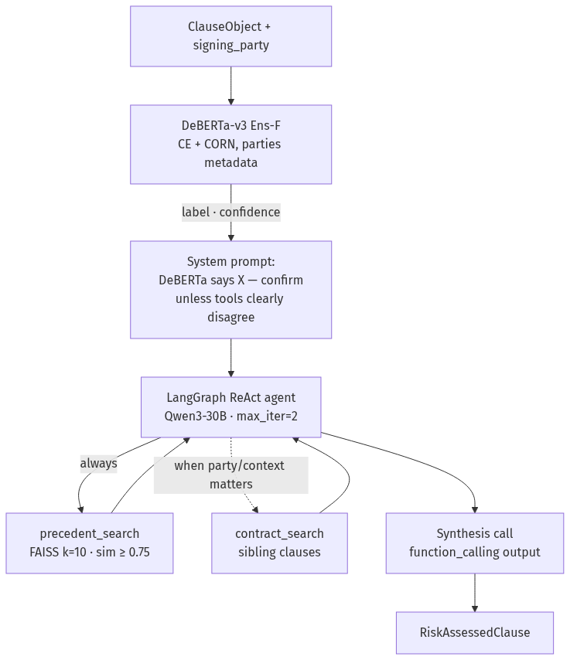
Figure 4. Stage 3 inference flow — DeBERTa-as-prior with constrained agent override.
- System prompt injects DeBERTa's label and confidence as the default signal plus the override constraint: confirm DeBERTa unless retrieval produces convergent contradicting evidence.
- Tools — precedent_search (FAISS top-k=10, min similarity 0.75) and contract_search (same-contract sibling clauses).
- Loop bounded by max_iterations=2.
- Metadata clauses (Document Name, Parties, Agreement Date, Effective Date, Expiration Date) are skipped — they route to the Stage 4 report header.
- Synthesis call — after the ReAct loop, a single explicit llm.with_structured_output(RiskAssessment, method="function_calling") call extracts {final_label, explanation, override_reason} from a clean single-turn prompt. The function_calling method is required because llama.cpp rejects langchain-openai's default method="json_schema" with HTTP 400.
- Output — RiskAssessedClause with agent_trace recording each tool invocation.
Parallel execution: agent_num_workers > 1 runs clauses concurrently via ThreadPoolExecutor, sharing the llama.cpp -np slot pool.

6.2.7 Evaluation harness (eval_stage3.py + run_ensemble.py)
- Five ablation modes — DeBERTa-only, RAG-only (FAISS vote, no LLM), constrained no-CS, constrained with CS, free-override.
- Resume support — checkpoints each clause result to a JSONL file so a partial run can resume.
- Override tracking — direction and accuracy of every override against ground truth.
- FAISS coverage diagnostic — per-class coverage and vote accuracy at chosen similarity thresholds.

6.3 What Was Tried

6.3.1 Loss functions
- Cross-entropy (locked baseline) — unified soft-target CE handles both hard and soft rows.
- Pure EMD (Wasserstein-1) (Run 12) — failed: collapsed to MEDIUM (the median class). At random init, predicting uniform softmax minimises EMD against MEDIUM; class weights cannot escape.
- Hybrid CE + 0.5×EMD (Run 13) — net-zero overall; dilutes ensembles because R13 agrees with peers 81–85% (vs 71% for diverse members).
- SORD with class-weight bug fix (Runs 16, 20) — still under-performed CE; ordinal neighbour-smearing adds noise that outweighs the ordering benefit on this data.
- CORN (Runs 17, 19, 23) — chain-rule 2-binary-head architecture. Collapsed MEDIUM on noisy v1 labels (F1 = 0.074, Run 17); recovered after v2 relabel (F1 = 0.479–0.528, Runs 19/23) and is now half of the production Ens-F.

6.3.2 Class weights
- Option A — `hard_counts` (Run 1, failed) — denominator counts hard rows only. Soft rows each contribute 0.5 to MEDIUM, which Option A ignores; MEDIUM ends up with disproportionate loss budget → collapse, macro F1 = 0.21.
- Option B — `effective_counts` (locked from Run 2 onward) — denominator includes soft-label probability mass.

6.3.3 Regularization
- Schedules — linear (Runs 1–4) → cosine (Run 5+, locked). Cosine tail kept the model from over-anchoring on MEDIUM as the uncertainty bucket.
- Weight decay — 0.01 (default) → 0.05 (Run 5, +0.020 macro) → 0.1 (Run 7, regressed −0.012). WD = 0.05 is the sweet spot.
- Dropout — 0.1 (default) → 0.2 (Run 8). Different fingerprint vs WD — makes the model more confident; useful in ensembles.
- LLRD — 0.9 (Run 6, failed: embeddings at 0.28× base LR, bottom layers under-adapted) → 0.95 (Run 9, locked: embeddings at 0.54× base LR; best HIGH F1 of any single-seed run).
- Long training — epochs=20 patience=5 on CE (Run 24) over-fit (val improved, test dropped). CE works best at epochs=10 patience=2; CORN needs epochs=20 patience=5 because it has a 1–2-epoch dead zone before HIGH wakes up.

6.3.4 Label modes
- Soft (default) — 99 SOFT_LABEL rows kept as probability vectors.
- Hard-only (Run 14) — drops soft rows from training. Best MEDIUM F1 at seed 42 (0.492) and best hard-only F1 (0.657). Confirms soft rows pollute MEDIUM signal.
- Argmax-soft (Run 15) — hardens soft vectors via argmax. Best HIGH F1 at seed 42 (0.675). Most diverse single model (lowest pairwise agreement with peers).

6.3.5 Multi-seed variance
- Seeds tested: 42, 7, 100. Multi-seed F (Runs 9, 10, 11) gives σ=0.020 on macro F1 and σ=0.035 on MEDIUM F1.
- Several intermediate "improvements" between runs sit inside the seed-noise band — must verify hyperparameter changes across seeds.
- Seed-only ensembling barely helps (Ens-6 ≈ mean of single F runs) — ensemble diversity must be structural, not stochastic.

6.3.6 Metadata injection
- Clause type only (v1, Runs 1–21) — [CLS] clause_type [SEP] clause_text [SEP]. Hard accuracy ceiling on party-dependent types.
- + Signing party (v2, Run 22+, locked) — [CLS] clause_type | signing party: <parties_span> [SEP] clause_text [SEP]. Single largest improvement in the training space: Run 22 vs Run 18 = +0.021 macro F1; LOW +0.041; MEDIUM +0.056. HIGH↔LOW polarity flips dropped from the dominant error type to 19% of remaining errors.

6.3.7 Model size
- DeBERTa-base — Stage 1+2's model. Inadequate tokenizer for legal text (p99 358 tokens).
- DeBERTa-v3-base (locked) — ELECTRA-style pre-training, 128k SentencePiece tokenizer. p99 292 tokens. Identical VRAM.
- DeBERTa-v3-large — closed (21+ runs of evidence showed the bottleneck is not capacity).

6.3.8 Architectures (Stage 3 inference)
Figure 5. Stage 3 architecture evolution v1 → v2 → v3 (locked).
- v1 Hybrid Confidence-Gated — DeBERTa confidence ≥ 0.6 fast path (single LLM call, no tools); below 0.6 escalated to ReAct agent. Removed: threshold was fragile (10–15% of clauses shifted across the gate with small temperature changes); high-conf clauses never benefited from retrieval; free LLM override on low-conf path was 47–58% accurate vs DeBERTa's 59.3% baseline.
- v2 DeBERTa + FAISS ensemble, LLM for explanation only — per-label FAISS vote thresholds (LOW=2, MEDIUM=2, HIGH=skip). Removed: FAISS coverage on HIGH was 18%; ensemble rarely diverged from DeBERTa, so the LangGraph loop was lost without gaining reliability.
- v3 All-clauses-through-agent, DeBERTa-as-default (locked 2026-05-04) — every clause goes through the ReAct agent; DeBERTa's label is the system-prompt default; agent overrides only on convergent tool evidence.
- Static LangGraph (considered) — fixed tool order, DeBERTa always final. Superseded by full ReAct because the worked examples needed conditional reasoning.
- Retrieval-Augmented Classification (RAC) (considered) — retrieved neighbors as classifier input. Deferred due to label-leakage risk and pipeline complexity.

6.3.9 Ensembling
- Best-of-axis > more-of-axis. Ens-B (5-way best-of-axis: WD + dropout + best F-seed + hard_only + argmax_soft) at macro 0.626 beat Ens-A (7-way, all members) at 0.620. Adding the worst F-seed (Run 11) dragged the average.
- Regularization diversity > parameter diversity. Ens-2 adding a fourth WD-only member did not improve over Ens-1 (3-way WD + dropout + LLRD).
- Label-mode diversity is a real axis. Ens-11 (Runs 14 + 15) matched Ens-1 with strictly better MEDIUM (0.502 vs 0.482).
- Production model: Ens-F (locked). CE+parties (Run 22) + CORN+parties (Run 23). Structurally diverse (different losses), complementary class fingerprints (CE strong on MEDIUM/HIGH, CORN strong on LOW recall). Macro F1 = 0.610.

6.4 Evaluation Criteria

6.4.1 Two-tier metrics
Tier | Metrics | When computed
A — primary | val macro F1, per-class P/R/F1, accuracy | every validation epoch
B — diagnostic | per-clause-type F1 (36 cells), ECE, KL-divergence on soft test rows | end of training only

Macro F1 is the primary metric because LOW dominates at 42.8% and class-blind accuracy would obscure model behavior. HIGH recall is tracked separately as the business-critical sub-metric — a missed HIGH is an unflagged legal risk.

6.4.2 Reference baselines
Baseline | Macro F1 | Note
Majority-LOW (always-LOW) | 0.20 | Relevant lower bound
Qwen-only labeler | 0.94 | Circular — evaluated against labels it produced
Gemini-only labeler | 0.92 | Circular — same caveat

Labeler "baselines" exceed any trained model because they are evaluated against labels they themselves produced. The 0.20 floor is the only honest lower bound; the labeler numbers are an artifact of circular validation.

6.4.3 Agent ablation modes
Five inference modes compared on the same 452-row hard-labeled test set:
- DeBERTa-only (no agent, no FAISS).
- RAG-only (FAISS vote, no LLM).
- Constrained, no `contract_search` — DeBERTa + FAISS + LLM with consensus override rule.
- Constrained, with `contract_search` — adds same-contract sibling tool.
- Free-override — DeBERTa + FAISS + LLM, no consensus constraint.

6.5 What Was Tried to Improve Evaluation
- Test-set stability across relabeling. Test ground truth changed after the v2 soft-label relabel (331 → 452 hard rows) and again at the experimental Sonnet swap (~54 test rows changed). Cross-block comparisons are invalid. Each block's results are reported separately; runs are clearly attributed to v1, v2, or parties-metadata blocks.
- Per-clause-type sample-size flagging. Per-type F1 is reported with row count next to each cell, and n<10 cells are flagged as statistically unreliable.
- Override-direction analysis. Every override is bucketed by direction (LOW→MEDIUM, HIGH→MEDIUM, …) and its accuracy is tracked separately. Identified the contract_search HIGH→MEDIUM regression at 25% accuracy.
- FAISS retrieval diagnostic. Per-class coverage and vote accuracy at the 0.75 similarity threshold — surfaced that HIGH coverage is only 18% and HIGH vote accuracy when covered is 17%.
[MANUAL UPDATE REQUIRED] Calibration measurement is documented as a planned activity (Expected Calibration Error + reliability diagrams; temperature scaling per Guo et al. 2017) but no ECE numbers or reliability diagrams have been committed to the repository. Suggested source: run `eval_stage3.py` with calibration flags on the val set, then fit T on val and re-evaluate on test. Estimated length: 1–2 paragraphs plus a small table.
[MANUAL UPDATE REQUIRED] A full per-clause-type F1 table for the production Ens-F on all 36 risk-bearing types is not currently committed (only Run 22 error directions are). Suggested source: re-run eval with `--per-type` flag and append. Estimated length: a 36-row, 4-column table plus 2 sentences of commentary.

6.6 Results

6.6.1 Five-mode ablation (full 452-row test set)
Mode | Macro F1 | LOW | MED | HIGH | Δ vs DeBERTa
DeBERTa-only (Ens-F) | 0.610 | 0.690 | 0.514 | 0.625 | —
RAG-only (FAISS vote) | 0.469 | 0.565 | 0.477 | 0.365 | −0.141
Constrained, no contract_search | 0.626 | 0.705 | 0.538 | 0.634 | +0.016
Constrained, with contract_search | 0.592 | 0.697 | 0.495 | 0.585 | −0.018
Free-override | 0.538 | 0.699 | 0.482 | 0.432 | −0.072

Constrained no-CS improves all three classes simultaneously over DeBERTa. RAG-only and free-override actively hurt. Adding contract_search at scale regresses — the cross-clause context that helps LOW gives the LLM superficial grounds to downgrade HIGH.

6.6.2 Error analysis (Run 22, 180 misclassified test rows)
Error direction | Count | Share
MEDIUM → LOW | 63 | 35%
LOW → MEDIUM | 40 | 22%
HIGH → MEDIUM | 26 | 14%
MEDIUM → HIGH | 16 | 9%
HIGH ↔ LOW polarity flips | 35 | 19%

81% of residual errors involve MEDIUM as either predicted or true class. HIGH↔LOW flips dropped from the dominant error mode pre-parties-metadata to 19% — the direct effect of injecting signing-party text into segment A.

6.6.3 Latency
- Constrained mode: ~7 seconds per clause (1–2 tool calls + synthesis).
- Free-override mode: ~20 seconds per clause (3+ tool calls).
- End-to-end: 5–15 minutes per contract, dominated by sequential Stage 3 agent calls. Scales near-linearly with agent_num_workers and llama.cpp slots.
[MANUAL UPDATE REQUIRED] A cost estimate (GPU-hours for the full Stage 3 training cycle, $/contract for inference) is not committed. Suggested source: A100 hourly rate × measured wall-clock across Runs 1–24; llama.cpp inference token-count × measured throughput. Estimated length: 2–3 sentences plus a small table.

6.6.4 Worked example
An IP Ownership Assignment clause — "Consultant hereby assigns to Company all right, title and interest in any deliverables…" — with signing party Jane Smith Consulting:
- DeBERTa predicts HIGH at 0.45 confidence.
- precedent_search returns 4/5 LOW votes among similar clauses ("signing party is the recipient of rights"; "standard work-for-hire administrative paperwork").
- contract_search returns the Compensation clause (Company pays Consultant $50K) and the Services clause (Consultant provides services to Company).
- The agent concludes Company is the client paying for work-for-hire; the IP transfer is standard, not HIGH risk — overrides DeBERTa to LOW with override_reason "4/5 precedents LOW + contract confirms work-for-hire direction."

6.7 What Worked
- Signing-party text in segment A — single largest accuracy lever (+0.021 macro F1, +0.041 LOW, +0.056 MEDIUM).
- Option B class weights (effective_counts) — fixed the MEDIUM collapse seen with Option A.
- Cosine schedule + WD = 0.05 + LLRD = 0.95 — best single-model recipe; best HIGH F1 of any single seed-42 run.
- Ens-F (CE + CORN, structurally diverse, complementary error profiles) — production model at macro F1 = 0.610.
- Constrained agent without `contract_search` — improved DeBERTa on all three classes simultaneously (+0.016 macro F1).
- v2 relabel with party metadata — 1,228 of 1,327 soft rows resolved to hard labels (92.5%).
- bf16 precision — numerically stable on DeBERTa-v3-base in classification mode; ~2× throughput vs fp32 on A100.
- Test-split seed scan — seed=100 was the only seed in a 10-seed scan that gave full 36/36 clause-type coverage in both val and test.
- Stratified group k-fold by contract — zero leakage with full clause-type coverage.

6.8 What Did Not Work
- Option A class weights (hard_counts) — MEDIUM collapse, macro F1 = 0.21.
- Pure EMD loss — collapsed to the median class.
- Hybrid CE + EMD — diluted ensembles, no class improved.
- SORD (even with class-weight bug fixed) — boundary noise outweighed ordinal benefit.
- CORN on v1 noisy labels — MEDIUM collapse, F1 = 0.074 on test (despite best HIGH single-model F1).
- Free LLM override — HIGH recall dropped to 0.297; Qwen 30B systematically downgrades HIGH.
- `contract_search` at full scale — −0.018 macro F1 vs DeBERTa; 12 HIGH→MEDIUM overrides at 25% accuracy.
- More-of-axis ensembling — adding correlated members regressed Ens-B; structural diversity matters.
- Seed-only ensembling — Runs 9 + 10 + 11 (same config, different seeds) ≈ mean of singletons.
- LLRD = 0.9 — too aggressive; embeddings under-adapted.
- WD = 0.10 — over-regularizes; biggest val/test gap (val > test, fitting val).
- Long CE training (epochs=20, patience=5) — overfit; val improved but test dropped −0.013.
- DeBERTa-v3-large — closed after 21+ runs of evidence; bottleneck is label noise, not capacity.
- Sonnet swap of human labels (Runs 25–26, reverted) — old models beat new models even on new test labels; Sonnet's labels on extreme-flip cases are differently wrong, not objectively better.
- Groq Llama-3.3-70B labeler — rate-limited (2,036 of 2,402 attempts returned ERROR), excluded from final consensus.

6.9 Key Takeaways
- The macro F1 ceiling at ~0.60–0.63 is label-bound, not architecture-bound. 24 training runs across five loss functions, three regularization regimes, and three label modes converge to 0.583–0.627.
- MEDIUM is the central problem. 81% of remaining errors involve MEDIUM as either predicted or true class. MEDIUM is defined by exclusion ("not clearly HIGH, not clearly LOW") and lacks an objective anchor.
- Signing-party metadata > any hyperparameter change. +0.021 macro F1 from one feature swap dwarfs the gains from every other knob tested.
- LLM is most useful as a verifier of a strong prior, not as a free reasoner. Unconstrained LLM override drops HIGH recall to 0.297. The consensus constraint is the entire architecture, not an optional guardrail.
- Structural ensemble diversity beats parameter or seed diversity. Ens-F (CE + CORN) is the production model precisely because the two members fail differently.
- Multi-LLM consensus labels are correlated. Qwen, Gemini, and Sonnet are trained on overlapping web data and may share systematic legal-reasoning biases — circular-validation risk on every metric reported.
- FAISS retrieval coverage is uneven across classes (LOW 42.6%, MEDIUM 38.1%, HIGH 17.8% at sim ≥ 0.75). HIGH-risk legal clauses use adversarial phrasing semantically indistinguishable from MEDIUM in MiniLM-L6 embedding space — better embeddings or hybrid BM25+FAISS retrieval are open work.
- `contract_search` is currently the production default-off setting. Cross-clause context helps LOW but hurts HIGH at scale; the regression is under investigation.

7. Stage 4: Report Generation

7.1 Overview
Stage 4 produces a structured RiskReport JSON for each contract. The stage is deterministic Python plus a single LLM call for the executive summary. There is no training — design is a hybrid of aggregation, lookup, and one prompted generation.

7.2 Components
- Aggregator — groups clauses by risk level and computes a weighted contract-level score (HIGH=1.0, MEDIUM=0.5, LOW=0.1, scaled by DeBERTa confidence, normalized to [0, 1]).
- Recommender — looks up per-clause boilerplate remediation text from a hand-curated 108-entry table (36 risk-bearing CUAD types × 3 risk levels).
- Executive summary — generated by Qwen3-30B from a structured prompt enumerating HIGH and MEDIUM clauses by type. One LLM call per contract; max_tokens=256.
- Metadata routing — the five metadata clause types (Document Name, Parties, Agreement Date, Effective Date, Expiration Date) populate the report header rather than the risk sections.
- Missing-protections detection — currently a no-op ([]); the field is reserved in the schema for a future companion-map check.

7.3 Output and provenance
Every RiskReport includes a models_used block recording the model that produced each section — Stage 1+2 extractor, Stage 3 classifier, agent LLM, and Stage 4 summary LLM — important for reproducibility and downstream auditability. The output schema fields are document_id, summary, high_risk[], medium_risk[], low_risk_summary, missing_protections[], overall_risk_score, total_clauses, and metadata.

8. Discussion, Limitations, and Future Work

8.1 Cross-cutting findings and threats to validity
Three findings shape the cross-stage discussion:
- The Stage 3 macro F1 ceiling at ~0.60 is remarkably stable. Training-recipe space is mostly noise around the same point — the bottleneck is labels, not optimization.
- Replacing human labels with Sonnet labels failed. Models trained on human labels beat models trained on Sonnet labels even on the new test labels. MANUAL_REVIEW rows are the most ambiguous extreme-flip cases; Sonnet's labels there are differently wrong, not objectively better.
- The constrained agent's improvement is positive but small (+0.016 over DeBERTa). The architecture works; it doesn't change the macroscopic ceiling.
Threats to validity:
- Circular validation. Train and test labels share their labeler pool. The only independent ground truth was the four-reviewer human pass, which proved inconsistent (17–53% pairwise agreement with Sonnet).
- Correlated labeler bias. Qwen, Gemini, and Sonnet are trained on overlapping web data and may share systematic legal-reasoning failure modes.
- Subjectivity of MEDIUM. Defined by exclusion ("not clearly HIGH, not clearly LOW") with no positive anchor — and 81% of remaining errors involve the MEDIUM boundary.

8.2 Limitations of the current system
- No independent legal-expert label validation. All risk labels are synthetic; even the human reviewers were not legal practitioners.
- Rare-type label poverty — 8–10 of 36 risk-bearing clause types have fewer than 5 examples of at least one class in the test split.
- MEDIUM is structurally under-defined and remains the dominant residual error source.
- `contract_search` hurts at scale — −0.018 macro F1 vs DeBERTa; default is currently off pending root-cause investigation.
- LLM bias toward downgrading HIGH — free-override drops HIGH recall to 0.297; the consensus constraint is the entire architecture.
- Stage 4 missing-protections detection is a no-op — the field exists in the report schema but always emits [].
- Stage 1+2 has 9 zero-F1 clause types that neither DeBERTa nor the baseline detects — these clauses are missing from the input to Stage 3 and silently lower the system's overall coverage.

8.3 Future work and ethical considerations
Future work, in rough priority order:
- Synthetic data for label-poor types. Prompt an LLM to rewrite existing MEDIUM/LOW clauses into HIGH-risk variants with documented adversarial modifications; human spot-check before training. Target: ≥15 examples per (type, label) cell.
- Hybrid retrieval (BM25 + FAISS via Reciprocal Rank Fusion). Lift HIGH-class FAISS coverage (currently 18% at sim ≥ 0.75) without dropping the threshold and losing precision.
- Better embeddings — jinaai/jina-embeddings-v3 (570M parameters, 8192-token context) or a contrastive embedding trained on the labeled pairs in our corpus.
- MEDIUM rubric redefinition — rewrite the labeling guide with explicit MEDIUM anchors ("conditional/triggered HIGH risk", "asymmetric but capped") and relabel only the MEDIUM rows under the new rubric.
- Two-stage cascade — binary HIGH-vs-rest first, then MEDIUM-vs-LOW on the residual.
- Missing-protections detection and per-clause LLM-generated mitigations for Stage 4.
- Independent gold set — 30–50 contracts hand-labeled by legal practitioners to break the circular-validation chain.
- Stage 1+2 coverage for zero-F1 types — apply RAG retrieval or few-shot LLM extraction for the 9 hardest clause types.
- Calibration measurement and temperature scaling — close the planned-but-not-run ECE work.
Ethical considerations:
- A system that flags legal risk must be deployed with a human in the loop.
- Synthetic-label provenance means model errors trace to LLM labeler biases, not to legal authorities — accountability is muddled.
- Perspective-anchored labeling (always the signing party) is itself an editorial choice that excludes the drafter's view; downstream users should be told.
- Recommendation-lookup boilerplate encodes a particular interpretation of standard market practice; jurisdictions vary.
- The system is positioned as triage, not adjudication.

9. Conclusion

9.1 Restatement of objectives and contributions
We built a four-stage modular pipeline that extracts, classifies, risk-assesses, and reports on commercial contracts. Stage 1+2 reaches Span IoU 0.358 against the rule-based baseline's 0.090. Stage 3's production agent reaches macro F1 = 0.626 on a 452-row hard-labeled test set, improving on the DeBERTa-only baseline of 0.610. Three durable contributions:
- A combined QA-style extractor and classifier with 4× the span-boundary precision of the rule-based baseline.
- A multi-labeler reconciliation protocol that produced 4,375 labeled clauses with full provenance.
- A constrained ReAct agent showing that an LLM is most useful as a verifier of a strong supervised prior, not as a free reasoner over evidence.

9.2 Reflection on architectural choices
The Stage 3 architecture pivots were as informative as the final number. Hybrid Confidence-Gated v1 taught us threshold fragility; the DeBERTa + FAISS ensemble taught us that retrieval coverage on HIGH clauses is too uneven for a deterministic vote; the locked all-clauses-through-agent design works because the LLM's role is bounded by the override constraint, not because the LLM has the strongest signal. Each pivot closed a hypothesis.

9.3 Closing thoughts on legal-AI feasibility
For contract triage — flagging clauses that need human review and producing a defensible structured report — the system is feasible at the current accuracy. For final-decision automation it is not. The data-quality ceiling at ~0.60 macro F1 is not architectural; it is the cost of synthetic labels generated by models that share the same biases the classifier inherits. Breaking that ceiling requires independent legal-expert label validation, a redefined MEDIUM rubric, or both.

References
[1] D. Hendrycks, C. Burns, A. Chen, S. Ball. CUAD: An Expert-Annotated NLP Dataset for Legal Contract Review. NeurIPS Datasets and Benchmarks, 2021.
[2] P. He, J. Gao, W. Chen. DeBERTaV3: Improving DeBERTa using ELECTRA-Style Pre-Training with Gradient-Disentangled Embedding Sharing. ICLR, 2023.
[3] N. Reimers, I. Gurevych. Sentence-BERT: Sentence Embeddings using Siamese BERT-Networks. EMNLP, 2019.
[4] J. Johnson, M. Douze, H. Jégou. Billion-scale similarity search with GPUs (FAISS). IEEE Transactions on Big Data, 2017.
[5] S. Yao et al. ReAct: Synergizing Reasoning and Acting in Language Models. ICLR, 2023.
[6] LangChain Inc. LangGraph documentation. https://langchain-ai.github.io/langgraph/ (accessed 2026-05).
[7] X. Shi, W. Cao, S. Raschka. Deep Neural Networks for Rank-Consistent Ordinal Regression Based on Conditional Probabilities (CORN). Pattern Recognition Letters, 2023.
[8] R. Diaz, A. Marathe. Soft Labels for Ordinal Regression (SORD). CVPR, 2019.
[9] C. Guo, G. Pleiss, Y. Sun, K. Q. Weinberger. On Calibration of Modern Neural Networks. ICML, 2017.
[10] T. Wolf et al. Transformers: State-of-the-Art Natural Language Processing. EMNLP demos, 2020.
[11] E. Hu et al. LoRA: Low-Rank Adaptation of Large Language Models. ICLR, 2022.
[12] P. Lewis et al. Retrieval-Augmented Generation for Knowledge-Intensive NLP Tasks. NeurIPS, 2020.
[13] The Atticus Project. CUAD v1 Dataset Card. HuggingFace, theatticusproject/cuad-qa.

