Project: Legal Contract Risk Analyzer (Multi-Agent System)
Real Industry Problem
Companies sign thousands of contracts:
- NDAs
- SaaS agreements
- vendor contracts
- employment agreements
Legal teams must manually review them to detect:
- risky clauses
- missing protections
- unusual obligations
The goal is to build an AI system that automatically analyzes contracts and flags risks.

High-Level Architecture
Contract PDF / Text
|
Clause Extraction Agent
|
Clause Classification Agent
|
Risk Analysis Agent
|
Report Generation Agent
|
Structured Risk Report

Agent 1 — Clause Extraction Agent
(Document understanding agent)
Goal
Break a long legal contract into structured clauses.
Example contract snippet:
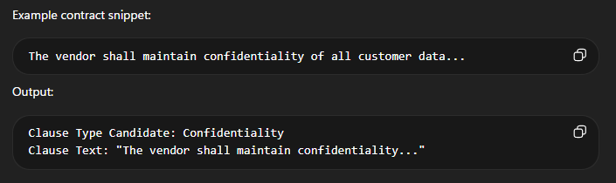Tasks
1️⃣ Parse contract documents
2️⃣ Identify clause boundaries
3️⃣ Extract meaningful text segments
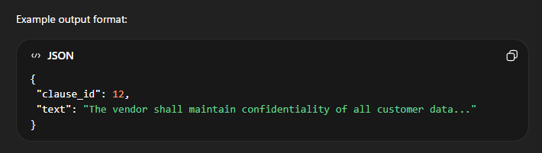

Dataset
CUAD Dataset (HuggingFace)
Contract Understanding Atticus Dataset
Contains:
- 510 commercial contracts
- 13,000+ annotated clauses
Clause types include:
- confidentiality
- termination
- indemnification
- liability
This dataset is perfect for your project.

Models / Tools
Low compute options:
- Legal-BERT
- DistilBERT
- spaCy NER
Alternative simple method:
- rule-based segmentation
- regex patterns

Evaluation Metrics
Measure:
precision
recall
F1 score
on clause extraction accuracy.
Agent 2 — Clause Classification Agent
(Legal understanding agent)
Goal
Identify what type of clause each extracted segment is.
Example input:
The agreement may be terminated with 30 days written notice.
Output:
Clause Type: Termination

Tasks
1️⃣ Take clauses from Agent 1
2️⃣ Classify clause category
Example output:
{
"clause_id": 12,
"clause_type": "Confidentiality"
}

Dataset
Again use CUAD dataset.
CUAD labels include ~40 clause categories like:
confidentiality
termination
governing law
liability
indemnification
payment terms
intellectual property

Models
Low compute options:
DistilBERT
RoBERTa-base
MiniLM
Even simpler:
Sentence Transformers + classifier

Evaluation
Metrics:
accuracy
macro F1
confusion matrix
Example confusion:
Termination vs Cancellation

Agent 3 — Risk Detection Agent
(Core “legal intelligence” agent)
Goal
Determine whether a clause is safe, risky, or missing protections.
Example:
Clause:
The company assumes unlimited liability for damages.
Output:
Risk Level: HIGH
Reason: Unlimited liability

Tasks
Analyze clause + type and detect:
High Risk
unlimited liability
no termination rights
one-sided indemnification
Medium Risk
ambiguous wording
unclear obligations
Low Risk
standard clause
balanced terms

Dataset
Use two sources:
CUAD dataset
For clause examples.
ContractNLI dataset
This dataset focuses on legal reasoning and entailment in contracts.
Example:
Hypothesis: Vendor is liable for damages
Clause text: ...
Model decides if statement is true.

Models
Good low-compute choices:
DeBERTa-small
MiniLM
Legal-BERT
Alternative approach:
LLM prompt classification
Example prompt:
Classify this clause as Low/Medium/High risk.
Explain reasoning.

Evaluation Metrics
risk classification accuracy
precision/recall
Optional advanced metric:
agreement with legal annotation

Agent 4 — Contract Report Generation Agent
(Summarization + reasoning agent)
Goal
Produce a human-readable contract risk report.
Example output:
Contract Risk Summary
---------------------
High Risk Clauses:
• Unlimited liability clause
Medium Risk Clauses:
• Automatic renewal clause
Missing Clauses:
• Data protection clause
Overall Risk Score: 6.5 / 10

Tasks
Combine outputs from:
- Clause Extraction Agent
- Classification Agent
- Risk Detection Agent
Then generate:
contract summary
risk explanation
recommendations

Dataset
For summarization tasks:
HuggingFace datasets:
BillSum
GovReport
LegalSumm
These contain long legal documents with summaries.

Models
Low compute options:
FLAN-T5-small
BART-small
T5-small
Or:
LLM prompting (Mistral / Llama)

Evaluation
Metrics:
ROUGE score
summary coherence
Optional human evaluation:
usefulness
clarity

