**Basic Details of the Team and**

**Problem Statement**

-

Problem Statement Title: Smart Agriculture product management

System

Team Name: Supreme

Team Leader Name: Rajnish Kumar

Institute Code (AISHE):

Institute Name:

Veltech

University Chennai.

Theme Name: Agriculture,

Foodtech

& Rural Development

**Idea/Approach Details**

Idea

/Solution/Prototype

here:

.

➢

Farmers even in

this era are facing problems with insufficient resources and with incomplete

information about the art of farming

➢

Some farmers grapple with severe financial constraints, leading to tragic outcomes like suicide.

➢

A pressing need exists to create a society where farmers can live without constant fear for their

future.

➢

The agricultural sector lacks direct channels for farmers to connect with consumers, often

relying on intermediaries, resulting in reduced returns and recognition.

➢

A forward

-

thinking platform connecting farmers directly with consumers, enabling equipment

sharing, and providing comprehensive agricultural resources and data.

➢

The platform includes real

-

time weather forecasts for informed decision

-

making and It fosters

a dynamic community for user interactions and collaboration.

➢

Benefits extend to various farmer scales, particularly aiding marginal, small, semi

-

medium,

and medium

-

scale farmers.

➢

The platform aims to harmonize the interests of farmers, producers, and consumers, enhancing

efficiency, reducing waste, increasing profitability, and enabling direct agricultural

sector

interactions.

2

Technology stack

:

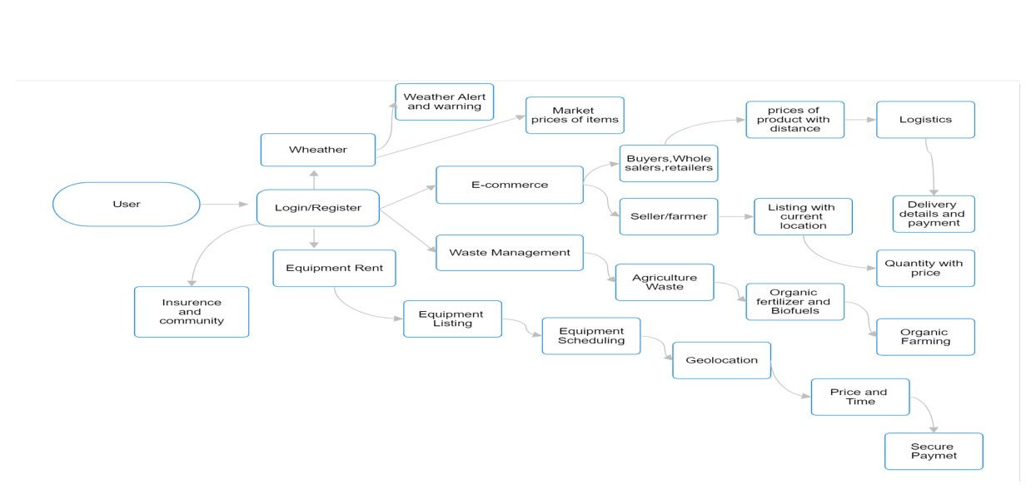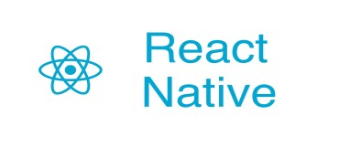

# Idea/Approach Details

Describe your Use Cases here Describe your Dependencies / Show stopper here

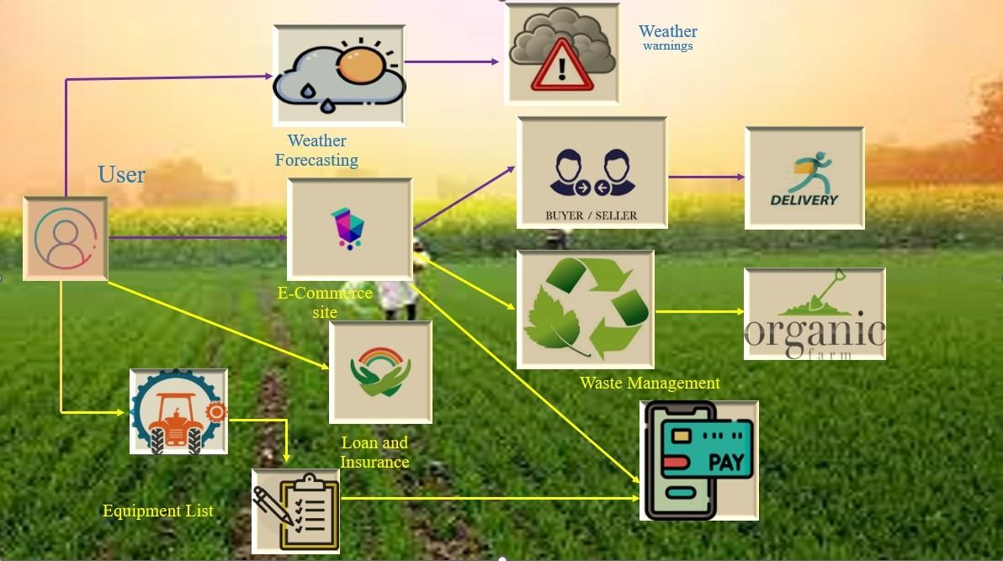⮚ In the context of the described digital platform, dependencies and showstoppers are critical considerations.

⮚ Dependencies include reliable internet connectivity for user access, accurate weather data providers for forecasting, geolocation services for features like e-commerce marketing, active community engagement for knowledge sharing, robust data security measures, and partnerships with insurance providers to offer coverage.

⮚ Showstoppers encompass the lack of internet access in underserved areas, the use of inaccurate weather data leading to uninformed decisions, potential privacy breaches eroding user trust, low user adoption hindering the platform's potential, technical failures causing service disruptions, and the absence of insurance options leaving farmers vulnerable.

⮚ Mitigation strategies should focus on infrastructure, cybersecurity, data partnerships, community building, equitable internet access, and securing insurance providers to ensure the platform's effectiveness and reliability.

3

# Team Member Details

Year

(

I,II,III,IV):

III

Year (I,II,III,IV):

III

**Team Leader Name: Rajnish Kumar**

Branch (Btech/Mtech/PhD etc): Btech Stream (ECE, CSE etc): CSE

**Team Member 1 Name: priyansu jaiswal**

Branch (Btech/Mtech/PhD etc): Btech Stream (ECE, CSE etc): CSE

|  |  |  |  |
| --- | --- | --- | --- |
| **Team Member 2 Name: Darpan Ghosh** |  |  |  |
| Branch (Btech/Mtech/PhD etc): Btech  **Team Member 3 Name: Umesh Kumar Mahto** |  | Stream (ECE, CSE etc): CSE | Year (I,II,III,IV): III |
| Branch (Btech/Mtech/PhD etc): Btech  **Team Member 4 Name: Jaybardhan Singh** |  | Stream (ECE, CSE etc): CSE | Year (I,II,III,IV): III |
| Branch (Btech/Mtech/PhD etc): Btech  **Team Member 5 Name:** |  | Stream (ECE, CSE etc): CSE | Year (I,II,III,IV): III |