* **Aim:**

The aim of this project analyzes the trend of COVID-19 Vaccination around the world and determine the effectiveness of vaccines based on country and year.

* **Introduction:**

COVID-19 has had a significant impact on the world, causing widespread illness, death, and disruptions to daily life. Governments and public health organizations around the world have implemented various measures to slow the spread of the virus, such as social distancing, mask-wearing, and lockdowns. Vaccines have also been developed and authorized for emergency use, and vaccination campaigns are ongoing in many countries.

* **Problem statement:**
* In order to know how many people are fully vaccinated by the initial protocol.
* To know the population which has received at least one dose of the vaccine.
* The different vaccines used and their availability in different countries.
* We can find out how many people are completely vaccinated.
* Total vaccinations by each year and then by country. In this analysis, we can see the number of people vaccinated per hundred.
* **Methodology:**

The dataset was provided with the project assignment which is basically the data available for the public and which is collected from the respective health departments of the countries or from the WHO.

The dataset contains information for the period December 2020 to March 2022.

**Step 1: Data cleaning**

I have used the Power BI tool to clean and transform the data as per my understanding and I have replaced values, grouped the data and created a new table where it seemed fit.

**Step 2: Data Exploration**

In order to take any necessary steps, we must understand the data we have, which is data exploration and based on our understanding we can go ahead with the appropriate data cleaning steps required.

**Step 3: Data Visualization**

In visualization, I took the help of Power BI Desktop software to make graphs and charts here some relevant graphs and charts are attached.

**Report View:**

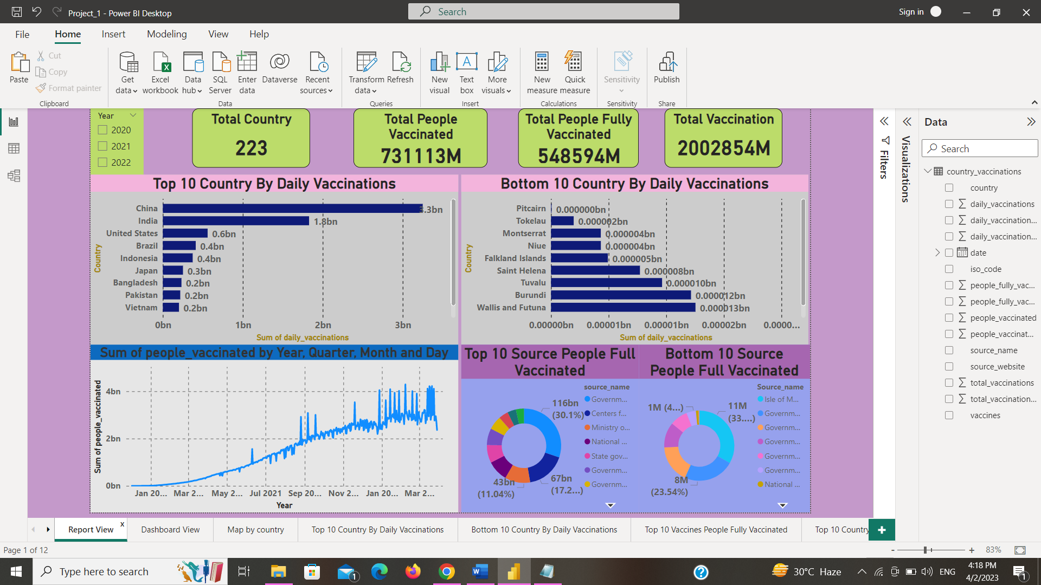

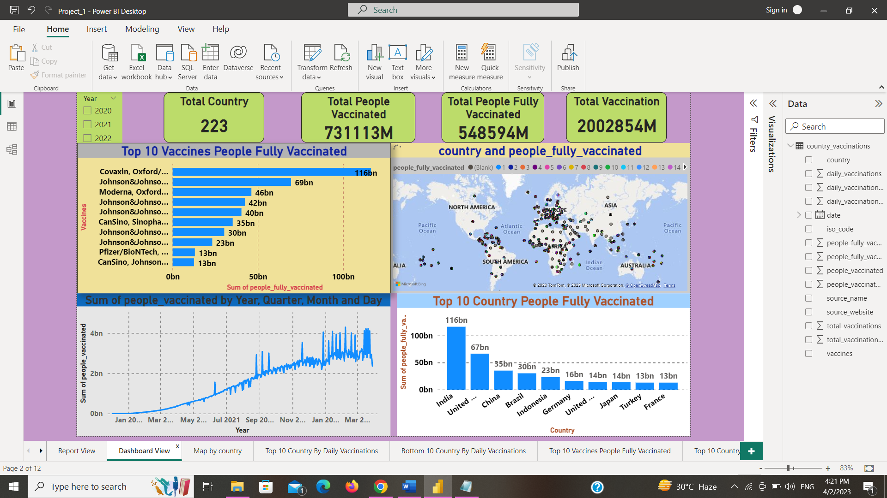

**Map By Country**

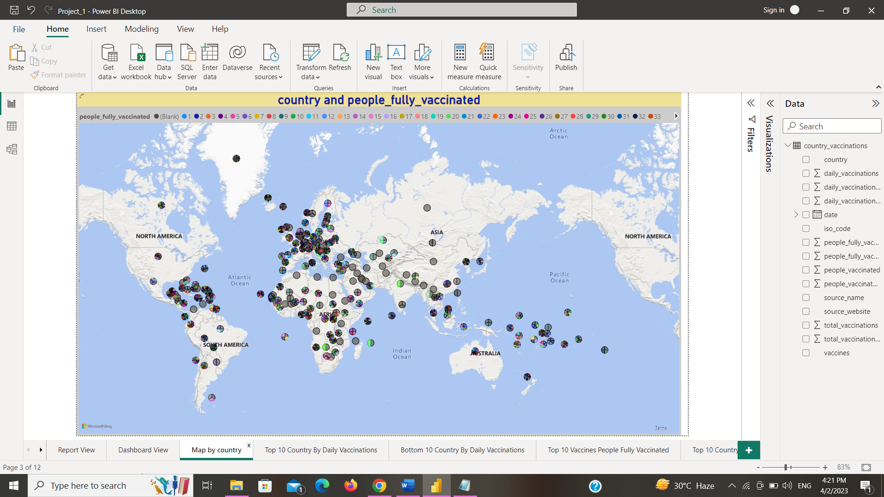

**Top 10 Countries by Daily Vaccinations**

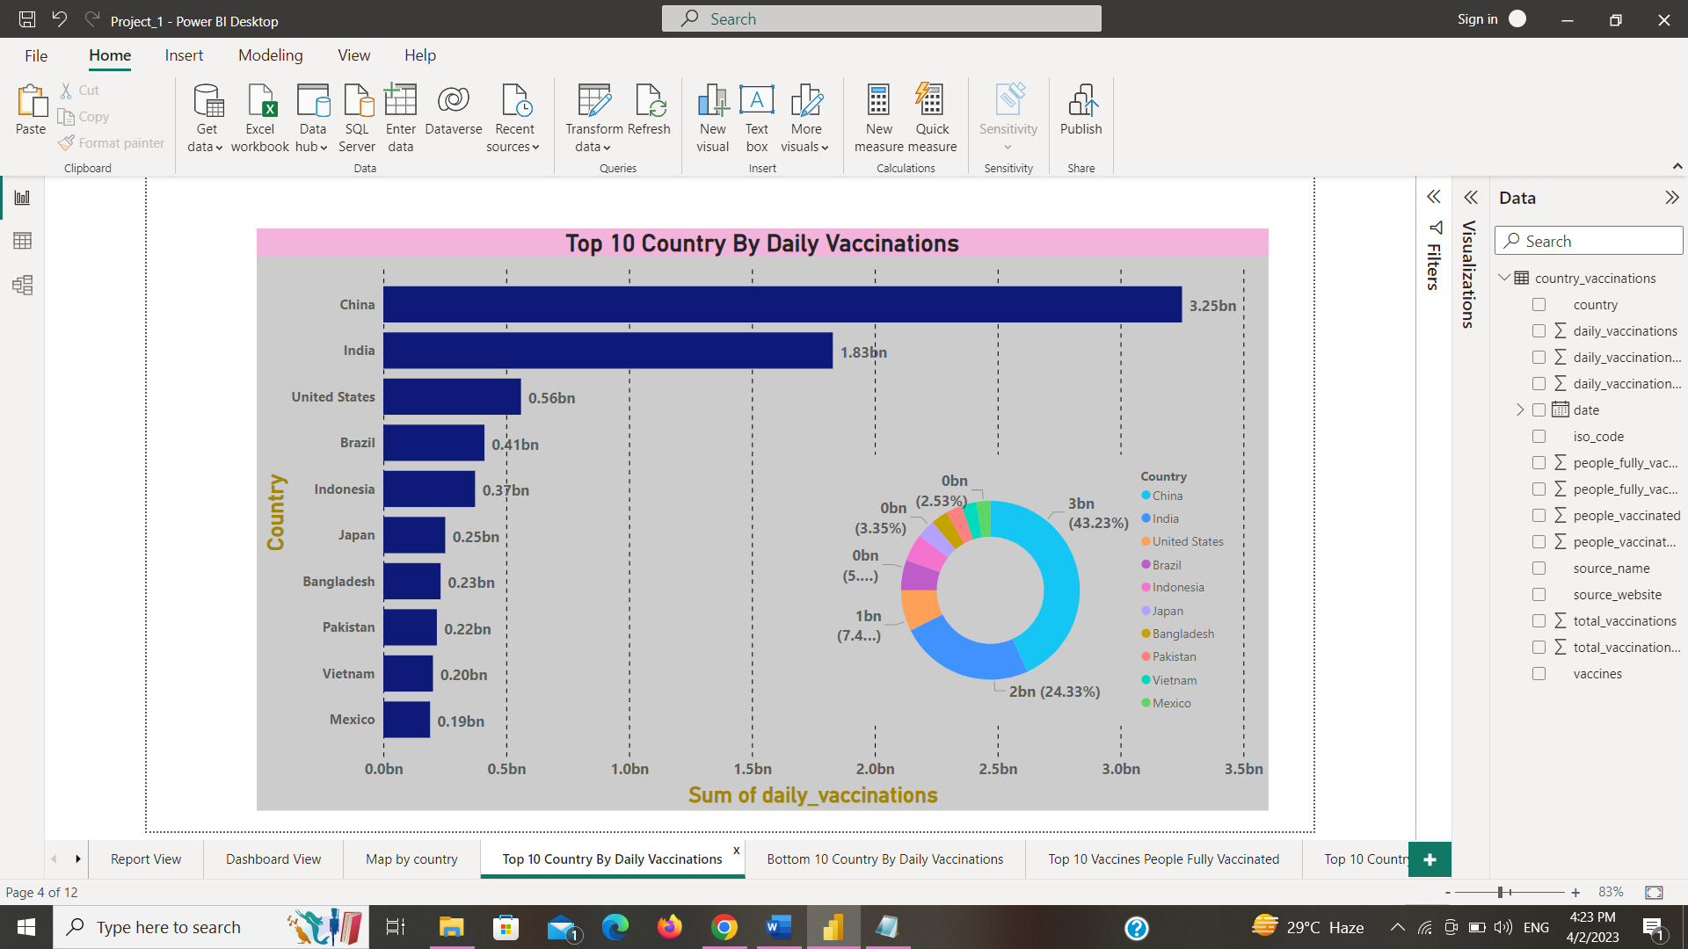

**Bottom 10 Countries by daily Vaccinations**

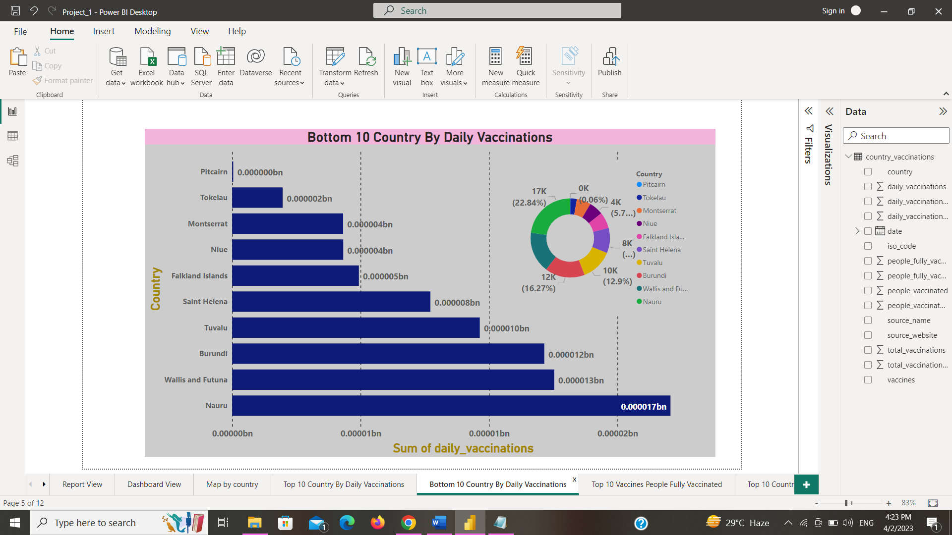

**Top 10 Vaccines people fully vaccinated**

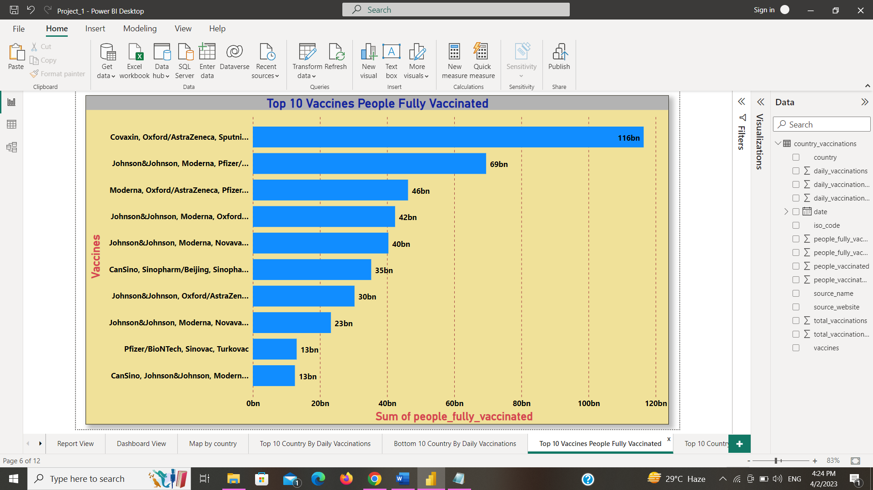

**Top 10 Countries People Fully Vaccinated**

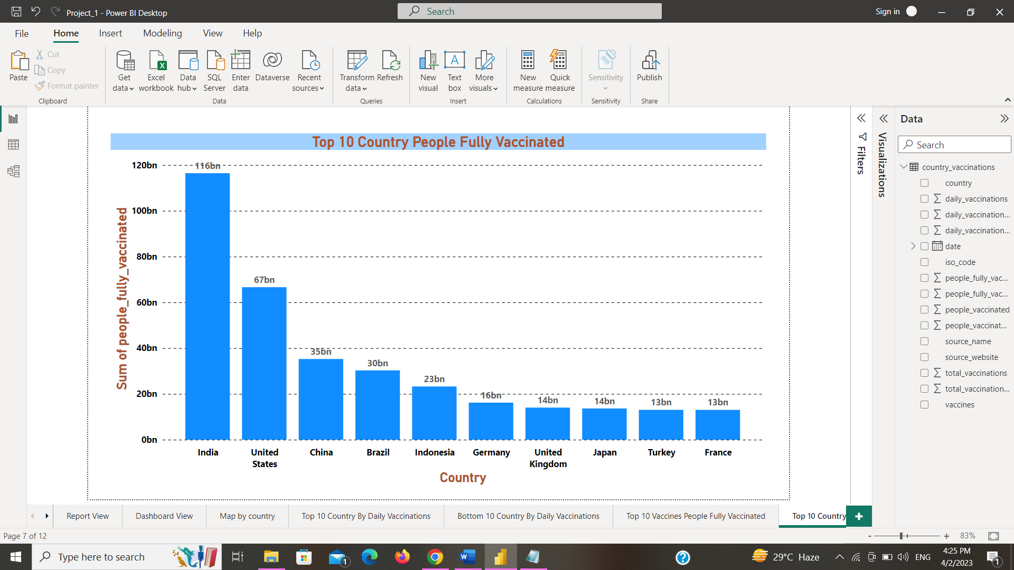

**Top 10 Sources People Fully Vaccinated**



**Bottom 10 Sources People Fully Vaccinated**

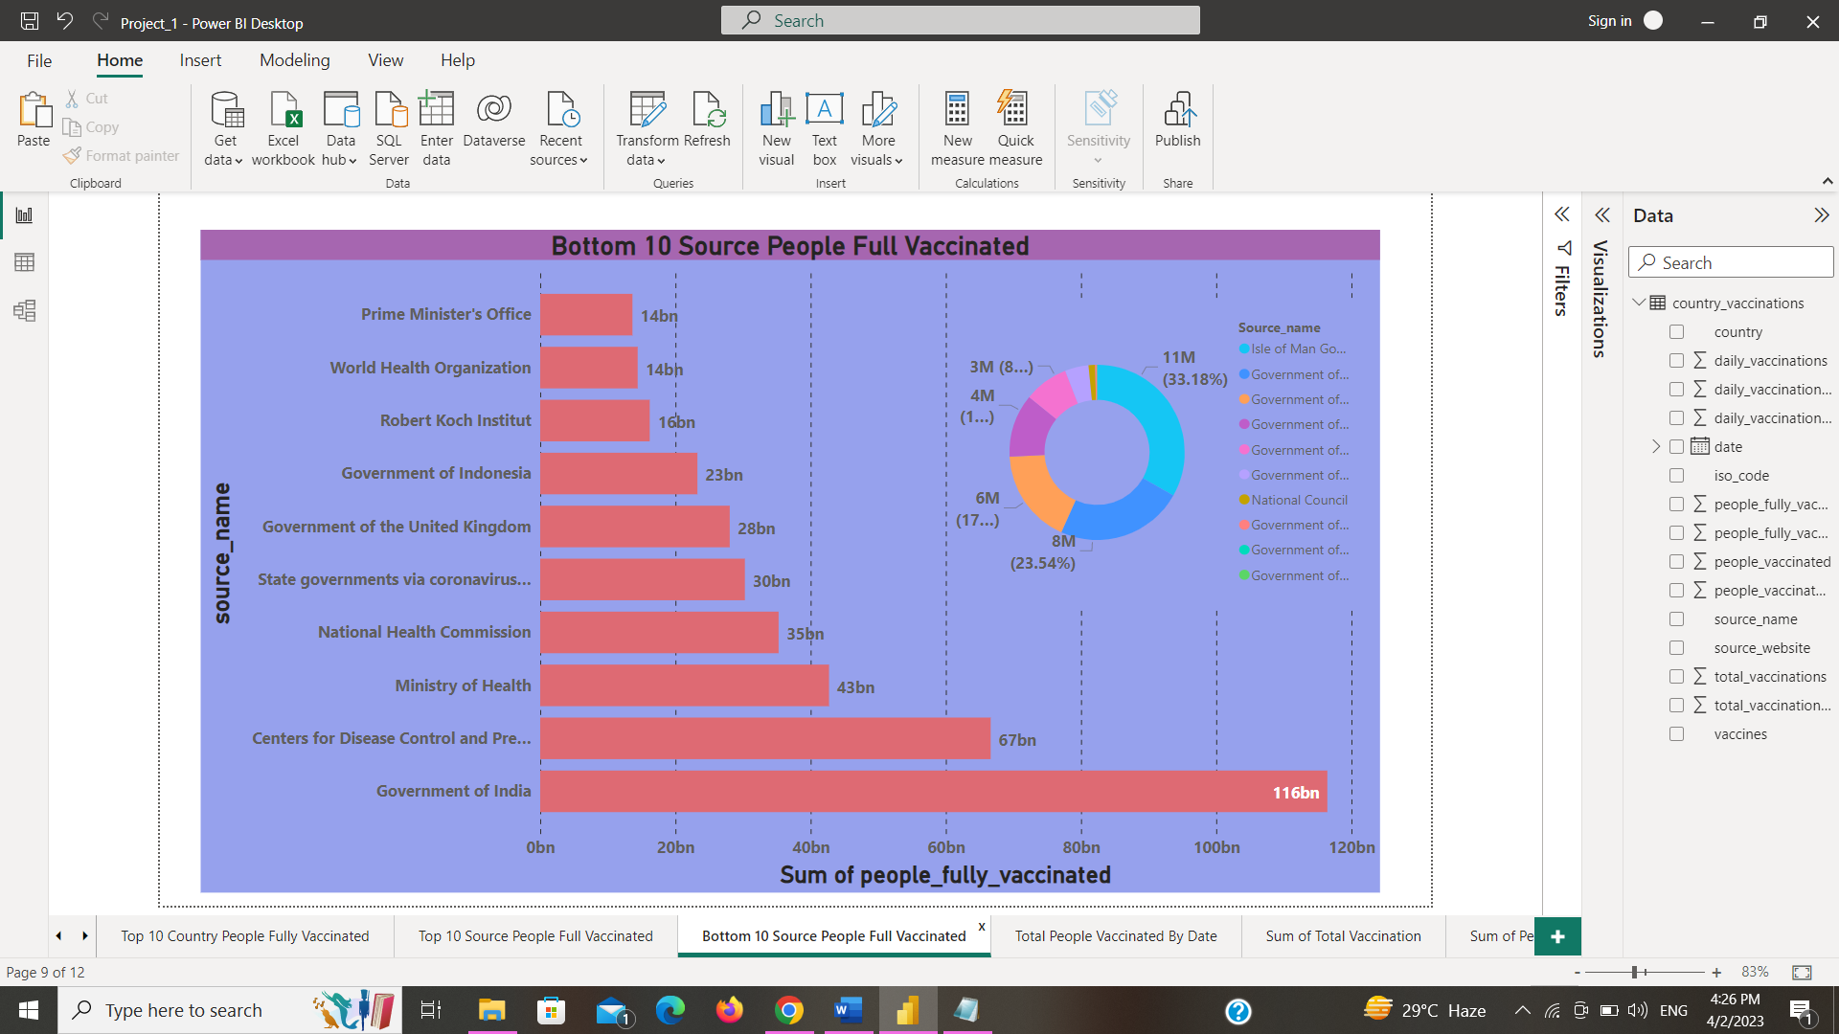

**Total People Vaccinated by Date**

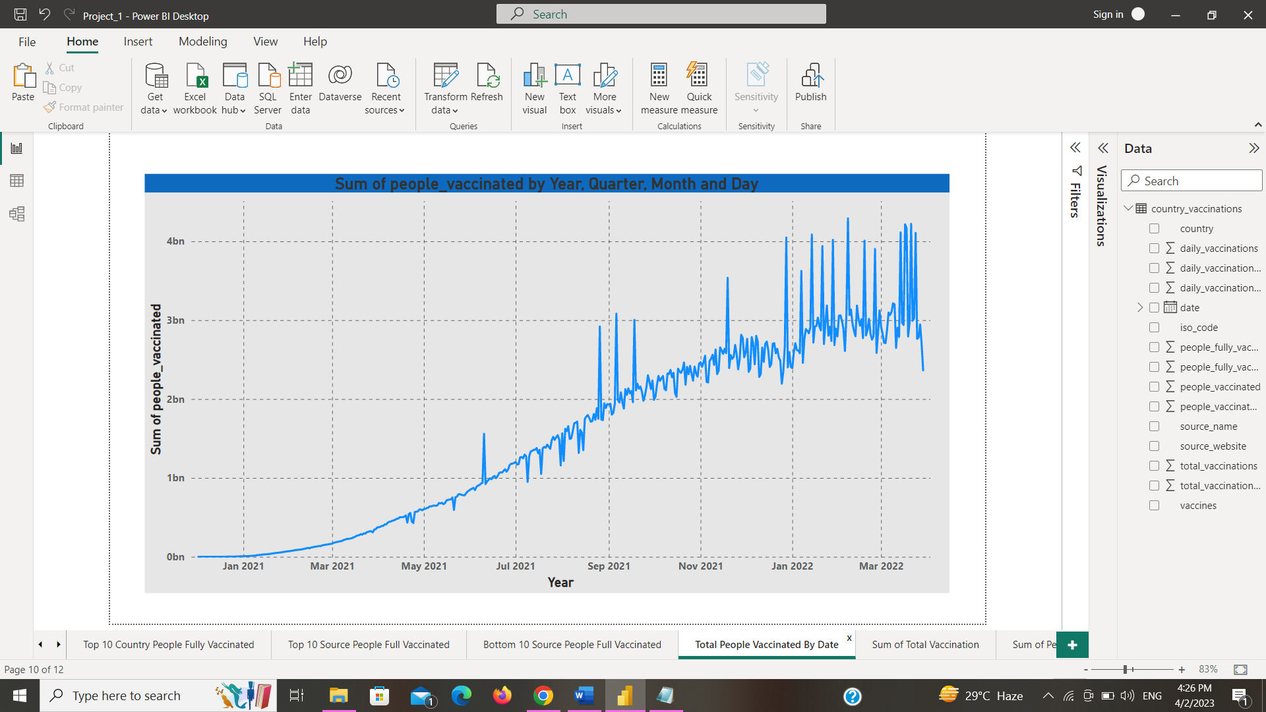

**Sum of Total Vaccination**

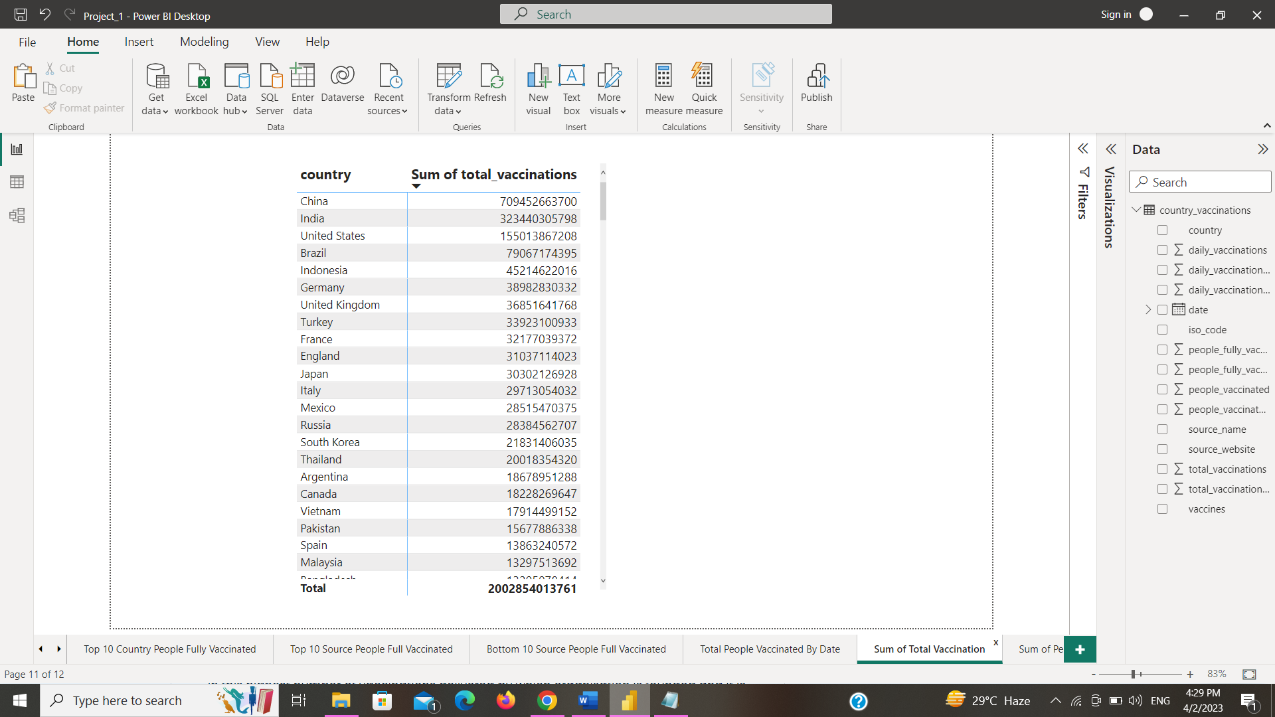

**Sum of Total people Vaccinated**

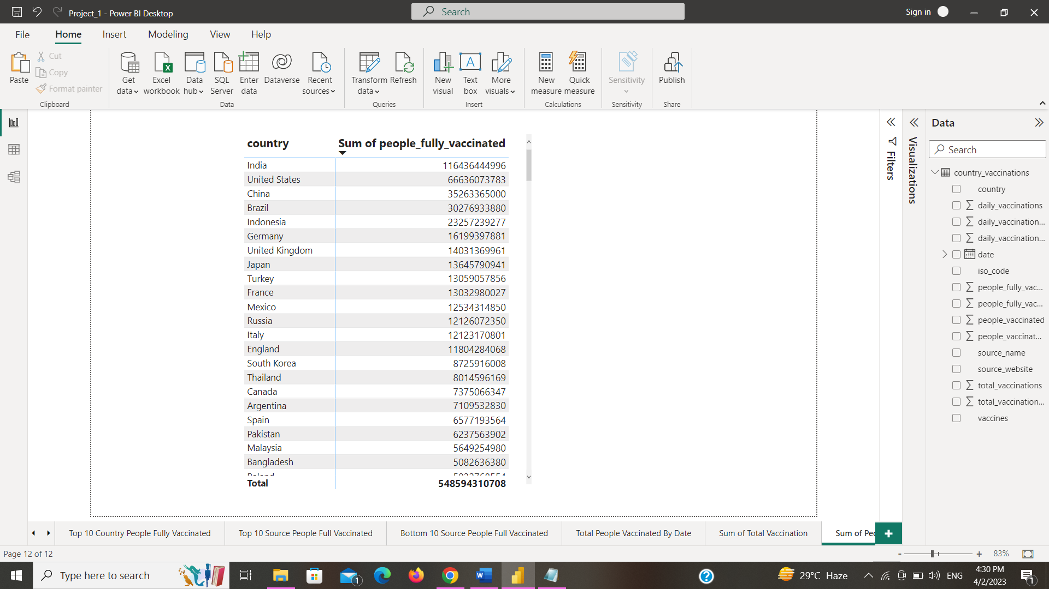

* **Analysis (Data sheets pertaining to it)**
* Country – The name of the countries (223 Countries in total)
* ISO Code – Code initials for the countries
* Date – The date, month and year of the data collected
* Total vaccinations – The total number of vaccinations administered which is nothing but the sum of the doses given on any particular date to the total vaccinations of the previous day.
* People vaccinated – The total number of people who received at least one dose of vaccine. This is also an aggregated column meaning it is the sum of the total of the previous day to the vaccinations of the present day.
* People fully vaccinated – The aggregated value of people who received the desired number of doses (min 2 doses and 1 booster dose may or may not be included).
* Daily Vaccinations Raw – gives the raw data collected on vaccinations
* Daily vaccinations – The vaccinations administered on any particular day
* Total vaccinations per 100 – The total vaccinations administered per 100 people which also aggregated data
* People vaccinated per 100 – The number of people who received at least one dose of vaccine, taking into account for every 100 people
* People fully vaccinated per 100 – For every 100 people how many are fully vaccinated (received min 2 doses)
* Daily vaccinations per million – gives the number of vaccinations administered for every million population on any particular day.
* Vaccines – gives the different vaccines and their manufacturers separated by commas.
* Source name – gives the name of the source from which data is provided.
* Source website – gives the website link from where the data was obtained.
* According to data on people fully vaccinated in the year.
* The dataset available is from 2020,2021,2022.
* Total vaccination by the country in map visualization.
* Total Highest Top 10 Country Daily vaccination
* Total Highest Top 10 Vaccine People Fully Vaccinated
* Total Highest Top 10 Country People Fully Vaccinated
* Total Highest Top 10 Source Name People Fully Vaccinated
* The total Highest Daily vaccination is 3250342496 in China.
* The highest number of vaccinations by the source name is the Govt of India is 116436444996
* The sum Of Total Vaccinations is 2002854013761
* The sum Of People Fully Vaccinated is 548594310708
* **Insights**
* More than half of the world has been successfully vaccinated against corona virus which brings a big relief.
* The most used vaccines around the world are Johnson and Johnson, Pfizer, Oxford and Moderna.
* China and India are leading in vaccinating their vast population followed by the USA.
* Economically weak countries are too far behind in the vaccination trend.
* **Recommendations**
* Like this dataset, we can perform operations with various categories, city-wise or region-wise.
* We can work on large datasets and analyze them with the proper format of the chart.
* The developed and economically strong countries should help out the underdeveloped and developing countries to improve the vaccination of the people.
* At least 90% of the population should be vaccinated at least once to avoid further problems.
* **Conclusions**
* In conclusion, we can take a look at the final report for further analysis.
* As we can see in the Report the top countries vaccination-wise, Top Country by the vaccination in daily and the best top 10 countries with our vaccines. Vaccination peeks in 2022. The Top 2 vaccine sources are India, and China.