* **Aim:**

The aim of this project analyzes the trend of Supply and Demand Gap Analysis of Sigma Cab Services and determine the effectiveness of cab for different distance, rating & pricing.

* **Introduction:**

The main objective is to analyze the cab details and customer details so that we can able to understand what types of cabs are mostly preferred by customer by that we can introduce that type of cabs in large numbers for future so that we can be more profitable

* **Problem statement:**
  + We have analyzed the sum of cancellation last month and sum of customers across months
  + We have analyzed the cancellation records according to the gender
  + We have analyzed the trip distance according to the different types of cabs
  + We have analyzed the customer rating according to the different types of cabs
  + We have analyzed the life style index according to the confidence life style index
  + We have analyzed the sum of all three variables according to the different types of cabs
  + We have analyzed the total trip distance according to the gender
  + We have analyzed the customer across months and surge pricing type according to destination type
  + We have analyzed the cancellation last month and sum of customers across months according to cab type
  + We have analyzed the customer across months according to gender
  + We have analyzed the sum of all three variables according to gender
* **Methodology:**

The dataset contains information for the random period

**Step 1: Data Importing**

In power BI desktop with the help of the get data option, import the CSV data which is named as SigmaCabs and click load option.

**Step 2: Data Cleaning**

After loading the data and after analyzing the data I understood that there are 131662 rows and 14 columns. And in that some of the columns contained null values I have replaced the null values by 0 with the use of replace functions and started working on the data.

**Step 3: Data Visualization**

In visualization part with the help of power BI desktop software I have used different kinds of charts, graphs, cards and table to display the data in the format which will be easy to understand.

**Report View:**

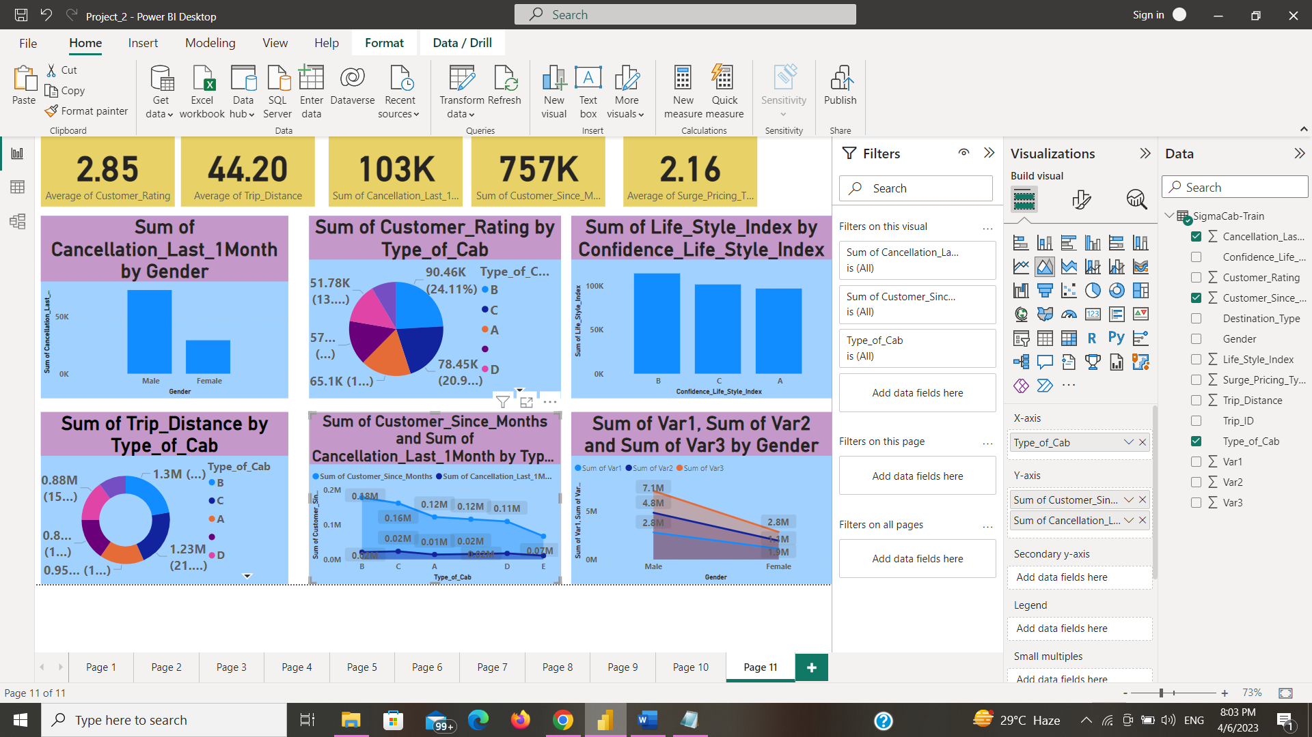

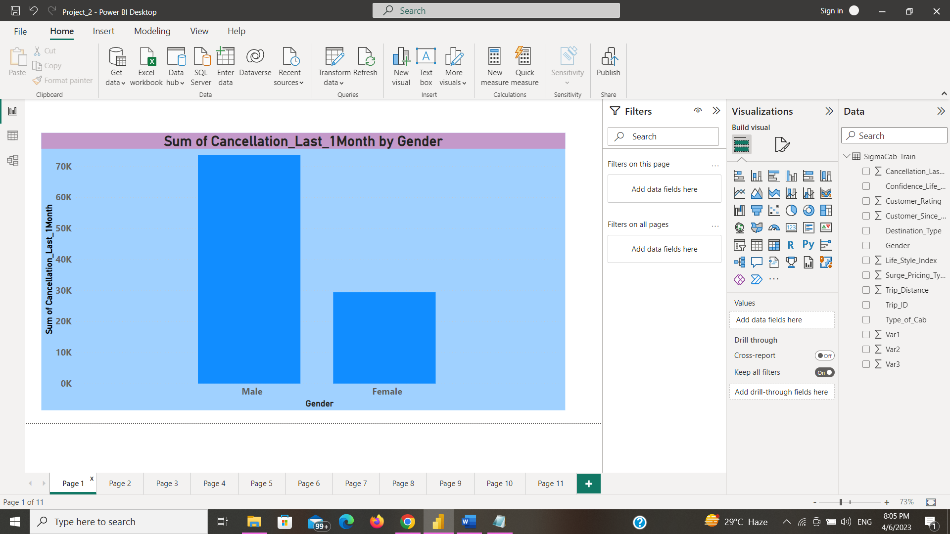

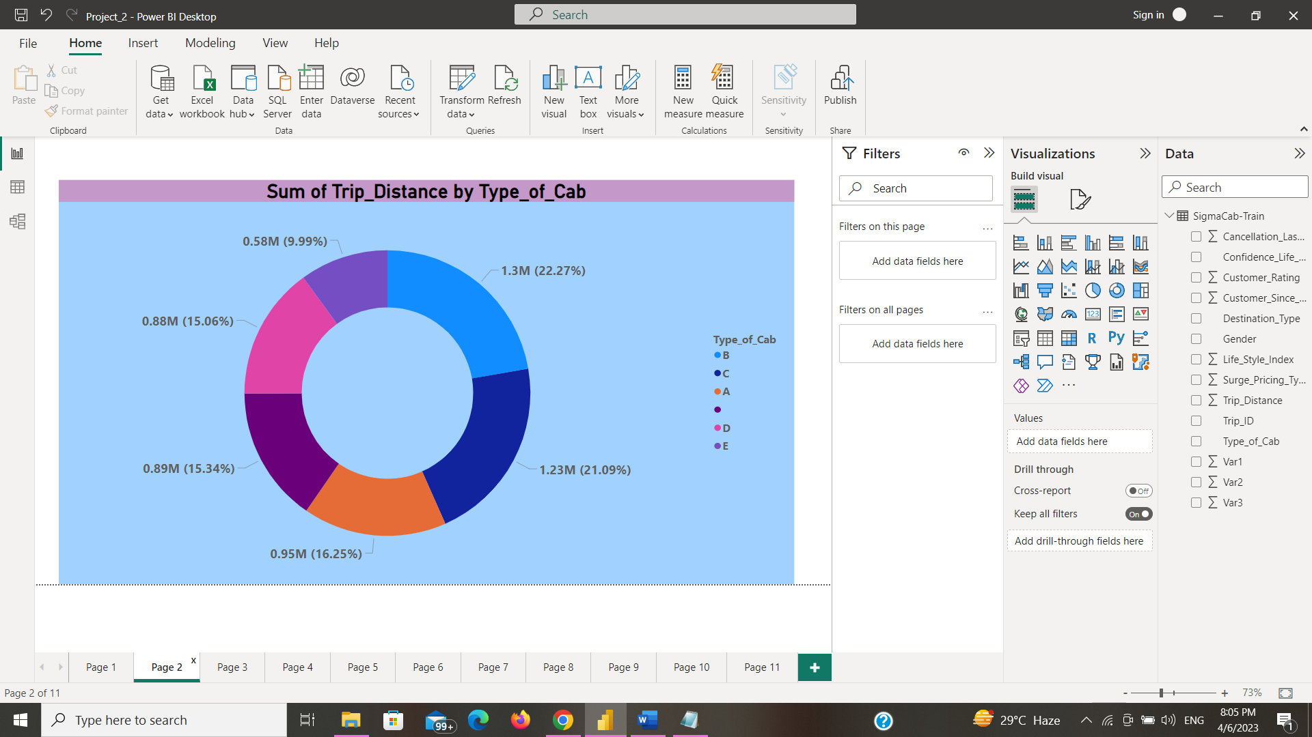

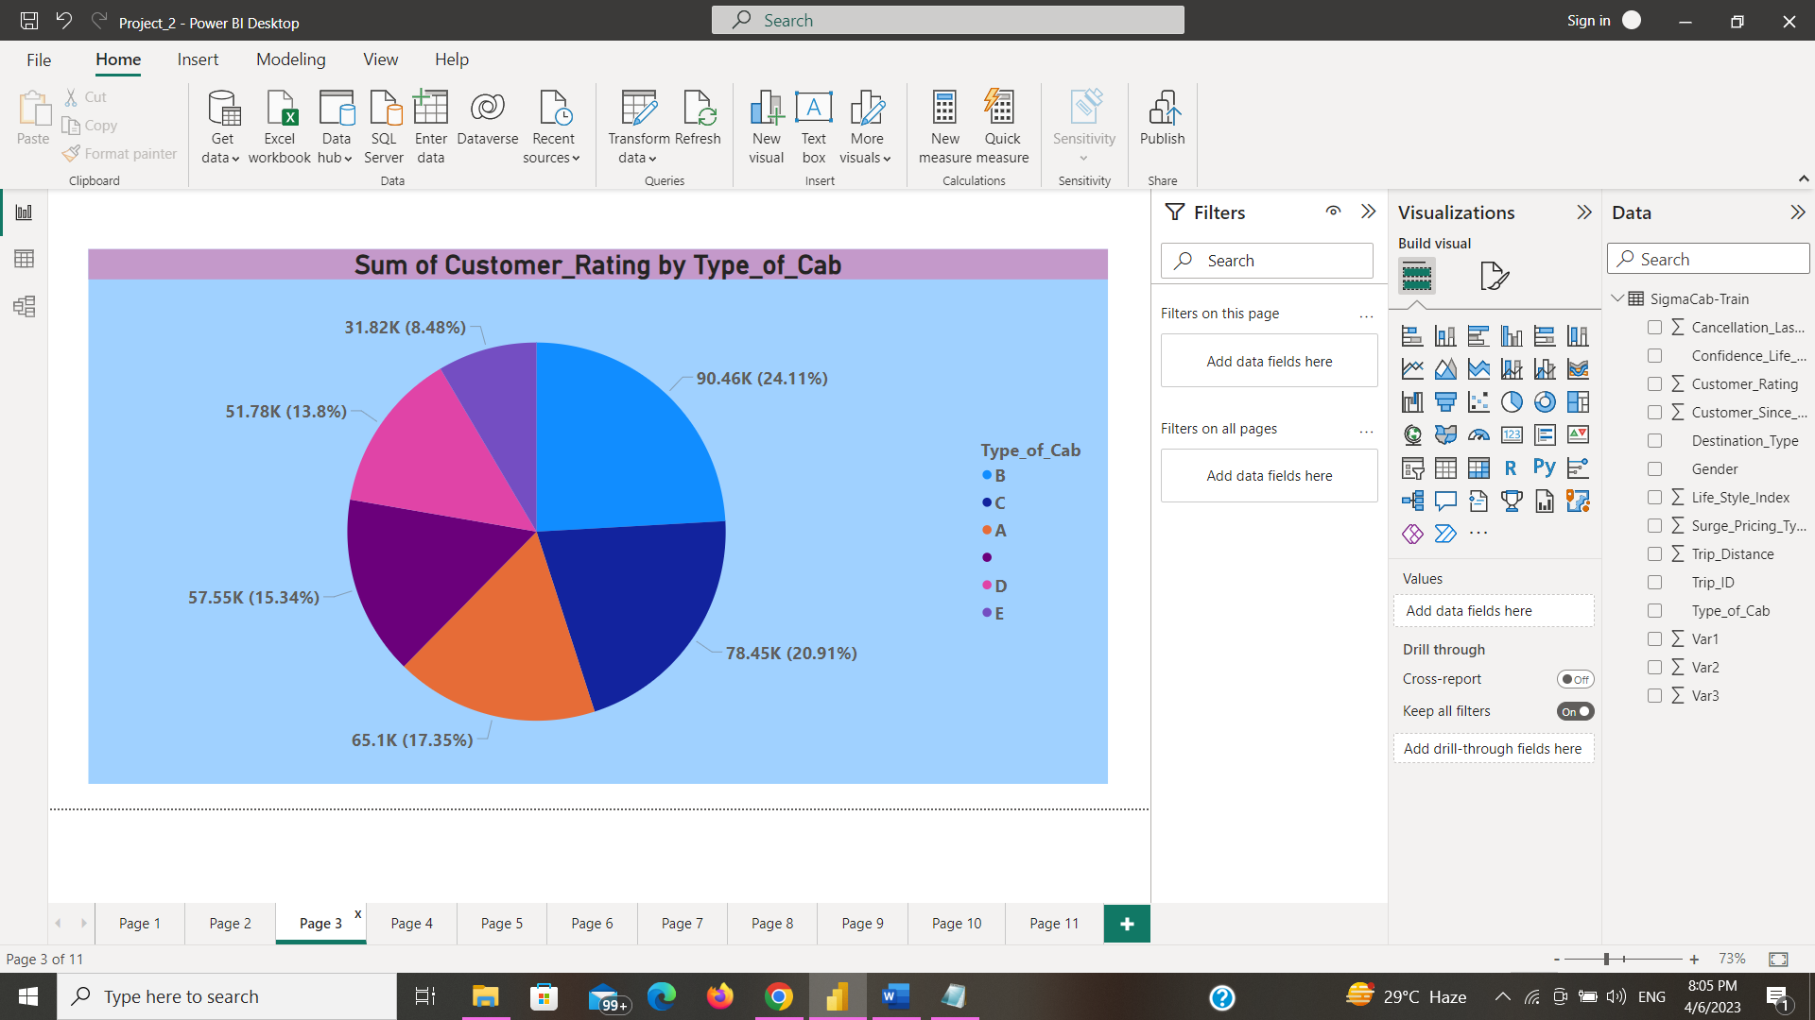

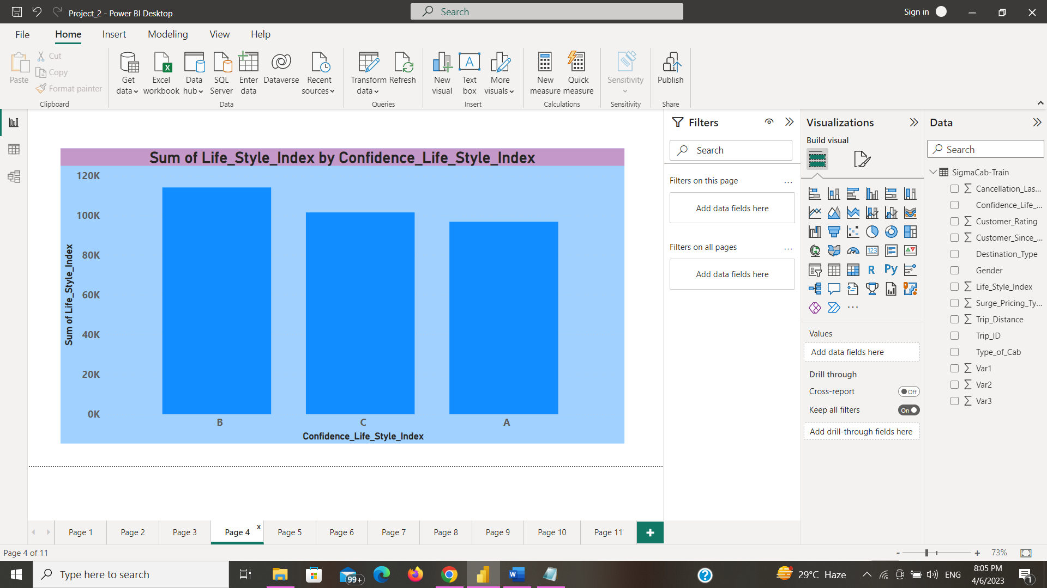

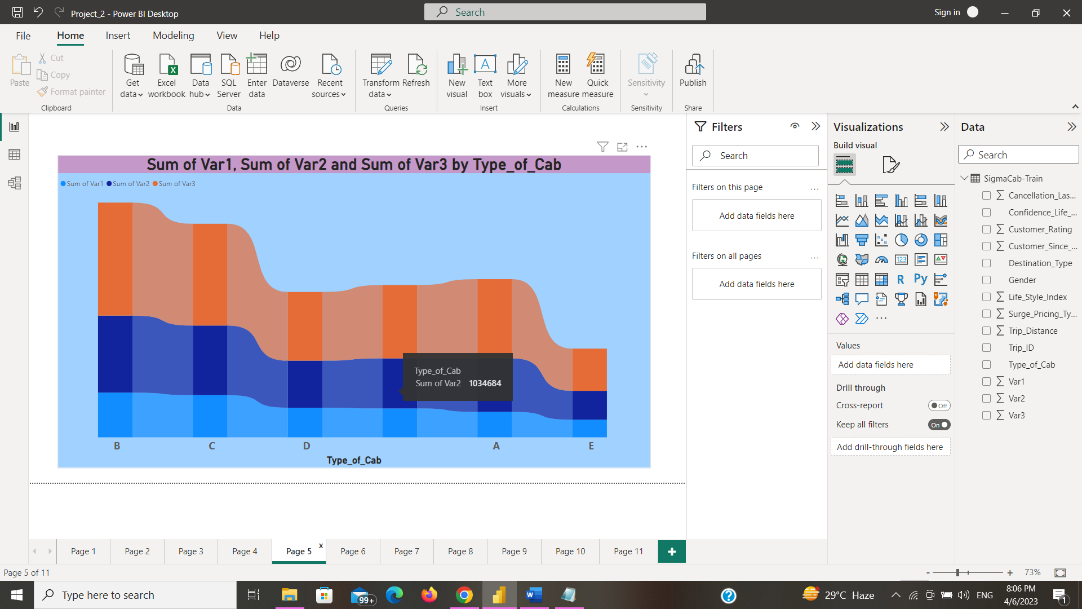

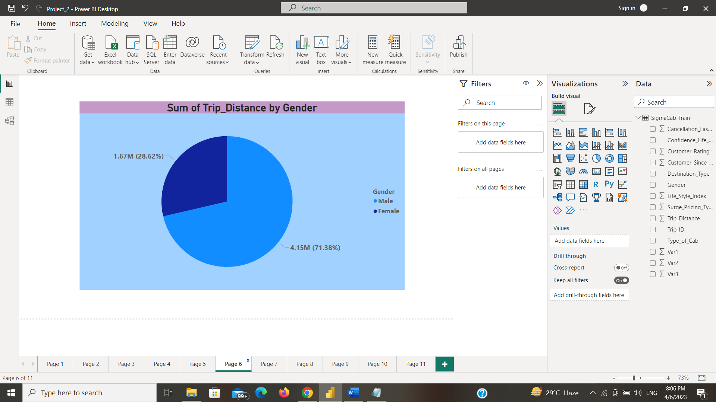

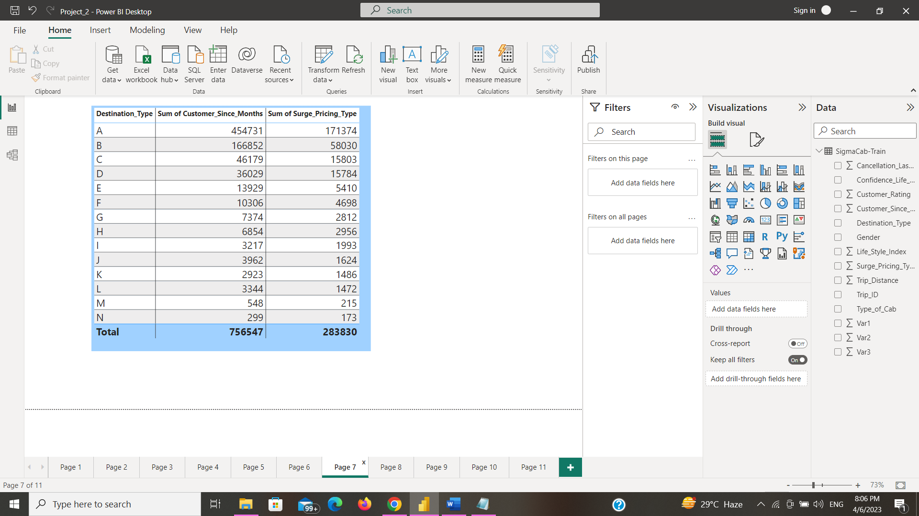

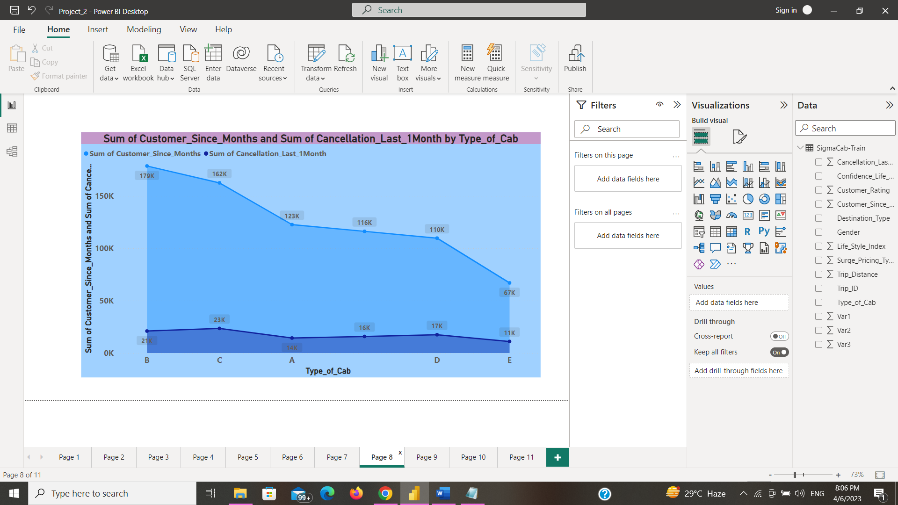

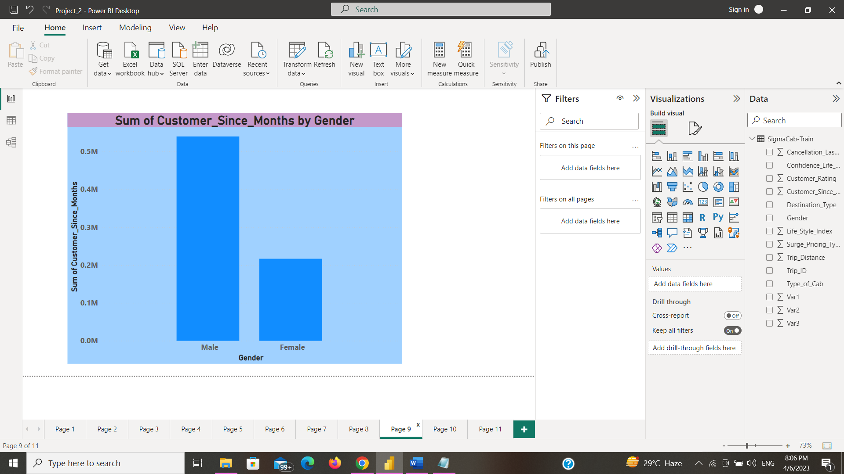

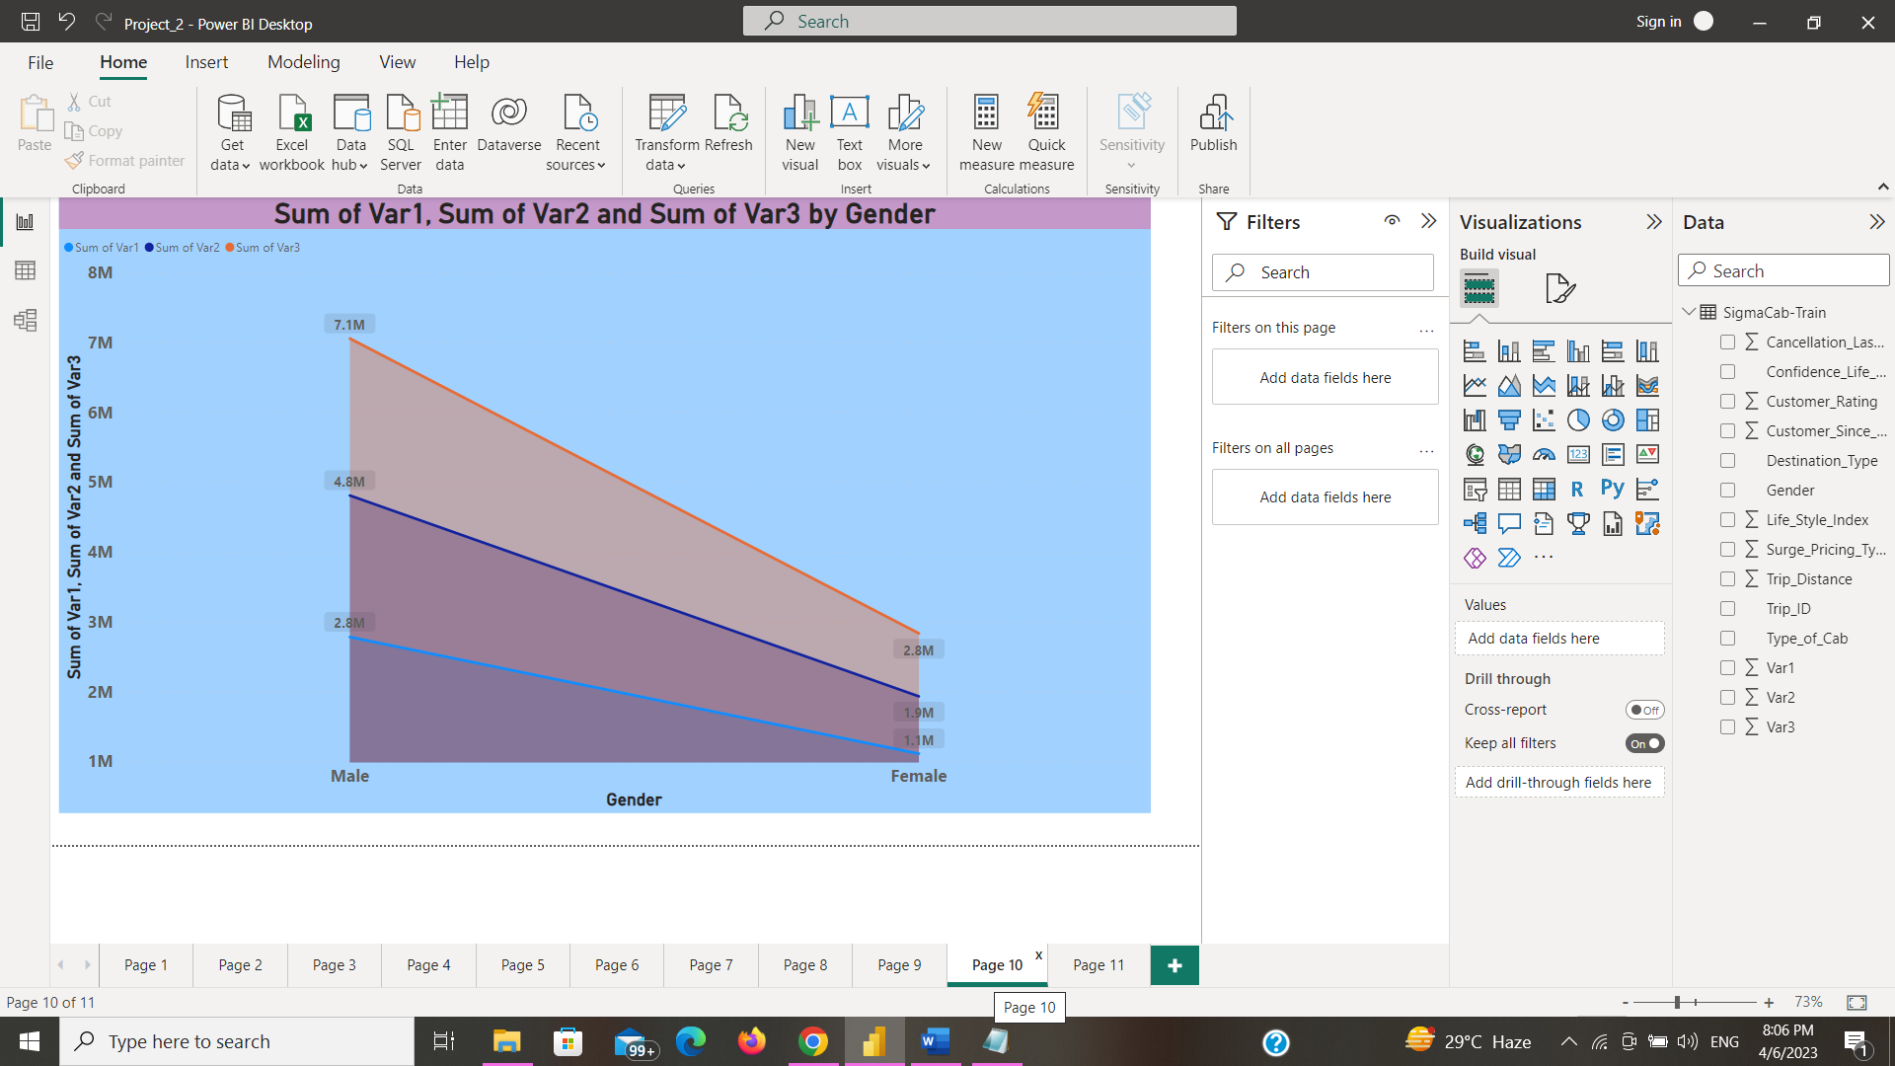

* **Insights**
* Here we have analyzed the average trip distance and average customer rating so that we able to calculate what will be average distance that the customer wants to travel and by average customer rating we can able to find our service satisfaction so that we can improve for future
* And also analyzed the customer rating and trip distance according to type of cab so that we can able to understand which type of cab is preferred by people
* And also analyzed the no. of customer details and cancellation details according by gender so that we can able to understand which gender is using the cab facilities more frequently
* And also analyzed which is the most frequently selected destination type and so that we can able to understand which destination needs more cabs
* **Recommendations**
* From the above analyses we can able to find that B type of cab is mostly used cab by distance and it’s also highly rated by customer rating so it will be good to launch B type of cabs more frequently in future so that profit will be increased
* And also, we came to know that male customers use cab services more often, so if we do advertisements more frequently means there will be chance of getting more female customers also
* And destination type A is most preferred destination followed by destination type B and C so having more cabs for that destination will increase profit
* **Conclusions**

From the above analysis we are able to know that we have to do some changes for that if we follow the above recommendations by doing continuous improvisation, we will more successful in future.