1. Using super store data  create Tree Map, Line Chart and Area Chart visualization

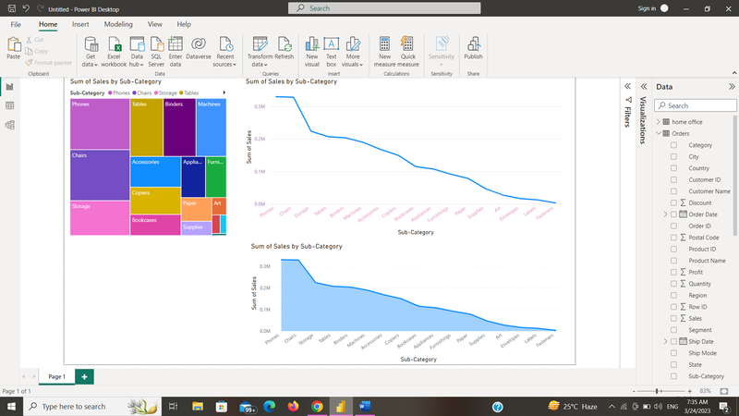

2. Edit Interactions - Using super store data attached in this document create total orders count and total sales using cards, add Year as slicer, and clustered Colum chart showing sales by year. Now make sure all the card is not filter by the slicer – Use Edit Interactions

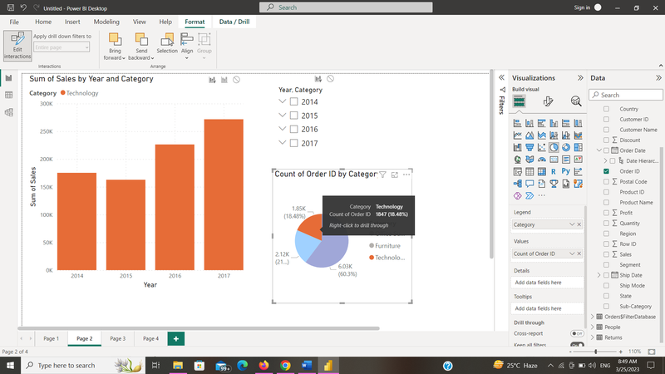

3. Drill Through Filters – Create Power BI report to demo Drill Through Filters and explain the steps

Step 1: Create a simple report

Step 2: Add a drill-through filter

Step 3: Configure the drill-through filter

Step 4: Add a drill-through page

Step 5: Add a visual to the drill-through page

Step 6: Test the drill-through filter

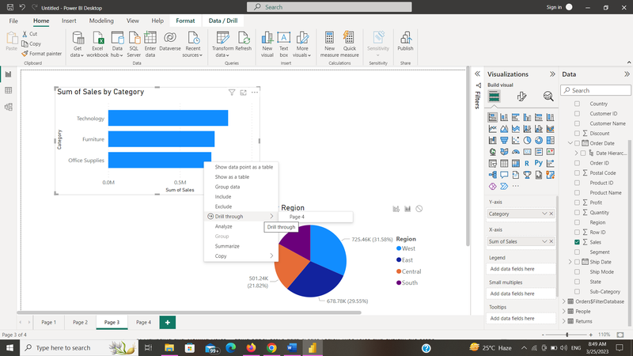

4. Bookmarks – Create 3 bar charts of same size with different values. Using button demo the bookmarks and explain the steps

Step 1: Create a simple report

Step 2: Add bookmarks

Step 3: Add a button

Step 4: Configure the button

Step 5: Test the bookmarks

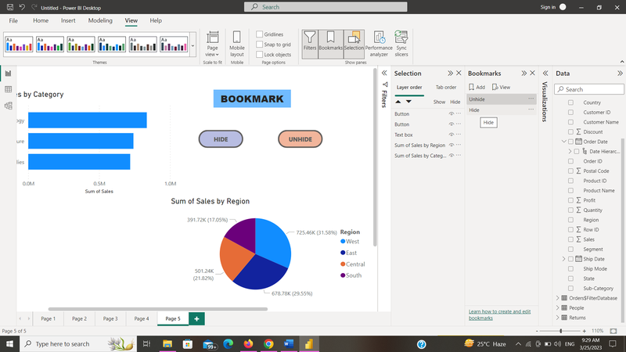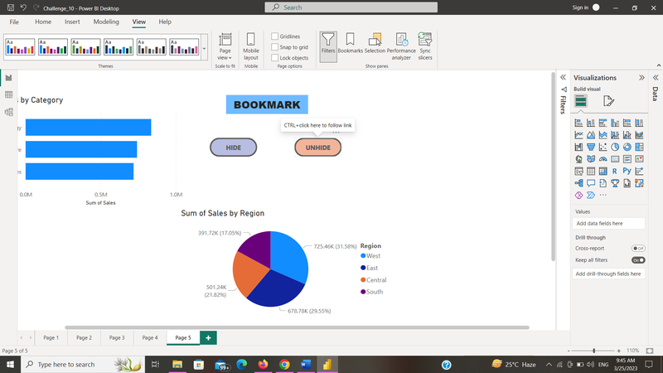

5. What-if parameters – Apply Dynamic discount on Sales data and explain the steps

Step 1: Create a simple report

Step 2: Add a What-If parameter

Step 3: Add a measure

Step 4: Use the measure in your visual

Step 5: Test the What-If parameter

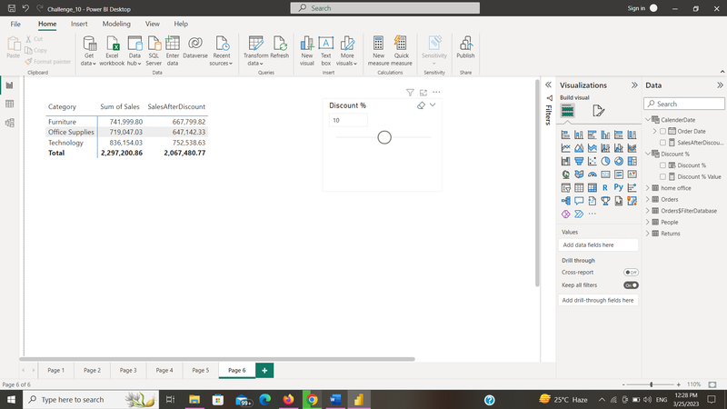

6. Managing and Viewing Roles – using super store data create region wise roles and explain the steps

Step 1: Import the Superstore dataset

Step 2: Create a role

Step 3: Define the role

Step 4: Assign users to the role

Step 5: Test the role

