1. Explain Merge Queries with an example?

--- Merge Queries is a transformation step that allows you to combine two or more tables based on a related column or set of columns.

Different Types of Merge:

* Left Outer
* Right Outer
* Full Outer
* Inner
* Left Anti
* Right Anti

Suppose we have two tables in our Power BI dataset: "Department" and "Employee". The "Department" table has the following columns: DepartmentID, DepartmentName. The "Employee" table has the following columns: EmployeeID, EmployeeName, and DepartmetID.

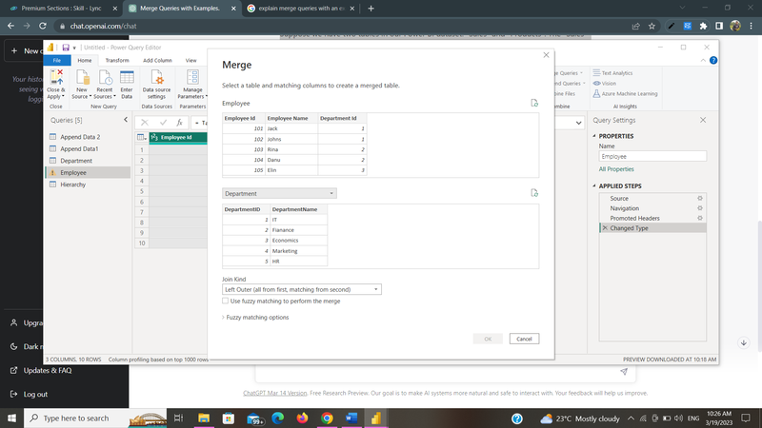

Different Tpyes of Merge:

* Left Outer

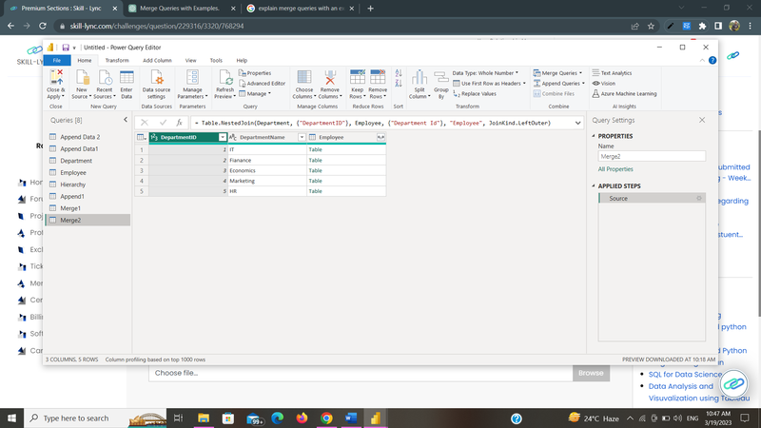

* Right Outer

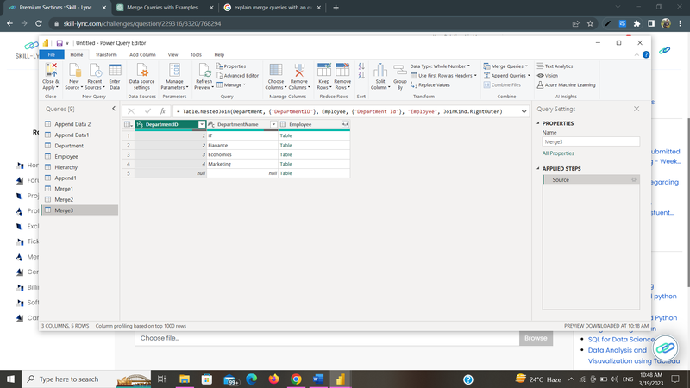

* Full Outer

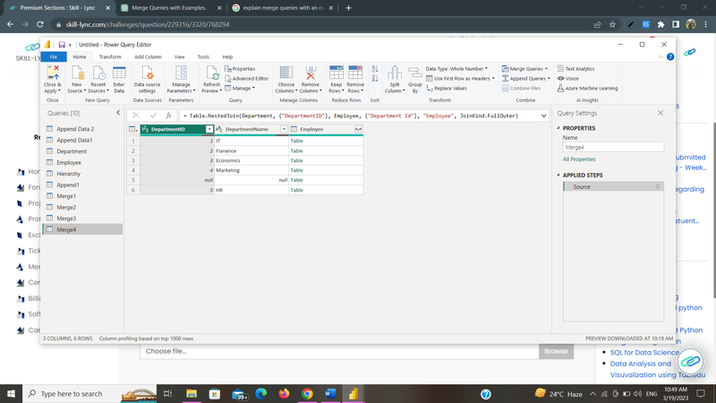

* Inner

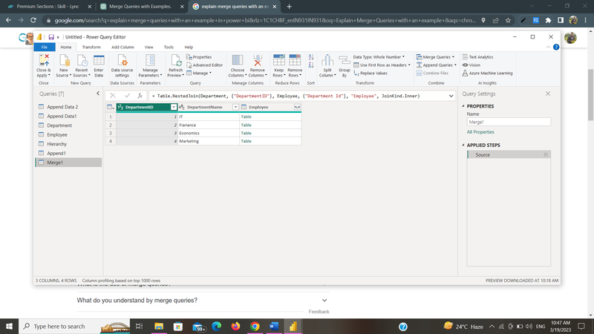

* Left Anti

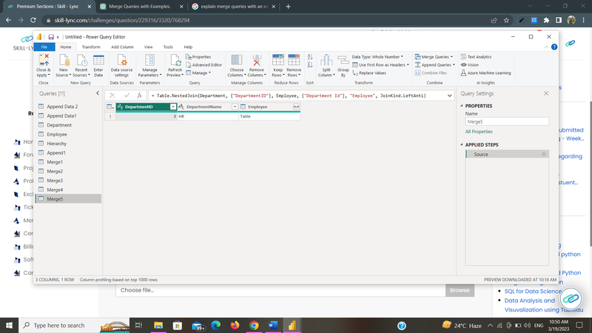

* Right Anti

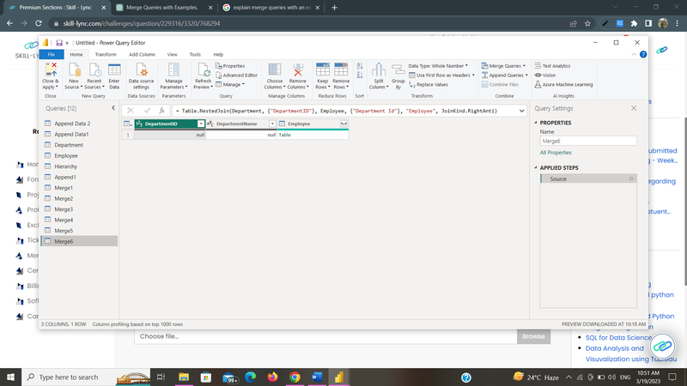

  2. Explain Append Queries with an example?

--- Append Queries is a transformation step that allows you to combine two or more tables vertically, i.e., stacking them one on top of the other. The result of an Append Queries transformation is a new table that includes data from all the appended tables.

Suppose we have two tables in our Power BI dataset: "Append Data1" and "Append Data 2". Both tables have the same structure, with columns such as ID, Name and Region.

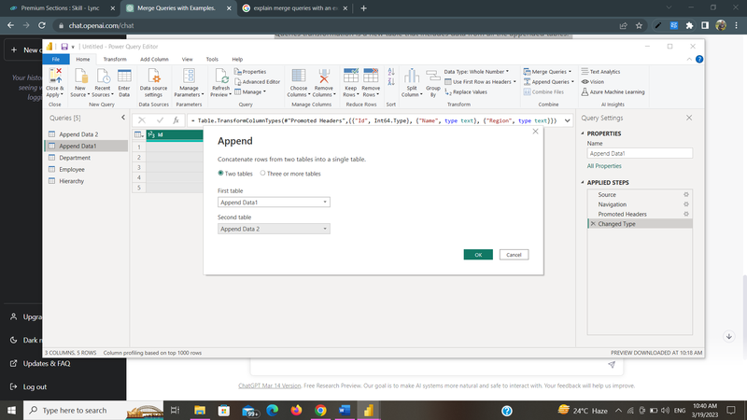

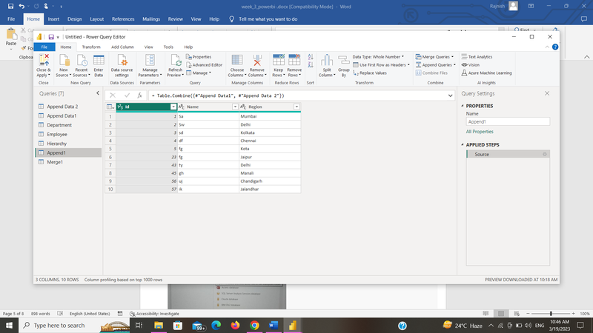

     3. Explain how to load multiple files from a folder?

--- Power BI has a built-in feature that allows you to load data from multiple files that are stored in a folder. This is useful when we have a large number of files with similar data structures and want to combine them into a single table.

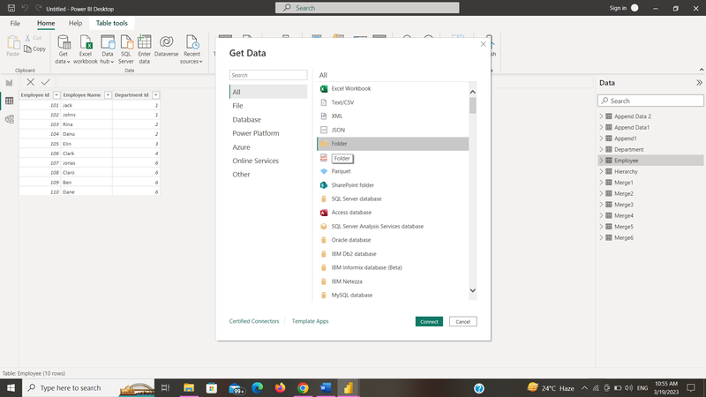

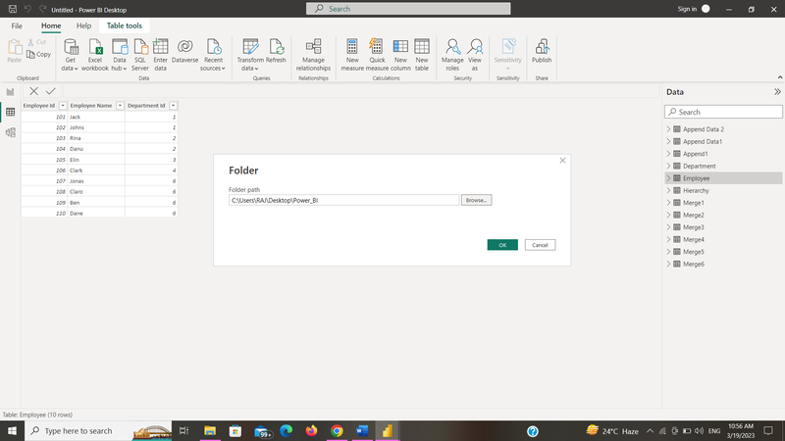

After that we have show up three options.

1.Load Data,

2.Transform Data

3.Combine Data – this option is new for this type of file upload.

Click on “Combine”, and two options will appear:

1.Combine & Transform Data

2.Combine & Load.

If our folder contains only the files we want and nothing else, we can go ahead and select Combine & Load.

 If we need to filter out files or do any other transformation, we need to select Combine & Transform.

After that click ok and we will get outut.

     4. Create Product Hierarchy in Power BI Desktop

