**1.  What is Relationship cardinality? Explain in details?**

**---**The  relationship cardinality means having unique or multiple instances per value for the joining field between two tables. Cardinality defined by the relationship and it refers to the relationship between two tables.

There are three types of Relatioship Cardinality:

1. One-to-One (1:1): Each instance of an entity is related to exactly one instance of another entity, and vice versa.
2. One-to-Many (1:N): Each instance of an entity is related to one or more instances of another entity, but each instance of the second entity is related to only one instance of the first entity.
3. Many-to-Many (N:N): Each instance of an entity can be related to one or more instances of another entity, and vice versa.

**2. What is filter flow? Explain with an example of filter flow?**

-- Data filter will be flown from lookup table to Data table

-- The filter context will be passed to all related data tables

-- Filter cannot be applied against the direction.

Example

* Open the power bi desktop and load the data.

*Then go to power bi desktop views & click on report view.

* The following figure shows the report view icon.

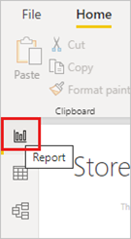

* Drag the data on to the data pane .

* After that  filter the data using filter which  is  in “visualizations”.

* The final output as shown in the below figure.

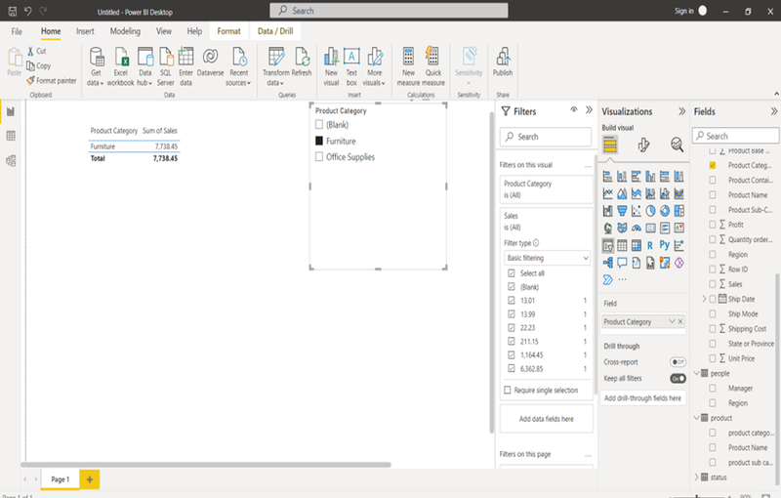

**3. Explain Many to Many Relationships with an example?**

For example, two tables might have had a column labeled Country. The values of Country weren't unique in either table, though. To join such tables, you had to create a workaround. One workaround might be to introduce extra tables with the needed unique values. With relationships with a many-to-many cardinality, you can join such tables directly, if you use a relationship with a cardinality of many-to-many.

***Example:***

 The following figure is the example for many-to-many relationships

