**1)What is difference between calculated column and calculated measure?**

|  |  |
| --- | --- |
| ***Calculated column*** | ***Calculated measure*** |
| * Calculated based on the information in each row | * Calculated based on the information from any filter in the report |
| * Appends static values in each row in the table | * Does not create a new data in the tables |
| * Table file size increases in power bi | * Does not increases the file size |
| * Mostly used as rows /columns/ filter in reports | * Always used within the values fields |

**2) Explain Quick Measures?**

Step 1:

To create a quick measure in Power BI Desktop, right-click or select the ellipsis ... next to any item in the Fields pane, and select New quick measure from the menu that appears.

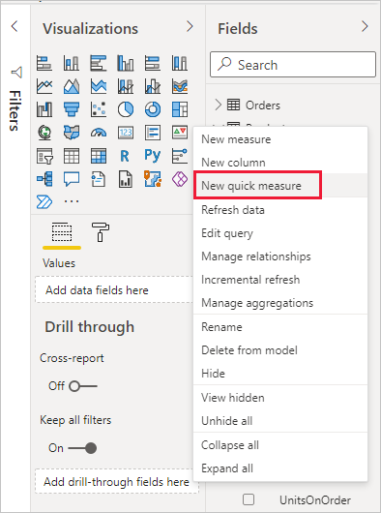

Step 2:

You can also right-click or select the drop-down arrow next to any value in the Values well for an existing visual, and select New quick measure from the menu.

When you select New quick measure, the Quick measures window appears, letting you select the calculation you want and the fields to run the calculation against.

Select the Select a calculation field to see a long list of available quick measures.

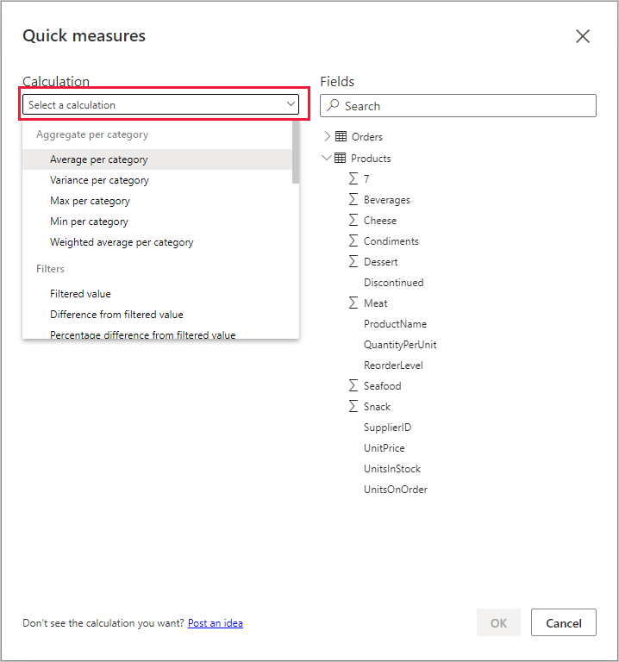

**3) Explain types of operators?**

In computer science, an operator is a character or characters that determine the action that is to be performed or considered.

There are three types of operator that programmers use:

* arithmetic operators
* relational operators
* logical operators

**Arithmetic operators:**

**Computers are designed to carry out calculations. Arithmetic operators allow arithmetic to be performed on values.**

| Arithmetic operation | Operator | Example |
| --- | --- | --- |
| Addition | + | x = x + 5 |
| Subtraction | - | x = x - 5 |
| Multiplication | * | x = x * 5 |
| Division | / | x = x / 5 |
| Integer division | DIV | x = x DIV 5 |
| Remainder | MOD | x = x MOD 5 |

**Relational operators:**

**Relational operators allow for assignment and enable comparisons to be made. They are used in condition testing.**

| Relational operation | Operator | Example |
| --- | --- | --- |
| Assignment | = | x = 5 |
| Equivalence | = or == | if x = 5 or if x == 5 |
| Less than | < | if x < 5 |
| Less than or equal to | <= | if x <= 5 |
| Greater than | > | if x > 5 |
| Greater than or equal to | >= | if x >= 5 |
| Does not equal | <> or != | If x <> 5 or if x != 5 |

**Logical operators:**

**Logical operators are used to combine relational operators to give more complex decisions.**

| Logical operation | Operator | Example |
| --- | --- | --- |
| And | AND | if x > 0 AND x < 10 |
| **Or** | OR | if topic == "Computing" OR topic == "Computer Science" |
| **Not** | NOT | while NOT x |

**4) Explain DAX syntax?**

A DAX formula always starts with an equal sign (=). After the equals sign, you can provide any expression that evaluates to a scalar, or an expression that can be converted to a scalar. These include the following:

* A scalar constant, or expression that uses a scalar operator (+,-,*,/,>=,...,&&, ...)
* References to columns or tables. The DAX language always uses tables and columns as inputs to functions, never an array or arbitrary set of values.
* Operators, constants, and values provided as part of an expression.
* The result of a function and its required arguments. Some DAX functions return a table instead of a scalar, and must be wrapped in a function that evaluates the table and returns a scalar; unless the table is a single column, single row table, then it is treated as a scalar value.

Most DAX functions require one or more arguments, which can include tables, columns, expressions, and values. However, some functions, such as PI, do not require any arguments, but always require parentheses to indicate the null argument. For example, you must always type PI(), not PI. You can also nest functions within other functions.

* Expressions. An expression can contain any or all of the following: operators, constants, or references to columns.

| Formula | Result |
| --- | --- |
| = 3 | 3 |
| = "Sales" | Sales |
| = 'Sales'[Amount] | If you use this formula within the Sales table, you will get the value of the column Amount in the Sales table for the current row. |
| = (0.03 *[Amount])  =0.03 * [Amount] | Three percent of the value in the Amount column of the current table.  Although this formula can be used to calculate a percentage, the result is not shown as a percentage unless you apply formatting in the table. |
| = PI() | The value of the constant pi. |

Formulas can behave differently depending on how they are used. You must always be aware of the context and how the data that you use in the formula is related to other data that might be used in the calculation.