**WEEK 7 CHALLENGE**

**1..Explain Common DAX Functions with examples and share the power bi desktop file for review.**

**--Answer--**

***DAX DEFINATION:***

* **DAX STANDS** for “Data Analysis Expressions”
* It is a formula language.
* It is used in a formula or expression to calculated and return one or more values.

* DAX is a programming language, that allows the users to define custom calculations.
* Some of the DAX functions are same as Excel functions.

***Common DAX functions:***

**1.. Date & Time Functions*:***

* **Date/Month/Quarter/Year :**

Returns the day of the month (1 to 31) / Returns the month as number (from I to 12) / Returns the quarter as a number from 1 to 4 / Returns the year of a date.

* **Hour/Minute/Second :**

Returns the hour as Number (from 0 (12:00 A.M.) to 23 (11:00 P.M.))/ Returns the minute as a number (from 0 to 59)/ Returns the seconds of a time value, as a number (from 0 to 59).

* **Today/Now :**

Returns the current date and time in date time format / Returns the current date.

* **Weekday/weeknum :**

Returns a number from 1 to 7 identifying the day / Returns the week number for the given date and year.

* **UTCNOW/ UTCTODAY :**

Returns the current UTC date and time / Returns the current UTC date

* **DATEDIFF :**

Returns the count of interval boundaries crossed between two dates

* **DATEVALUE :**

Converts a date in the form of text to a date in datetime format.

* **TIMEVALUE :**

Converts a time in text format to a time in datetime format.

**The following figure shows Date & Time function:**

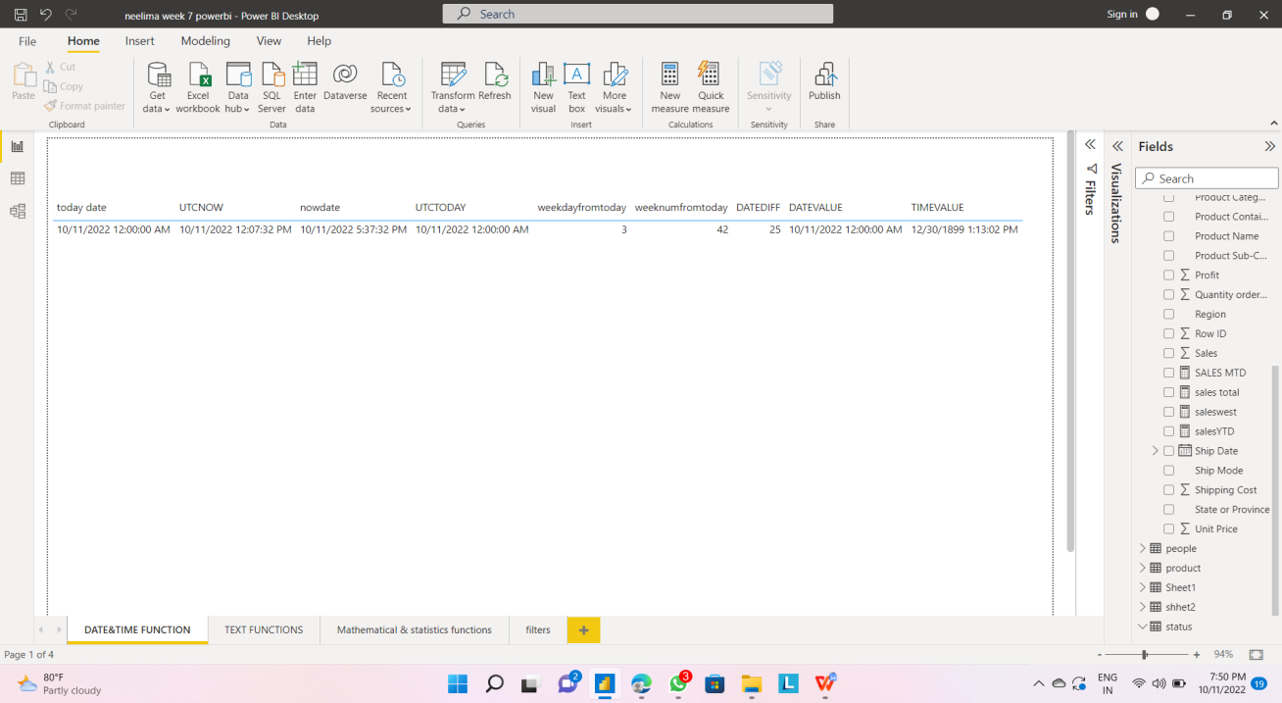

**2..Text Functions :**

* **CONCATENATE/ COMBINE VALUES :**

Joins two / more text strings into one text string.

* **FIND :**

Returns the starting position one text string within another

text string.

* **LEFT/MID/RIGHT:**

Returns the specified number of characters from the start/middle / end of a text string.

* **LEN:**

Returns the number of characters in a text string.

* **SUBSTITUTE:**

Replaces existing text with new text in a text string.

* **VALUE:**

Converts a text string that represents a number to a number.

**The following figure shows Text function:**

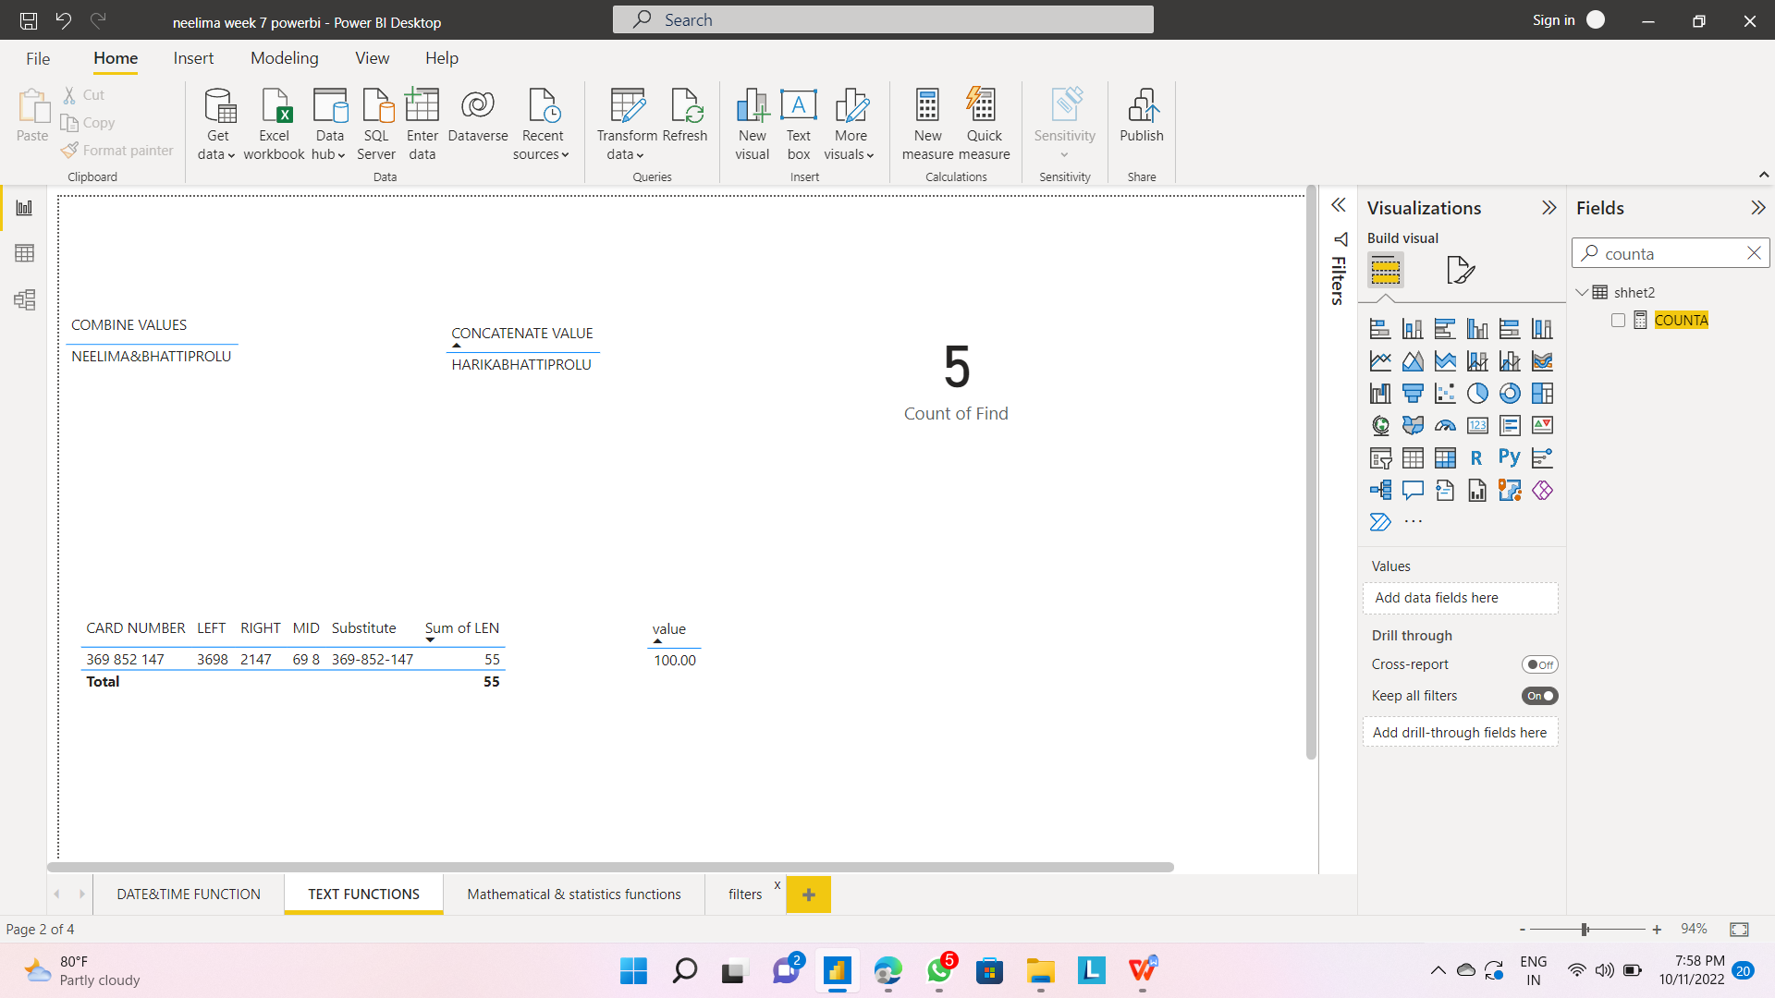

**3.Mathematical & statistics functions**

* **ROUND/ROUNDDOWN/ROUNDUP :**

Rounds a number to the specified number of digits / Rounds a number down, toward zero / Rounds a number up, away from 0

(zero)

* **SUM :**

Adds all the numbers in a column

* **AVERAGE:**

Returns the average (arithmetic mean) of all the numbers in a column.

* **MIN/MAX:**

Returns the smallest / largest values in a column

Counts the number of cells in a column that contain numbers.

* **COUNT:**

Counts the number of cells in a column that are not empty.

* **COUNTA:**

Counts the number of blank cells in a column.

Counts the number of rows in the specified table, or in a table defined by an expression.

* **DISTINCTCOUNT:**

Counts the number of distinct values in a column.

**The following figure shows Mathematical & statistics function:**

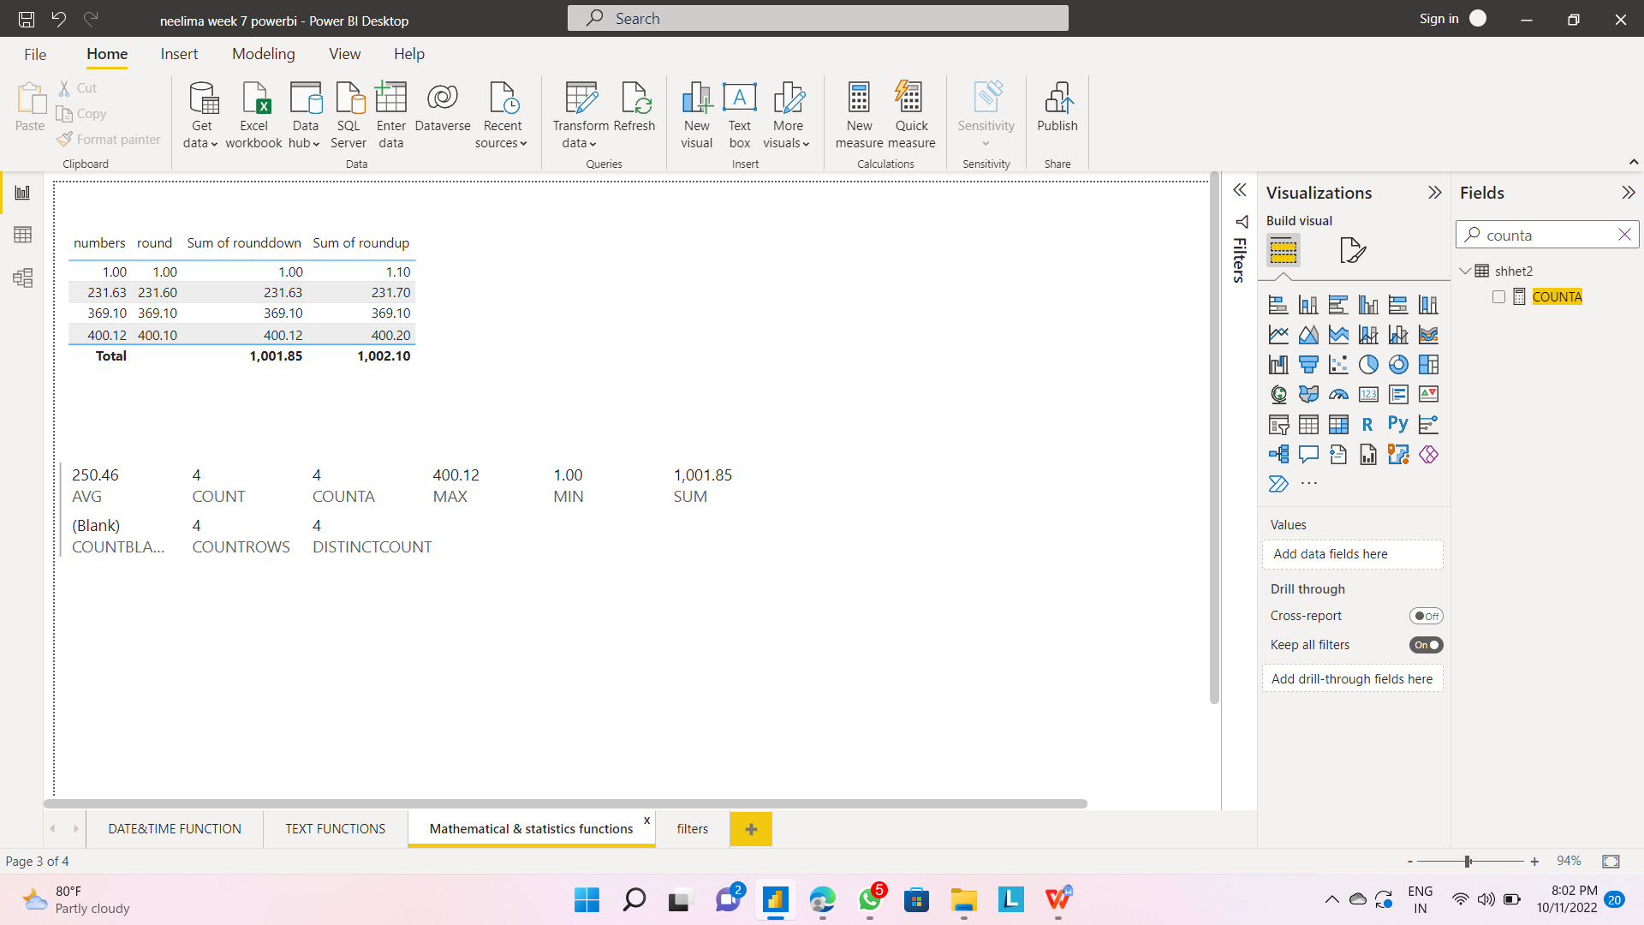

**4..Filter Functions**

Returns a table that represents a subset of another table or expression i.e., a table containing only the filtered rows

**Syntax:**

FILTER(<table>,<filter>)

**Example:**

* Total Sales FILTER('Sales',

RELATED('Sales' [Sales TerritoryCountry])<>"United States")

**The following figure shows Filter function:**

