1.  Explain Table manipulation functions – CROSSJOIN, EXCEPT, INTERSECT with examples

Answer:

Table manipulation functions are used to perform set operations between two or more tables.

Here are the explanations and examples of three of these functions:

1. CROSSJOIN : In Power BI, the CROSSJOIN function is called the "CrossJoin" function. It can be used to combine two tables into a single table. Example-

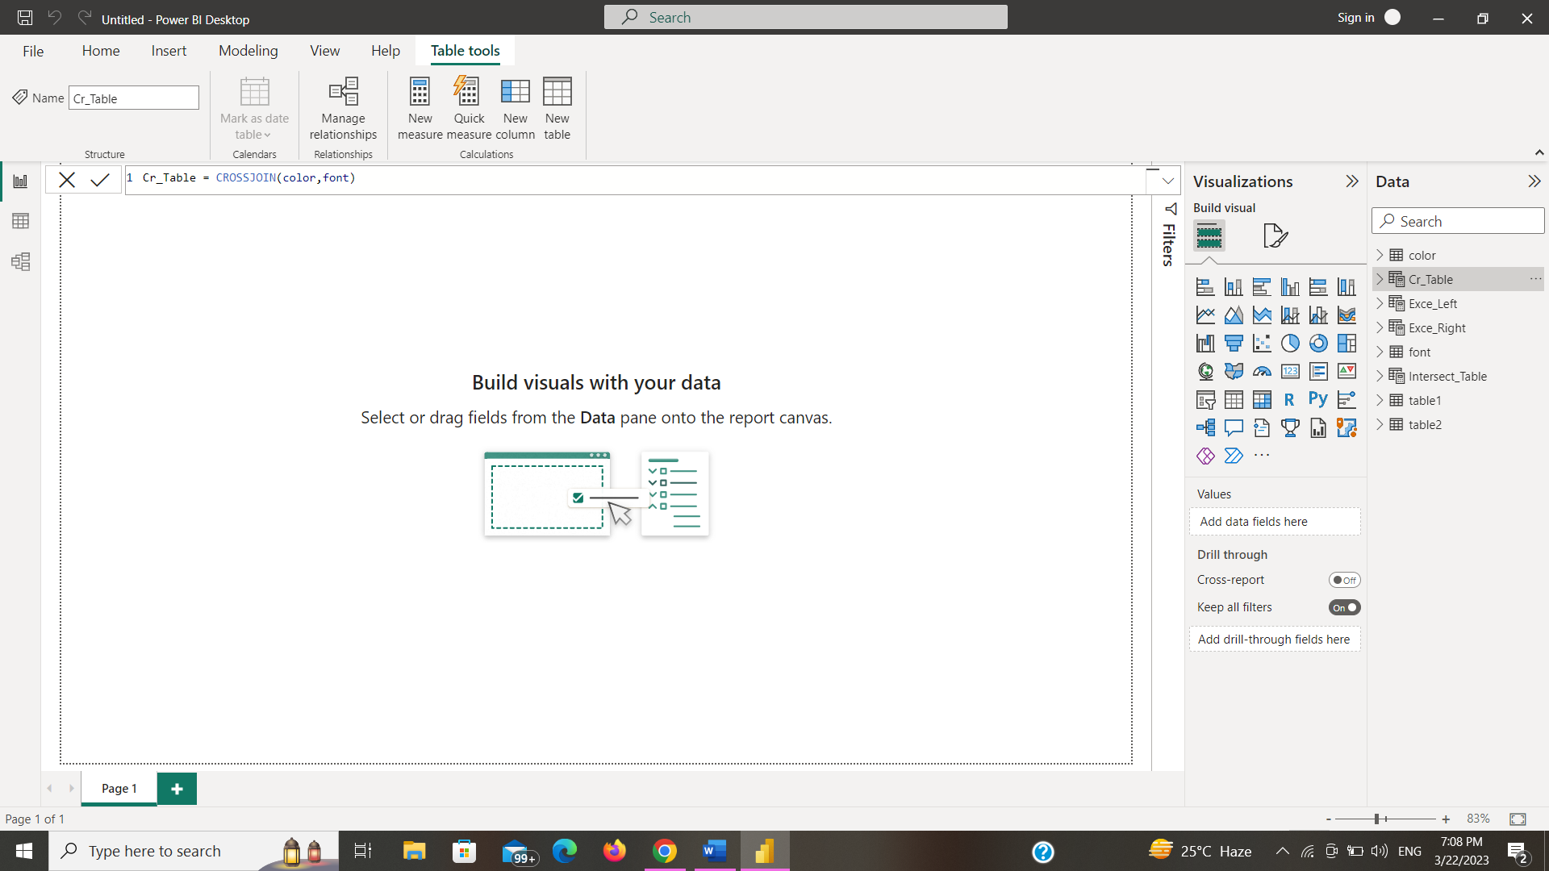

1. Except: Returns the rows from one table that are not in another table. The number of columns in both tables must be the same.

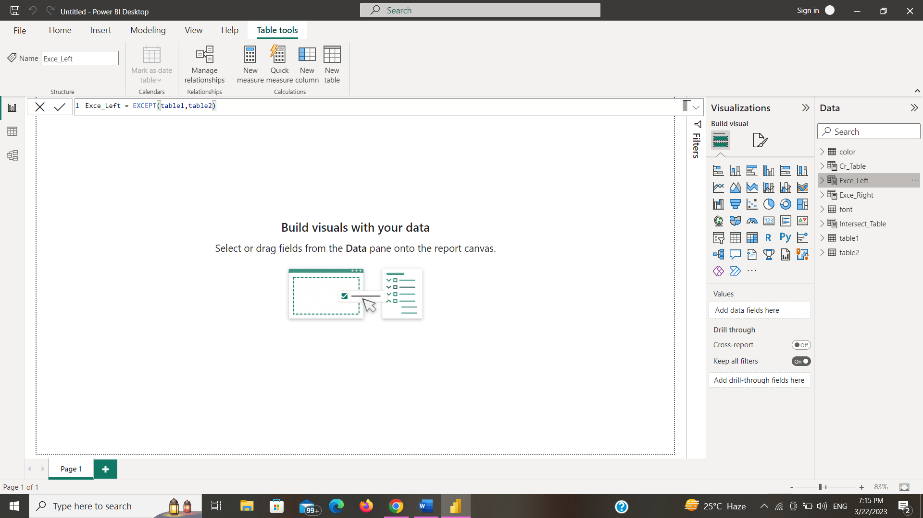

1. Intersect: It returns the row intersection of two tables. Can retain duplicate entries.

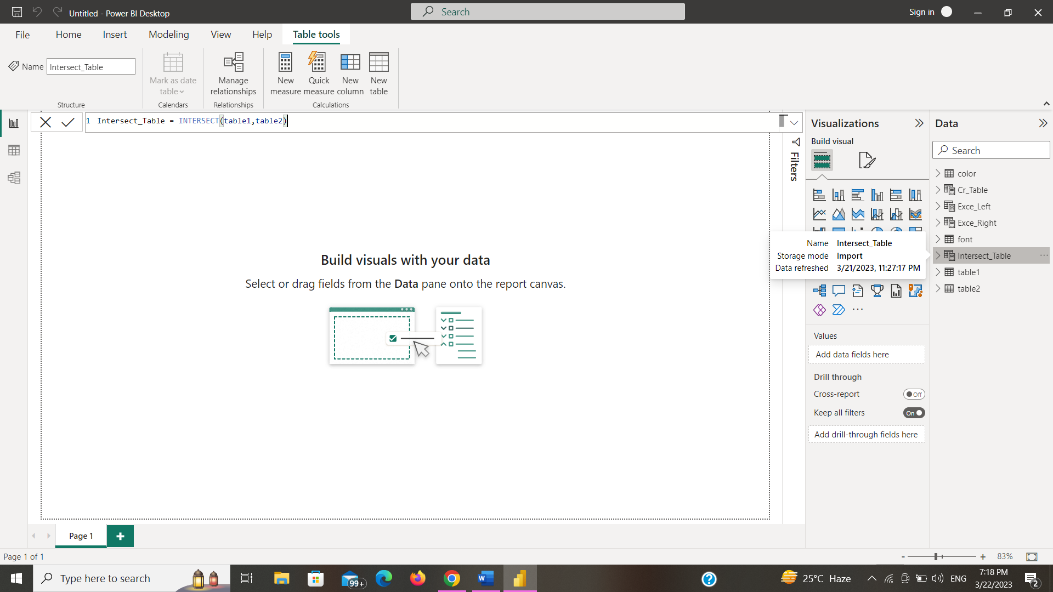

**2. Explain Relationship functions – RELATED, RELATEDTABLE and USERELATIONSHIPS with examples**

Explain Relationship Functions Relationship functions in Power BI allow you to establish connections between different data tables in your data model. These functions help you to create meaningful relationships between different data sources and enable you to analyze data across multiple tables.

• RELATED: This function allows you to retrieve data from a related table based on a common column between two tables.

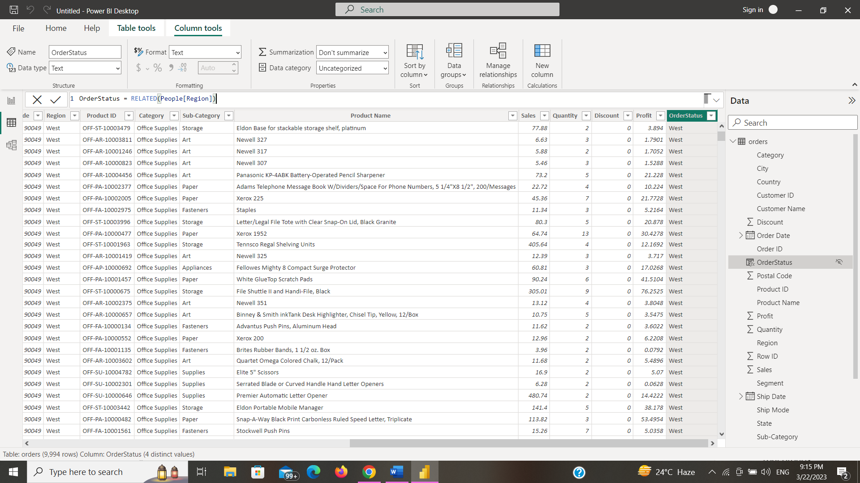

• RELATEDTABLE: This function returns a table that is related to the current table. This function is particularly useful when working with calculated tables or when creating complex DAX formulas.



• USERRELATIONSHIP: Power BI allows you to override the default relationship between two tables and create a new relationship that is used for a specific calculation or analysis.

Syntax: USERRELATIONSHIP(column1,column2)

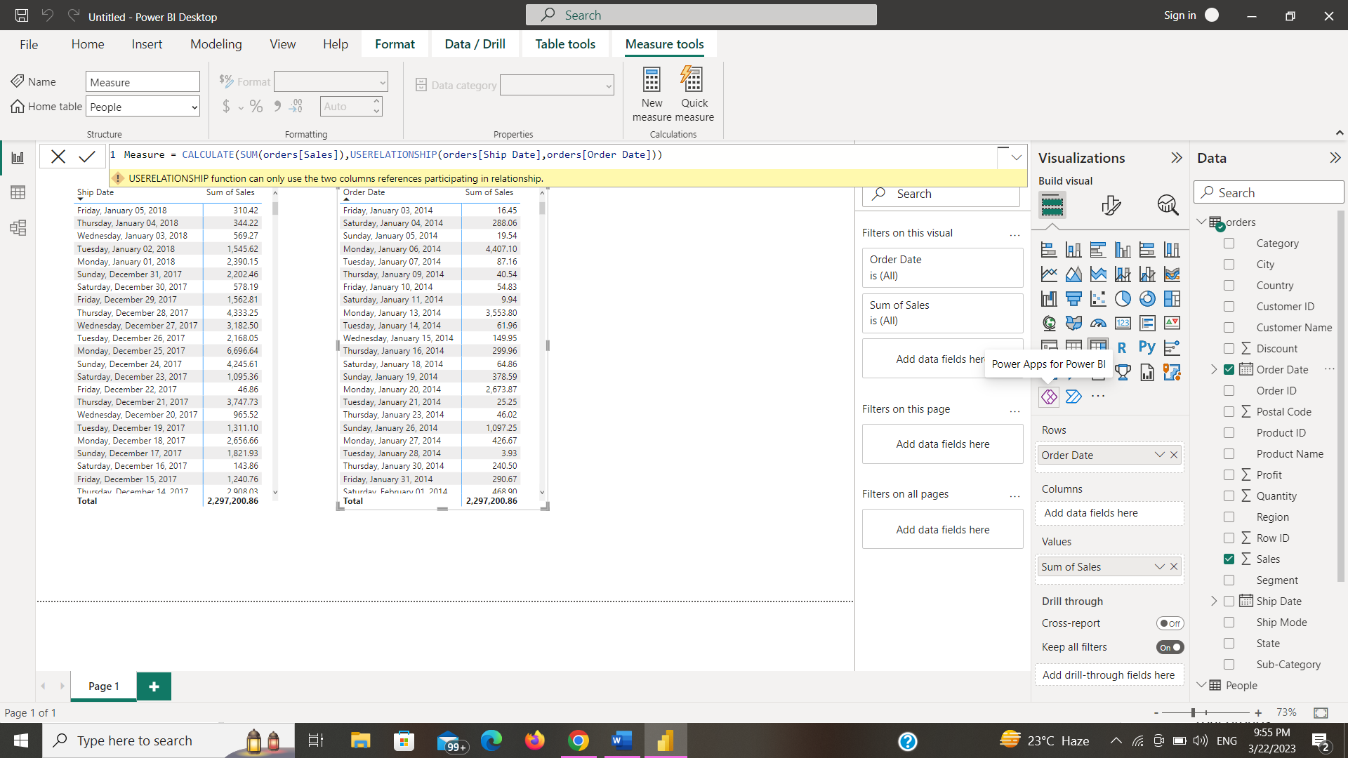

1. **Create an automated calendar table using Order table and add column like Month and Year and apply date formatting**

