1. **Explain Power BI Desktop – Report View and Panes**

Power BI Desktop is a free application you install on your local computer that lets you connect to, transform, and visualize your data. With Power BI Desktop, you can connect to multiple different sources of data, and combine them (often called modeling) into a data model.

**Report View:** In The report view can create, design, and customize reports based on your data. The Report View is where you can add visuals, tables, charts, and other data visualizations to represent your data in a clear and meaningful way.

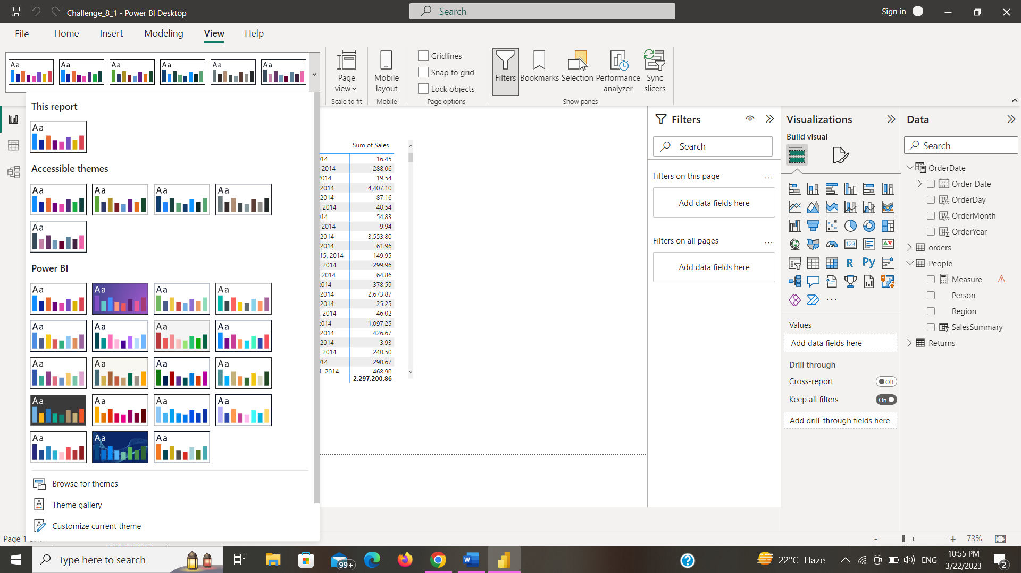

**Report Panes:** In Power BI that provide different functionalities and features to help you create and customize your reports.

Here are Some Report Panes:-

* Fields Pane
* Visualizations
* Filters Pane
* Pages Pane
* Selection Pane
* Fields well
* Visualization Well

1. **Explain Power BI Desktop – Filter Panes and the usage**

Power BI Desktop is a free application you install on your local computer that lets you connect to, transform, and visualize your data. With Power BI Desktop, you can connect to multiple different sources of data, and combine them (often called modeling) into a data model.

**Filter Panes:** The Filter Pane in Power BI is a powerful tool that allows you to add and manage filters in your report. Filters are used to limit the data that is displayed in your visuals, allowing you to focus on specific aspects of your data.

The Filters section allows you to add filters to your entire report. You can select a field from the Fields list and drag it into the Filters section to create a filter. You can then select the values you want to include or exclude from your report, and Power BI will automatically update your visuals accordingly.

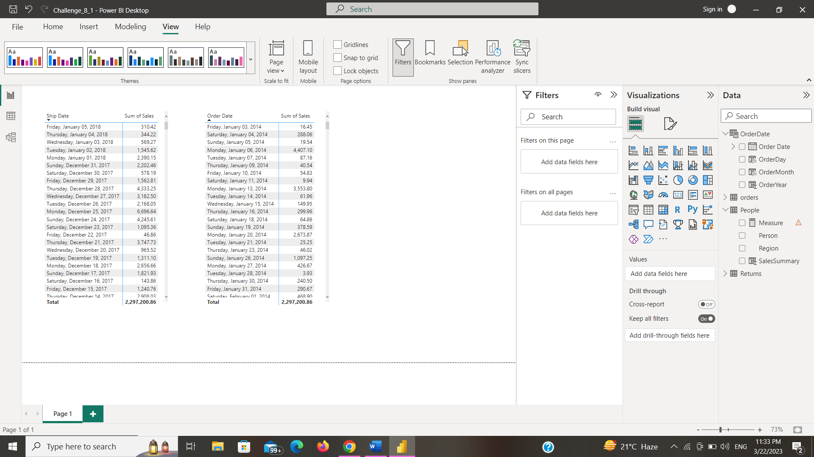

1. Matrix Visualization – Add Product Category as Rows, Add Year as Column, Add Profit as Sales and do the conditional formatting

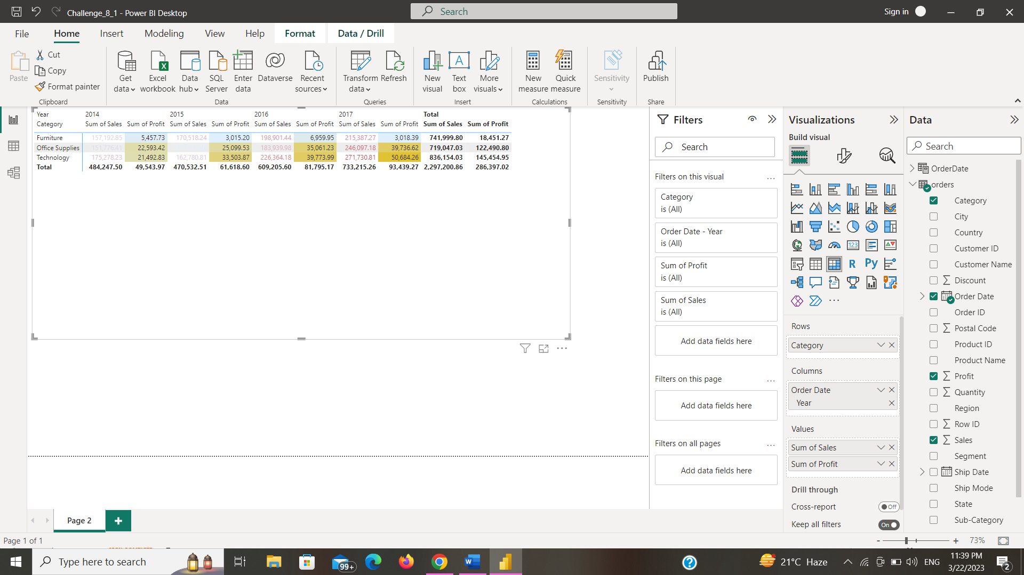

1. Slicers – Explain various options in Slicer and difference between Slicer & Filters

* Slicers are particularly useful when you want to provide users with a way to filter data on the fly.

Options in Slicer:-

* Orientation
* Type
* Selection Control
* Style
* Search
* Sorting
* Show/Hide Items
* Syncing

Difference between Slicer & Filters

Slicers provide an interactive and intuitive way for users to filter data in a report by selecting one or more values from a list. Slicers can be added to a report page and can be customized in various ways, such as by setting the orientation, selection control, style, and syncing with other visuals.

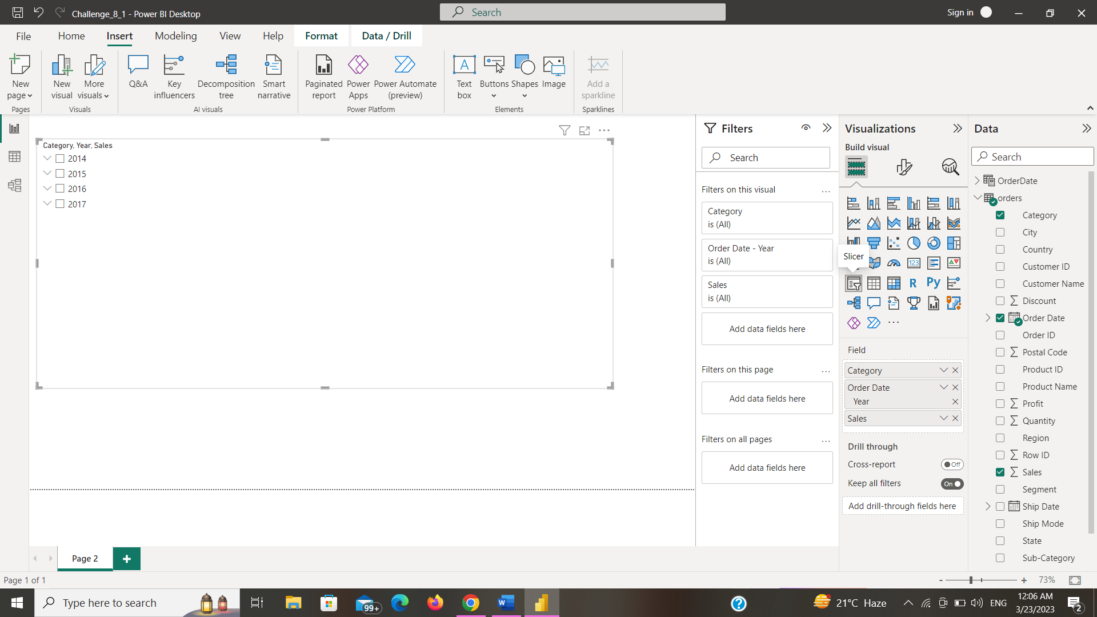

1. Map – use world cities and create various map visuals

