1)Consider the set S = {5,6,3,4} within the universal set U ={x: x<10, x ∈Z+} .Draw a Venn diagram to represent S and S’. Find n(S) and n(S’). Find if n(S)+n(S’)=n(U).

Solution:

set S = {5,6,3,4}

set U = {1,2,3,4,5,6,7,8,9}

n(s) = 4

n(s’) =5

n(U)= if n(S)+n(S’) = 4+5 =9

U

2) Write a set showing all vowels of the English language.

Solution:

Set V= {a, e, I, o, u}

3) If A = (5, 7, 8, 9}, B = {3, 4, 5, 6} and C = {2, 4, 6, 8, 10}; where n is the total number of distinct elements in a set. Find,

Solution:  
a) n(A) + n(B)= 4+4=8  
b) n(AUB)=7 (AUB={5,7,8,9,3,4,6})  
c) n(A⋂B)=1 (A⋂B ={5}  
d) n(AUB)+n(A⋂B) = 7+1 = 8  
e) n(B)+n(C)-n(B⋂C) = 4+5-5 = 4  
f) Is : n(A)+n(B)=n(AUB)+n(A⋂B) ? - True

4+4=7+1

8=8  
g) Is n(BUC)=n(B)+n(C)-n(B⋂C) ? - False

7=4+5-5

7=4

4) Write in set notation form to represent all people who can enter America. Hint (American citizens, Proper Visa holders, Government officials with diplomatic passport can enter the USA)

Solution: A = {x : x is an American citizen} U {x : x is a proper Visa holder} U {x : x is a government official with a diplomatic passport}

5) True or False:  
a) 3 ∈ Z (True or False) – TRUE (The symbol Z represents the set of integers, which includes all whole numbers (positive, negative, and zero). The number 3 is a whole number, so it is an element of the set Z. Therefore, the statement "3 ∈ Z" is true.)

b) 5+4i ∈ Q (True or False)- False  
c) 5i ∈ C (True or False) - True  
d) -2 ∈ Z+(True or False) - False  
e) 2 ∈ Z- (True or False) - False

6) Write a set that will contain the different ways by which a customer can pay the shop keeper. Hint: COD, Credit card etc.

Solutions:

P = {Cash on delivery (COD), Credit card, Debit card, Mobile payment, Online payment, Check}

In set notation, we can write:

P = {x : x is a method of payment accepted by the shopkeeper}

7) Find the number of members in a set, whether the set is countable or uncountable for all the sets given below. Validate your findings.  
a) A:(factors of 20)

Factors of 20 = 1,2,4,5,10,20 => n(F)=6

b) B : (all squares) => 1,4,9,16,25,36,49,64,81,100,121,…… (uncountable)

c) C = {x:x ∈ Z, -5<x<10} => Z=5 to 9 => -5, -4, -3, -2, -1, 0, 1, 2, 3, 4, 5, 6, 7, 8, 9 => (countable) => n(Z)=15

d) D:{prime number less than 20} =>s(D)={ 2, 3, 5, 7, 11, 13, 17, 19} => n(D)=8  
e) E:{all the prime numbers} => uncountable  
f) F:{all irrational numbers} => uncountable  
g) G={x:x ∈ Z, -5 < x<10} => Z=5 to 9 => -5, -4, -3, -2, -1, 0, 1, 2, 3, 4, 5, 6, 7, 8, 9 => (countable) => n(Z)=15

8) Draw a Venn Diagram to represent the A={1,2,3,4,5,6}, B={1,2,3,4,9,11},C={25,28} U=N

U

A B

9) In the Following Figure shade the regions as asked.  
a) A

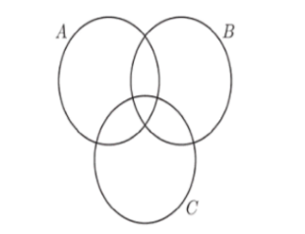  
b) B⋂C

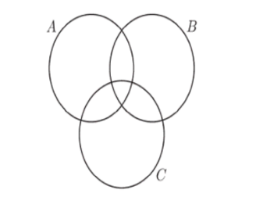  
c) B’

  
d) AUB



e) A⋂B⋂C

  
f) (A⋂B⋂C)’

  
g) AUB

  
h) AUBUC



i) (B⋂C)UA

  
j) (AUB)⋂C

  
k) (A⋂C)U(B⋂C)

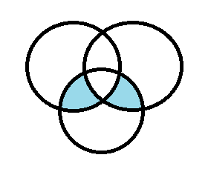

l) (A⋂B)UC

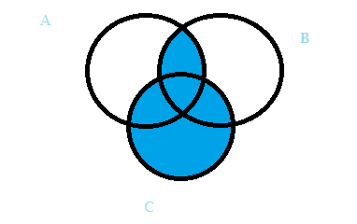

m) (AUC)⋂(BUC)

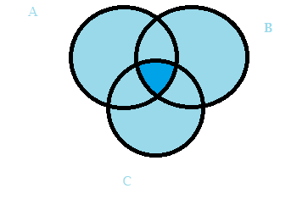

10) In a class of 40 students 34 liked dark chocolate, 22 liked sweet chocolate. 2 of them hate chocolates.  
a) Find the number of students who eat both types of chocolates.

Solution: n(A ∩ B) = 34 + 22 - 38

n(A ∩ B) = 56 - 38

n(A ∩ B) = 18  
b) Find the number of students who like at least one of the chocolates.

Solution: 38