Q1.  List out different types of products available in Tableau.

- Tableau desktop

- Tableau Public

- Tableau cloud

- Tableau Prep

- Tableau Viewer

- Data Management

- CRM Analytics

Q2. What is the difference between Tableau Public and Desktop?

- All Listed data sources can be connected with Tableau Desktop. But, in Tableau Public only excel and text files can be connected.

- In Tablea Desktop no body can see you reports unless provided with an access. But, In Tableau public all the reports are public once they are published.

- In Tablea Desktop unlimited rows data can be processed, store and shared. But, In Tableau Public 1 million rows data can be processed, store and shared.

- Tableau Desktop is paid. But, Tableau Public is Free.

- Tableau Desktop is meant for someone with a career in Business Intelligence and Data warehousing such as Analysts and BI Professionals. But, Tableau Public is for anyone interested in understanding data and sharing those findings as data visualizations with the world. Journalists, writers, bloggers, students and more.

Q3. Difference between Tableau online and server.

- Tableau online is used as high performance data repositories. And, Tableau server is used to share and create visualisation for organisation with full security.

- Tableau online has features data management, cloud, reliable services and atomatic updates. And, Tableau  Server has atomatic updates and flexible architecture also provides scalability & security.

- Tableau online does not use own memoy it share resources with the CPU. And, Tableau server uses its own RAM, cooling power, dedicated power regulators.

- In Tableau Online we can purchase and maintain multiple sites, configure users and permissions. And, In tableau Server we can create and maintain multiple sites at no additional cost, configure users and permissions.

- In Tableau online we can upload your company logo. And, In Tableau Server change the logo and the company name that appears in various web browser locations and tooltips

Q4. Download the latest version of Tableau and connect to the excel file.

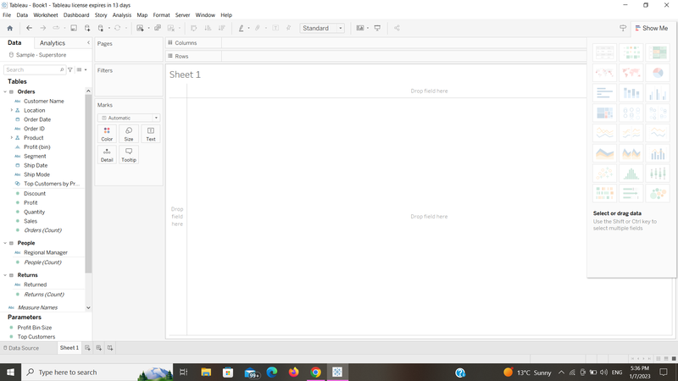

Q5. Use the Extract connection in Tableau and import the  excel file  and save it.

