BLUESTOCK FINTECH
Mutual Fund Analytics Platform
End-to-End Data Engineering, ETL Pipeline & Interactive Dashboard
─────────────────────────────────────────────
Company: Bluestock Fintech Pvt. Ltd.
Domain: Mutual Fund / Fintech
Project Type: Individual Capstone (7 Days)
Technologies: Python | SQL | Power BI | Pandas | Matplotlib
Date: August 2026

1. Executive Summary
This report presents the complete documentation of the Bluestock Fintech Mutual Fund Analytics Platform — a full-stack data engineering and analytics project. The platform ingests live NAV data from the mfapi.in REST API, processes 87,000+ rows across 10 datasets, stores everything in a normalised SQLite star schema database, and delivers business insights via an interactive 4-page Power BI dashboard.
Key Outcomes:
• Top Fund by Composite Score: ICICI Pru Midcap Fund — 100/100
• Best Sharpe Ratio: Mirae Asset Large Cap Fund — 1.45
• Best 3-Year CAGR: Axis Midcap Fund — 35.11%
• Highest Alpha vs Nifty 100: SBI Small Cap Regular — 0.30
• Highest Daily VaR Risk: SBI Small Cap Direct — -2.69%
• Worst Max Drawdown: SBI Small Cap Direct — -52.57%
• SIP Inflow Growth: Rs.14,000 Cr (2023) → Rs.31,002 Cr (Dec 2025 All-Time High)
• Folio Growth: 13.26 Crore → 26.12 Crore in just 4 years
• At-Risk SIP Investors: 97.8% have transaction gaps exceeding 35 days

2. Problem Statement
Despite India's mutual fund industry managing over Rs.81 lakh crore in AUM across 1,908 schemes and 26.12 crore investor folios, individual investors and financial advisors struggle with data-driven fund selection due to five core problems:
• P1: Data Fragmentation — NAV, AUM, SIP and portfolio data scattered across AMFI website in different formats (TXT, PDF, HTML). No unified database exists.
• P2: Performance Comparison Gap — No single platform for risk-adjusted comparison across AMCs. Raw NAV data requires significant transformation to compute Sharpe, Alpha, Beta.
• P3: No Benchmark Tracking — Retail investors unaware whether their fund outperforms Nifty 50/100. Tracking error requires both NAV and benchmark index data.
• P4: Investor Behaviour Blind Spot — Limited visibility into demographic and geographic SIP patterns across T30 and B30 cities.
• P5: Slow Reporting — Static monthly PDFs replaced by live self-service dashboards with drill-down capability.

3. Data Sources & Datasets
All data sourced from publicly available AMFI India, mfapi.in, NSE and BSE sources. 10 pre-provided datasets plus 6 live-fetched NAV CSVs from the mfapi.in REST API.

Dataset | Description | Rows | Source
01_fund_master.csv | 40 MF schemes master list | 40 | AMFI India
02_nav_history.csv | Daily NAV 2022–2026 | 46,000 | mfapi.in
03_aum_by_fund_house.csv | Quarterly AUM — 10 AMCs | 90 | AMFI Quarterly
04_monthly_sip_inflows.csv | Monthly SIP data | 36 | AMFI Monthly Note
05_category_inflows.csv | Net inflows by category | 144 | AMFI
06_industry_folio_count.csv | Folio growth data | 21 | AMFI
07_scheme_performance.csv | Risk-return metrics | 40 | Computed
08_investor_transactions.csv | SIP/Lumpsum/Redemption | 32,778 | Simulated
09_portfolio_holdings.csv | Top equity holdings | 322 | AMFI
10_benchmark_indices.csv | Nifty/BSE index data | 8,050 | NSE/BSE

4. ETL Pipeline & System Architecture
The project follows a classic 5-layer data engineering architecture mirroring real-world fintech pipelines used at companies like Zerodha, Groww and Paytm Money:
• Layer 1 — Extract: Loaded 10 pre-provided CSVs + fetched live NAV from mfapi.in REST API for 6 schemes using Python Requests library
• Layer 2 — Transform: Cleaned all 10 datasets — parsed dates to datetime, forward-filled weekend/holiday NAV gaps, removed duplicates, converted data types, validated AMFI codes against master list
• Layer 3 — Load: Designed 8-table SQLite star schema and loaded all cleaned data using SQLAlchemy ORM
• Layer 4 — Analyse: Computed CAGR, Sharpe, Sortino, Alpha, Beta, VaR, CVaR, Max Drawdown across 40 schemes in Jupyter notebooks
• Layer 5 — Visualise: Built 4-page interactive Power BI dashboard with slicers, KPI cards and drill-down capability

4.1 Database Schema (Star Schema)

Table | Type | Rows | Key Columns
dim_fund | Dimension | 40 | amfi_code (PK), fund_house, category, expense_ratio
dim_date | Dimension | 1,612 | date_id (PK), date, year, month, quarter, is_weekday
fact_nav | Fact | 46,000 | amfi_code (FK), date, nav, daily_return_pct
fact_transactions | Fact | 32,778 | tx_id (PK), investor_id, amfi_code, amount_inr
fact_performance | Fact | 40 | amfi_code (FK), sharpe, alpha, beta, max_drawdown
fact_aum | Fact | 90 | fund_house, date, aum_lakh_crore, aum_crore
fact_sip_industry | Fact | 36 | month, sip_inflow_crore, active_sip_accounts_crore
fact_portfolio | Fact | 322 | amfi_code (FK), stock_symbol, weight_pct, sector

5. Exploratory Data Analysis (EDA)
15 publication-quality charts were created covering NAV trends, AUM growth, SIP inflows, investor demographics, geographic distribution, sector allocation and correlation analysis.

5.1 NAV Trends — All 40 Schemes (2022–2026)
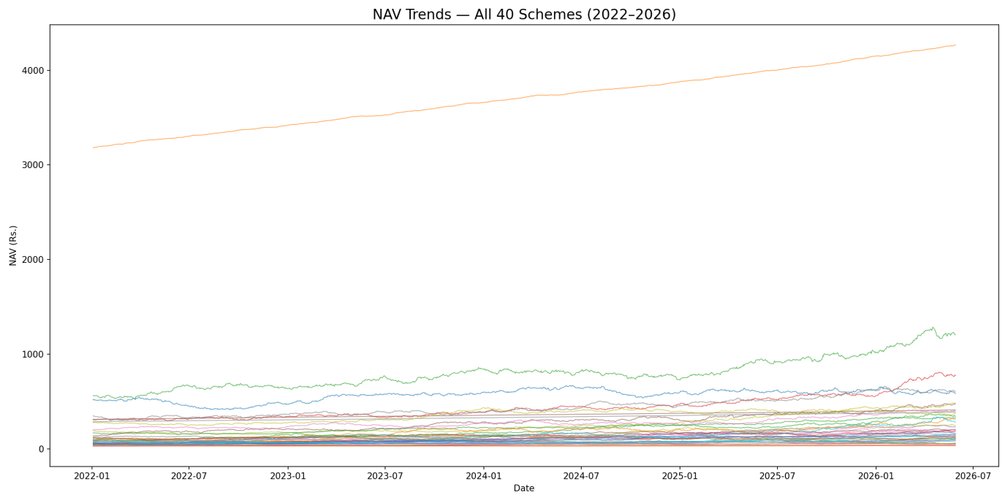
Figure 1: Daily NAV trends for all 40 schemes from Jan 2022 to May 2026. Consistent upward trend with no major crashes.

5.2 AUM Growth by Fund House (2022–2025)
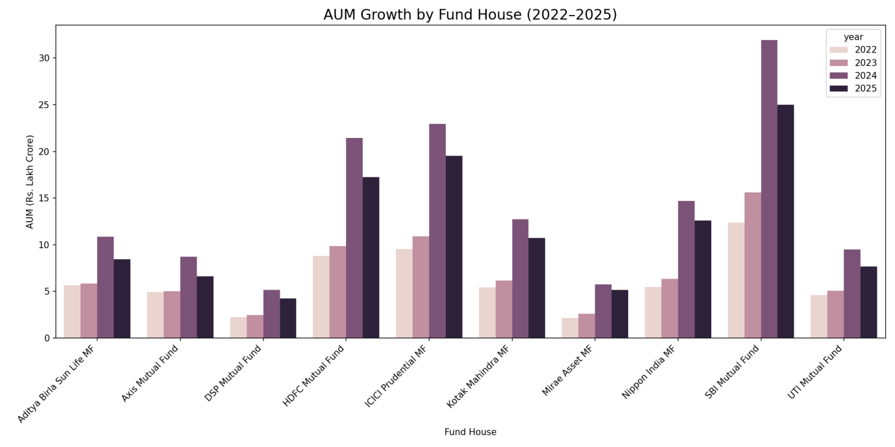
Figure 2: AUM growth by fund house for each year. SBI Mutual Fund dominates..

5.3 Monthly SIP Inflows (2022–2025)
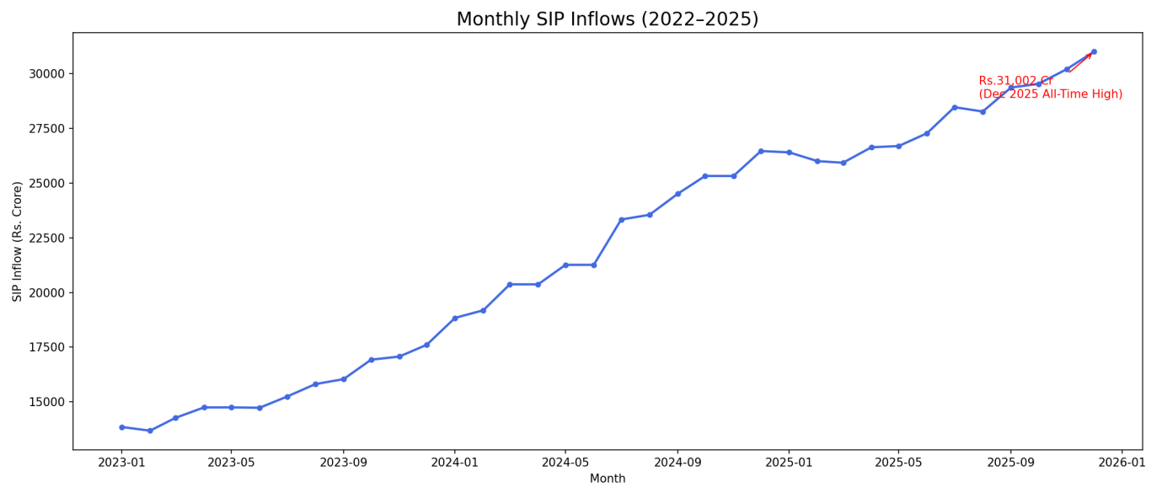
Figure 3: Monthly SIP inflows showing consistent growth to Rs.31,002 Cr all-time high in Dec 2025.

5.4 Sector Allocation — All Equity Fund Portfolios
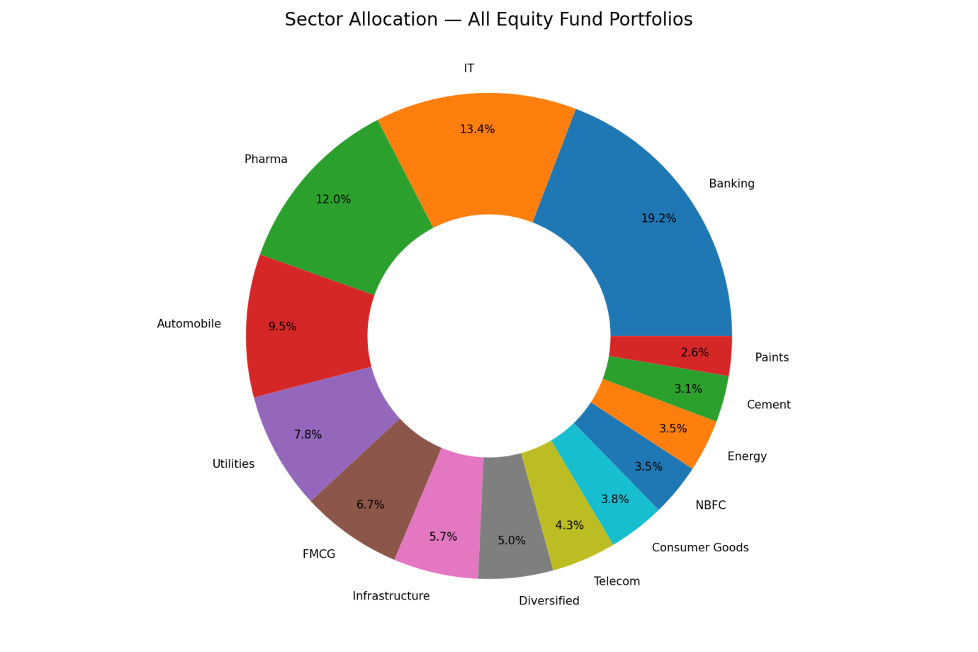
Figure 4: Sector allocation donut chart. Banking (19.2%) and IT (13.4%) dominate equity fund portfolios.

5.5 Key EDA Findings
• All 40 fund NAVs show consistent upward trend from 2022–2026 with no major crashes
• SBI Mutual Fund dominates AUM at Rs.12.50 lakh crore, followed by ICICI Pru (Rs.10.74L Cr) and HDFC (Rs.9.30L Cr)
• SIP inflows more than doubled — from Rs.14,000 Cr (early 2023) to Rs.31,002 Cr (Dec 2025 all-time high)
• Liquid funds dominate category inflows by a massive margin — most popular category
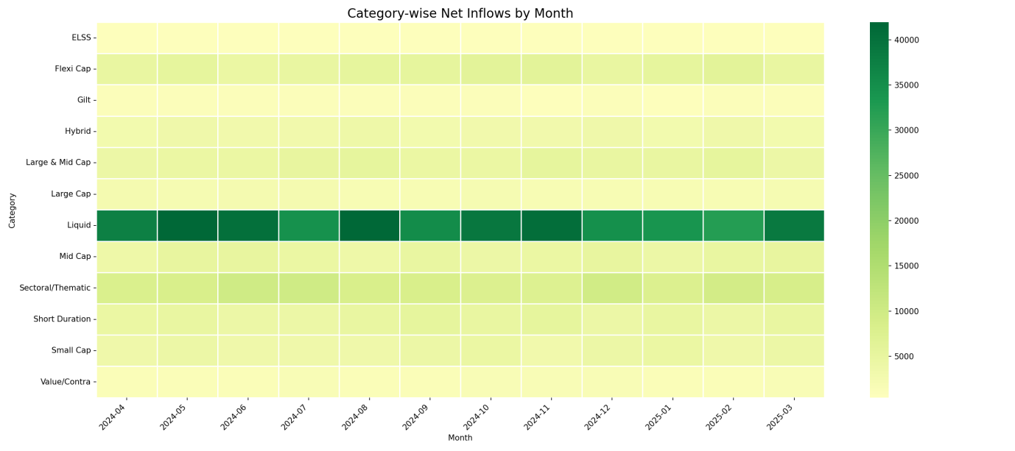
• 26-35 age group drives 41.1% of all MF investments — millennials are the primary demographic
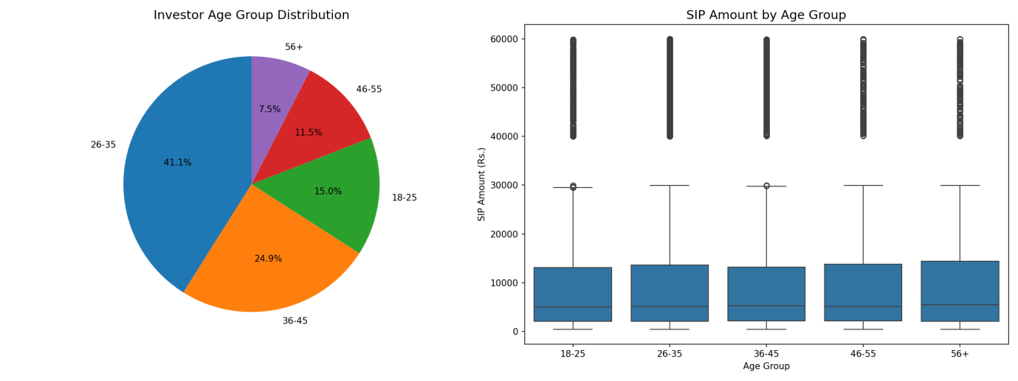
• Madhya Pradesh and Punjab lead SIP investments by state — surprising finding
• 66.3% transactions from T30 cities, 33.7% from B30 showing growing MF penetration
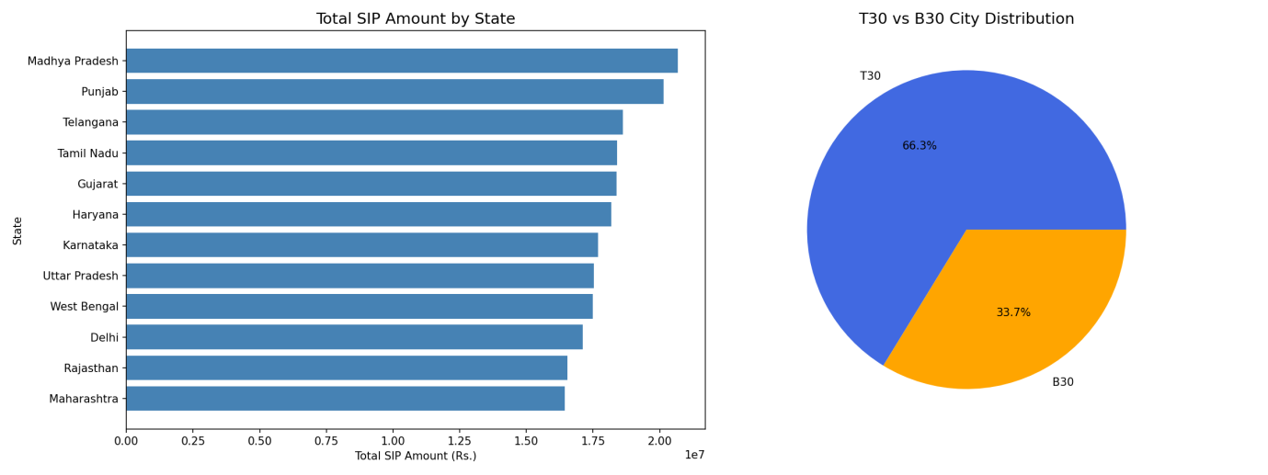
• Total MF folios doubled from 13.26 Cr to 26.12 Cr in just 4 years
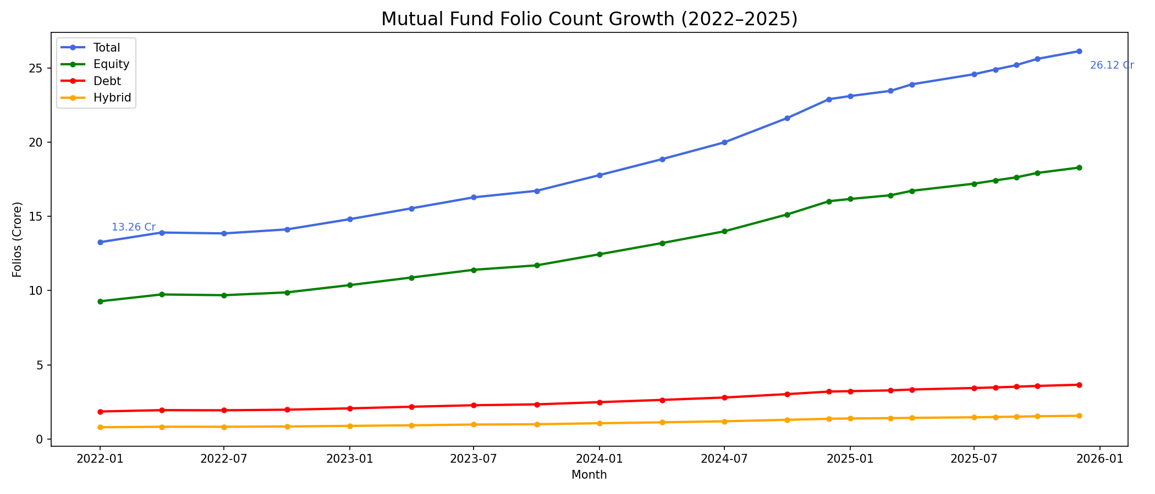
• Low cross-fund correlations (-0.09 to 0.05) — strong diversification potential

6. Fund Performance Analytics
Comprehensive risk-adjusted performance metrics computed from 46,000 daily NAV records for all 40 schemes. Risk-free rate set at 6.5% (RBI repo rate proxy).

6.1 Top 10 Funds — Composite Scorecard
Composite Score = 30% × 3yr Return Rank + 25% × Sharpe Rank + 20% × Alpha Rank + 15% × Expense Ratio Rank (inverse) + 10% × Max Drawdown Rank (inverse)

Fund Name | Score | Sharpe | 3yr CAGR | Alpha
ICICI Pru Midcap Fund - Regular | 100.00 | 1.18 | 31.78% | 0.29
Axis Midcap Fund - Regular | 95.56 | 1.00 | 35.11% | 0.26
HDFC Mid-Cap Opportunities Fund | 95.27 | 1.09 | 32.44% | 0.27
Mirae Asset Large Cap Fund | 94.67 | 1.45 | 34.00% | 0.27
Kotak Flexicap Fund - Regular | 92.60 | 1.31 | 29.58% | 0.27
ICICI Pru Bluechip Fund - Direct | 89.64 | 1.03 | 32.49% | 0.25
SBI Small Cap Fund - Regular | 88.91 | 0.95 | 26.67% | 0.23
DSP Small Cap Fund - Regular | 88.68 | 0.95 | 27.00% | 0.30
Mirae Asset Tax Saver Fund | 87.50 | 1.23 | 29.18% | 0.28
SBI Bluechip Fund - Regular | 86.46 | 1.21 | 30.46% | 0.23

6.2 Benchmark Comparison — Top 5 Funds vs Nifty 50 & Nifty 100
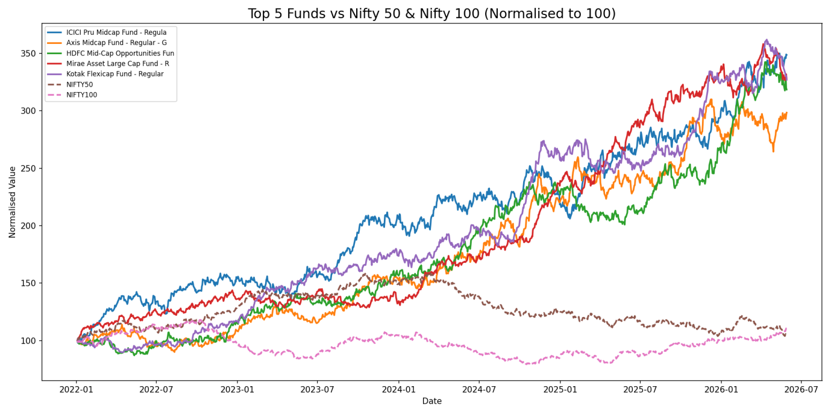
Figure 5: Top 5 funds vs Nifty 50 & Nifty 100 normalised to 100. All funds achieved 3x+ returns vs benchmark indices over 2022–2026.

6.3 Risk Metrics Summary
• Best Sharpe Ratio: Mirae Asset Large Cap Fund — 1.45 (best risk-adjusted return)
• Best Sortino Ratio: Mirae Asset Large Cap Fund — 2.39 (lowest downside risk)
• Highest Alpha: SBI Small Cap Regular — 0.30 (best excess return over Nifty 100)
• Worst Max Drawdown: SBI Small Cap Direct — -52.57% (highest peak-to-trough decline)
• All top 5 funds outperformed Nifty 50 and Nifty 100 by 3x over 2022–2026

7. Interactive Power BI Dashboard
A 4-page interactive Power BI dashboard was built with slicers, drill-downs, KPI cards and the Bluestock Fintech logo. Each page has at least 2 interactive slicers for filtering.

Page 1 — Industry Overview
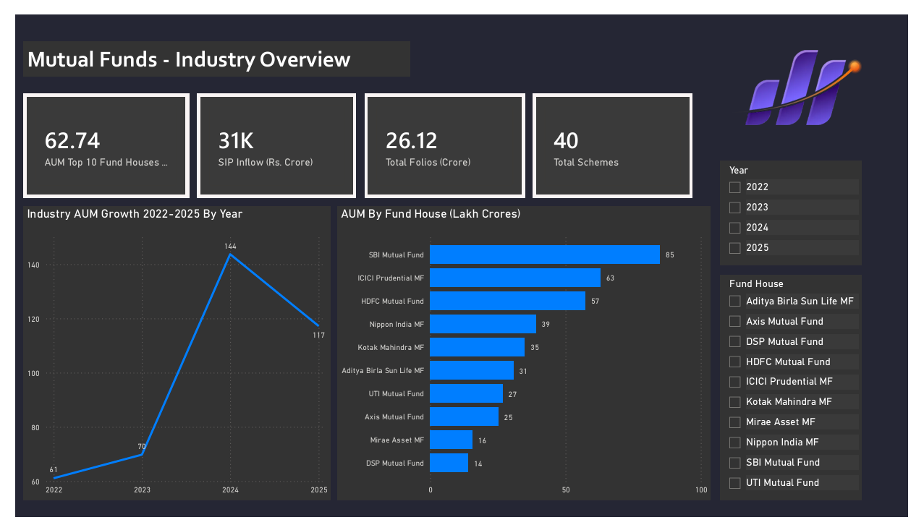
Figure 6: Industry Overview — KPI cards showing AUM Rs.62.74L Cr, SIP Inflow Rs.31K Cr, Folios 26.12 Cr and 40 Schemes. AUM growth line chart and AUM by Fund House bar chart.

Page 2 — Fund Performance Analytics
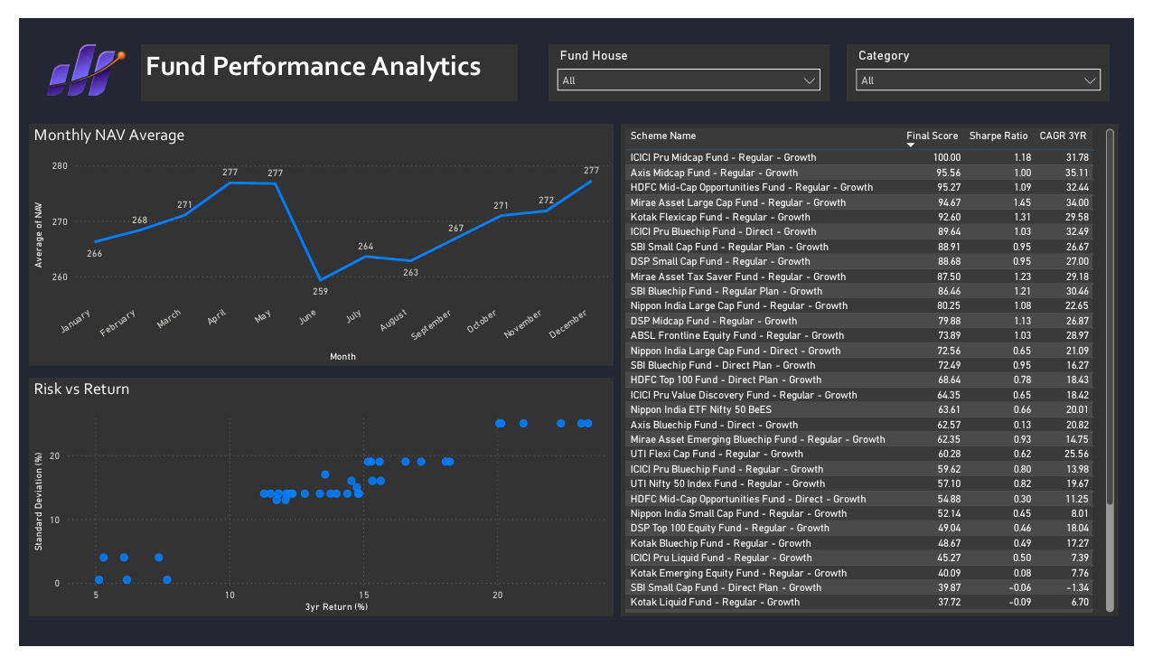
Figure 7: Fund Performance Analytics — Sortable fund scorecard table, Risk vs Return scatter plot and Monthly NAV trend. Slicers: Fund House and Category.

Page 3 — Investor Analytics
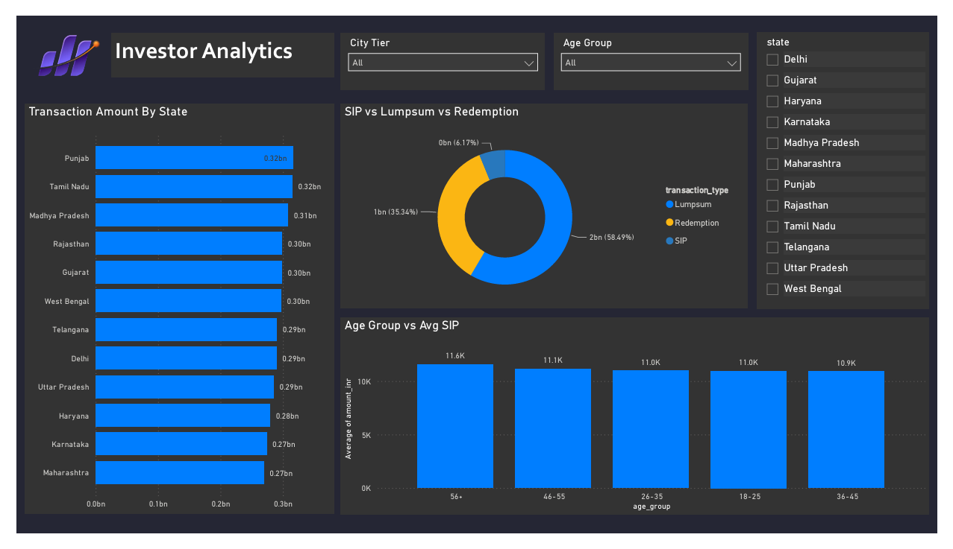
Figure 8: Investor Analytics — Transaction Amount by State, SIP vs Lumpsum vs Redemption donut chart and Age Group vs Avg SIP. Slicers: State, Age Group, City Tier.

Page 4 — SIP & Market Trends
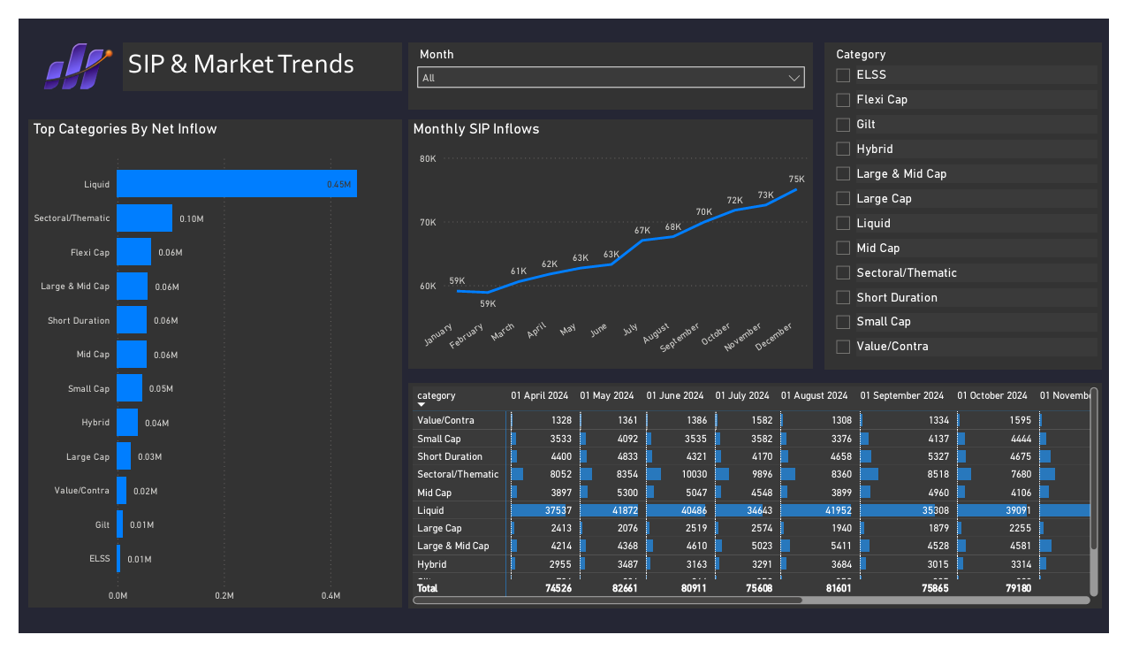
Figure 9: SIP & Market Trends — Top Categories by Net Inflow, Monthly SIP Inflows line chart and Category inflow matrix heatmap. Slicers: Month and Category.

8. Advanced Analytics

8.1 Value at Risk (VaR) & Conditional VaR (CVaR)
Historical VaR computed at 95% confidence level for all 40 schemes using daily return distributions:
• Highest Risk: SBI Small Cap Direct — VaR -2.69%, CVaR -3.24%
• Second Highest: Axis Small Cap Regular — VaR -2.62%, CVaR -3.17%
• Small Cap funds consistently show highest VaR — confirming their high-risk nature
• Liquid funds show near-zero VaR — safest category confirmed quantitatively

8.2 Rolling 90-Day Sharpe Ratio
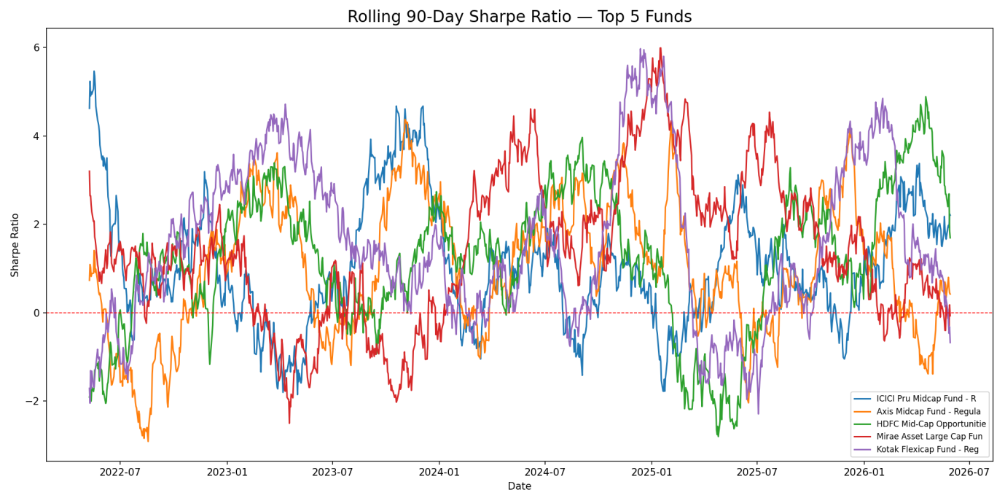
Figure 10: Rolling 90-Day Sharpe Ratio for top 5 funds. All funds show positive Sharpe for majority of 2022–2026 with peak performance in mid 2024–2025.

8.3 Investor Cohort Analysis
Cohort Year | Investors | Avg SIP Amount | Total Invested | Transactions
2024 | 4,803 | Rs.1,07,422 | Rs.3,491 Crore | 32,499
2025 | 197 | Rs.1,09,158 | Rs.30.45 Crore | 279

• 2025 cohort investors have higher avg SIP — newer investors investing more per transaction
• 2024 cohort dominates total transactions with 32,499 vs only 279 in 2025 (partial year)

8.4 SIP Continuation Analysis
• 1,362 active investors with 6+ SIP transactions analysed
• 1,332 At-Risk investors (97.8%) — gaps exceeding 35 days between transactions
• Only 30 Regular investors (2.2%) — major SIP retention challenge for AMCs
• Recommendation: Implement auto-debit mandates and SIP reminder campaigns

8.5 Fund Recommendation Engine
Risk Appetite | Top Recommended Fund | Sharpe Ratio | 3yr Return
Low | ICICI Pru Liquid Fund - Regular | 7.68 | 7.68%
Low | Kotak Liquid Fund - Regular | 6.18 | 6.18%
Moderate | HDFC Top 100 Fund - Regular | 1.06 | 14.84%
Moderate | Mirae Asset Large Cap - Regular | 1.06 | 14.81%
High | Kotak Emerging Equity - Regular | 0.96 | 18.23%
High | ICICI Pru Midcap - Regular | 0.95 | 18.08%

8.6 Sector Concentration (HHI)
• Most Concentrated: Axis Bluechip Regular (HHI 2967) — heavily weighted in few sectors
• Mirae Asset Tax Saver (HHI 2549) and HDFC Mid-Cap Direct (HHI 2531) also highly concentrated
• High HHI = concentrated portfolio, higher sector risk for investors

9. Recommendations
• Fund Selection: ICICI Pru Midcap (Score 100) and Mirae Asset Large Cap (Sharpe 1.45) are top picks for risk-adjusted returns based on the composite scorecard
• SIP Retention: 97.8% at-risk investors need targeted retention campaigns — AMCs should implement mandatory auto-debit and SIP reminder notifications
• B30 Penetration: 33.7% transactions from B30 cities shows growth opportunity — increase digital financial literacy outreach in smaller cities
• Risk Awareness: Small Cap investors should be informed of -52.57% max drawdown risk before investing — improve suitability assessment
• Gender Gap: Only 33.5% female investors — targeted financial literacy programs and women-focused SIP products needed
• Portfolio Diversification: Funds with high HHI (>2500) should consider sector diversification to reduce concentration risk

10. Limitations
• Investor transaction data is synthetically generated — real behavioural patterns may differ from analysis
• Only 40 of 1,908 industry schemes covered — not fully representative of the complete market
• SQLite used for development — production deployment would require PostgreSQL or a cloud data warehouse (Snowflake/BigQuery)
• No pipeline orchestration (Airflow/cron) — ETL runs manually; real-world deployment needs scheduling
• Dashboard not deployed to cloud — Power BI Service or Tableau Public deployment pending
• Beta values are near zero — suggesting low correlation with Nifty 100 benchmark which may indicate data alignment issues

11. Technical Stack

Category | Tool / Library | Purpose
Language | Python 3.10+ | All data processing, ETL and analytics
Data Processing | Pandas 2.0+ | DataFrames, cleaning and aggregation
Numerical | NumPy 1.24+ | Risk metrics and statistical functions
Statistics | SciPy 1.10+ | OLS regression for Beta/Alpha computation
Visualisation | Matplotlib, Seaborn, Plotly | Static and interactive EDA charts
Database | SQLite3 (built-in) | Local relational star schema database
ORM | SQLAlchemy 2.0 | Python-to-SQLite interface
Dashboard | Power BI Desktop | Interactive 4-page BI dashboard
API Client | Requests 2.30+ | mfapi.in live NAV data fetching
Notebooks | Jupyter Lab 4.x | EDA and analytics notebooks
Version Control | Git + GitHub | Code versioning and submission

Disclaimer
All data in this project is sourced from publicly available information published by AMFI India, NSE, BSE and open APIs (mfapi.in). NAV values are anchored to real historical values from mfapi.in. Investor transaction data is synthetically generated but uses real geographic, demographic and behavioural distributions observed in the Indian MF market. This project is intended for educational purposes and skill development at Bluestock. It does not constitute financial advice. Mutual Fund investments are subject to market risks. Please read all scheme related documents carefully before investing.

