Problem# 7: Array Manipulation – Output

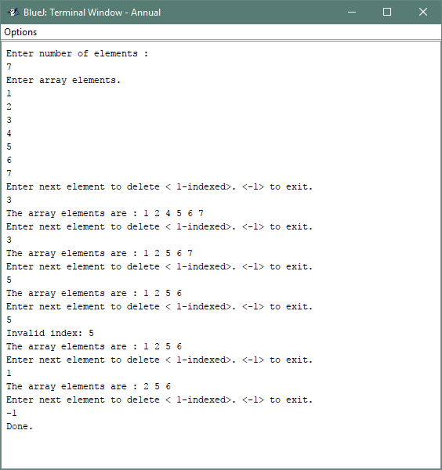

Problem# 7: Array Manipulation – Output

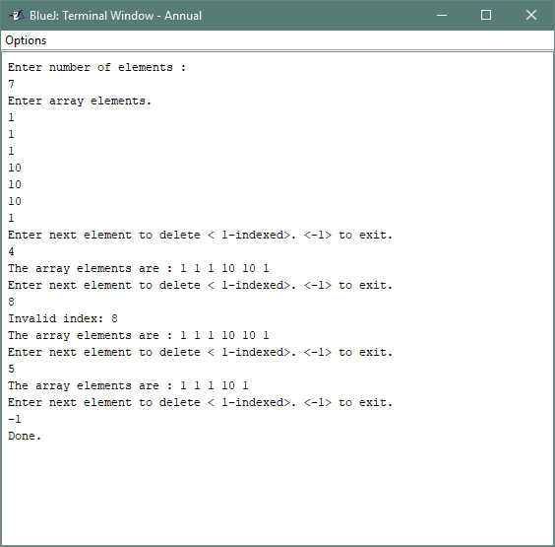

Problem# 3: Date – Output

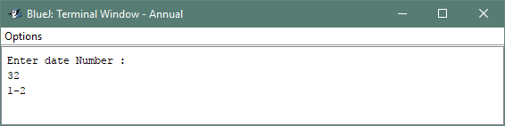

Problem# 3: Date – Output

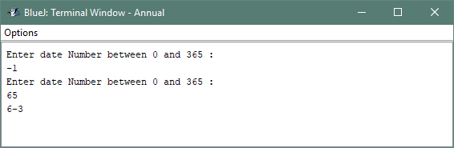

Problem# 3: Date – Output

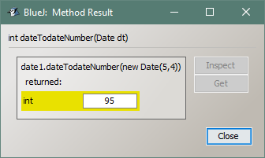

Problem# 1: Wordshift – Output

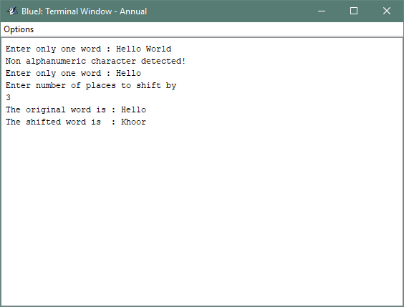

Problem# 1: Wordshift – Output

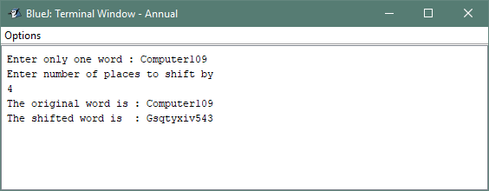

Problem# 2: SelSort – Output

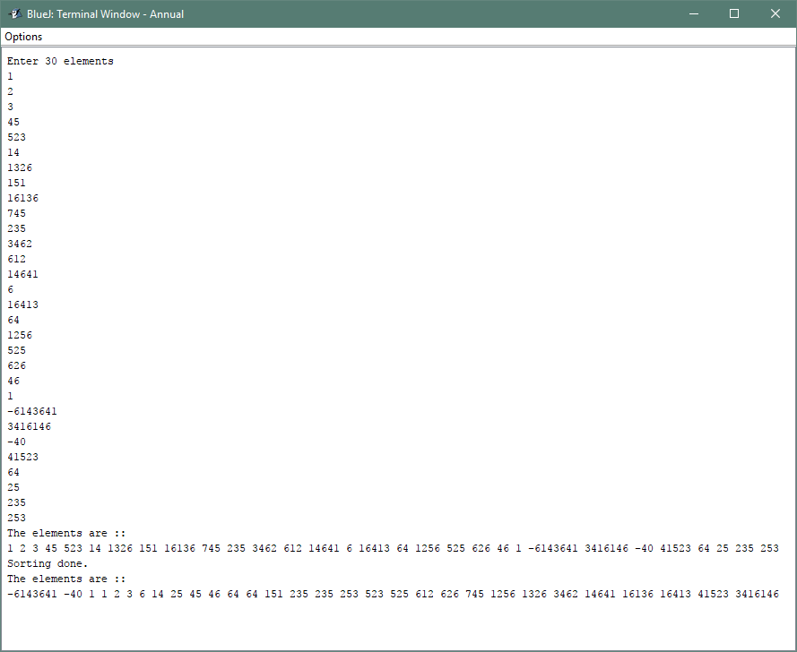

Problem# 2: SelSort – Output

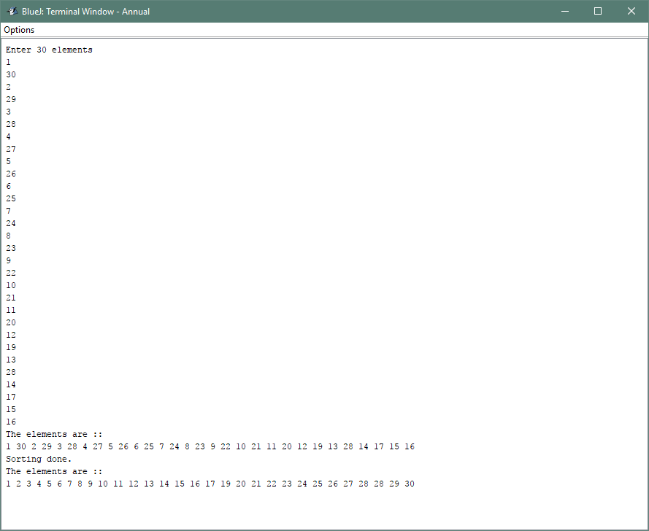

Problem# 4: Exchange – Output

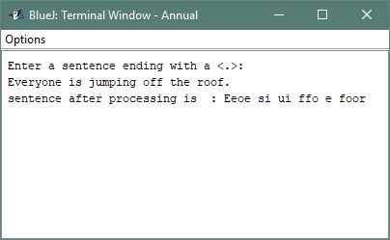

Problem# 4: Exchange – Output

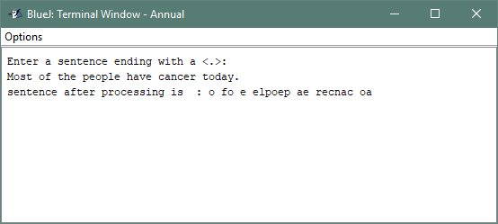

Problem# 5: StringModify – Output

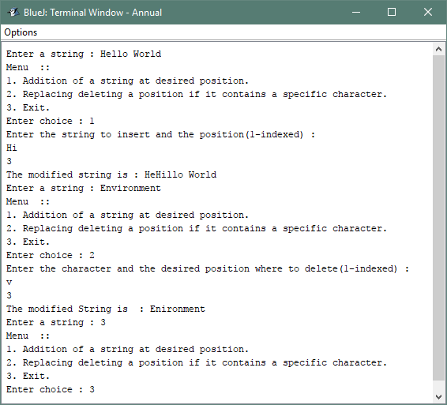

Problem# 5: StringModify – Output

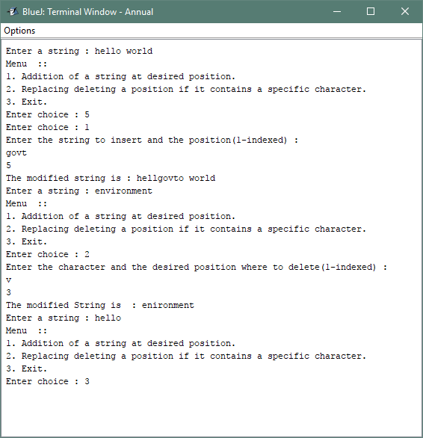

Problem# 6: WordFrequency – Output

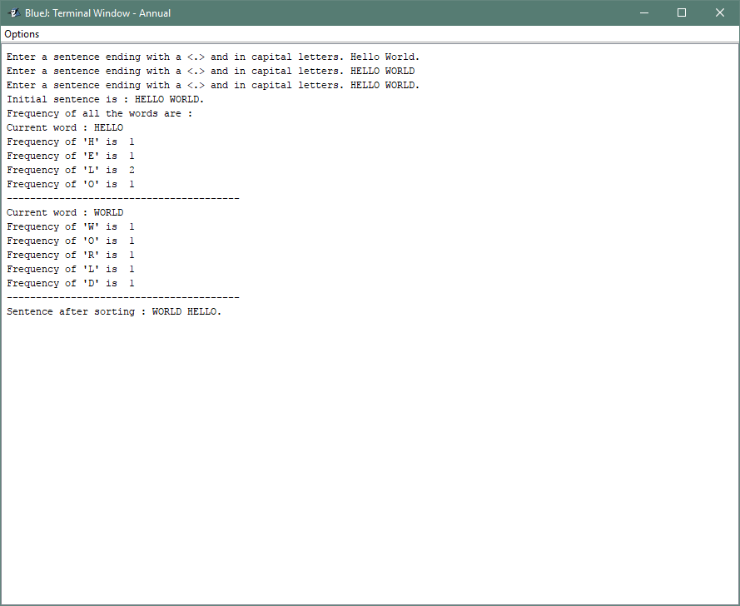

Problem# 6: WordFrequency – Output

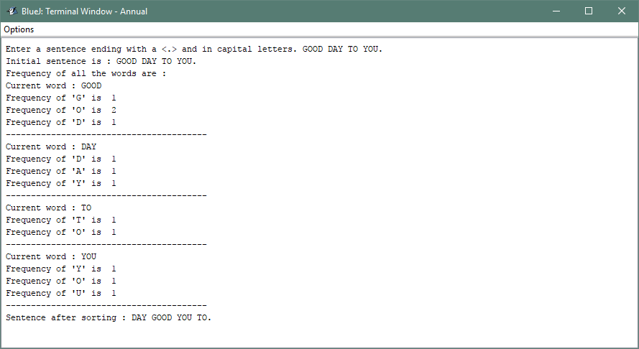

Problem# 8: WordSort – Output

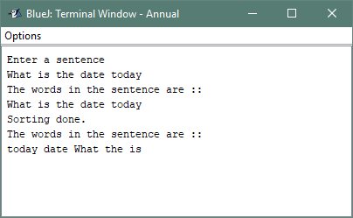

Problem# 8: WordSort – Output

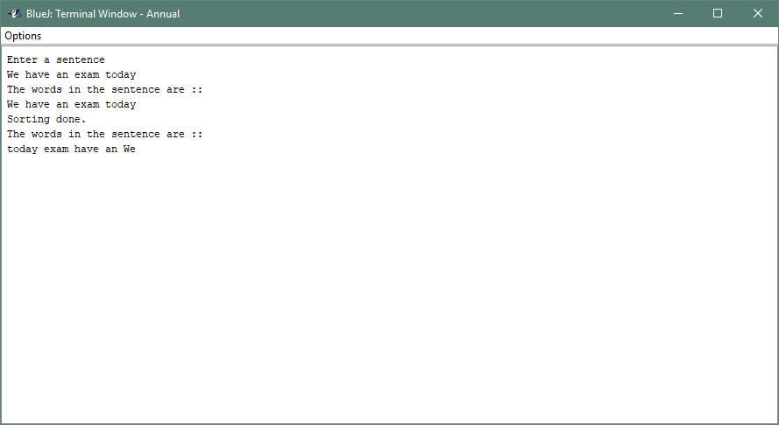

Problem# 9: SeriesSum – Output

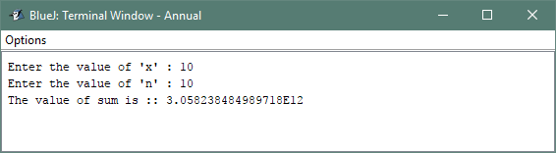

Problem# 9: SeriesSum – Output

