**Title:A GUI to obtain performance indices for any given system**

|  | **group member 1** | **group member 2** | **group member 3** |
| --- | --- | --- | --- |
| **Name** | **Ayeshee Sinha** | **Rahul Roy** | **Rajorshi Mandal** |
| **Email ID** | **ece2021046@rcciit.org.in** | **ece2021044@rcciit.org.in** | **ece2021050@rcciit.org.in** |

**Abstract :**

This report presents a second-order system response calculator implemented in Python. The calculator computes various parameters such as natural frequency, damping ratio, rise time, peak time, peak overshoot, maximum peak overshoot, and settling time based on user-provided numerator and denominator coefficients of the transfer function. The system response is visualized through a graphical plot. This tool aids in the analysis and design of control systems.

**Novelty of this work:**

This work offers a comprehensive tool for analyzing second-order system responses with user-friendly input via a graphical user interface (GUI). It allows users to quickly assess system behavior and make informed decisions in control system design.

**Functional Block diagram :**

The system comprises two main functional blocks: the GUI interface and the calculation engine. The GUI accepts input coefficients from the user and triggers the calculation process. The calculation engine computes the system response parameters and generates visual output.

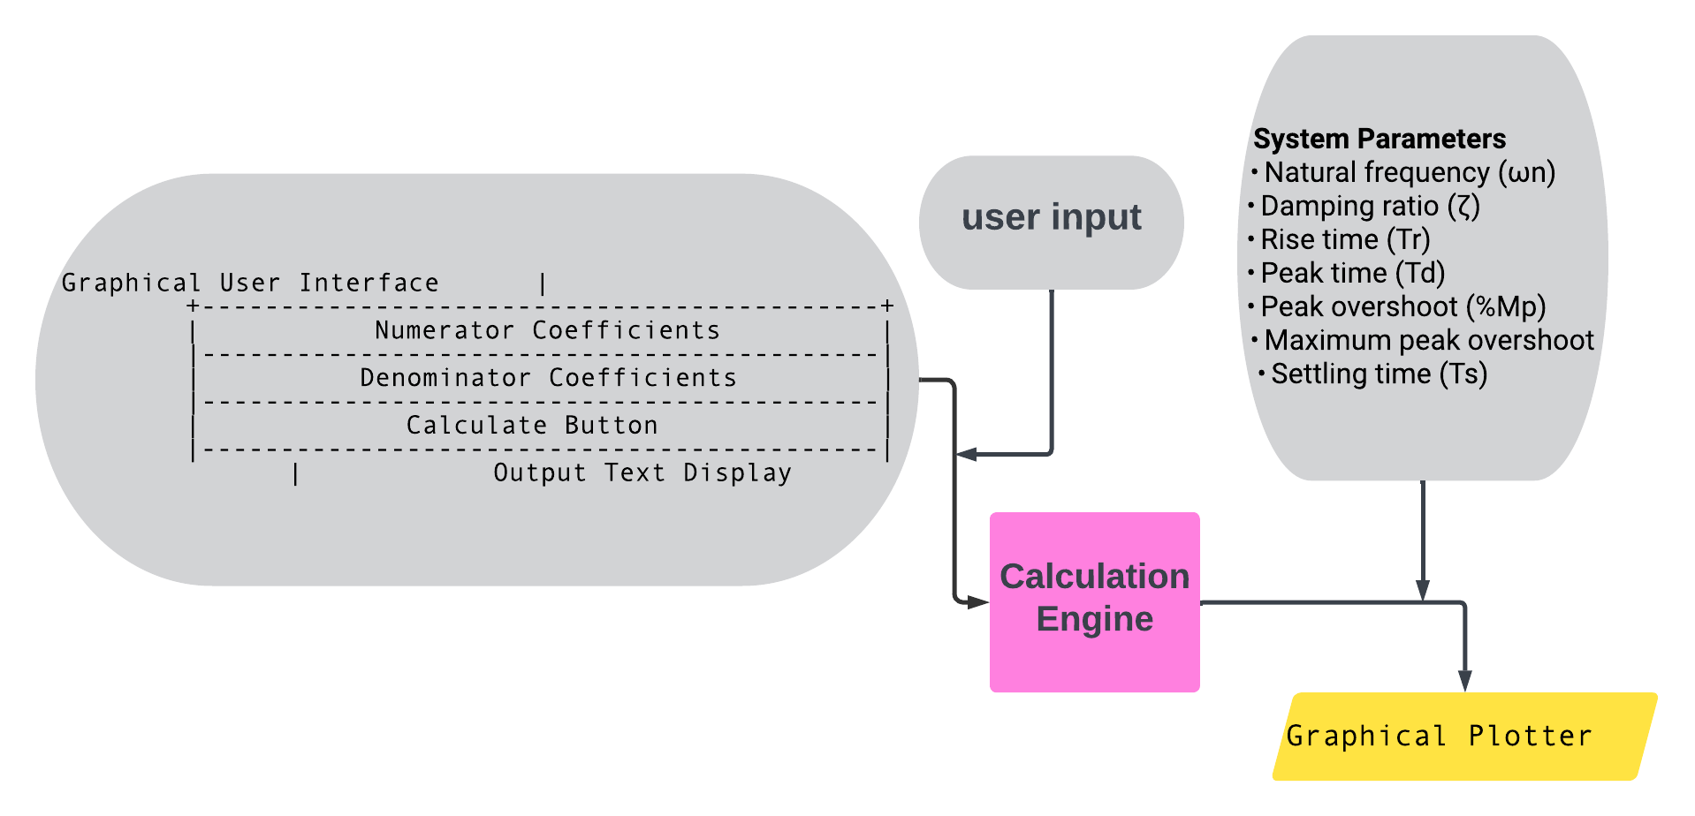

**Working methodology :**

* User inputs the numerator and denominator coefficients of the transfer function through the GUI.
* Upon clicking the "Calculate Response" button, the system triggers the calculation process.
* The calculation engine uses symbolic computation to determine the natural frequency and damping ratio.
* It computes various system response parameters including rise time, peak time, peak overshoot, maximum peak overshoot, and settling time.
* Based on the damping type (underdamped, critically damped, or overdamped), the output response equation is determined.
* The results are displayed in the GUI, and a graphical plot of the system response is generated.

**Algorithm:**

* Accept user input of numerator and denominator coefficients.
* Compute natural frequency and damping ratio using symbolic computation.
* Calculate rise time, peak time, peak overshoot, maximum peak overshoot, and settling time.
* Determine the output response equation based on damping type.
* Display results in the GUI.
* Generate a graphical plot of the system response.

**Installation process of modules(if any):**

Installed the following modules ->

* NumPy
* SymPy
* Matplotlib
* Tkinter

**Result:**

**Case 1 : underdamped system -> 1**

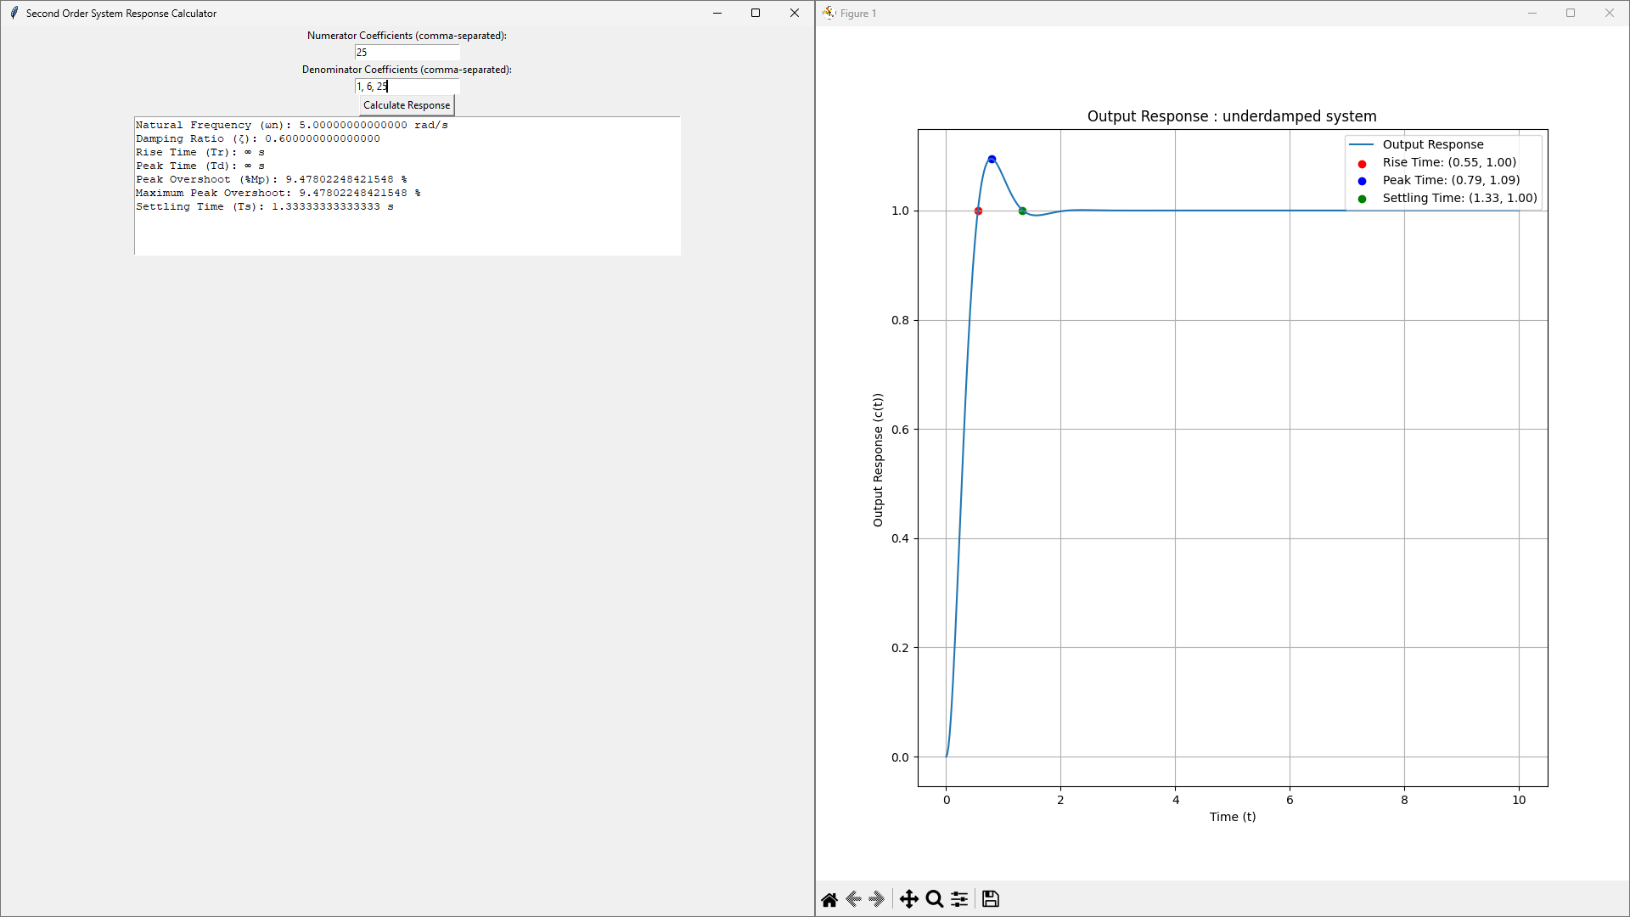

**casse 2 : underdamped system 2**

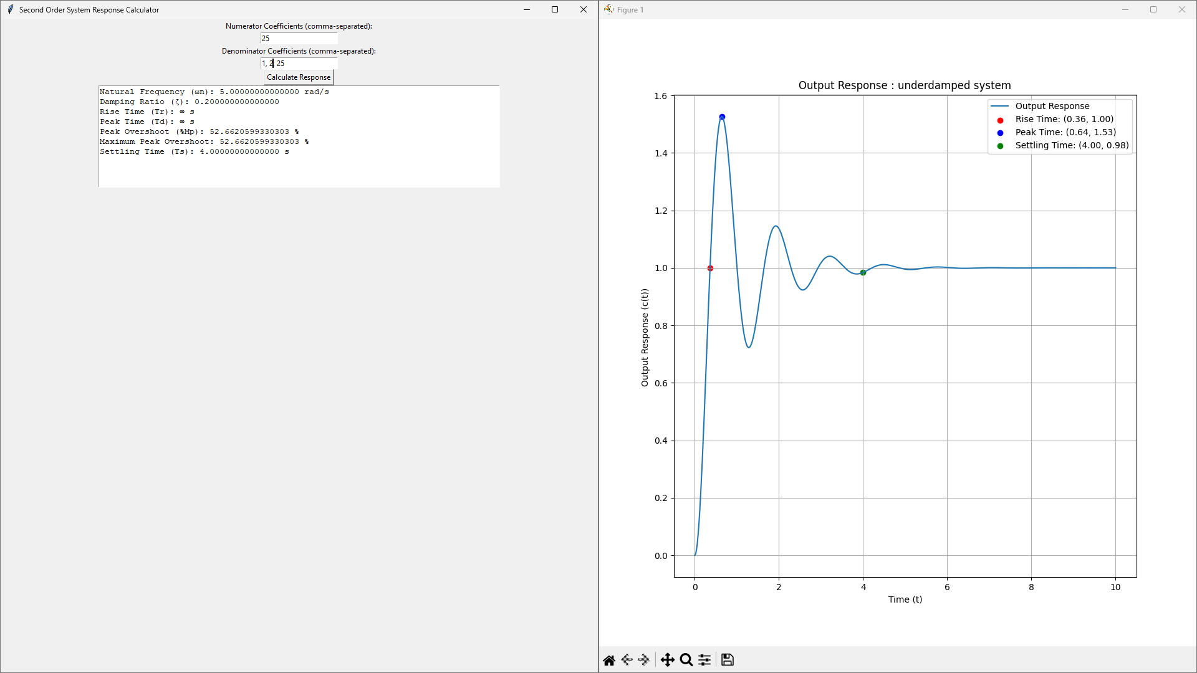

**case 3 : Criticallydamped system**

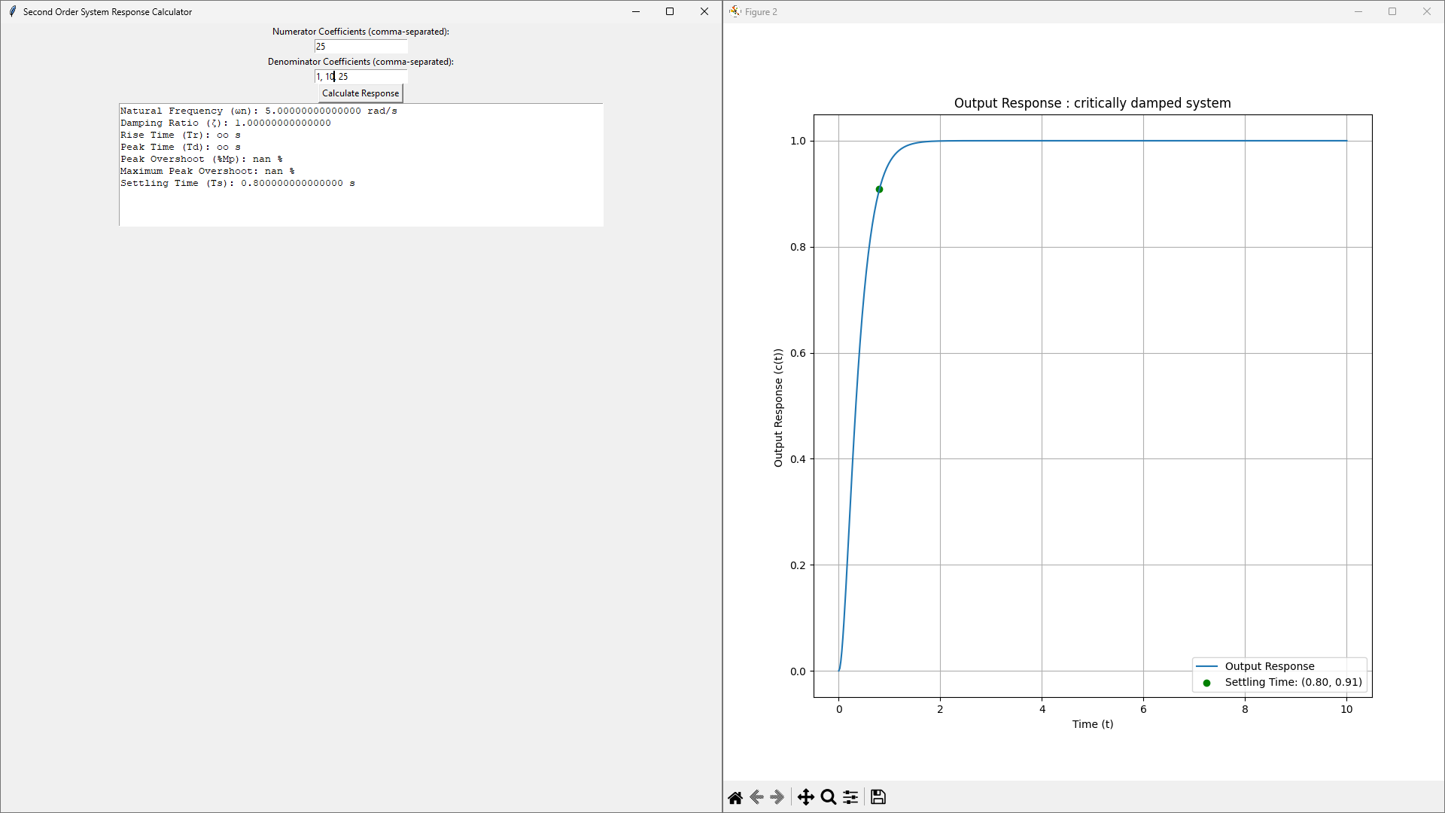

**case 4 : Overdamped system**

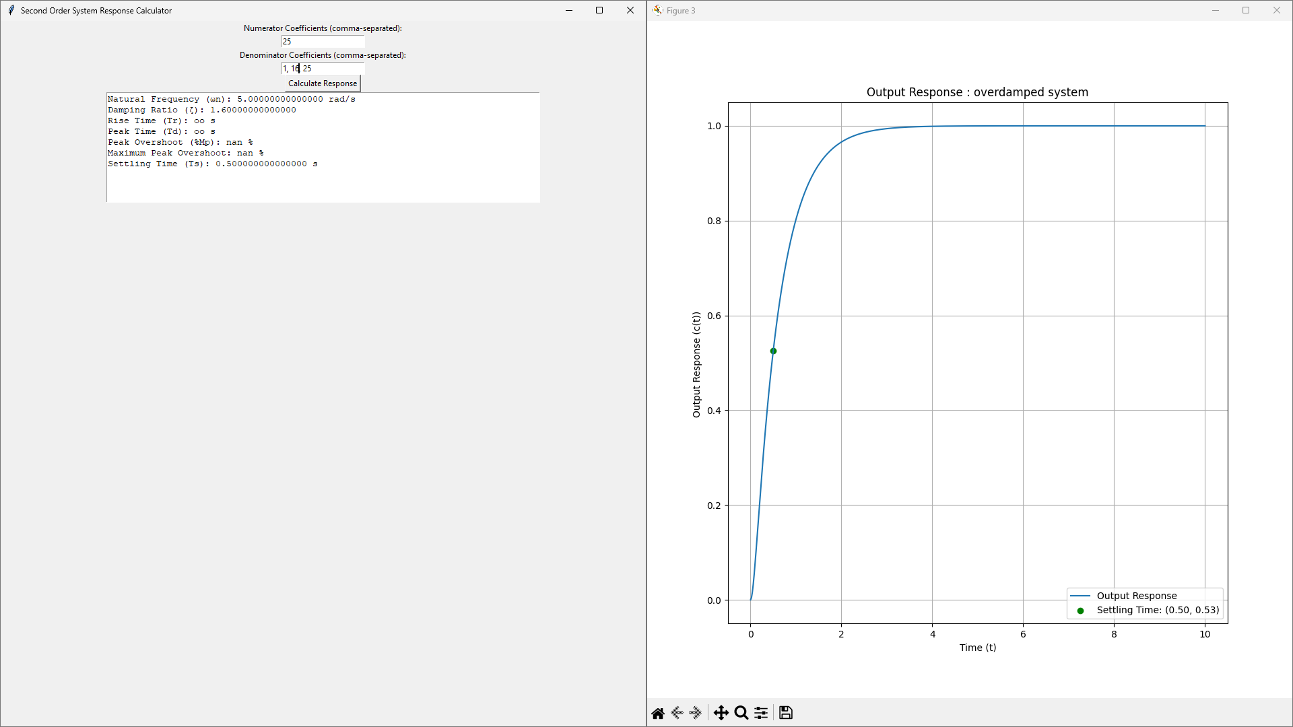

**Observation:**

The tool accurately calculates system response parameters for a variety of damping scenarios, providing valuable insights into system behavior.

Underdamped System (Numerator coefficients: 25, Denominator coefficients: 1, 6, 25): The plot of the underdamped system response exhibits pronounced oscillations with a gradual decrease in amplitude over time. This behavior is characteristic of underdamped systems, where the damping ratio (ζ) is less than 1. The rise time (Tr) and settling time (Ts) are relatively fast compared to critically and overdamped systems.

Critically Damped System (Numerator coefficients: 25, Denominator coefficients: 1, 10, 25): In the critically damped system response plot, there are no oscillations observed. Instead, the response quickly approaches the final steady-state value without overshooting. This behavior is typical for critically damped systems, where the damping ratio (ζ) is exactly 1. The rise time (Tr) is minimal, indicating a rapid response to changes, while the settling time (Ts) is also shorter compared to overdamped systems.

Overdamped System (Numerator coefficients: 25, Denominator coefficients: 1, 15, 25): The plot of the overdamped system response displays a slow, monotonic approach to the final steady-state value without oscillations. This behavior is characteristic of overdamped systems, where the damping ratio (ζ) is greater than 1. The rise time (Tr) is longer compared to underdamped and critically damped systems, indicating a slower response to changes. However, the overshoot is minimized, resulting in a smoother transition to the final state. The settling time (Ts) is longer compared to underdamped and critically damped systems due to the slower response dynamics.

**Conclusion:**

The second-order system response calculator presented in this report offers a convenient and efficient solution for engineers and researchers involved in control system analysis and design. By providing a user-friendly interface and comprehensive analysis capabilities, the tool enhances the understanding and optimization of second-order systems.

**References:**

Web article service :

* stackoverflow
* geeksforgeeks
* tutorialspoint